4-15:

Turning out that what I did in problem 3-13 last time was already putting multithread into practice, so the consequence from last time is pretty identical.

Here’s the result from last time:

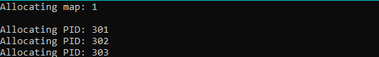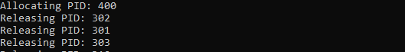

4-15：

After user enter the number, we’d create a new thread and pass the number to function.



And here is how to find the prime number:

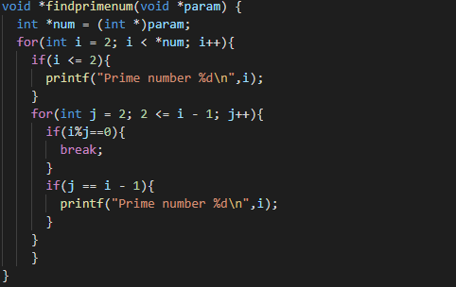

Here is the executing result:

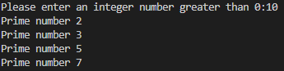

6-30:

Modifying the code from 4.15 we add one mutex lock inside the process.

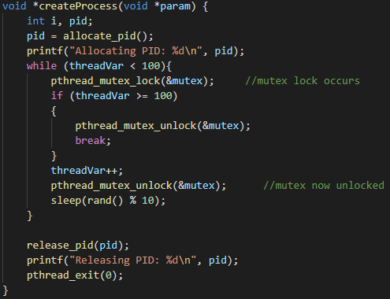

Each thread is ensured that the given thread isn’t affecting the next thread.

Project CH.4:

Write a multithreaded sorting program, here I use divide and conquer method to sort the list.

Here is divide:

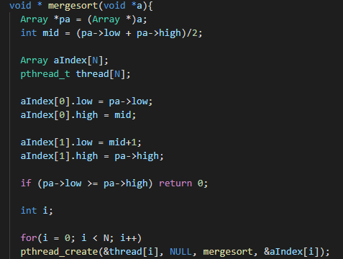

Here is conquer:

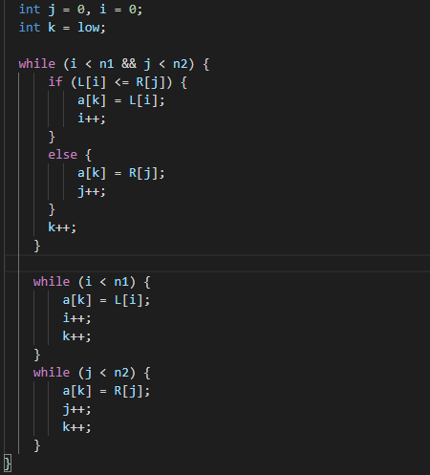

Here is input the list:



Here is the result:



Project CH.6:

The Dining Philosophers Problem

By implementing semaphore lock we can check if two adjacent philosopher is eating or not:

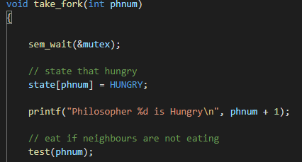

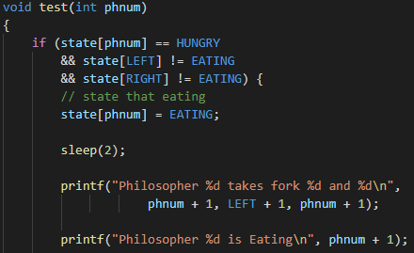

And the result is here:

