2026 H1 Economics student answers and teacher markings
Question by question transcription with the student's diagrams and the teacher's marks and comments. Case Study 1 is marked 30/40 and Case Study 2 is marked 20/40 in the original scans.
Student text is in black. Teacher markings and comments are in red below the relevant passage. Source page numbers refer to the 25-page PDF. The original answer-page images at the end preserve the handwritten markings in context.
Wording, spelling, grammar, and unfinished sentences are retained. Strikethrough shows readable crossed-out writing. [unclear] and [crossed out unclear] identify handwriting that cannot be read confidently; square-bracketed descriptions are transcription notes.

Marks recorded on the script
Case Study 1 | Marks | Case Study 2 | Marks
1(a)(i) | 1 | 2(a) | 3
1(a)(ii) | 0 | 2(b) | 3
1(b) | 2 | 2(c)(i) | 2
1(c) | 7 | 2(c)(ii) | 1
1(d)(i) | 0 | 2(d) | 4
1(d)(ii) | 3 | 2(e) | 3
1(e)(i) | 2 | 2(f) | 4
1(e)(ii) | 2
1(f) | 2
1(g)(i) | 2
1(g)(ii) | 3
1(h) | 6
Total | 30/40 | Total | 20/40
Individual marks are transcribed from the circled marks and final breakdowns. Working annotations such as P1 are retained with their relevant passages.

Case Study 1

Question 1 a i
1(a)(i) | Recorded mark 1
Source page 11
Price Elasticity of Supply is a measure of the degree of responsiveness of the quantity supplied [crossed out unclear] of a good to its change in its price, ceteris paribus.
Teacher marking 1(a)(i) Circled 1. A tick appears at the reference to price.

Question 1 a ii
1(a)(ii) | Recorded mark 0
Source page 11
The PES in the market for electricity generation is likely to be [crossed out unclear] more [crossed out unclear] than 1.
Teacher marking 1(a)(ii) Circled 0. PES and the comparison are circled and crossed in red. There are overwritten alternatives around the word more; see the original image.

Question 1 b
1(b) | Recorded mark 2
Source page 11
Over the period, both metered electricity consumption by both data centres and other customers has increased. The [crossed out unclear] increase [crossed out unclear] in metered electricity consumption by data centres is higher than other customers over the period.
Teacher marking 1(b) Circled 2. Ticks on both data centres and the comparison with other customers.

Question 1 c
1(c) | Recorded mark 7
Source page 11
Demand factors are more significant in contributing to the amplified price spikes. Extract 2 states that "data centres used 22% of Ireland's electricity in 2025, more than all urban homes combined." This likely indicates that there [crossed out unclear] is a change shift in the taste and preferences for data centres which now depend more on electricity. This leads to an increase in the demand [crossed out unclear] seen by the rightward shift in the DD curve from DD1 to [crossed out unclear] DD2.
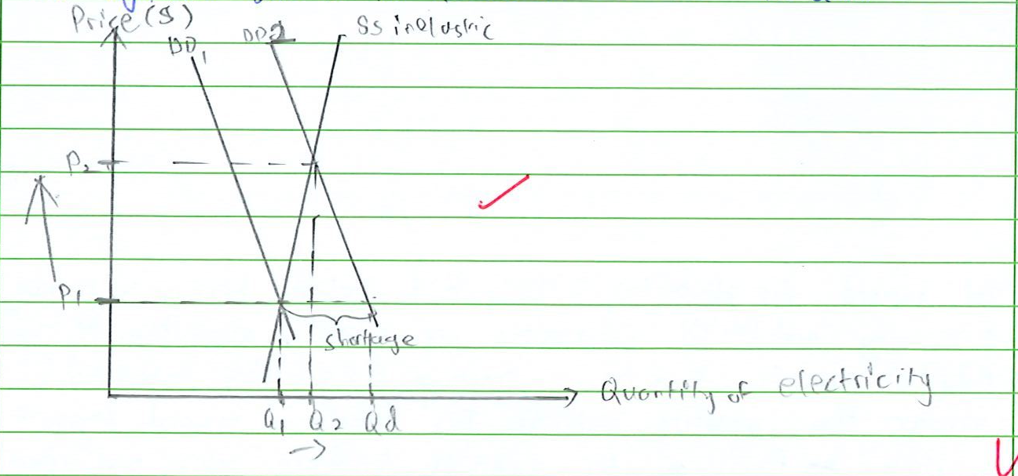
Demand shift diagram Source page 11
Teacher marking 1(c) A circled 1 appears beside the opening explanation. Tick on the demand shift and on the diagram.
The supply for electricity is likely to be inelastic because the level of stock available to supply electricity to generate data centres
Teacher marking 1(c) The explanation of inelastic supply is crossed. Margin comment reads: link to how it "takes years"?
Source page 12
is limited. At the original price P1, there is a shortage as quantity demanded is greater than quantity supplied. This [crossed out unclear] exerts an upward pressure on price. With unplanned fall in inventories, firms will increase prices to remain profitable. Quantity supplied increase while quantity demanded falls and the process continues until a new equilibrium price P2 and equilibrium quantity Q2 is achieved. The large increase in price from P1 to P2 explains the amplified increase in price.
Teacher marking 1(c) Ticks on shortage and the large increase in price.
Supply factors are more significant in contributing to the amplified price spikes. Extract 2 states that [crossed out unclear] electricity "output fluctuates significantly with weather conditions". The differences in the first nine months, electricity [unclear] in weather conditions, especially renewable ones, wind speeds and solar factors on the supply. This results in the shift to fall. Since natural gas is a factor input for electricity, an increase in the costs of natural gas and hence electricity results in leads to a fall in supply for electricity seen by the right leftward shift in the curve from SS1 to SS2.

Supply shift diagram Source page 12
Teacher marking 1(c) A circled P1 appears at the start of this paragraph. The margin comment reads: link to COP for elect. gen. from nat. gas? Tick on the supply shift and the diagram. The crossed-out quotation and some middle wording are unclear; see the original page image.
The demand for electricity is likely to be inelastic because it is now a necessity and limited substitutes are currently available. At the original price P1, there is a shortage as quantity demanded is greater than quantity supplied. This exerts an upward pressure on price. as firms [crossed out unclear] will want to increase price and reduce output at the same time. Quantity demanded increase while quantity supplied falls, and the process continues until the new
Teacher marking 1(c) Tick on necessity and limited substitutes.
Source page 13
equilibrium price P2 and new equilibrium quantity Q2 is achieved. There is a large increase in price from P1 to P2 and less than proportionate fall in quantity demanded from Q1 to Q2, hence explaining the amplified price increase.
Teacher marking 1(c) Tick on the price change.
In conclusion, it is more likely that supply factors will contribute more to the amplified price spikes than demand factors because in the long run, the supply can continue to fluctuate due to weather conditions that vary in Ireland. Demand factors are less significant because in the long run, electricity can be increased to meet the [crossed out unclear] needs of households and data centres, and more alternatives are likely to be created.
Teacher marking 1(c) Teacher writes QS ↑? below increased. The claim about alternatives is underlined with a circled question mark. Final breakdown: L2 - 6; E - 1; circled total 7.

Question 1 d i
1(d)(i) | Recorded mark 0
Source page 13
Purchasing power parity
Teacher marking 1(d)(i) Circled 0. The phrase power parity is circled and crossed.

Question 1 d ii
1(d)(ii) | Recorded mark 3
Source page 13
Short-term fossil fuel subsidies serve as indirect subsidies for producers. [crossed out unclear] fossil fuels are factor inputs for electricity generation so fossil fuel subsidies reduces cost of purchasing factors of production by producers, hence a fall in cost of production for producers, resulting in an increase in the supply as seen by the rightward shift in the supply curve from SS1 to SS2 in the diagram. At the original price P1, there is a surplus as quantity supplied is greater than quantity demanded. This exerts a downward pressure on price. Firms are more willing and able to sell off their surplus goods and services at lower prices and increase output at the same time. Quantity demanded increase while
Teacher marking 1(d)(ii) Circled 3. Ticks on factor inputs and the supply explanation. Supply and supply curve are circled and crossed. Margin comment: not only electricity but for most g/s.
Source page 14
quantity supplied falls and the adjustment process continues until new equilibrium price [crossed out unclear] P2 and new equilibrium quantity Q2 is achieved. The lower price P2 indicates a fall in the price of fossil fuels, which is passed on as lower costs to consumers, and consumers increase quantity purchased at Q2. Hence short-term fuel subsidies reduce cost of living in Ireland.
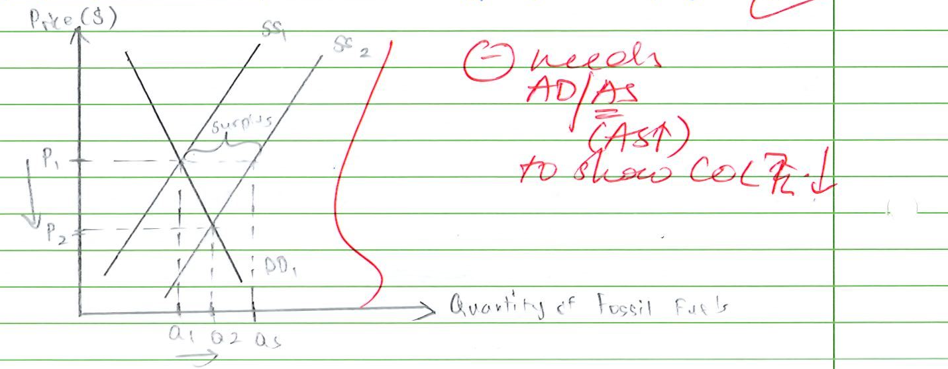
Fossil fuel subsidy diagram and teacher comment Source page 14
Teacher marking 1(d)(ii) The closing claim is marked with a cross. Beside the diagram: needs AD/AS (AS ↑) to show COL ↓.

Question 1 e i
1(e)(i) | Recorded mark 2
Source page 14
A good is non-rivalrous in nature when the consumption of the good by an additional user does not reduce the amount or benefits available to others. Extract 1 states that "many countries are investing heavily in renewable electricity generation". [crossed out unclear] and electricity generated is delivered to "where it is consumed through the electricity grid." The renewable electricity means that an increase in the consumption of electricity by one person does not reduce the amount of electricity available for other consumers, hence it is non-rivalrous.
Teacher marking 1(e)(i) Circled 2. Ticks on the definition and the explanation.

Question 1 e ii
1(e)(ii) | Recorded mark 2
Source page 14
Extract 2 says that "Ireland has restricted new electricity grid connections for data centres" and "New projects are now permitted only if they satisfy stricter connection requirements". This indicates that the Ireland can restrict non-payers such as data centres from benefiting or consuming electricity [crossed out unclear] from the use of electricity grid connections even though it has already been provided. This characteristic is excludability, which is not a feature of a public good.
Teacher marking 1(e)(ii) Circled 2. Ticks on the explanation and excludability.

Question 1 f
1(f) | Recorded mark 2
Source page 15
Johor is more of an alternative to Singapore. Extract 3 states that while "Johor's proximity" allow multinationals "to expand across the Causeway", it serves more of as an "advantage of Johor's cheaper land, construction costs as well as operating expenses". This is also seen as "Singapore faces constraints such as availability of land, power supply" which "incentivise corporations to explore alternative locations". This means that cost of production purchasing factors of production [crossed out unclear] of data centres and hence Cost of production of data centres in Johor is lower than in Singapore meaning multinationals can increase their supply to a greater extent in Johor than in Singapore.
Teacher marking 1(f) Circled 2. Tick on the cost explanation. Comment: "expl. whether" needs 2-sided expl.

Question 1 g i
1(g)(i) | Recorded mark 2
Source page 15
Negative externalities refer to external costs imposed [crossed out unclear] on third parties, neither the consumer nor the producer, from the production or consumption of the good by a firm or consumer. Extract 4 states that construction of data centres "can consume as much water as 2200 households per day, and as much electricity as 21000". This not just leads to "increasing competition for water and electricity supplies" but also "complaints about dust and Noise from the construction site and destruction of greenery and hills". Third parties here are residents living near the construction sites data centres. The above Case evidence suggests possible increase in allergies and health problems such as respiratory issues due to the dust. This increases residents' healthcare costs. Destruction of greenery could reduce space for relaxation, negatively impacting well-being of the residents.
Teacher marking 1(g)(i) Circled 2. Tick on respiratory issues. Teacher writes good with a smiley face at the end.

Question 1 g ii
1(g)(ii) | Recorded mark 3
Source page 15
The the Marginal private Benefits (MPB) of construction of new data centres is the potential benefits that can be gained from researching about electricity and how it can be powered. [crossed out unclear] Marginal Private Costs (MPC) would be the cost of purchasing factors of production for the construction. Firms seek to maximise self-interest and [crossed out unclear] produce at quantity Qp where MPB = MPC. However, they do not take into account the [crossed out unclear] external costs incurred by third parties as explained
Teacher marking 1(g)(ii) Circled 3. Tick at MPB = MPC.
Source page 16
This results in a divergence in the MSC and MPC curve where MSC > MPC since MEC > 0, MSC = MPC + MEC and [unclear] in (gi). [crossed out unclear] Society's optimal amount is at Qs where Marginal Social Cost (MSC) = Marginal Social Benefit (MSB). However, there is an overproduction of resources between quantity Qs and Qp. This leads to deadweight welfare loss indicated by the shaded area in the diagram, leading to too many resources allocated to construction of data centres.
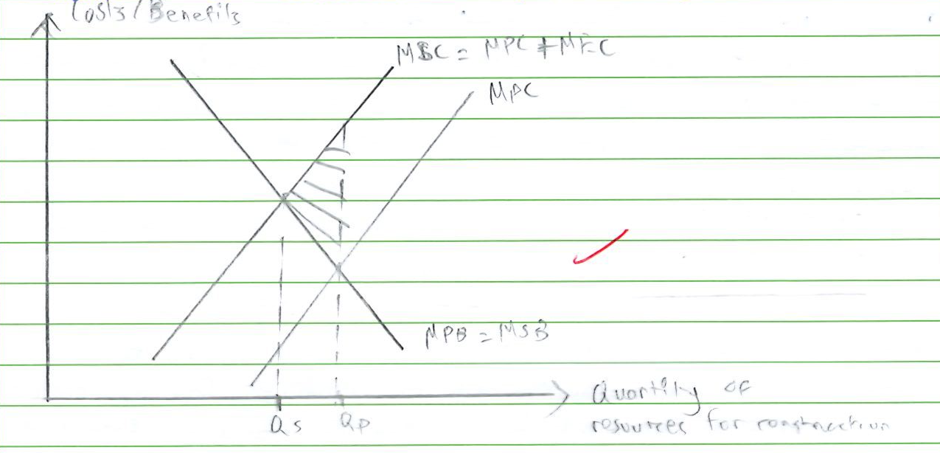
Negative externality diagram Source page 16
Teacher marking 1(g)(ii) Ticks on MSC > MPC, the social optimum, and the overproduction explanation. Tick on the diagram. The formula and linking words at the right-hand edge are cramped; see the original image.

Question 1 h
1(h) | Recorded mark 6
Source page 16
A government needs to consider both benefits and costs when investing heavily in renewable electricity generation.
Teacher marking 1(h) Tick on the opening sentence.
Extract 1 says that "countries are investing heavily in renewable electricity generation" and "additional investment is needed to expand electricity grid capacity". With an increase in investment, this leads to an increase in the AD seen by rightward shift of curve from AD1 to AD2. At original GPL P1, aggregate quantity demanded is greater than aggregate quantity supplied, leading to a shortage. With fall in inventories, firms increase prices to remain profitable. This also leads to multiplier effect where a person's increase in [crossed out unclear] spending leads to another person's increase in income. Multiple rounds of spending and repeatedly occurs which becomes smaller each round due to savings, tax, import expenditure. GPL increases from P1 to P2 and RNY increases more than proportionately from Y1 to Y2. Increase in Real national output indicate [crossed out unclear] Actual economic growth. More labour is also being employed to produce
Teacher marking 1(h) A circled 1 appears at the start. Teacher writes G ↑? beside investment. Ticks on shortage, the multiplier explanation, and Y1 to Y2.
Source page 17
electricity, reducing unemployment.
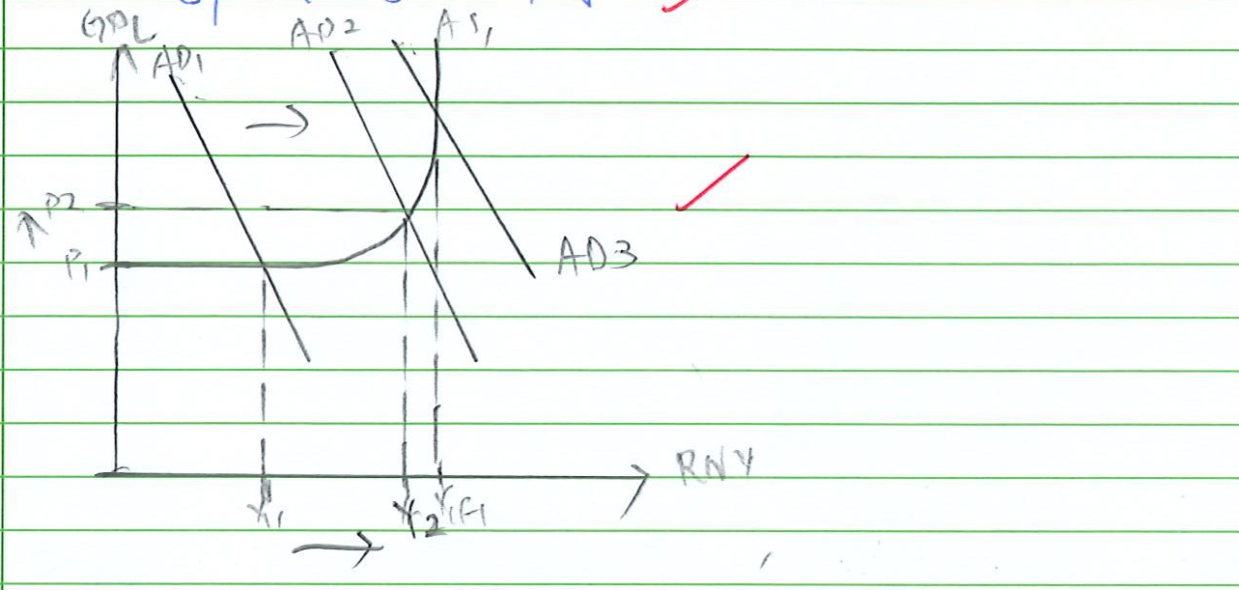
Aggregate demand diagram Source page 17
Teacher marking 1(h) Tick on reducing unemployment and the diagram.
However, demand-pull inflation occurs due to the increase in GPL and increase in the persistent increases may lead to overheating of the economy where the AD is at AD3. the Opportunity Costs are also incurred as more [crossed out unclear] costs money is allocated in investing in electricity, reducing resources available for other sectors like healthcare and education.
Teacher marking 1(h) A circled P1 appears beside this paragraph. Ticks on the inflation explanation and the opportunity cost example. Final breakdown: L2 - 6; E - 0; circled total 6.

Case Study 2

Question 2 a
2(a) | Recorded mark 3
Source page 19
The old-age-to-working-age ratio of Japan Both countries are projected to experience a projected increase in the old-age-to-working-age ratio over the period. The projected increase in the old-age-to-working-age ratio of Japan is smaller than that of South Korea over the period. The old-age-to-working-age ratio of Japan in 2024 is higher than [crossed out unclear] that of South Korea, while in 2054, the projected old-age-to-working age ratio of Japan is lower than that of South Korea.
Teacher marking 2(a) Circled 3. Ticks on both comparisons. Case Study 2 total 20/40 is written in the original page header.

Question 2 b
2(b) | Recorded mark 3
Source page 19
The production possibility curve (PPC) shows the maximum attainable combination of goods that can be produced by a country over a specified period of time with all of its resources fully and efficiently utilised at a given state of technology. Extract 5 states that aging in better health" is associated with longer and more productive working lives." Longer working lives indicates that the quantity of labour available to produce output increases. This results in an increase in productivity and hence increase in productive capacity. Potential economic growth occurs as seen by the outward shift of the PPC curve from PPC1 to PPC2, which also indicates an increase in maximum employment level of output.
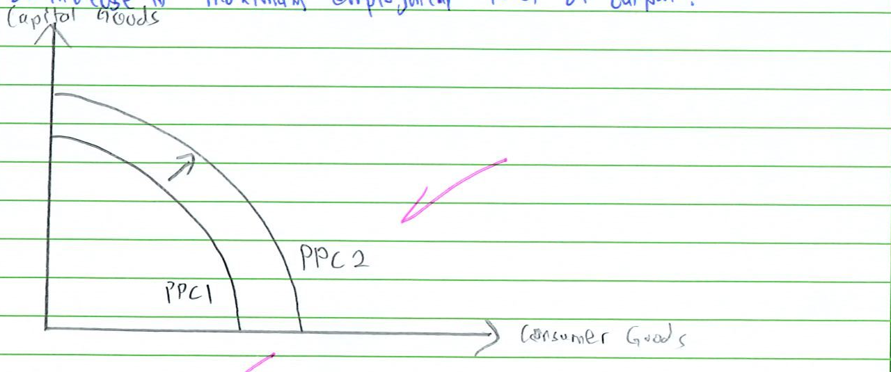
Production possibility curve diagram Source page 19
Teacher marking 2(b) Circled 3. Ticks on the case evidence, productive capacity, and PPC shift. Tick on the diagram.

Question 2 c i
2(c)(i) | Recorded mark 2
Source page 19
The first reason is as seen in Extract 6 is "labour shortages" which "were driving up wages." The labour shortages results in an upward pressure on prices, which causes firms' cost of production of hiring labour to increase, resulting in prices of wages to increase and wage-push inflation exists in the Japan. The second reason is a "weak yen" which "was raising import costs". [crossed out unclear] A weak yen indicates that
Teacher marking 2(c)(i) Ticks on the first explanation.
Source page 20
one unit of yen could be buy more units of foreign currencies. This results in an increase in price of imported goods and an increase in the price of raw materials imported into Japan. This leads to an increase in import-induced inflation in Japan. Both an increase in wage-push and import-induced inflation in Japan leads to cost-push inflation in Japan.
Teacher marking 2(c)(i) Circled 2. Teacher corrects more to less. Teacher adds in yen above the imported-goods explanation. Comment below: link to AS ↓ GPL ↑.

Question 2 c ii
2(c)(ii) | Recorded mark 1
Source page 20
[crossed out unclear] Bank of Japan's decision to raise its policy interest rate is a tight monetary policy intended to reduce Aggregate Demand (AD)
Teacher marking 2(c)(ii) Tick on tight monetary policy and AD.
Raising the policy interest rate from 0.5% to 0.75% was
Teacher marking 2(c)(ii) The sentence ends here in the scan. Circled 1 and a large diagonal marking line. Page 21 contains no further student answer.

Question 2 d
2(d) | Recorded mark 4
Source page 22
Material standards of living (MSOL) refers to the quantity of goods and services available for consumption by the average individual in an economy over a given time period.
Teacher marking 2(d) Tick on the definition.
Extract 7 states that "the peak wage system was designed to use the savings from cutting older workers' pay to also hire younger employees in a bid to boost productivity". However, the implementation of such a policy has resulted in "highest elderly poverty rates among developed nations" and "workers over 60 earn 29% less on average than younger colleagues." the Cutting older workers' pay would mean older workers will receive less of an income, reducing their disposable incomes and hence purchasing power. Older workers' confidence will fall with the implementation of the policy, reducing their consumption and hence the AD as seen in the diagram from AD1 to AD2. A fall in AD with constant AS would suggest a fall in real national income from Y1 to Y2 and hence fall in real Gross Domestic Product (GDP). More people are also being unemployed as the [crossed out unclear] AD2 lies on the horizontal range of the AS, which indicates ample spare capacity. More people are [crossed out unclear] less able to satisfy their material needs and wants since real national output has fallen and consumer confidence has fallen. Assuming population size remains the same, with a fall in real GDP, real GDP per capita falls, hence average MSOL falls.
Teacher marking 2(d) Ticks on the explanation. Teacher writes 2nd effect? beneath this paragraph.
Source page 23
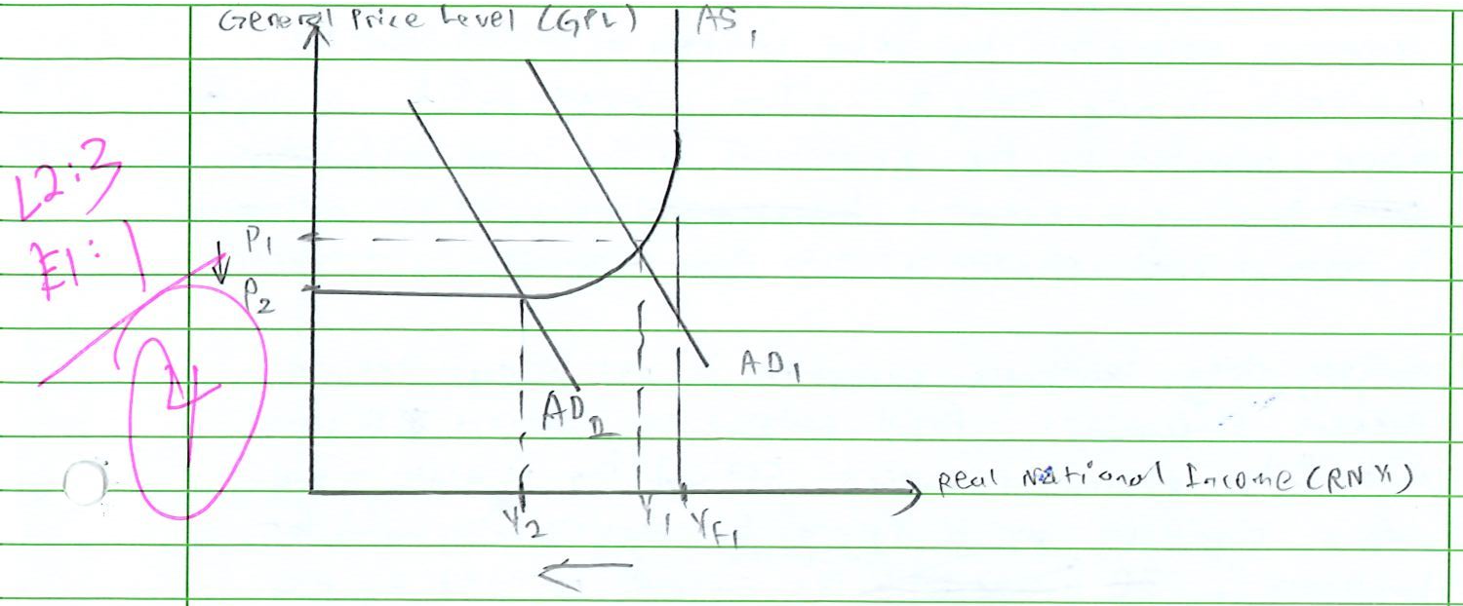
Aggregate demand diagram and mark breakdown Source page 23
Teacher marking 2(d) Beside the diagram: L2: 3; E1: 1; circled total 4.
Real GDP per capita is not suitable as an indicator for the Standard of Living (SOL) for whole older workers, [crossed out unclear] because not all of the older workers above the a certain age will be working. The the income distribution among these workers will not be even, so the real GDP per capita does not accurately reflect the quantity of amount of Goods and Services available for all consumption by an older worker in the country. economy. [crossed out unclear] The composition of GDP for older workers might also not be accurate in reflecting their real GDP per capita, as most older workers would purchase more healthcare services since they will be worried about their health at this stage.
Teacher marking 2(d) Margin comments include substantiate, case, and eg. Tick on the income-distribution explanation. Arrows point from the comments to the relevant wording.

Question 2 e
2(e) | Recorded mark 3
Source page 23
Rising healthcare expenditure is an example of an expansionary fiscal policy involving an increase in the government expenditure to influence AD and overall economic activity.
Teacher marking 2(e) The teacher's nearby comment clarify this term? points to fiscal sustainability in the following paragraph.
Rising healthcare expenditure is likely to threaten Singapore's fiscal sustainability. Extract 8 says that "the government has set aside $20.9 billion for health" while the projected expenditure by 2030 "would likely be close to $30 billion a year". [crossed out unclear] The extract also says "a lot of the money will go towards building more facilities, including new hospitals, nursing homes and community care centres; and for manpower costs." All of this
Teacher marking 2(e) Teacher writes clarify this term? above this paragraph. Ticks on the evidence.
Source page 24
indicates an increase in government expenditure which indicates an increase in AD. However, this increase, together with the projected increase in expenditure by 2030 is likely to indicate that the government is more likely to run into a budget deficit, assuming tax revenue collected by the government is the same and budget government budget is [crossed out unclear] measured by difference in revenue and expenditure, hence fiscal sustainability is threatened.
Teacher marking 2(e) Final breakdown written at the top of page 24: L2: 3; E: 0; circled total 3. A margin note says concept near the budget explanation.
However, rising healthcare expenditure is not always likely to threaten Singapore's fiscal sustainability. Extract [crossed out unclear] 8 states that "the government expects GDP and tax receipts to grow, with a significant part of future tax receipts being used for healthcare". [crossed out unclear] Some of the tax revenue collected by the government will be used to for healthcare expenditure, [crossed out unclear] and this tax revenue is typically collected from workers by the government. Singapore government will spend less of its own expenditure on healthcare, resulting in the [crossed out unclear] government's budget to more likely be in a [crossed out unclear] budget surplus than budget deficit, hence fiscal sustainability is unlikely to be threatened.
Teacher marking 2(e) Margin note: fiscal sustainability not same as fiscal deficit / surplus. The original image shows the note's full placement and arrows.
In conclusion, Singapore's fiscal sustainability is unlikely to be threatened, so long as most of the tax revenue it collects is used for healthcare expenditure rather than the government increasing its expenditure by itself.
Teacher marking 2(e) The final claim is underlined. Teacher writes WDYM? and what expenditure!

Question 2 f
2(f) | Recorded mark 4
Source page 24
Inclusive economic growth (IEG) refers to a stable rate of growth that can be sustained over the long run, and is broad-based across economic sectors and creates productive employment opportunities for the majority of the population.
Teacher marking 2(f) Tick on the definition.
Raising the retirement age is the best policy for achieving IEG in economies experiencing population ageing. Extract 6 states that in Japan, "59% were extending retirement ages or rehiring retired employees." This meant that the quantity of labour will increase to produce the same level of output. There is an increase in
Teacher marking 2(f) Ticks on the evidence and quantity of labour.
Source page 25
productivity, hence increase in productive capacity. This increases the AS as seen LRAS seen by rightward shift of AS from AS1 to AS2. Maximum employment level of output increases from Yf1 to Yf2. Additionally with more labour in the economy, this can result in a surplus in the quantity of labour in the labour market. This exerts a downward pressure on wages which indicates [crossed out unclear] lower Cost of hiring more workers for firms. SRAS increases, seen by the downward movement of AS from AS1 to AS2. At the original GPL P1, P1, there is a surplus as aggregate quantity supplied is greater than aggregate quantity demanded. This causes firms to be more willing and able to sell off their surplus goods and services at lower prices. GPL falls from P1 to P2 and RNY increases from Y1 to Y2.
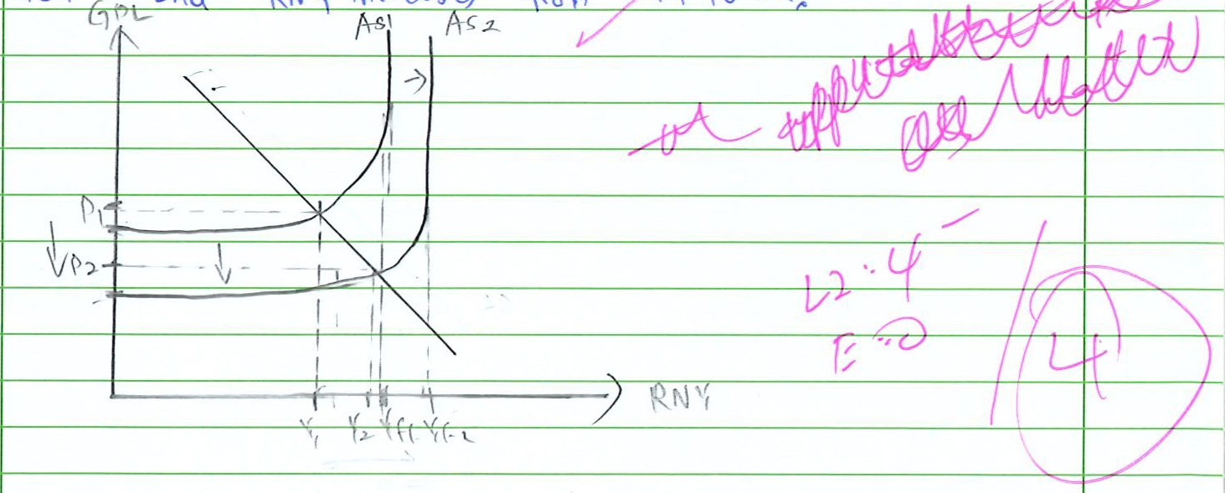
Aggregate supply diagram and mark breakdown Source page 25
Teacher marking 2(f) Ticks on the shifts and output changes. Beside the diagram, one overwritten comment is only partly legible: [unclear] as labour. Final breakdown: L2: 4; E: 0; circled total 4.
At P2 and Y2, more labour is being employed, meaning more people can earn an income at that point. Since both actual and economic growth has occurred and there is a reduction in income inequality, this helps in achieving IEG.
Teacher marking 2(f) The link to income inequality is underlined. Margin comments: how so? and elab on this!
Improvements in Technology is another policy that can be used to achieve IEG. Extract 6B says that "technology offers another set of solutions when it comes to manpower efficiency" and in a smart ward, "a nurse can manage six" patients, boosting efficiency by 20 percent. This indicates
Teacher marking 2(f) The answer ends here in the supplied scan. Teacher writes incomplete with a large caret.

Original answer pages and teacher markings
These anonymised images allow direct comparison with the transcription and retain the original ticks, crosses, arrows, marginal comments, and overwritten writing. Pages 18 and 21 contain no student answers; each has a diagonal marking line.

Source page 11


Source page 12


Source page 13


Source page 14


Source page 15


Source page 16


Source page 17


Source page 19


Source page 20


Source page 22


Source page 23


Source page 24


Source page 25


