EXPLORATORY DATA ANALYSIS (EDA) REPORT
E-Commerce User Purchase Dataset
This report presents the exploratory data analysis performed in the supplied Jupyter notebook. The analysis examines the structure, descriptive statistics, distributions, and correlations of an e-commerce user dataset.

1. Objectives
- Understand the size and structure of the dataset.
- Examine data types and identify missing values.
- Summarize the numerical variables using descriptive statistics.
- Study the distribution of the target/purchase-related variable.
- Identify relationships among numerical features using correlation analysis.
- Visualize the distributions of selected numerical variables.

2. Dataset Overview
The dataset contains 1,500 records and 9 columns. All columns are non-null in the supplied analysis, so no missing values are reported.
Column | Data Type | Non-Null Count
Age | int64 | 1500
Gender | int64 | 1500
AnnualIncome | float64 | 1500
NumberOfPurchases | int64 | 1500
ProductCategory | int64 | 1500
TimeSpentOnWebsite | float64 | 1500
LoyaltyProgram | int64 | 1500
DiscountsAvailed | int64 | 1500
PurchaseStatus | int64 | 1500

3. Descriptive Statistics
The supplied notebook reports the following key descriptive statistics. Age ranges from 18 to 70 years with a mean of 44.30 years. Annual income ranges from approximately 20,001.51 to 149,785.18, with a mean of approximately 84,249.16. NumberOfPurchases ranges from 0 to 20, with a mean of 10.42. TimeSpentOnWebsite ranges from about 1.04 to 59.99, with a mean of 30.47. LoyaltyProgram has a mean of 0.327, while PurchaseStatus has a mean of 0.432.
Variable | Mean | Std. Dev. | Minimum | Maximum
Age | 44.299 | 15.537 | 18 | 70
Gender | 0.505 | 0.500 | 0 | 1
AnnualIncome | 84,249.164 | 37,629.493 | 20,001.513 | 149,785.176
NumberOfPurchases | 10.420 | 5.887 | 0 | 20
ProductCategory | 2.013 | 1.428 | 0 | 4
TimeSpentOnWebsite | 30.469 | 16.984 | 1.037 | 59.991
LoyaltyProgram | 0.327 | 0.469 | 0 | 1
DiscountsAvailed | 2.555 | 1.705 | 0 | 5
PurchaseStatus | 0.432 | 0.496 | 0 | 1

4. Data Quality Findings
The notebook's info() output shows 1,500 non-null values for every column. Therefore, based on the supplied EDA output, there are no missing values in the dataset. The dataset contains two floating-point variables (AnnualIncome and TimeSpentOnWebsite) and seven integer variables.

5. Visualization Analysis

5.1 Target Distribution Plot
The first generated plot is titled 'Target Distribution: NumberOfPurchases'. It actually displays the frequency of NumberOfPurchases values from 0 through 20. The bars are annotated with percentages of the 1,500 records. The distribution is spread across the full 0–20 range rather than being a binary 0/1 purchase-status distribution.
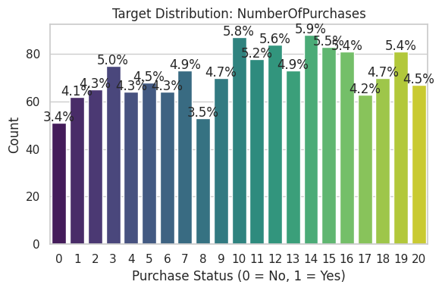

5.2 Feature Correlation Heatmap
The correlation heatmap shows the relationships among all numerical variables. With PurchaseStatus as the reference target, the largest positive correlations shown are LoyaltyProgram (0.31), DiscountsAvailed (0.30), TimeSpentOnWebsite (0.28), and NumberOfPurchases (0.22). AnnualIncome has a correlation of 0.19 with PurchaseStatus. Age has a negative correlation of -0.26 with PurchaseStatus. Gender and ProductCategory have correlations close to zero with PurchaseStatus in this dataset.
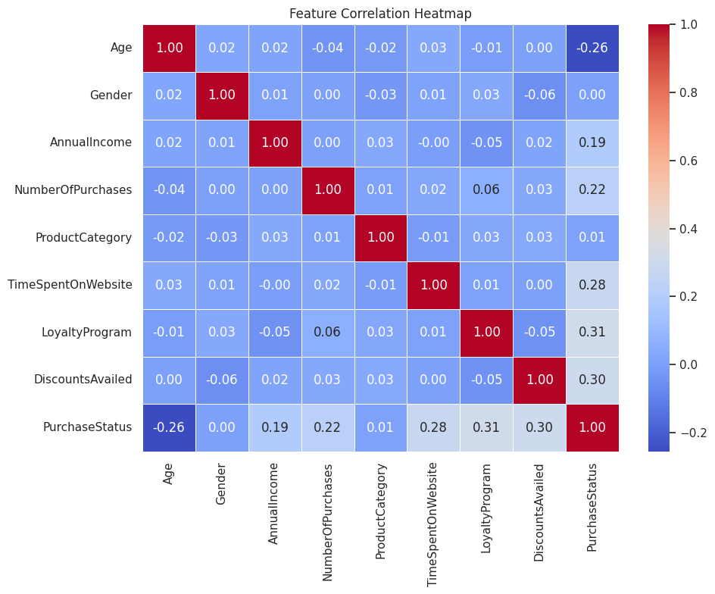

5.3 Numerical Feature Distributions
The notebook plots distributions for the first four numerical columns: Age, Gender, AnnualIncome, and NumberOfPurchases. Age covers the 18–70 range. Gender is binary and appears relatively balanced between 0 and 1. AnnualIncome spans approximately 20,000–150,000. NumberOfPurchases spans 0–20 and is distributed across the range.
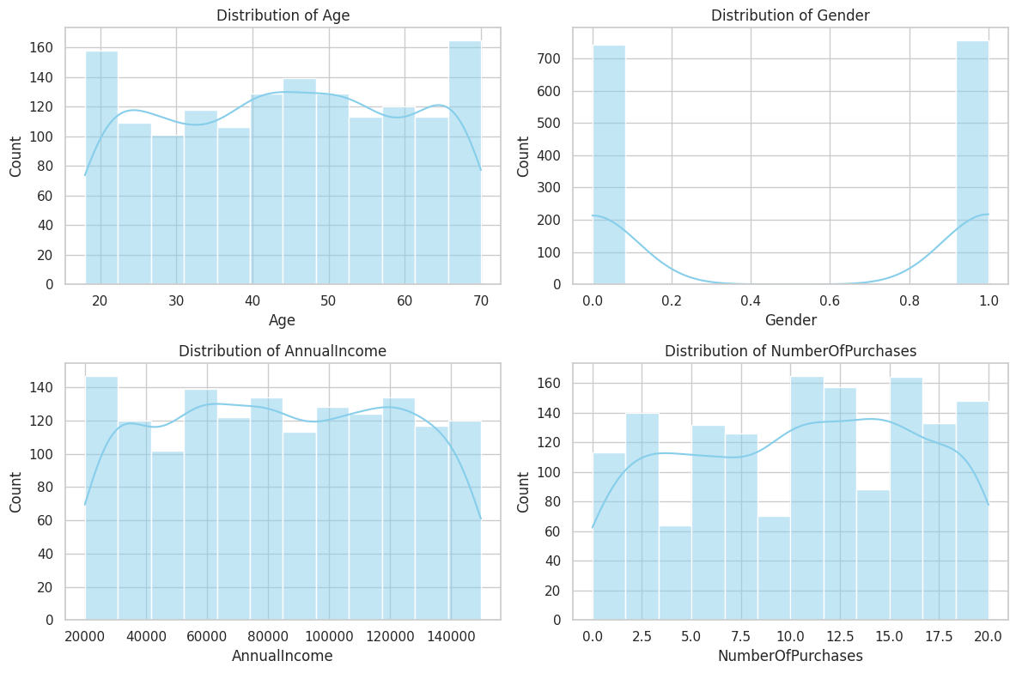

6. Important Observation About the Notebook Code
There is a target-column selection issue in the supplied code. The code searches for the first column whose name contains 'purchase', 'label', or 'target'. Because NumberOfPurchases appears before PurchaseStatus, the expression selects NumberOfPurchases as target_col. Consequently, Graph 1 is not a PurchaseStatus class-distribution plot even though its axis label says 'Purchase Status (0 = No, 1 = Yes)'. The actual binary target column in the dataset is PurchaseStatus.
For a corrected target distribution, the code should explicitly use: target_col = 'PurchaseStatus'. This would produce a binary 0/1 distribution instead of the 0–20 NumberOfPurchases distribution.

7. Key EDA Findings
- The dataset has 1,500 rows and 9 columns.
- No missing values are reported by the notebook.
- Age ranges from 18 to 70 years, with a mean of 44.30.
- AnnualIncome has a wide range, from approximately 20,001.51 to 149,785.18.
- NumberOfPurchases ranges from 0 to 20, with a mean of 10.42.
- PurchaseStatus has a mean of 0.432, indicating that 43.2% of records have PurchaseStatus = 1 if the binary coding is interpreted as 0/1.
- Among the displayed correlations with PurchaseStatus, LoyaltyProgram (0.31), DiscountsAvailed (0.30), and TimeSpentOnWebsite (0.28) are the largest positive correlations.
- Age has the strongest negative correlation with PurchaseStatus among the listed features (-0.26).
- Gender and ProductCategory show correlations very close to zero with PurchaseStatus.

8. Conclusion
The EDA provides an initial understanding of the e-commerce user dataset. The data are complete with respect to missing values, and the numerical variables cover meaningful ranges. The correlation analysis shows that LoyaltyProgram, DiscountsAvailed, TimeSpentOnWebsite, and NumberOfPurchases have positive linear associations with PurchaseStatus, while Age has a negative association. These are correlations only and do not by themselves establish causation. Before using the notebook for further modelling, the target-column selection in the first visualization should be corrected to PurchaseStatus.

End of Report

