NT WORLD INK / CYBER SECURITY AWARENESS / SESSION 3
AI, Deepfakes, and the New Shape of Online Deception
The threats that have changed recently. AI tools have made scams cheaper to produce and far more convincing, and have brought new risks: fake audio, fake video, and information leaking out of everyday tools. This session brings you up to date, without assuming any technical knowledge.
Start Here
In Session 2 we learned to spot the convincing message. This session is about what has changed in the last couple of years, because AI tools have moved the goalposts. Scams are cheaper to make, easier to personalise, and a lot more believable than they used to be. On top of that, there are new tricks: fake voices, fake video, and the quiet risk of leaking information into the very tools we are starting to use for work.
The tools changed. The defence did not. Slow down, check the source, and never act on a message, a voice, or a video on its own.
How AI Is Making Scams More Convincing
For years the advice was simple: watch for bad spelling and clumsy English. That advice is now out of date. Scammers use the same AI writing tools everyone else does, so their messages are in perfect English, every time.
• The writing is flawless now. No more typos to give it away. A scam can read exactly like a real message from your bank, a supplier, or your manager.
• Scams are personalised at scale. AI can take public information about you and write a message tailored to you, for thousands of people at once.
• Fake voices and faces are cheap to make. A short clip of someone's voice from social media is enough to clone it.
The old rule is dead; the new rule still works
"Bad English means scam" no longer holds. The reliable rule now is the one from Session 2: unexpected plus urgent means stop and check. Good writing proves nothing about who really sent a message.

Deepfakes: Fake Voices, Fake Video, Fake Calls
A deepfake is audio, video, or an image made or altered by AI to look and sound real. It might be a voice on the phone that sounds exactly like a family member, or a video of a public figure saying something they never said.
• A phone call in a voice you know. The family emergency scam, supercharged. The voice can be cloned from a few seconds of audio from social media. The same trick is used at work, in the voice of your manager or CEO.
• A video on social media. A clip of a politician, celebrity, or doctor promoting an investment or saying something shocking. The face and voice look right, but the words are put in their mouth by AI.
The tells that still give them away
• The story is urgent and emotional and pushes you to act now; the same lever as every scam.
• In video, look for odd edges, blurring around the face or hair, strange blinking, lips not matching the words, or a flat tone.
• The request is the giveaway, not the voice. A real loved one, or a real manager, will not refuse to verify who they are.
Agree a verification step, at home and at work
The simplest defence against a cloned voice is a question only the real person could answer, or a word your family agrees in advance. If a panicked call asks for money, hang up and call the person back on the number you already have. At work, confirm any unusual request through a second channel. A real person is never harmed by you taking a minute to check.

Misinformation and What to Trust Online
Not everything fake is trying to steal from you. A lot of it is just trying to get your attention, your click, your share. AI has made it cheap to produce dramatic images and headlines that are exaggerated, out of context, or simply made up. The danger is not only being fooled yourself; it is passing it on to others who trust you. This matters most when feelings are running high, and there is no higher-feeling moment than right after a disaster.
A Real Example: After the Cyclone
When a cyclone affected the Top End, these two videos appeared in search results within hours, while people were still anxious and looking for information. Both use the real cyclone's name, dramatic imagery, and alarming claims to pull in views.
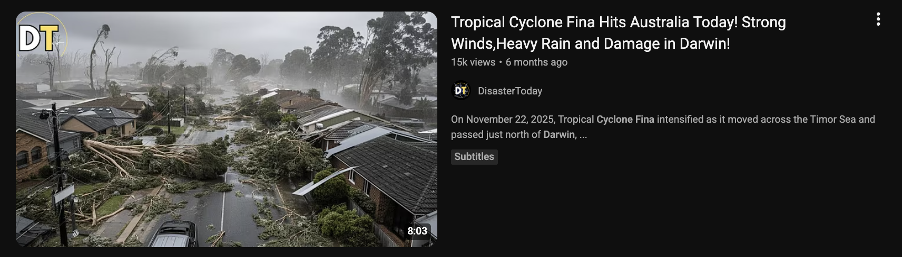
DisasterToday, 15k views. The flattened gum trees and tiled-roof houses look more like a southern suburb than tropical Darwin.
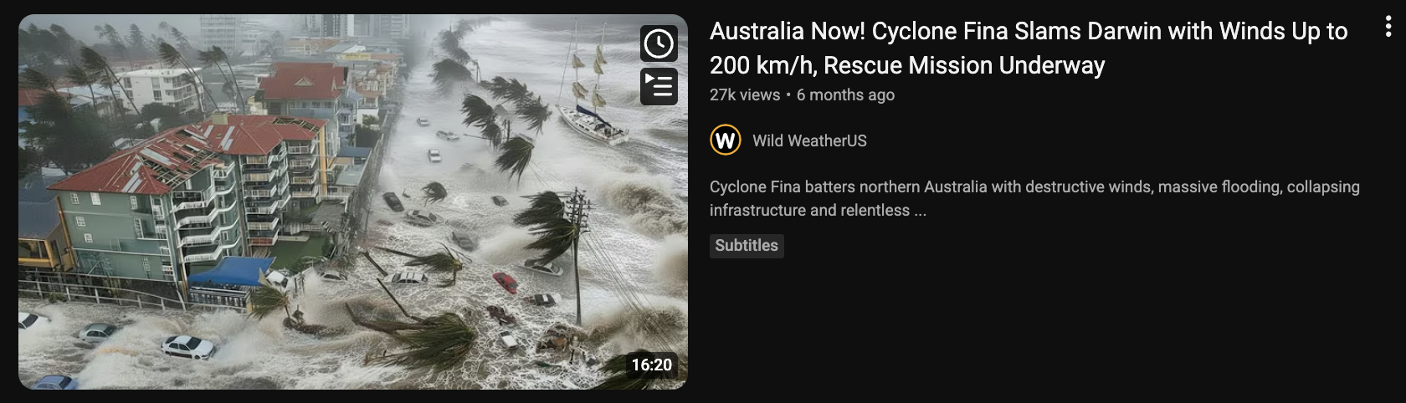
Wild WeatherUS, 27k views. A flooded high-rise beachfront that does not match Darwin's foreshore, posted by a United States channel.
The warning signs in these two
Sensational, fear-loaded titles (Slams, Up to 200 km/h, Rescue Mission Underway) built to make you click during an emergency. A channel that does not match the place (Wild WeatherUS reporting on Darwin); content farms repackage every disaster worldwide for views. Pictures that do not match the place, or look too dramatic to be true, a sign of recycled footage or AI-generated images. Vague, round numbers and no named source. And the timing: they appear fast, while real information is still coming out.

How to check before you believe it, or share it
A quick truth check
• Pause before you share. Strong feelings are the point. If something makes you scared or outraged, that is the moment to slow down, not to hit share.
• Go to the source. For weather and emergencies in the Territory: the Bureau of Meteorology (bom.gov.au), the NT Government emergency and SecureNT pages, and ABC Emergency, not a random channel or social post.
• Check the place and the date. Does the image really show here, and now? Dramatic disaster footage is very often from another country or another year, relabelled. Ask plainly: does this even look like Darwin?
• Be extra careful right after an event. The first hours of any disaster are when misinformation is thickest. Wait for, and pass on, official advice only.

Why this matters for Council and community
Staff are trusted, so what you share gets believed and passed on further. Sharing a fake or exaggerated image during an emergency can cause real panic, or send people the wrong way at the worst possible time. Sticking to official sources, and helping the people around you do the same, is part of keeping the community safe.

Keeping Council Information Out of AI Tools
AI chatbots are genuinely useful, and more of us are using them. But it is worth knowing where your words go. With many free public tools, what you type can be stored and may be used to help train the next version of the tool. In plain terms: it leaves your control. That is fine for a recipe; it is not fine for information about residents, staff, or Council business.
• Free, paid, and enterprise accounts differ. Free public tools usually offer the least privacy. Enterprise or workplace accounts set up by your organisation are built so your data stays inside and is not used for training. The safe choice for work is whatever tool your workplace has approved.
A plain rule for what never to paste into an AI tool
Do not paste personal or sensitive information (names with details, addresses, dates of birth, health or financial information), anything confidential about Council business, or any password, into a public AI tool. A simple test: if you would not put it on a public noticeboard, do not put it into a chatbot. For work, use only the tools your workplace has approved.

Protecting Your Own Identity
Deepfakes and impersonation need raw material: photos of your face, recordings of your voice, video of you. The more of that is public, the easier you are to copy. You do not have to disappear from the internet; you just reduce what is freely on offer.
• Check the privacy settings on your social media so photos and videos are not public to the whole world.
• Think before posting long clips of your own voice, or your children's voices, publicly.
• Be cautious with fun apps and quizzes that ask for photos, your voice, or personal details.
• Agree a verification word or question with family, so a cloned voice cannot fool them, or you.
What to Take Away
Your up-to-date deception checklist.
☐ Stop trusting good spelling and grammar as a sign an email is real; AI writes perfectly now.
☐ Treat an unexpected, urgent call in a familiar voice as possibly fake; hang up and call back on a known number.
☐ Agree a verification word with my family, and use a second channel to check unusual requests at work.
☐ Pause before sharing anything dramatic online, especially right after a disaster.
☐ Check weather and emergency news at official sources (BOM, NT Government, ABC Emergency), not random channels.
☐ Never paste personal, sensitive, or confidential information, or passwords, into a public AI tool.
☐ Use only workplace-approved AI tools for any work that involves real information.
☐ Tighten my social media privacy so my face and voice are not public to everyone.
Knowledge Check
Five quick scenarios to check what has landed. Have a think about each, then read the answer.
1. A dramatic video of a flooded street, said to be your town during the cyclone, is being shared fast in a community group. Do you share it on to warn people?
Answer. No, not until you have checked it. Disaster footage is very often from another place or another year, or made or exaggerated by AI. Before sharing, check an official source (the Bureau of Meteorology, the NT Government emergency page, or ABC Emergency) and ask whether the image even matches your town. Sharing a fake during an emergency can cause real panic. If you want to help, pass on the official advice instead.
2. You get a phone call. It is your daughter's voice, crying, saying she has had an accident and needs money sent right now. What do you do?
Answer. Do not send anything. Hang up and call your daughter back on the number you already have for her. A voice can be cloned from a few seconds of audio online, and the panic is there to stop you thinking. If you cannot reach her, call someone who would know where she is. This is why agreeing a verification word with family in advance is so useful; a cloned voice cannot answer it.
3. A scam email arrives in perfect English, with the Council logo and writing that sounds just like your manager. Does the good English and familiar style mean it is safe?
Answer. No. Good writing now proves nothing. Scammers use the same AI writing tools as everyone else, so flawless English and a convincing style are easy to produce, and logos are easy to copy. Rely on the checks from Session 2 instead: was it expected, is it urgent, does it ask for money, a payment change, a login, or secrecy? Verify through a second channel before acting.
4. You want to use a free AI chatbot to help write a letter to a resident, and it would be quicker to paste in the resident's name, address, and case notes. Is that okay?
Answer. No. Do not paste a resident's personal information into a free public AI tool. What you type can be stored and used to train the tool, which means it leaves Council's control and may breach privacy rules. Either use a workplace-approved AI tool that keeps data inside, or write the letter with the identifying details removed and add them yourself afterwards. If you would not put it on a public noticeboard, do not paste it into a chatbot.
5. A video on social media shows a well-known doctor recommending an investment scheme. The face and voice look completely real. Should you trust it?
Answer. Be very sceptical. This is a common deepfake scam. A real face and voice can be generated by AI, with the words put in their mouth. Look for the tells, odd edges or blurring, lips not quite matching, a flat tone, and remember the biggest one: a genuine expert is not selling you a get-rich scheme through a social media clip. Never act on a video like this; check the claim through a reputable, named source first.

ntworldink.com · Cyber Security Awareness · Session 3 of 4 · Everything from this session, free to print and share

