MVC Filters:

InBuildFilters

1. OutputCache
2. Authentication
3. ValidateInput
4. ValidateAntiForgeryToken
5. ExceptionHandlers

1.OutputCache:

It will cache the action method results. Next time before execute this action it check cache and take results from that instead of executing every time action method.(based on OutputCache parameters, ex. DurationTime…etc)

2. Authentication:

Using this build in feature we can authenticate login user.

Types Of Authentication

* Form
* Windows

Form: using this we can identify login user and allow only login users to access form or action method

Windows: Using this we can allow only system windows login users to access controller actions.

Ex:

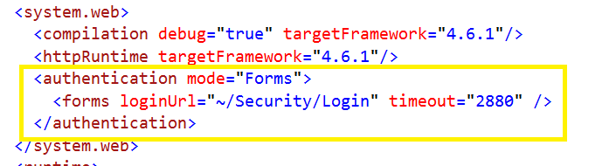

3.ValidateInput:

This will remove html tags and will accept the exact text. By default, if we are not provided this filter when we send text with html tag will get error.

4.ValidateAntiForgeryKey

If some try to copy script are html from our web site and try to use same code and try to call our site using this filter we can block.

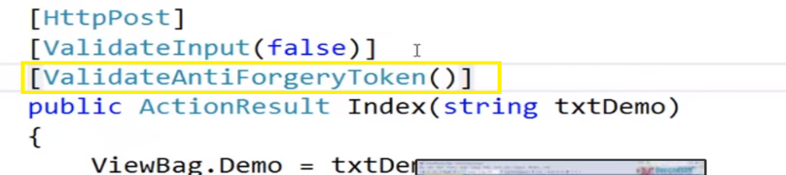

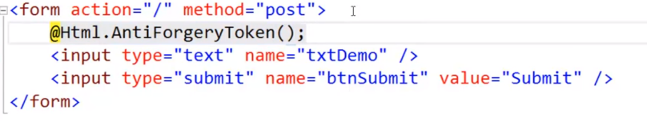

While executing if you check browser html we can find like below, so if they copy this code and use in their website while they execute this code, it will validate cookie value with this below value so it won’t work.

Actually they don’t get any cookie value to commapre this, but when we execute this from our website

We will get cookie from @html.AntiForenToken method

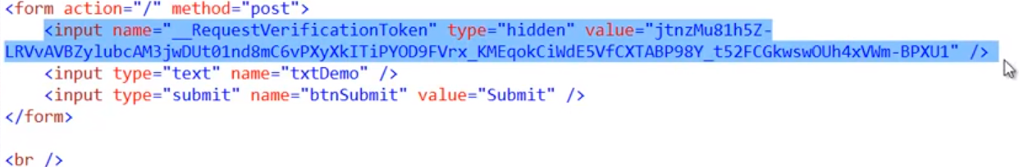

5.Handle error

Using this filter we can handle exception.

Create base class, inherit handle error class

handle error inherited from handleerrorattribute class.

After this just use handle error attribute on top of action method, So it will redirect to specific error page when error occur.

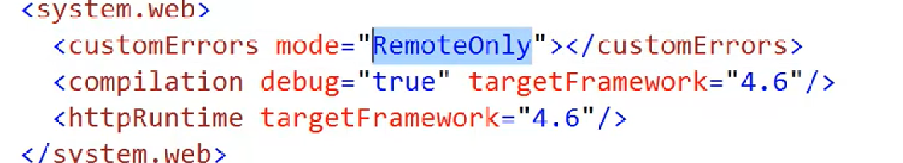

**CustomFilter Creation**

Categories of Filters:

* AuthencationFilter
* ActionFilters
* ResultFilter
* ExceptionFilter

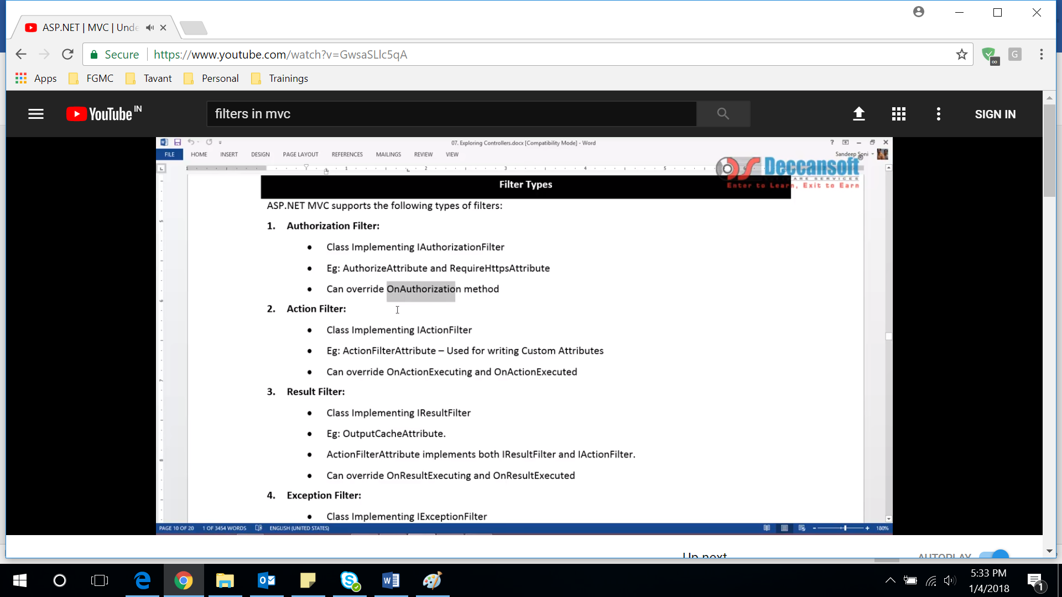

If we want to create our custom filter we can inherit above attribute classes and override those methods

Ex:

