## <https://app.pluralsight.com/library/courses/aspnetwebapi/table-of-contents>

What I Know

WCF is based on SOAP protocol

What is SOAP Protocol?

WCF REST will support HTTP protocol, Usually it support so many protocol like that it support HTTP protocol also, But it not particularly implemented for HTTP.

Web API based on HTTP protocol, HTTP protocol will support by all browsers.

Remaining protocols like ‘Https,WsHttp’ will not support by all browsers.?

What is WebAPI

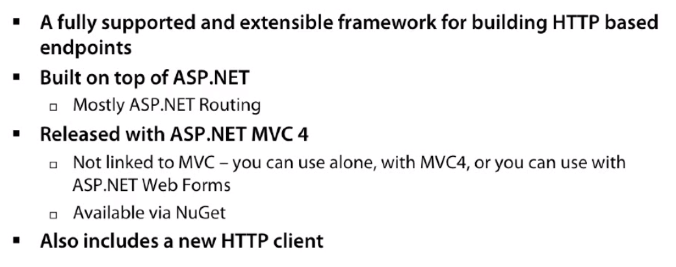

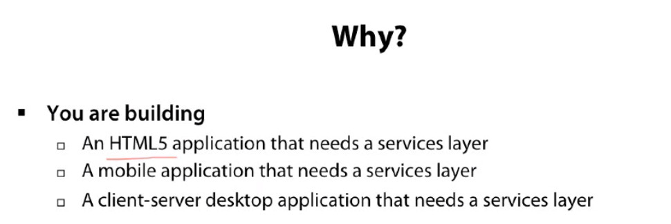

Install Web Api from Nuget package.

**ApiController** Is base controller for WebAPI

Inherite ApiController to all controller where webapi has to implement.

Add global.asax page to project, and add HttpRoute to GlobalConfiguarions.

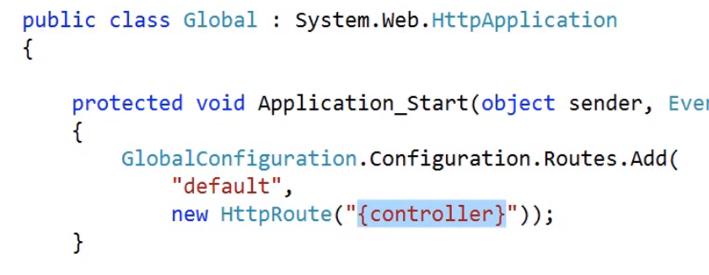

In WCF we will use URL in endpoint address. This URL doesn’t contain any method name, Through proxy we will get entire class access and we use those methods.

In WCF Rest we no need to make web config changes, directly we can call endpoints.

In WCF Rest and WCF services are same only calling part is differ.

WCF Rest and Web api calling parts are same.

In WebApi also we can directly call endpoints.

The ways of call web api and WCF rest is same.

We will use httpclient class for calling web api and WCF rest services.

httpclient class mainly having below methods

GET

POST

PUT

DELETE

PATCH