Nicholas Tice

Data Sources

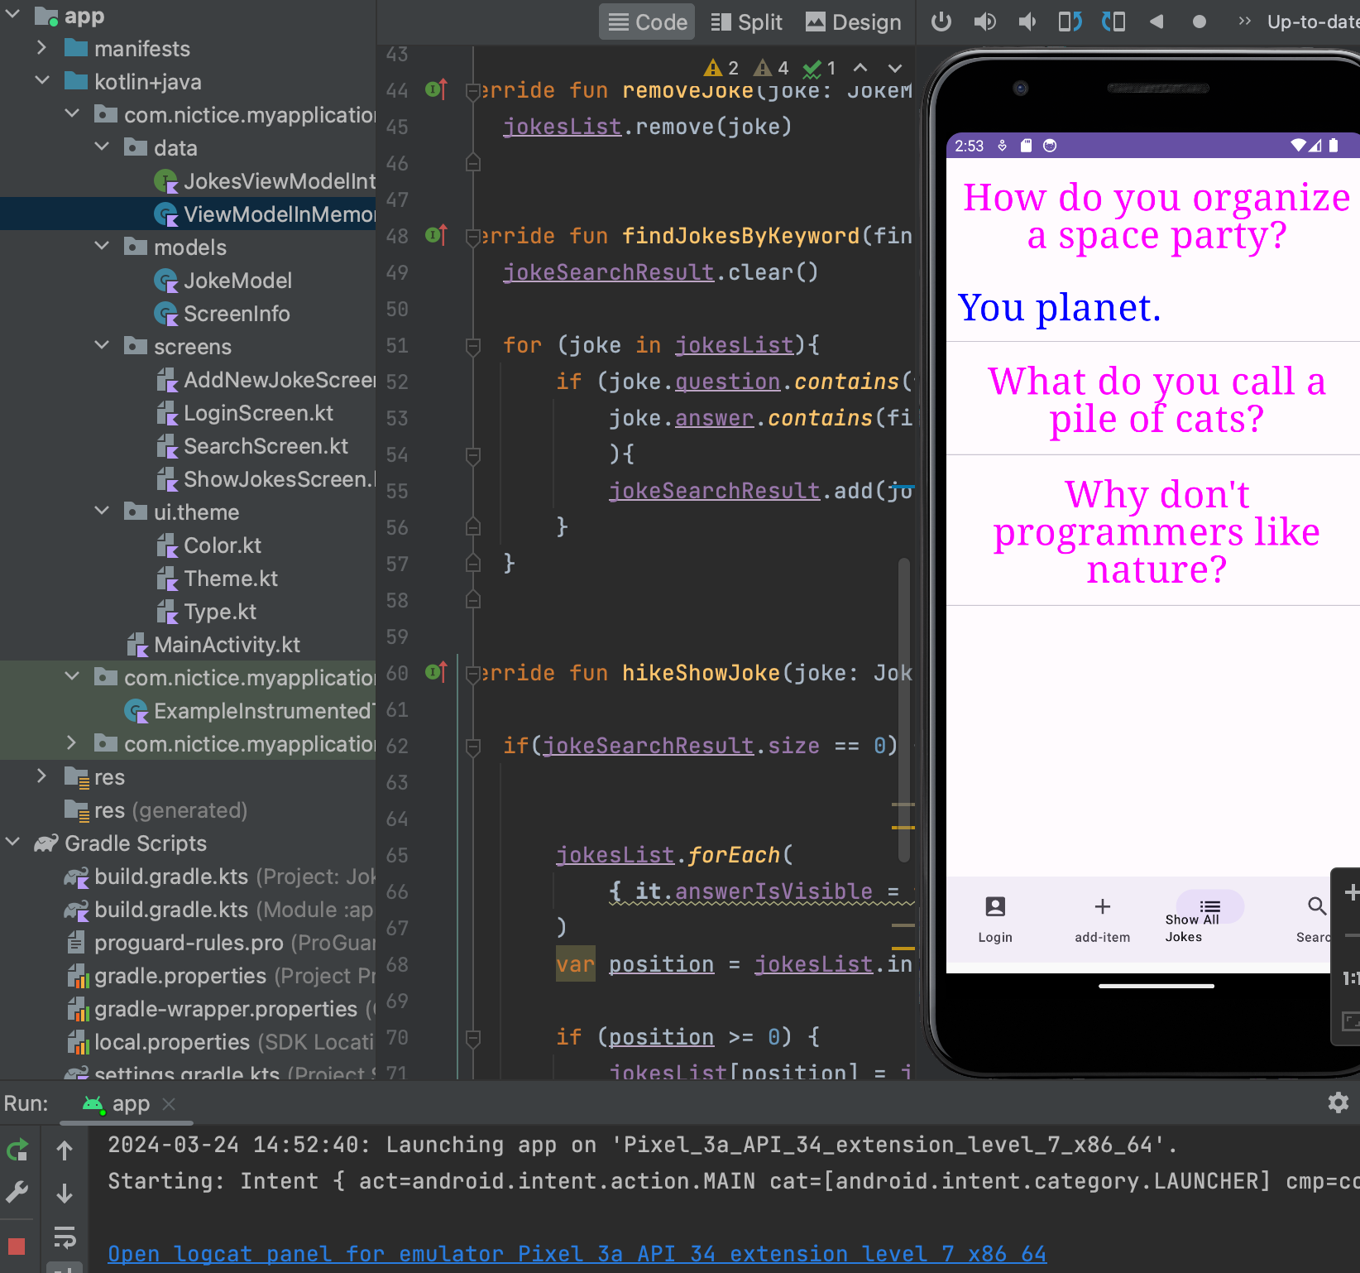

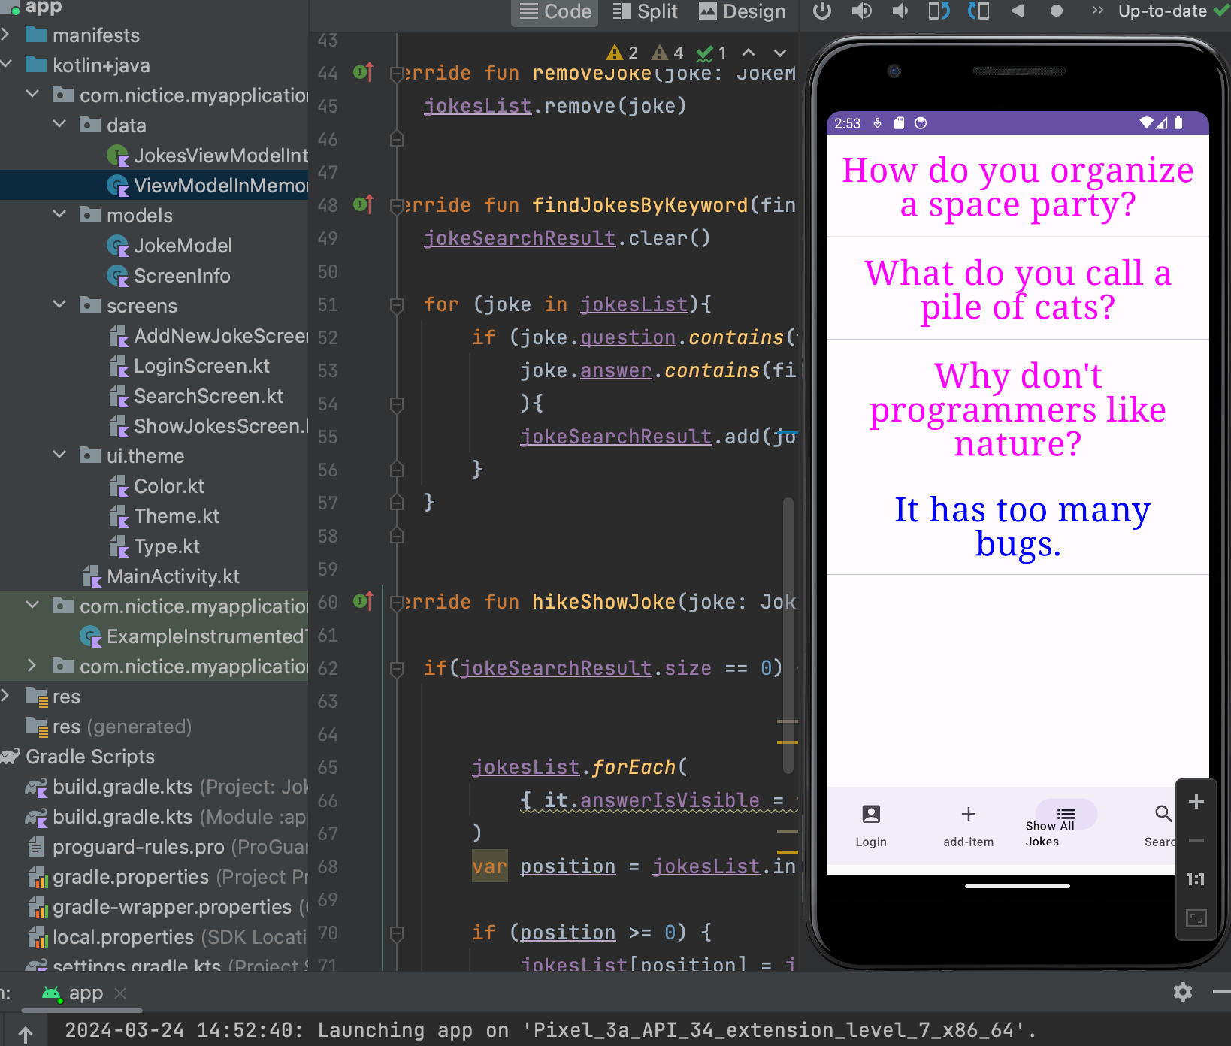

Screenshots show the hide feature working of the new ViewModelInMemory File

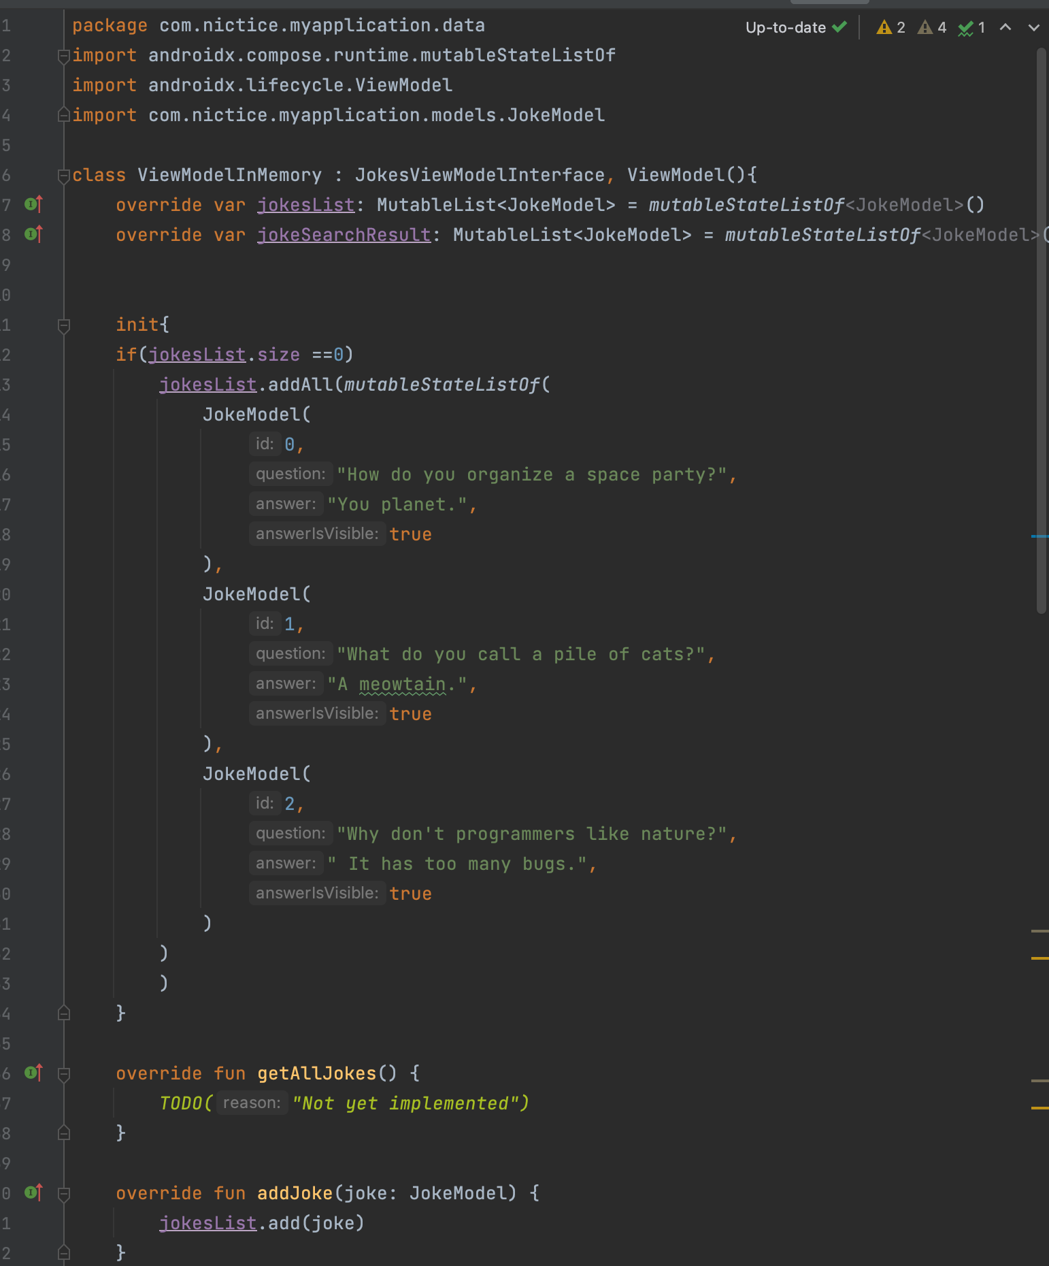

JokeModelInterface code of new tutorial