In your writeup, write 100-150 words describing this lab, and what you think each
step is about or is supposed to accomplish.

The goal of this lab is to introduce the student to the most common utilities and functions that will be used. Viewing, Editing, Copying/Moving files are all core functions to have located before learning more about the systems. Students will be using these utilities more than others so it is important to drill them in early. Regularly screenshotting these functions helps both to track progress and ensure that the student pays attention to these key screens. Moving to the previous screen using F3 is important so the student is expected to know how to get back to the primary options menu. Finaly the importance of logging off properly is highlighted because if you don’t the system will prevent you from logging back in until the next soft clear (typically hourly).

My View Panel Entry Screen
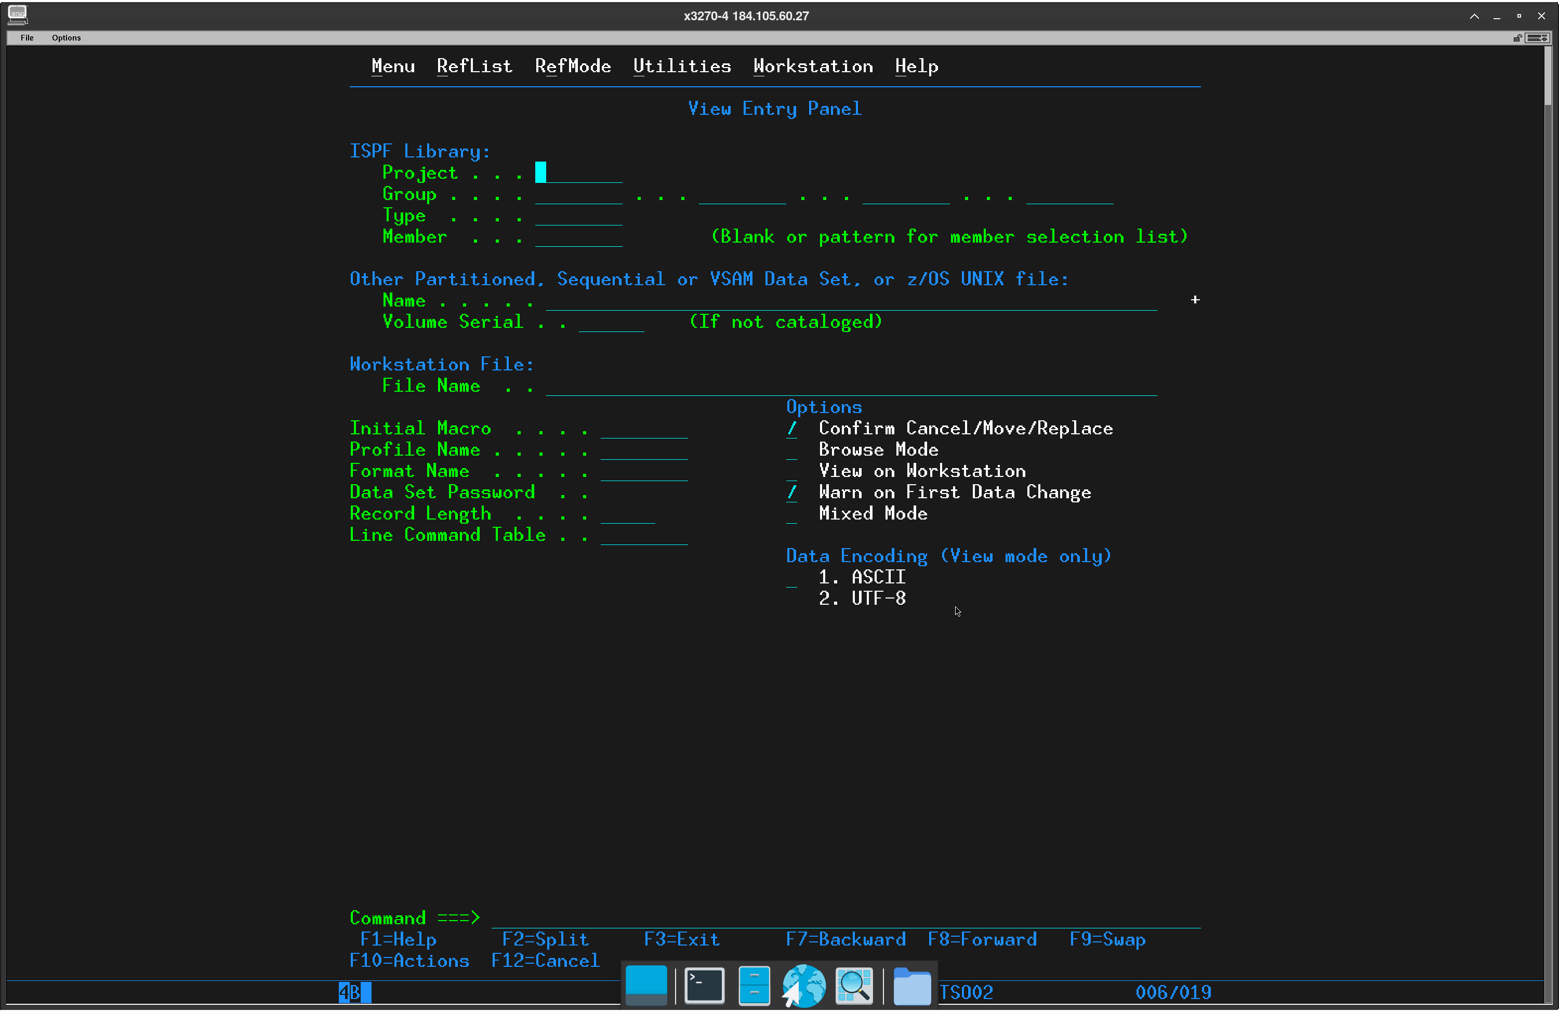
My JCL dataset members
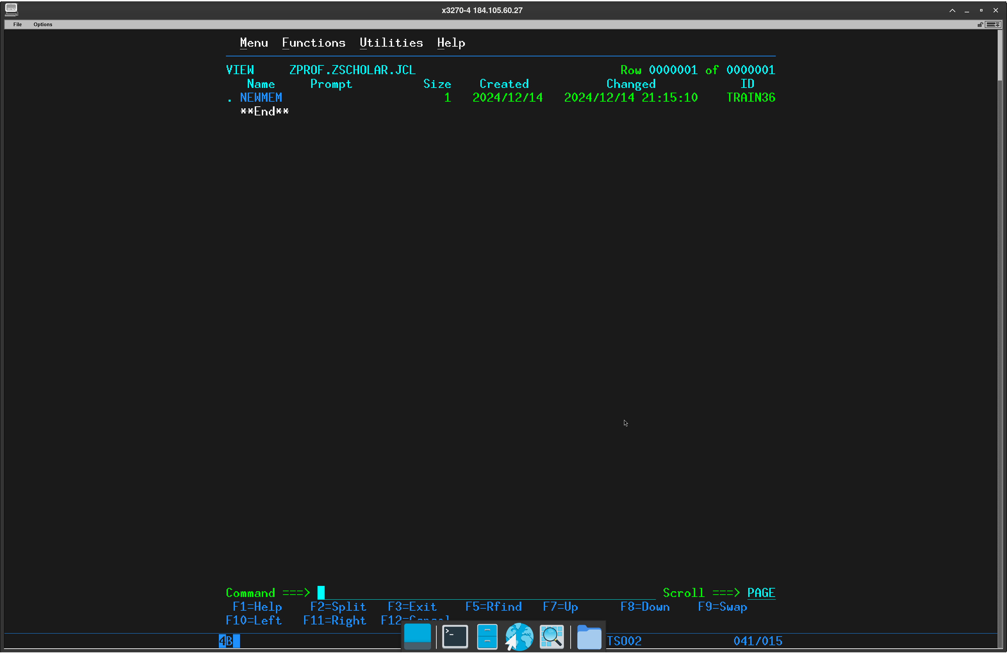
(CWSEAY.JCL wasnt working?)
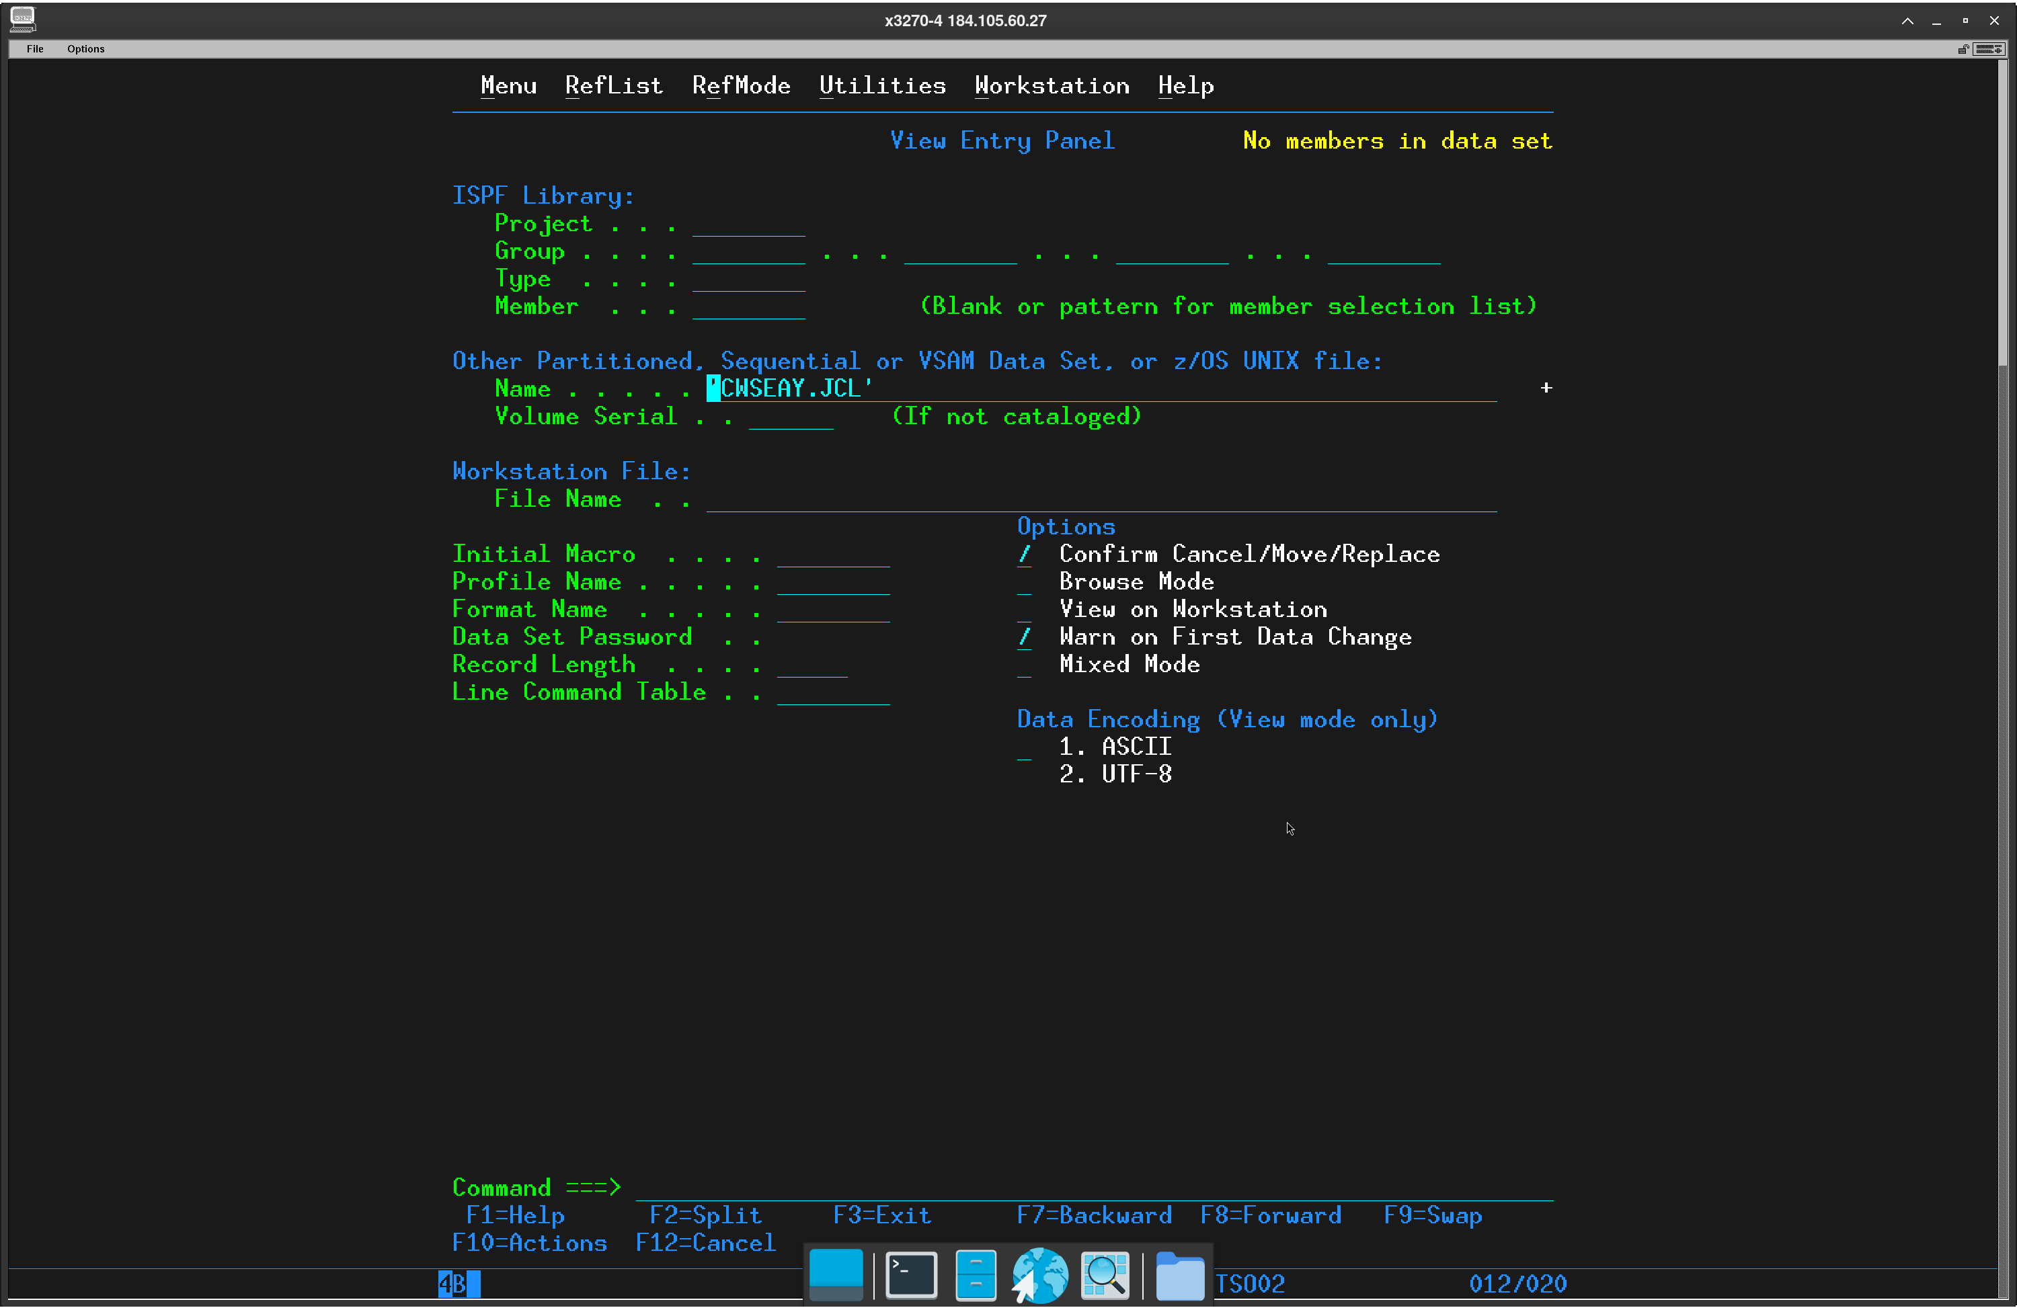
Dataset Member NEWMEM
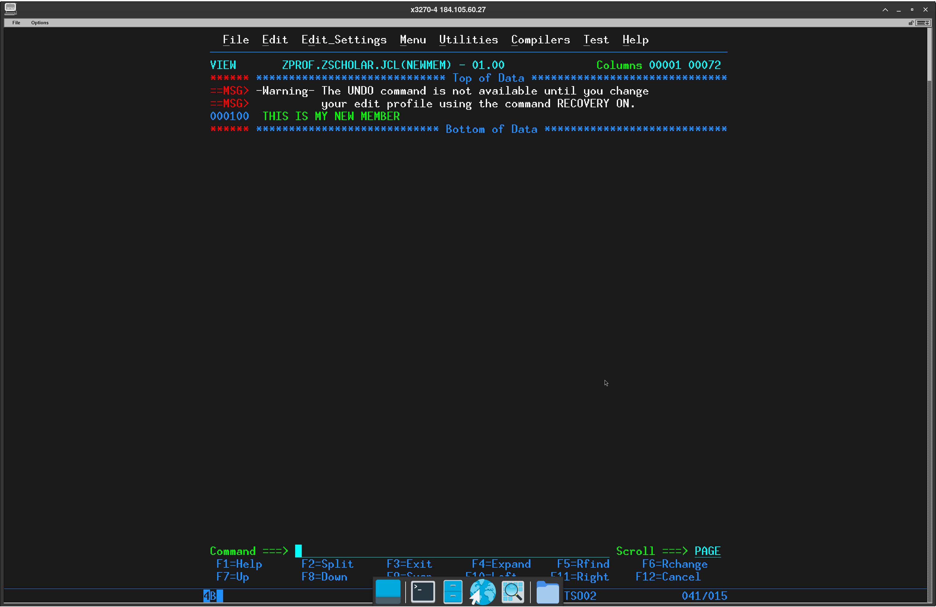
Move and Copy Utility Panel
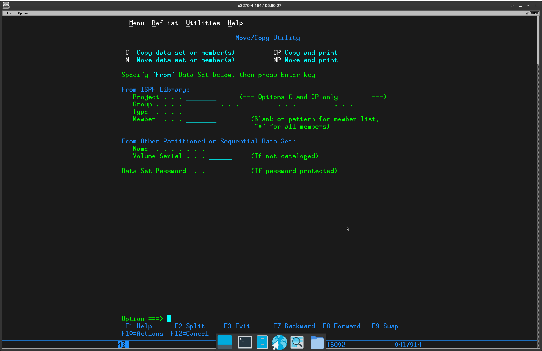
My Command Shell
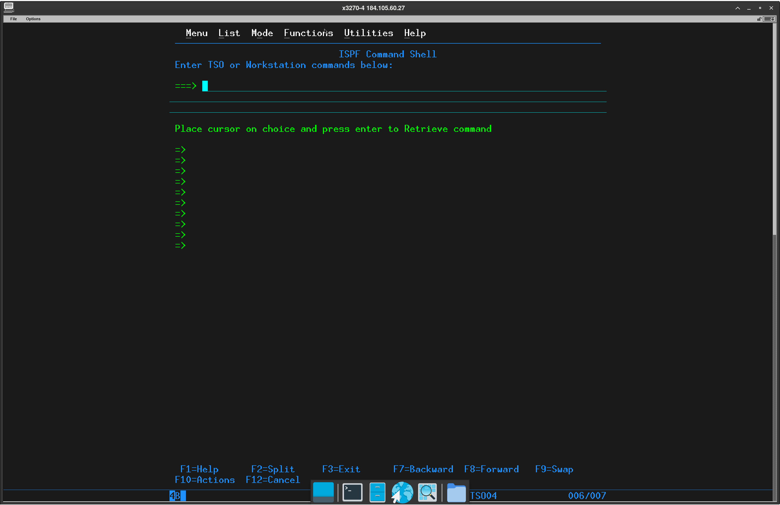

Time Stamp Log
