Now write on 100-200 words on what you have done, in grammatically correct business
English prose.

Profile prefixes
Profile settings
LISTC datasets
ISPF datasets
dataset members
PFSHOW function keys
First we dive deeper into TSO commands,
We are at the TSO ready prompt.
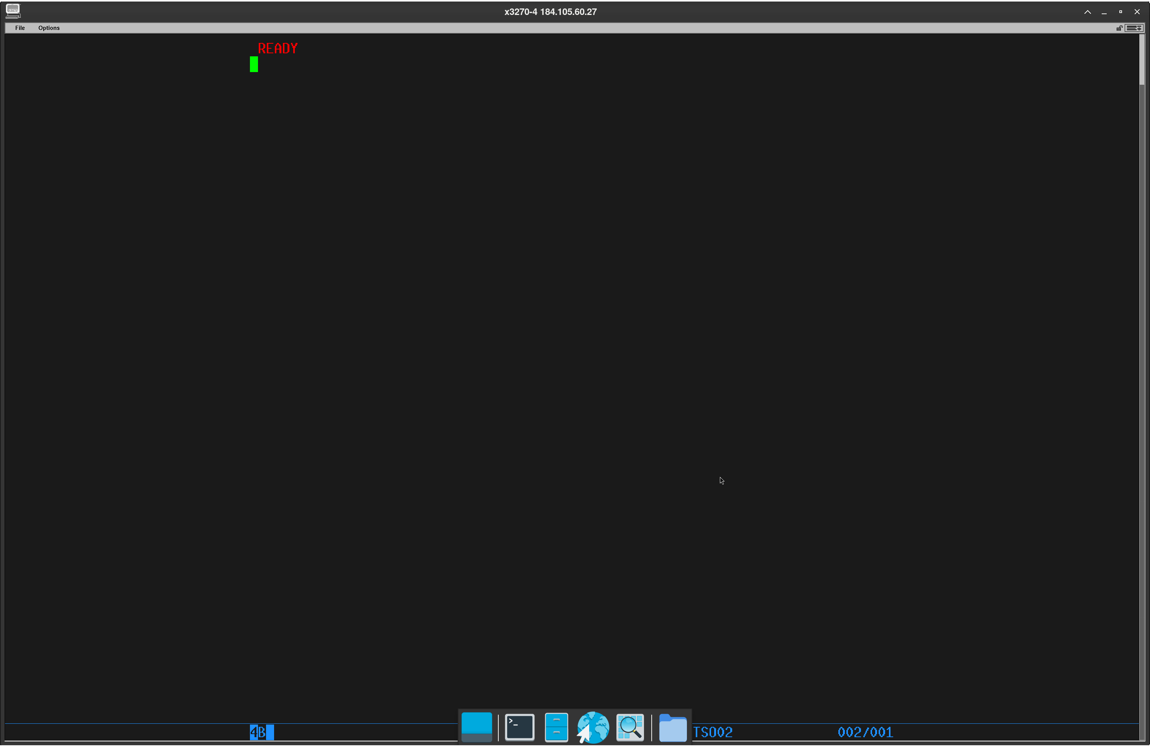

My profile prefix
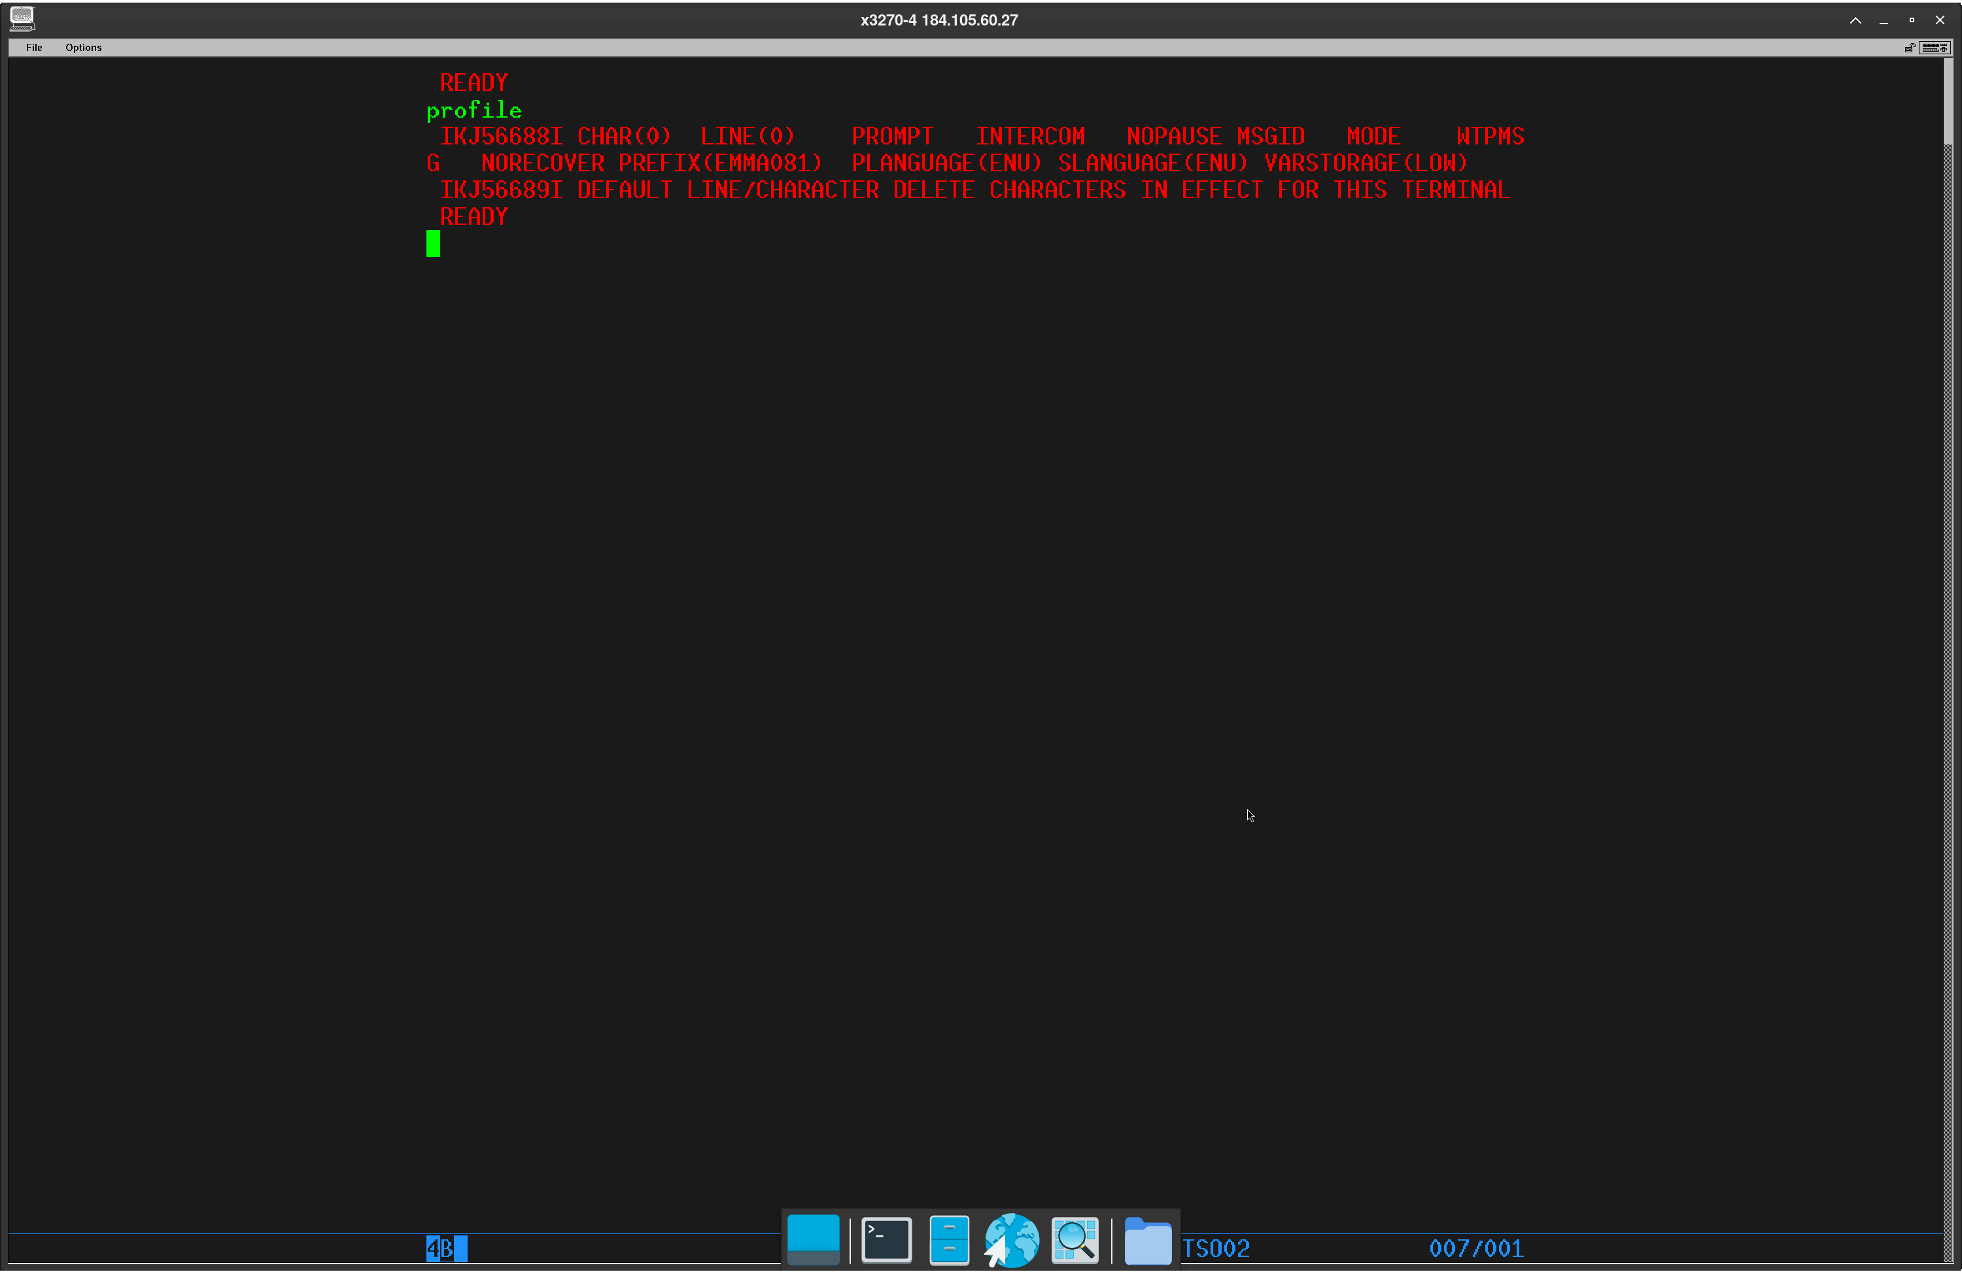

My profile settings
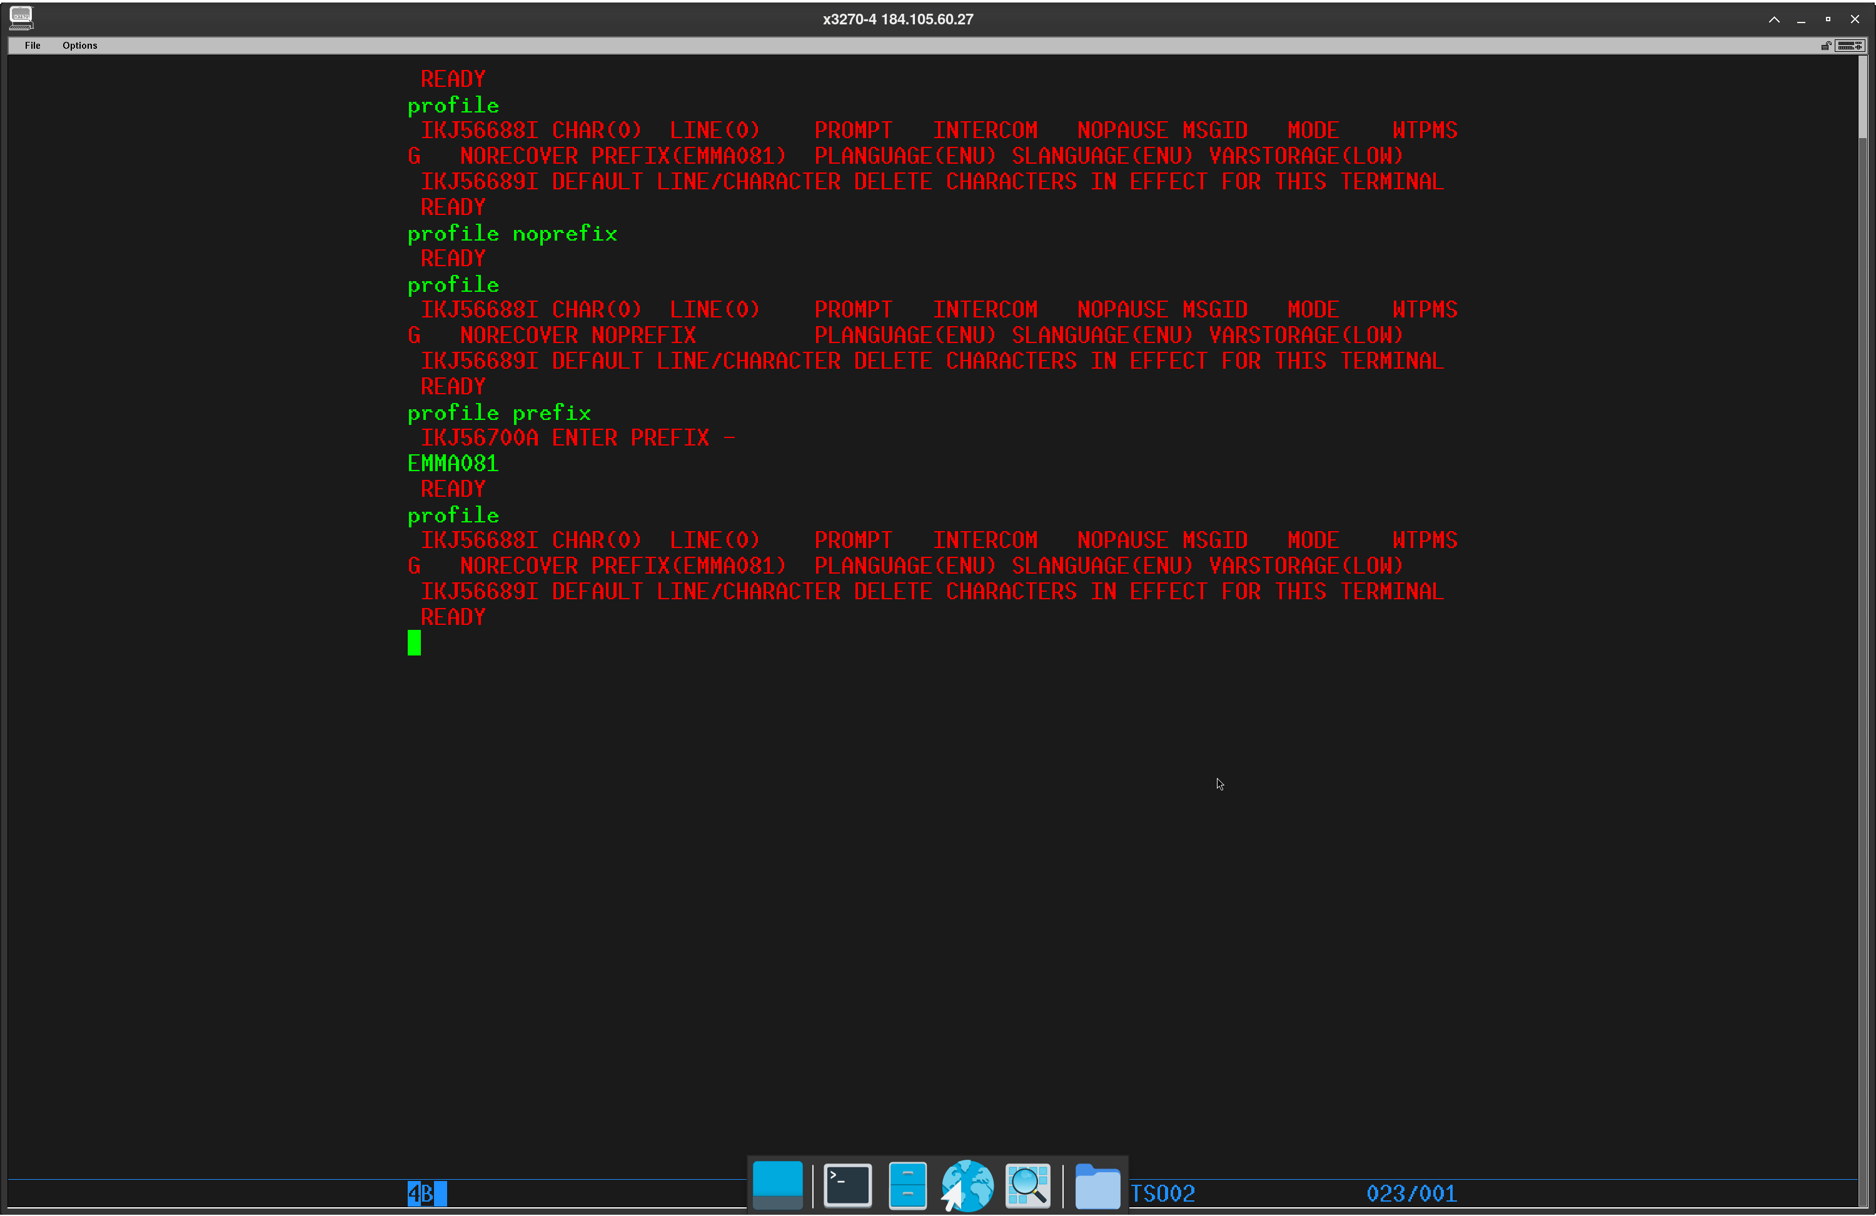

My catolog items listed
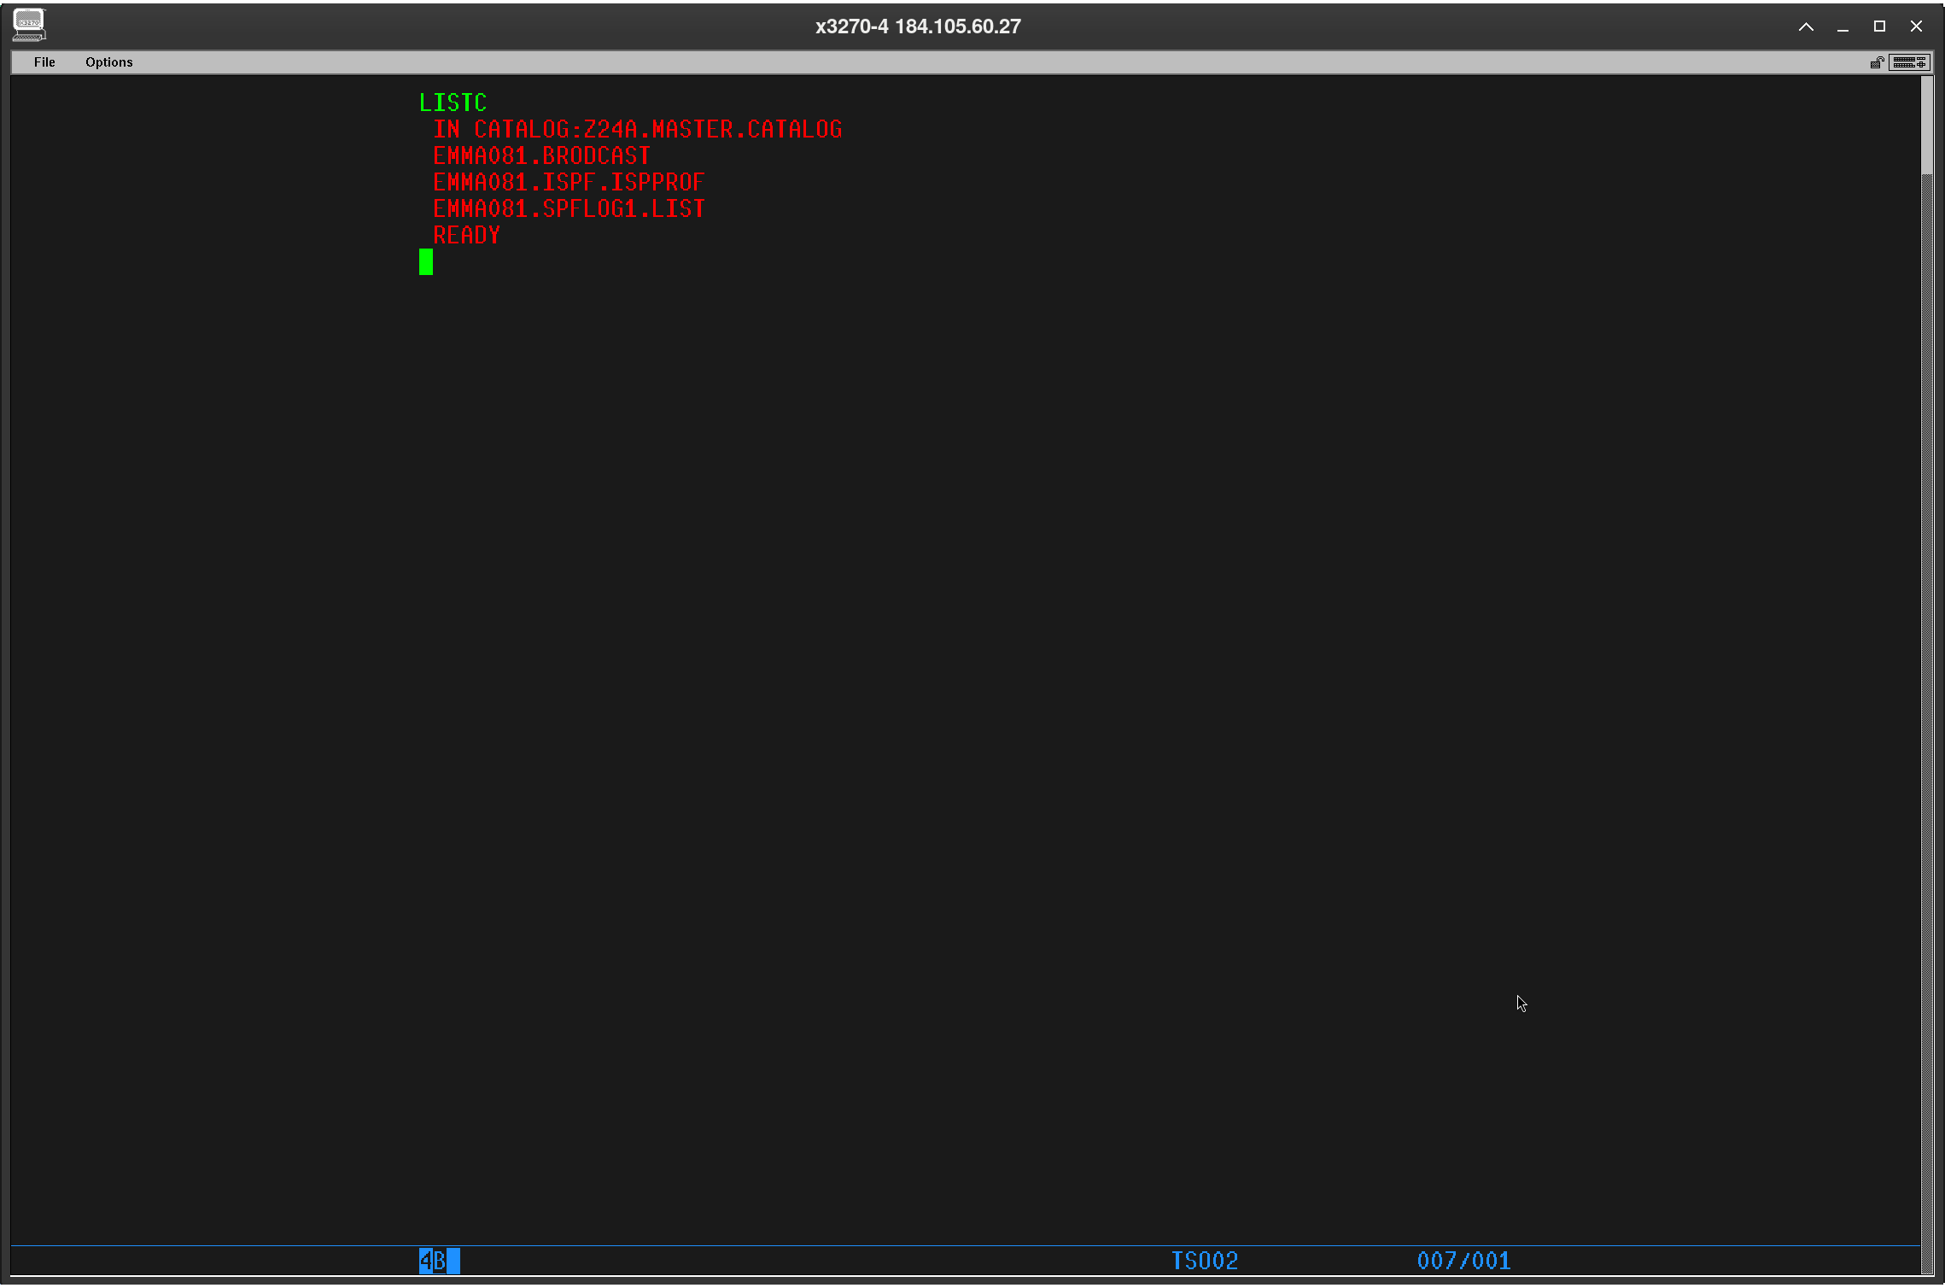

SYS1 DATASETS
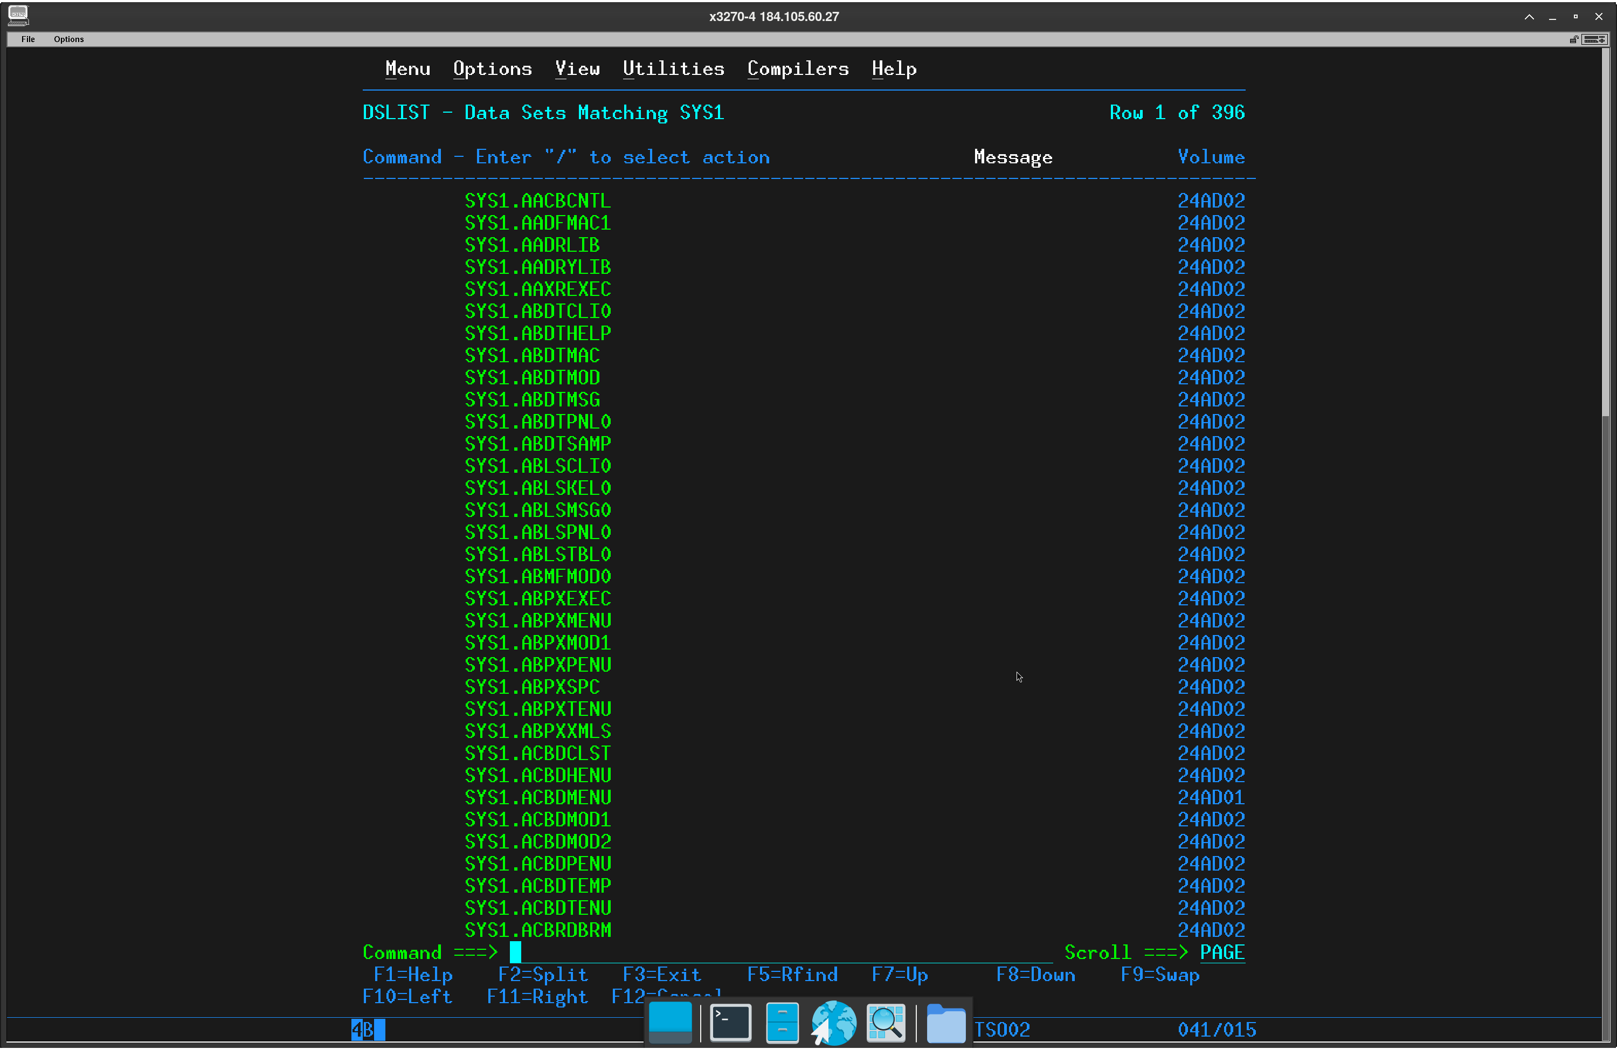

Sys1.proclib Dataset
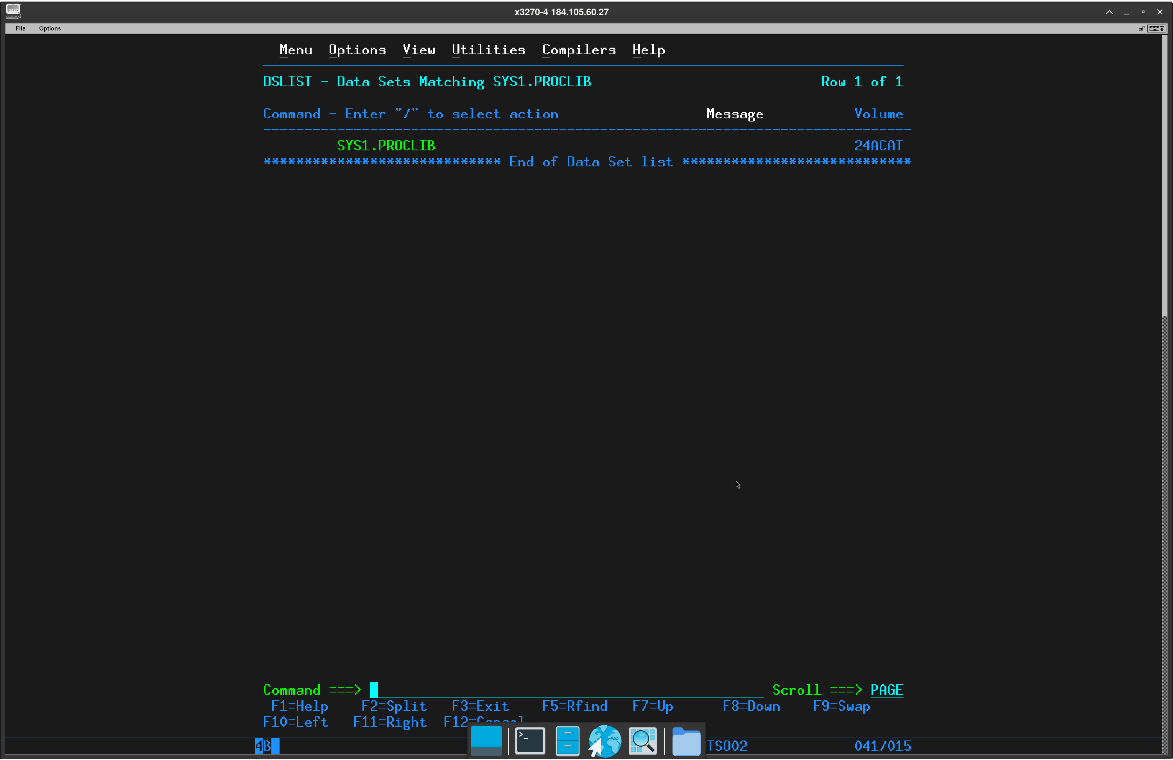

Members of SYS1.PROCLIB
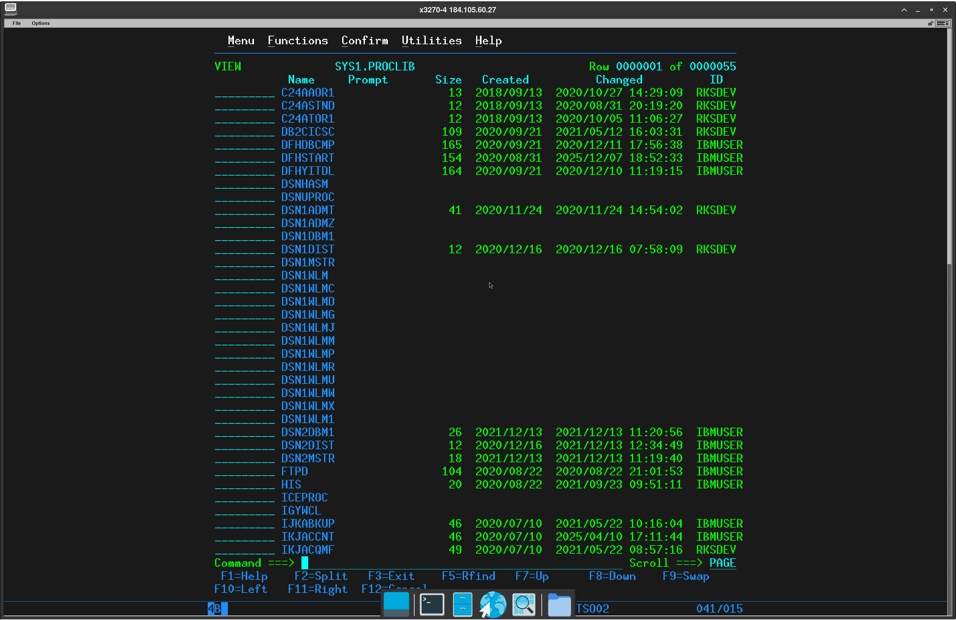

Member DFHSTART of SYS1.PROCLIB
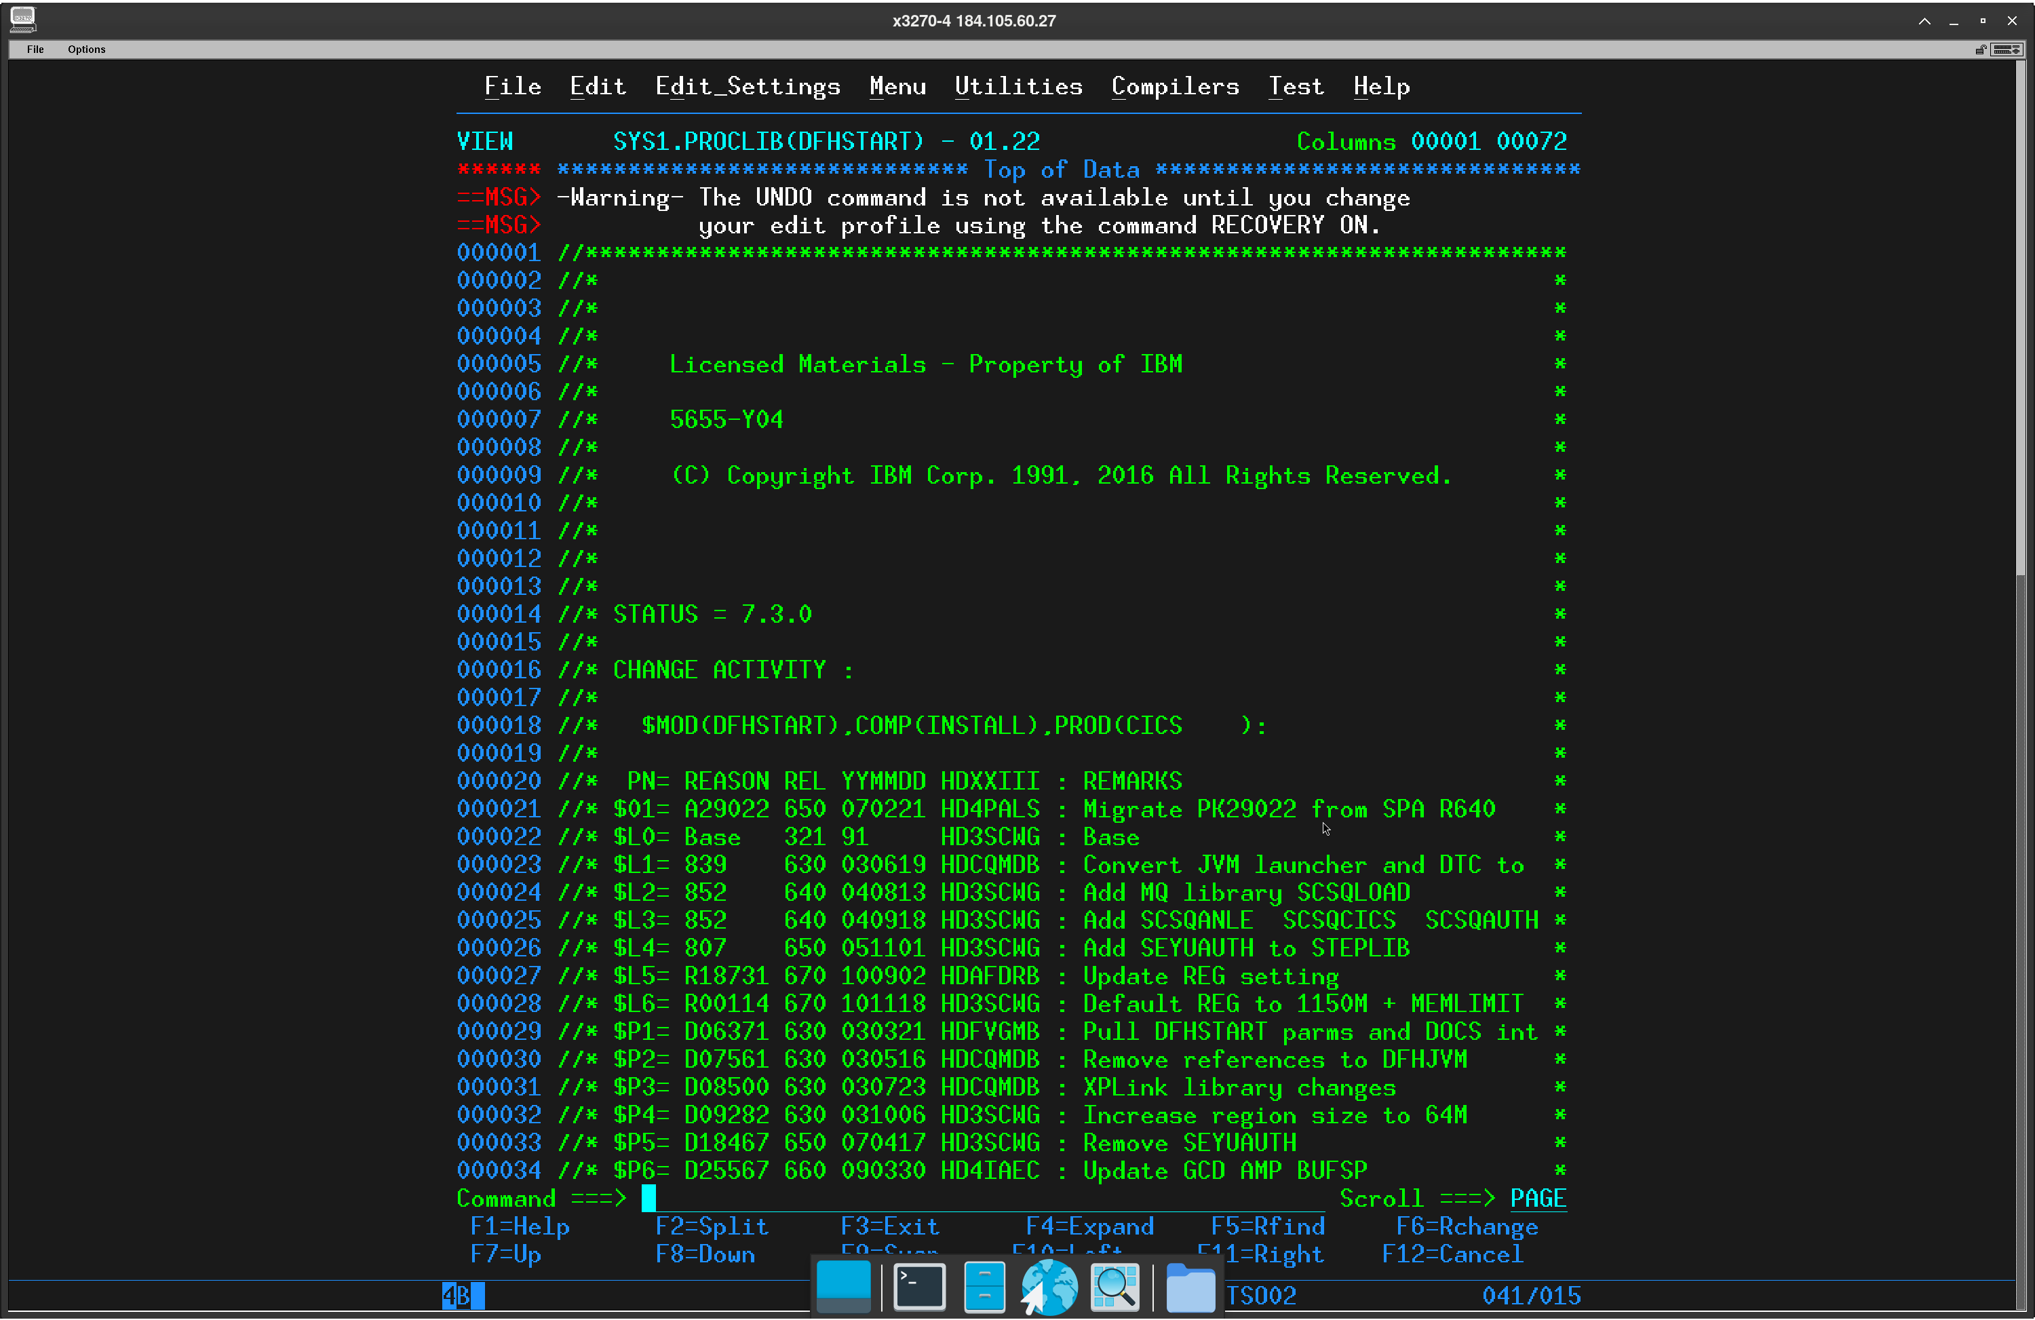

PFSHOW OFF
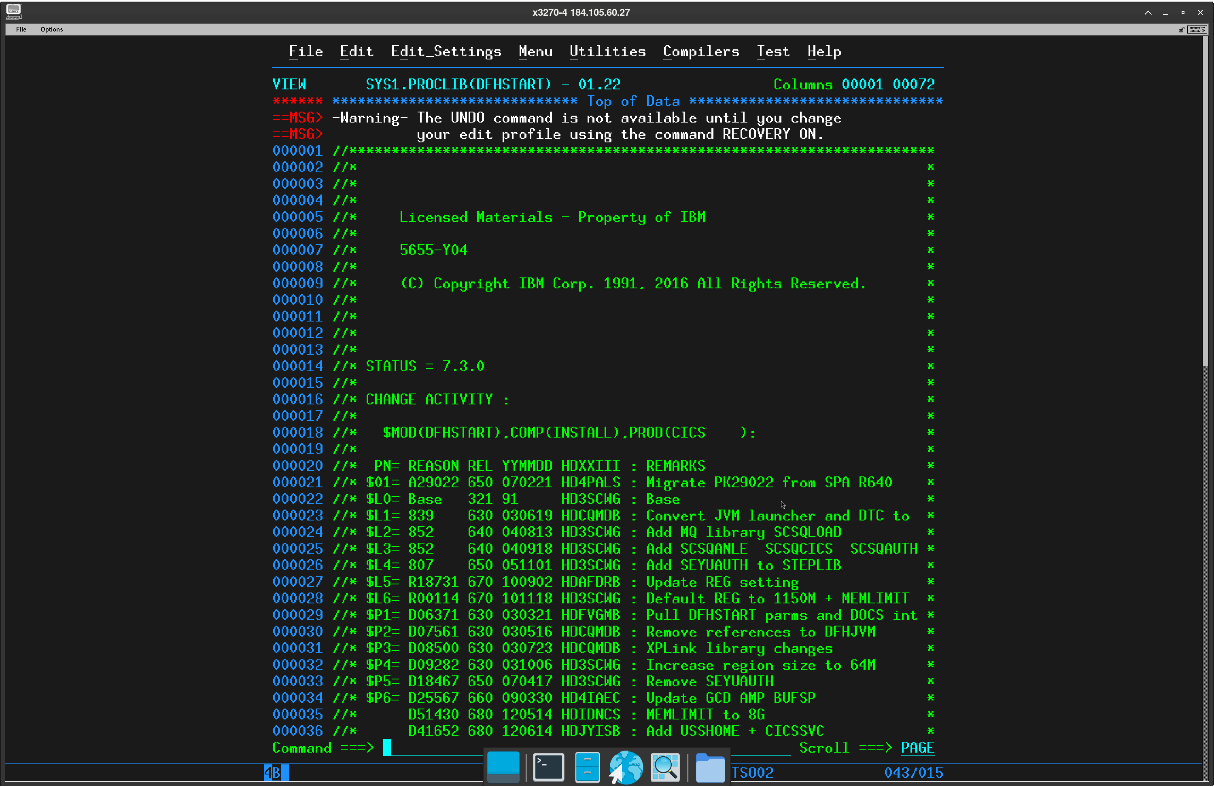

PFSHOW ON
