Installing 3270 emulation software and logging into the Marist system.

We will be using Mochasoft’s 3270 emulation. The college is providing TN3270 software for windows XP/7/8/10 and Mac OS free of charge. There are several other operating systems supported by Mochasoft but the college is not providing them, you will have to purchase them if you want to use them. See http://mochasoft.dk/index.html for more information.

Step 1: Go to http://mochasoft.dk/download.htm and download the appropriate version of TN3270 emulation software for your operating system.

Step 2: Install the TN3270 software on your computer and launch TN3270 and register it.
Installation is a click thru. See registration screen shots below.
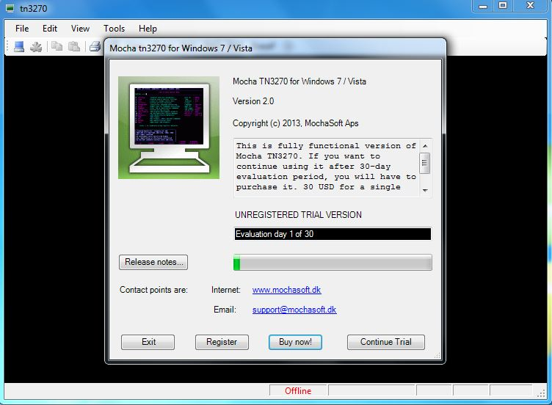
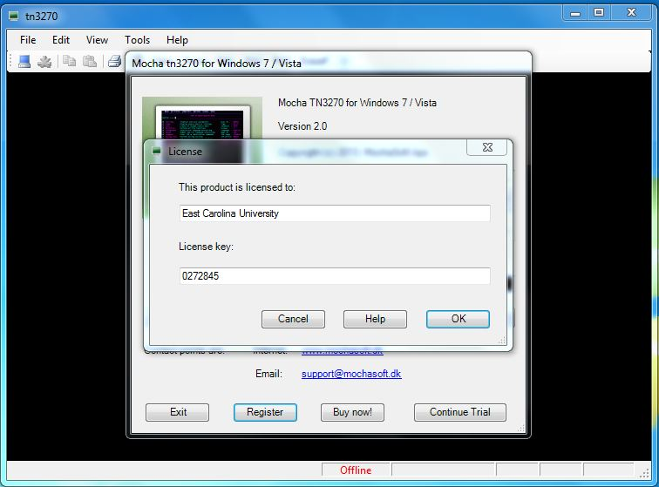

The license keys for TN3270 are as follows;

Windows (XP/7/8): 0272845

Mac OS X (see Mochasoft download site for version support): b44944 (a lower case b is required)

Continue to Step 3:

Step 3: Configure your TN3270 software. Make sure you change the port number to 1023.
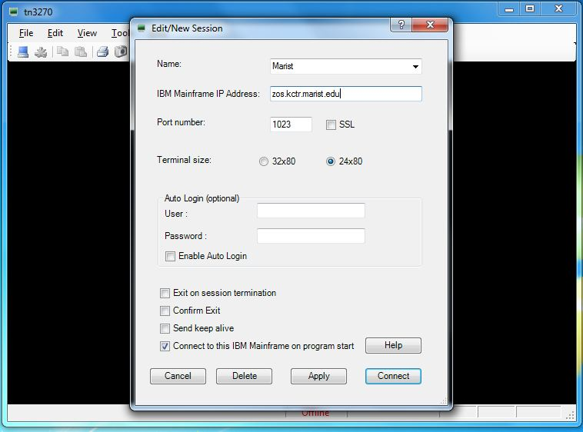

After entering the configuration information press APPLY and then CONNECT.

You should now see the following

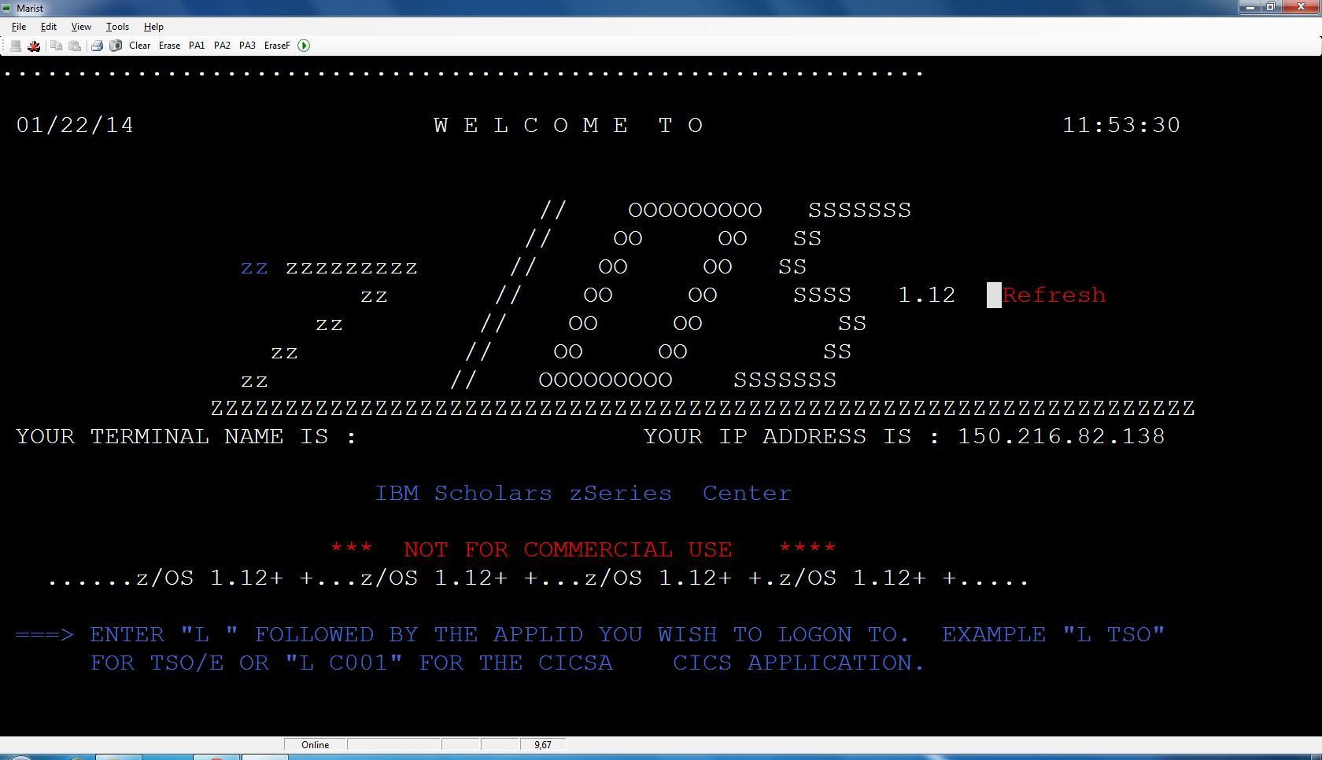

Step 4: Logon to Time Sharing Option (TSO) by entering “L TSO” and pressing enter
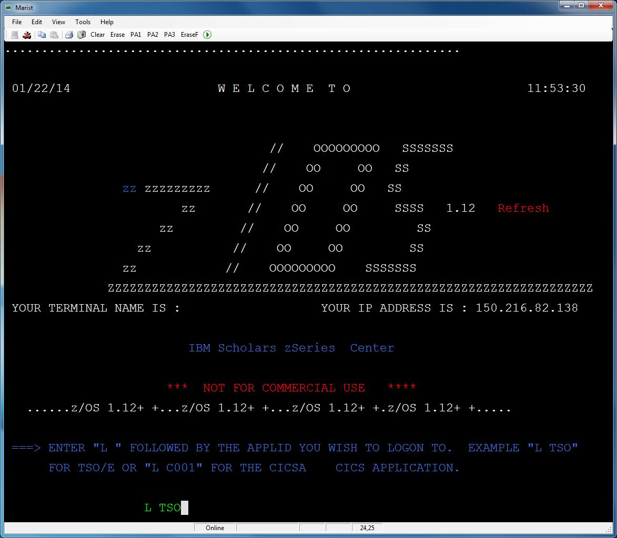

Next enter your Marist Userid and pressing enter, it will begin with KC. See below

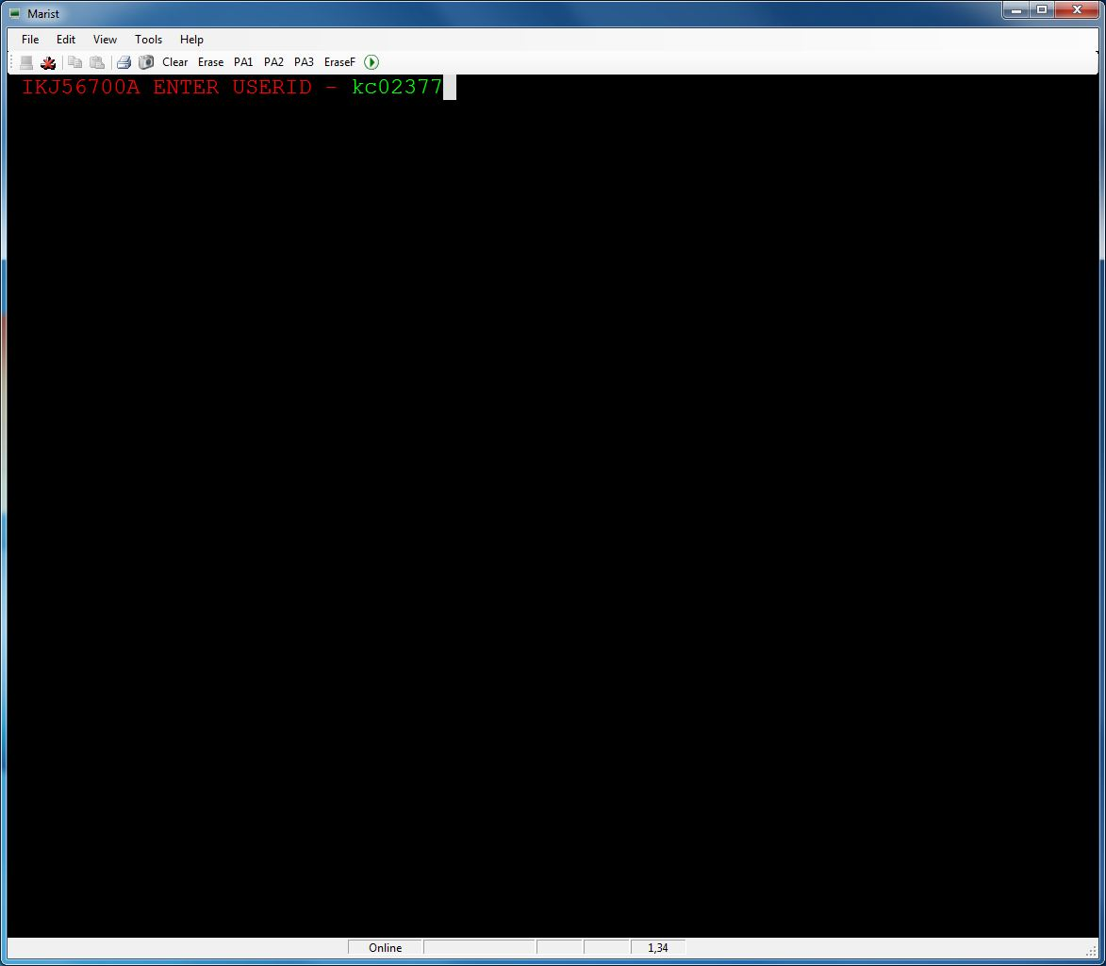

You will next see a panel asking for your password. During your initial login your password is your Marist ID. You will be forced to create a new password during your initial login. So you enter your Marist ID and press enter. Then (ONLY THE FIRST TIME YOU LOGIN) you enter your Marist ID as your password and press enter. The cursor will jump to the right, you create a new password. Case does not matter but no special characters and make it 8 characters long. Type in the new password and press enter. The cursor will jump to the confirm password field so you enter your newly created password again and press enter. Now you have your personalized password for the Marist system.

If you forget your password I cannot tell you what it is I can only reset your account back to the original state, after which you’ll have to go through the initial password creation process again.

ALWAYS PRESS ENTER AFTER TYPING IN YOUR PASSWORD.
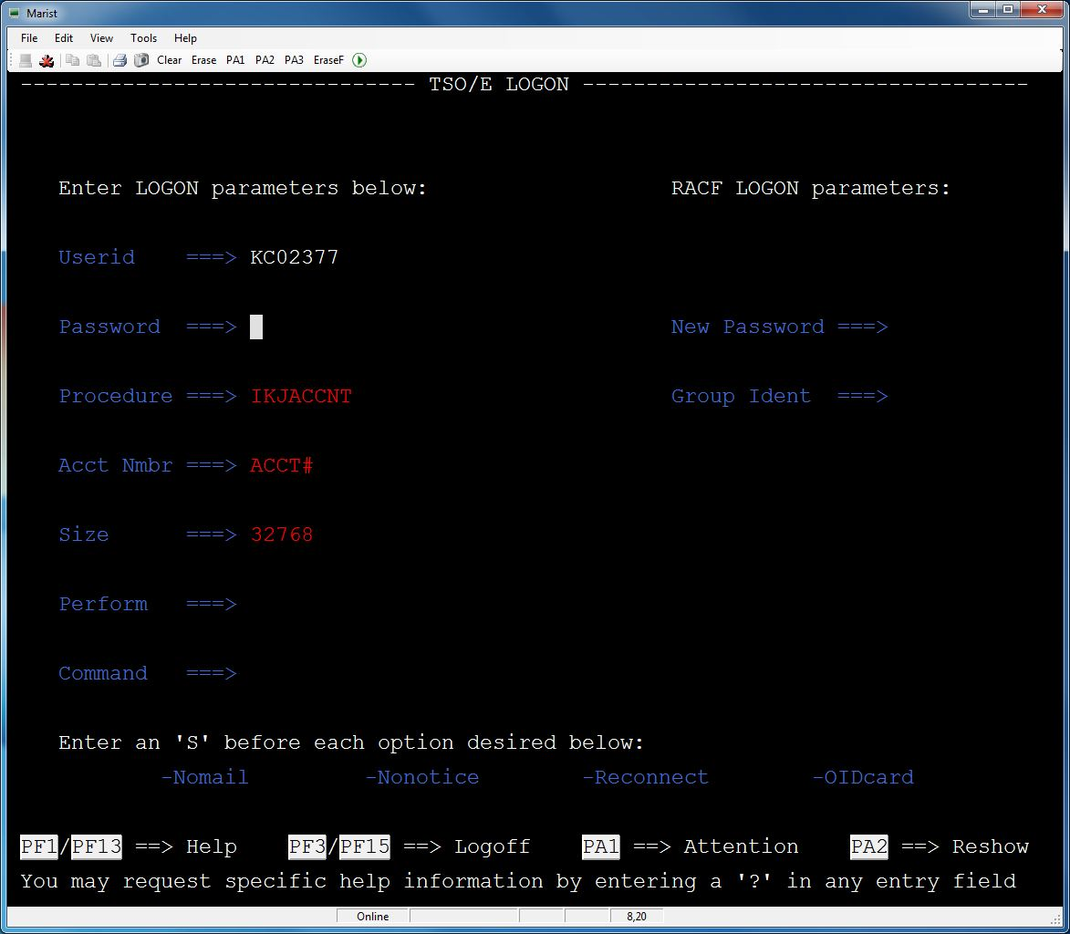

After entering your password and pressing enter you will next see a welcome message followed by 3 asterisks. In TSO/ISPF whenever you see 3 asterisks (***) it means the system is waiting for input.

Press enter to proceed to ISPF.
The following is the ISPF primary option menu. This is your stepping off point for working on the mainframe.

