

**KB6003 Vehicle Aerodynamics**

**Tutorial 1**

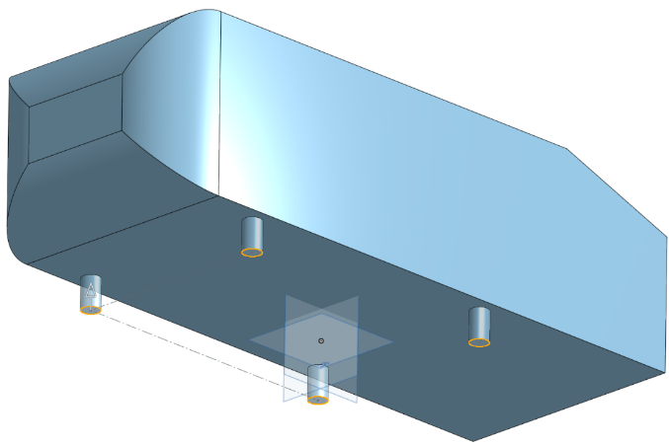

Ahmed Body Design

**Date: 01th October 2016**

Ravindu Ranaweera

Contents

Table of Figures 2

Table of Tables 2

1 Introduction 3

2 Onshape CAD 3

2.1 Getting Started 3

2.2 Creating an Ahmed Body Model on Onshape 4

2.3 Exporting Parts to STL Files. 13

Appendix A: Ahmed Body Dimensions 14

# Table of Figures

Figure 2.1: Basic browser compatibility. 3

Figure 2.2: Creating a new document on Onshape. 4

Figure 2.3: Name the document as "Ahmed_Body". 4

Figure 2.4: Changing the units of the workspace. 5

Figure 2.5: Change to "Top" view. 5

Figure 2.6: Creating a sketch on the "Front" plane. 5

Figure 2.7: Create a new sketch. 6

Figure 2.8: Sketch a rectangle on the "Front" plane. 6

Figure 2.9: Defining body dimensions of the Ahmed body. 6

Figure 2.10: Extruding the body from the sketch. 7

Figure 2.11: Create a variable "angle". 7

Figure 2.12: Move the variable up in the features list. 7

Figure 2.13: Sketching on the surface of the extrude. 8

Figure 2.14: Sketching a right angled triangle at the corner of the body. 8

Figure 2.15: Assigning variable "angle". 8

Figure 2.16: Removing the triangle from the main extruded body. 9

Figure 2.17: Filleting the front of the extrude. 9

Figure 2.18: Sketching a circle and offsetting it. 10

Figure 2.19: Using "Linear Pattern" tool. 11

Figure 2.20: Result of the linear sketch pattern. 11

Figure 2.21: Extruding the bottom supports of the body. 12

Figure 2.22: Finished Ahmed Body. 13

Figure 2.28: Select part(s) for exporting. 13

# Table of Tables

Table 2.1: Export parameters for the STL file. 13

# Introduction

These is the first in a series of tutorials aimed at setting up a simple case, simulating in OpenFOAM and post processing using ParaView. This tutorial will look into creating an Ahmed body and exporting it to a STL file to be used for CFD analysis.

# Onshape CAD

Onshape is a free modern CAD system that runs on web browsers using HTML5, CSS, JavaScript, and WebGL technologies. It officially supports Chrome, Firefox, Safari and Opera. This eliminates OS restrictions and other compatibility/availability issues.

## Getting Started

1. It is recommended to check basic browser compatibility prior to running Onshape. This can be done from <https://cad.onshape.com/check>. If all tests yield positive results as shown in figure 2.1 below, the browser is capable of running Onshape.

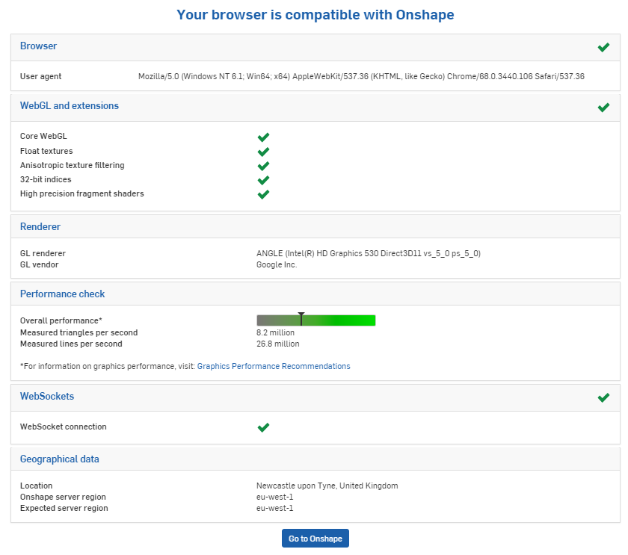

Figure 2.1: Basic browser compatibility.

1. Register for an Onshape Academic account using your university (ac.uk) email account from the link below;

<https://www.onshape.com/products/education>

1. Follow the instructions to complete the registration and sign in.
2. This will load the “Documents” screen which would show your CAD models and models shared with you. You can search for any publically available models as well.
3. You may be familiar with other CAD software which may use a different mouse input for view manipulation. These settings can be changed from “View manipulation” under “Preferences” located in “My account” section.
4. The desired default units can also be set from “Units” under “Preferences” in “My account” section.
5. If any modelling tools cannot be found, please right click on the toolbar and select “Customize toolbar”. The subsequent window can be used to search the tools library.

## Creating an Ahmed Body Model on Onshape

1. Create a new document by clicking the “Create” button at the top left corner of the screen and selecting “Document” as shown in figure 2.2.

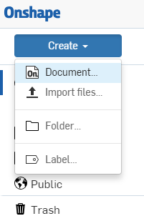

Figure 2.2: Creating a new document on Onshape.

1. Name the new document as “Ahmed_Body” or any other name of preference and click “OK”.

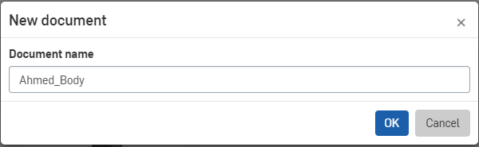

Figure 2.3: Name the document as "Ahmed_Body".

1. You will now be navigated to your “Workspace”. It is important to set the units of your drawing to millimetres (mm), same as the drawing in Appendix A. This can be done by clicking the “Main Menu”, “Workspace properties…” and changing the “Default length unit” to “Millimetre”. Click the green tick (henceforth referred to as “ok”) button () to apply changes.

Note: Alternatively units can be set by default by following step 6 of section 2.1 “Getting Started”.

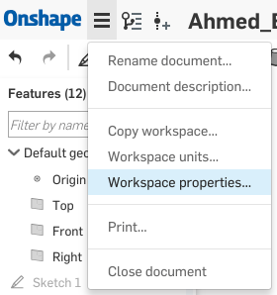 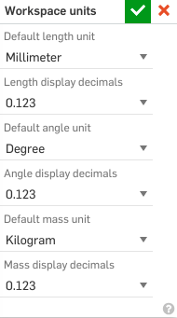

Figure 2.4: Changing the units of the workspace.

1. Select the “Front” from the “View Selector” on your top right and then select the “Top” view to get a top down view of your plane.

Note: Make sure the z-axis positive towards you.

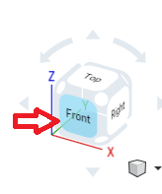 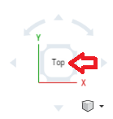

Figure 2.5: Change to "Top" view.

1. Please click and select the “Top” plane from your workspace or “Features” tree (figure 2.6) and click “Sketch” (figure 2.7). Alternatively, you can select the “Front” and then “Top” plane and press “Shift + s”.

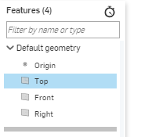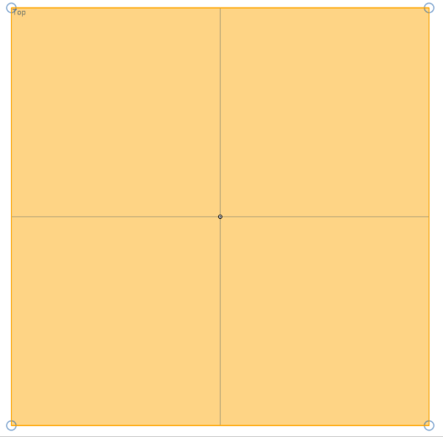

Figure 2.6: Creating a sketch on the "Front" plane.

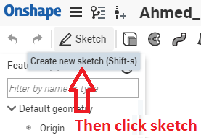

Figure 2.7: Create a new sketch.

1. Using the “Corner Rectangle” tool () sketch a rectangular shape as shown in figure 2.8 below.

Note: If tools cannot be found, please right click on the toolbar and select “Customize toolbar”. The subsequent window can be used to search the tools library.

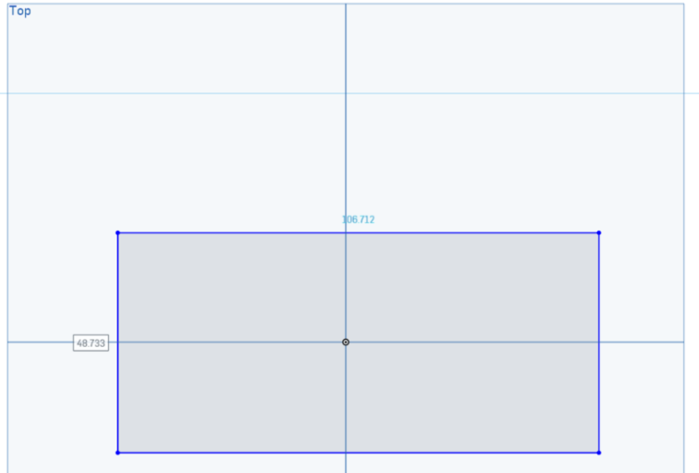

Figure 2.8: Sketch a rectangle on the "Front" plane.

1. Use the “Dimension” tool () and click on the lines to define front dimensions of the Ahmed Body as per Appendix A with the “origin” as centre (figure 2.9).

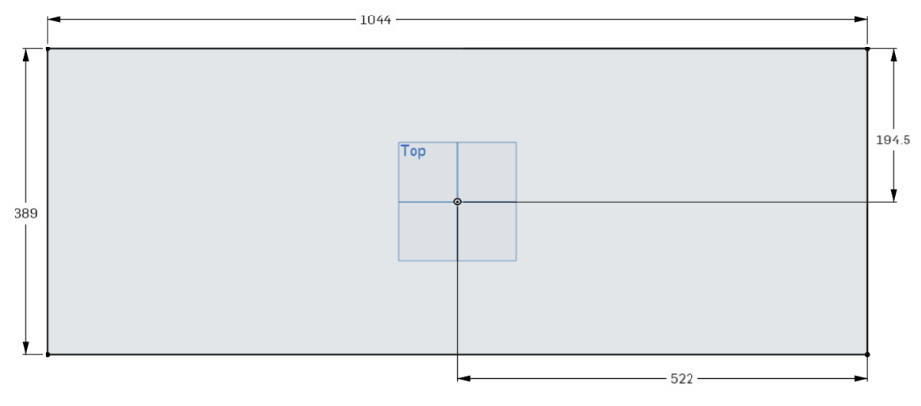

Figure 2.9: Defining body dimensions of the Ahmed body.

1. Select the sketch and click on “Extrude” tool () to extrude the body. Select the Solid tab, “New” tab and “Blind” option from the dropdown menu with 288 mm. Click ok () to extrude.

Note: Make sure the extrude is in positive direction of the z-axis. You can use the arrows () next to “Blind” to change directions of extrusion if needed.

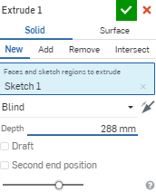 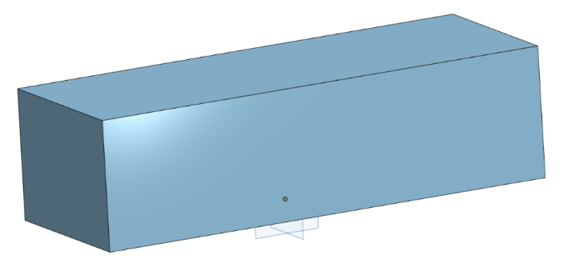

Figure 2.10: Extruding the body from the sketch.

1. Exit the sketch if you haven’t by clicking ok (). Then select the “Variable” tool (), select “Number” tab and create a variable (figure 2.11) called “angle” with “20” as the “Value”. This should now appear on your “Features” list on screen right. Move this variable above the extrude in the list (figure 2.14)

Variables can be used to define values and refer these to your sketches and other features. They allow quick dimensional changes (revisions) to the original model.

|  |  |
| --- | --- |
| Figure 2.11: Create a variable "angle". | Figure 2.12: Move the variable up in the features list. |

1. Click on the “Front” plane surface of the extruded object (figure 2.13) and create a sketch, then adjust your view to show the sketch plane as shown in steps 4.

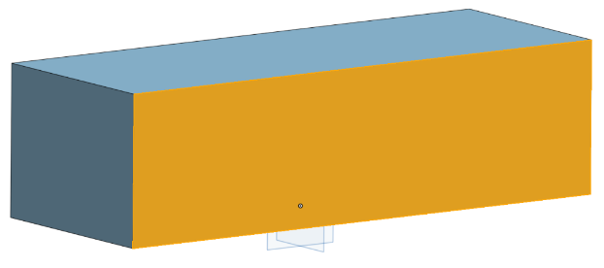

Figure 2.13: Sketching on the surface of the extrude.

1. Using the “Line” tool (), draw a line from the rear top edge to the rear side edge and connect it along the edge of the extruded body to form a right angled triangle. Dimension the inner diagonal line (hypotenuse) as 222 mm.

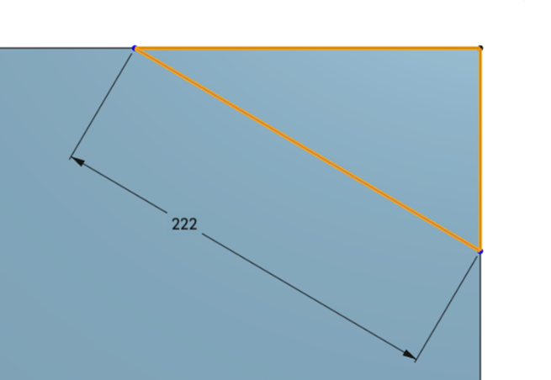

Figure 2.14: Sketching a right angled triangle at the corner of the body.

1. Now using the “Dimension” tool () select the angle between the top edge and the diagonal line. Enter “#angle” as the dimension. This will allow the angle value to be modified easily.

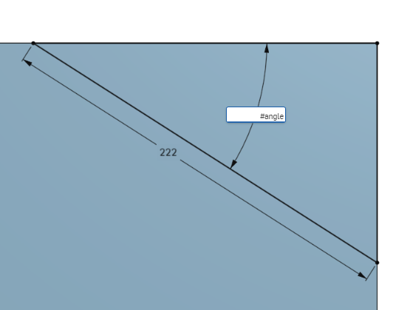

Figure 2.15: Assigning variable "angle".

1. Exit the sketch 2 and click on the “Extrude” tool () and select the “Remove” tab under the “Solid” tab and select “Through all” from the dropdown menu. Now select the triangle sketched in step 11 and 12 (if sketch not selected automatically) and click ok (). This should remove the triangle from the main extruded body.

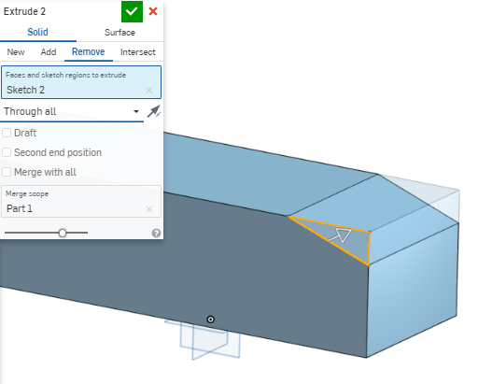

Figure 2.16: Removing the triangle from the main extruded body.

1. Select the “Fillet” tool () and click on the front edges of the body as shown in figure 2.17 below. Then select “Circular” from the drop down menu with 100 mm as the radius and click ok ().

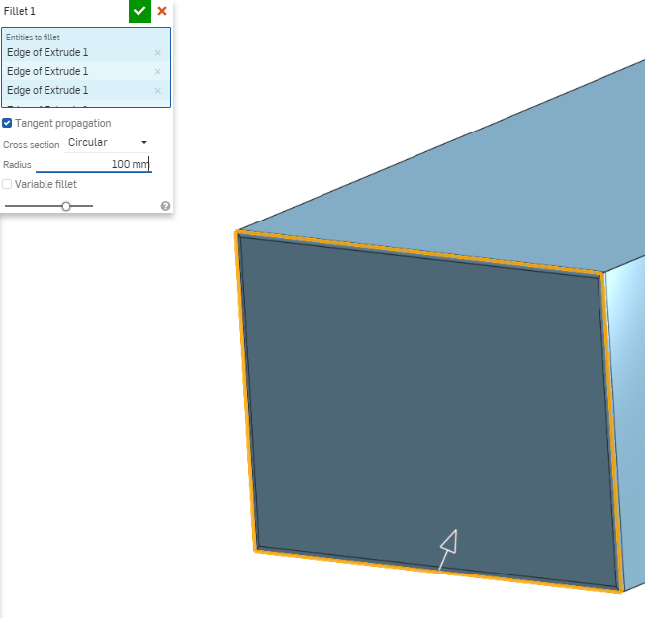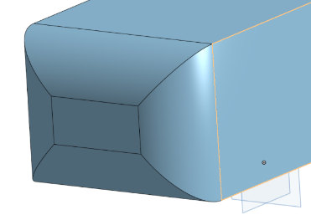

Figure 2.17: Filleting the front of the extrude.

1. Select the “Top” plane and create a new sketch. Adjust the view similar to step 4 but to bottom view.

Note: Make sure the z-axis is positive away from you.

1. Using “Centre Point Circle” () sketch a circle on the sketch in step 15. Use the “Dimension” tool () to define the radius (30 mm), offset the circle’s centre 202 mm from the front of the body and 163.5 mm from the centreline (the “Right” plane in this case) of the body.

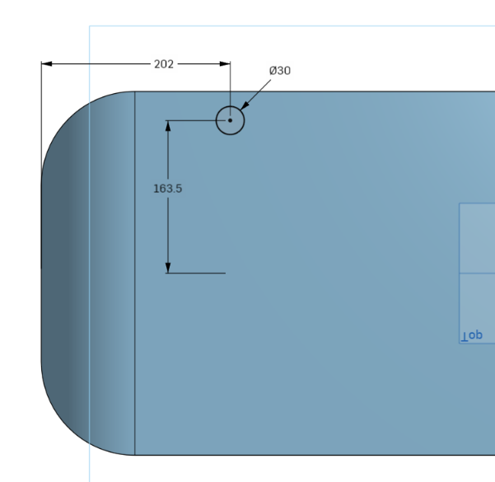

Figure 2.18: Sketching a circle and offsetting it.

1. Select the “Linear Pattern” tool () and click on the circle. Enter “2” to the horizontal and vertical copy multiples with 327 mm (163.5 x 2) and 470 mm respectively to distances (figure 2.19) and click the left mouse button to confirm. The generated sketch should resemble the figure 2.20 below.

Note: If x and y axis dimensions for the new pattern are not visible, drag the arrows of the pattern and they will appear.

|  |
| --- |
| Figure 2.19: Using the "Linear Pattern" tool. |
| Figure 2.20: Resulting linear sketch pattern. |

1. With the sketch open or selected, use the “Extrude” tool () to extrude the circles away (down) from the surface of main body. This can be done with “Bind” and the arrows next to it ().

Note: Confirm that the Add” tab in “Solid” tab is selected. Otherwise Onshape will create the extrudes as a new part.

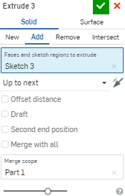

Figure 2.21: Extruding the bottom supports of the body.

1. The extrudes in the previous step are below the x and y axis (negative z-axis direction). The “Transform” tool () can be used to shift the body to 0 z-axis. Select the tool and select “Translate by XYZ” from the dropdown. Now click on “Part 1” from the “Parts” tree (or simply click on the extruded part), enter “+50 mm” in the “Z” direction and click ok.
2. The main body is now complete and should look similar to the figure 2.23 below.

|  |  |
| --- | --- |
| Isometric |  |
| Front (Body) | Rear (Body) |
| Side  Figure 2.22: Final Ahmed Body. | |

## Exporting Parts to STL Files.

1. Right click on the part(s) to be exported from the “Parts Tree” in the bottom right of your screen and select export.

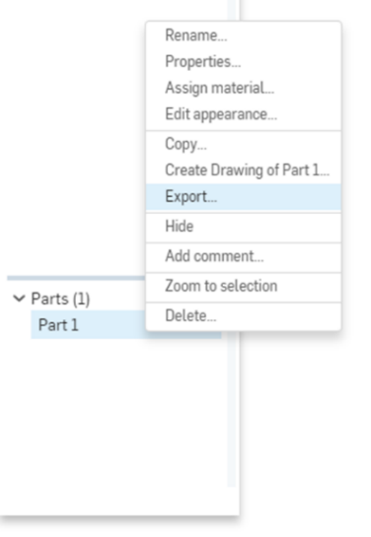

Figure 2.23: Select part(s) for exporting.

1. Please select the required parameters and click “OK” to download. The recommended parameters for this tutorial are shown in table 2.1.

Table 2.1: Export parameters for the STL file.

|  |  |  |
| --- | --- | --- |
| File Name: | ahmed_body_ref | Replace “ref” with the body revision references (such as angle) |
| Format: | STL |  |
| STL Format: | Binary | Lower file size |
| Units: | Metre | Auto scales it for OpenFOAM |
| Resolution: | Fine | For finer surfaces (better for CFD) |
| Options: | Download |  |

Note: It is advisable to avoid spaces in file names, as they can be misinterpreted by some CLI software or scripts.

# Appendix A: Ahmed Body Dimensions

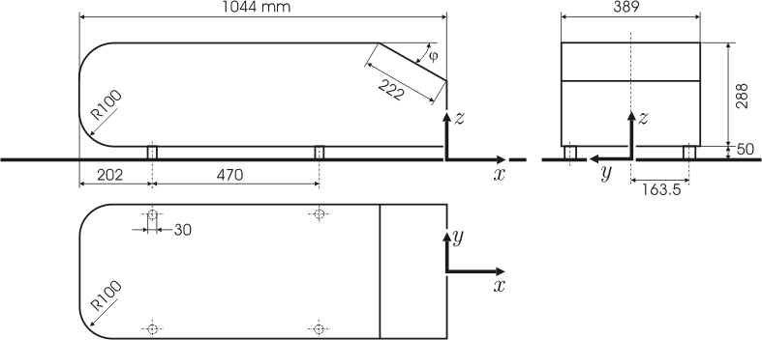

From: <https://www.cfd-online.com/Wiki/Ahmed_body>