DAMG7370 Final Project Report
Washington State Real Estate Investment Analysis
Seattle Campus - Group 1
Members: Huizhen Li, Yao Li, Ming-Hsiang Lee
GitHub URL: https://github.com/NU-YaoLi/DAMG7370-Project.git

1. Team Contribution
NUID | Name | Role | Contribution Summary
002649260 | Huizhen Li | Partial System Architecture Design & Data Modeling | 1. Designed end-to-end cloud architecture on AWS after research. 2. Designed and implemented the dimensional data model using star schema. 3. Built the landing-to-final ETL job.
002415604 | Yao Li | Partial System Architecture Design & Data Workflow Implementation | 1. Designed end-to-end cloud architecture on AWS after research. 2. Implemented data ingestion and cleaning pipeline. 3. Built PySpark ETL jobs on AWS Glue. 4. Orchestrated the full pipeline using AWS Step Functions with parallel execution.
002308390 | Ming-Hsiang Lee | Data Visualization & Dashboard | 1. Built the interactive Streamlit dashboard connected to the RDS PostgreSQL data warehouse. 2. Designed and implemented investment analysis metrics. 3. Created multi-section visualizations for historical trend analysis and investment comparison across WA metro areas.

2. Project Objective
The primary goal of this project is to build a production-grade data pipeline and analytical platform to help real estate investors make data-driven decisions in the Washington State housing market. Washington State was chosen because of its fast-growing metro areas, rising housing demand, and wide variation in property values between coastal cities like Seattle and smaller inland markets - making it a strong case study for comparative investment analysis. The platform is designed for individual investors, property analysts, and portfolio managers who want to evaluate rental yield, affordability, and market timing across different regions.
Sample Analyses:
- Historical house value trends across WA metro areas
- Monthly rental income patterns by geography
- Estimated mortgage payment trends over time
Deep Analyses:
- Gross Rental Yield: Annual rental income as a percentage of property value, identifying the most efficient investment markets
- Net Cash Flow: Monthly rental income minus mortgage payment, identifying markets where rental income covers carrying costs
- Price-to-Rent Ratio: A key metric to determine whether buying or renting is more advantageous in a given market
These analyses empower investors to identify high-yield markets, assess affordability, and optimize their real estate investment strategy across Washington State.

3. Dataset Introduction
- Zillow Home Value Index (ZHVI) Dataset:
This dataset contains monthly median home values at the city level across the United States, segmented into three price tiers: bottom (0–33rd percentile), middle (33rd–67th percentile), and top (67th–100th percentile). The dataset covers the period from January 2012 to 2025 and includes 60 cities in Washington State. It serves as the primary indicator of property appreciation trends and market valuation.
- Zillow Total Monthly Payment Dataset:
This dataset provides estimated total monthly mortgage payments at the metro level, assuming a 20% down payment on a median-priced home. The dataset spans from January 2012 to 2025 and covers 11 metro areas in Washington State. It is used to assess housing affordability and calculate net cash flow for potential investors.
- Zillow Observed Rent Index (ZORI) Dataset:
This dataset captures observed monthly rental prices at the ZIP code level. The dataset covers the period from 2015 to 2025 and includes 222 ZIP codes in Washington State. It provides granular rental income estimates, enabling analysis of rental yield and market competitiveness across Washington State metro areas.

4. System Architecture
Our project is deployed entirely on AWS, utilizing Amazon S3, AWS Glue, AWS Step Functions, Amazon RDS PostgreSQL, and Streamlit for visualization. Amazon S3 was chosen as the data lake for its low-cost, scalable object storage. AWS Glue provides serverless ETL with built-in PySpark support, removing the need to manage cluster infrastructure. AWS Step Functions coordinates multi-step workflows with built-in retry and error handling. Amazon RDS PostgreSQL offers a managed relational database that supports complex SQL queries needed for dimensional modeling. The entire infrastructure is provisioned through AWS CloudFormation as Infrastructure as Code (IaC), enabling repeatable and version-controlled deployment.
The workflow begins with downloading raw Zillow CSV datasets and uploading them to Amazon S3, which serves as the data lake. AWS Glue Python Shell jobs clean and interpolate missing values before PySpark-based Glue jobs transform the wide-format CSVs into long-format relational records. Transformed data is loaded into a PostgreSQL landing schema on Amazon RDS, then promoted into a dimensional star schema through a final upsert job. The processed data is visualized through an interactive Streamlit dashboard.
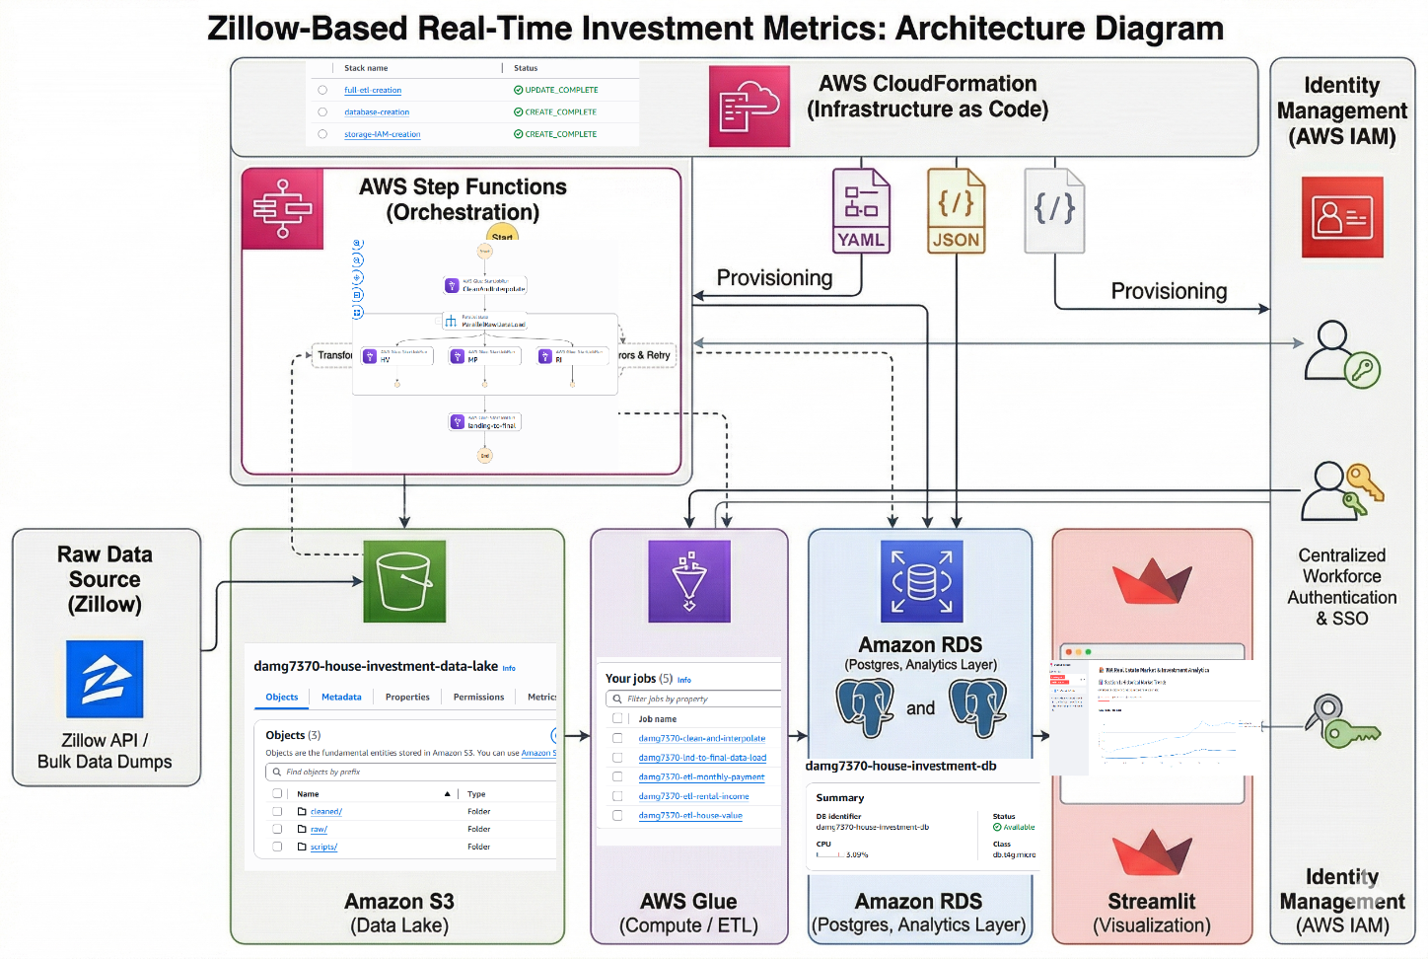

5. Data Pipeline
The pipeline is orchestrated by AWS Step Functions and consists of three sequential stages:
- Stage 1 - Data Cleaning (Serial): A Python Shell Glue job reads raw CSV files from S3, trims whitespace, and applies horizontal linear interpolation to fill missing values within time series columns. Cleaned files are written back to the cleaned/ S3 prefix.
- Stage 2 - Raw to Landing (Parallel): Three PySpark Glue jobs run simultaneously - one each for house value, monthly payment, and rental income. Each job unpivots the wide-format time series data into a long-format relational structure and loads it into the PostgreSQL landing schema using JDBC.
- Stage 3 - Landing to Final (Serial): A Python Shell Glue job executes a series of SQL upsert operations to promote data from the landing schema into the final business tables and dimensional star schema. Conflict resolution ensures idempotent execution upon rerun.
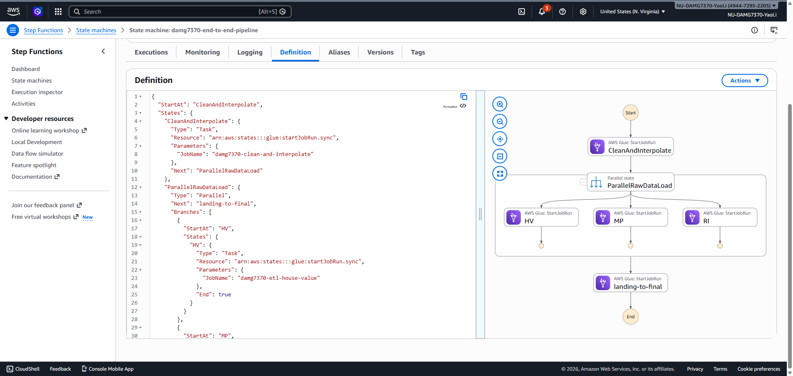

6. Data Transformation and Modeling
6.1 Data Cleaning and Interpolation
Raw Zillow CSVs contain missing values within monthly time series columns, particularly for smaller or less-tracked markets. Across all three datasets, missing values were most prevalent in the ZIP-level rental dataset (approximately 59%) and less pronounced in the city-level home value data (approximately 7%), with the metro-level payment data being nearly complete (<1% missing).
To address this, we chose linear interpolation over other methods (such as forward-fill or mean imputation) because housing prices tend to change gradually over time, making a straight-line estimate between known months the most reasonable approach. We applied linear interpolation horizontally across date columns using Pandas (interpolate(method='linear', axis=1, limit_area='inside')). This approach fills gaps between known values without extrapolating beyond the data range, preserving data integrity for downstream analysis.
6.2 Wide-to-Long Transformation (Unpivot)
The raw Zillow datasets are structured in wide format, where each monthly date is a separate column. This format is not suitable for relational database storage or time series analysis. Using PySpark's stack() function, we transformed each dataset from wide to long format, converting hundreds of date columns into individual rows with a metric_date and corresponding value column. This transformation reduced schema complexity and enabled efficient SQL-based time series queries downstream.
6.3 Dimensional Modeling (Star Schema)
To support efficient analytical querying, we implemented a star schema with one shared dimension table and three fact tables.
dim_geography consolidates geographic metadata from all three data sources. A key data quality step was standardizing inconsistent naming. For example, 'Seattle, WA' was unified to 'Seattle-Tacoma-Bellevue, WA' across all sources before joining. The dimension table is populated using a UNION of distinct metro values from all landing tables, with ON CONFLICT DO UPDATE to handle incremental refreshes.
The three fact tables - fact_house_value, fact_monthly_payment, and fact_rental_income - reference dim_geography via a surrogate geo_key foreign key, replacing redundant text-based geographic fields. Each fact table stores monthly aggregated metrics with (geo_key, metric_date) as the unique constraint, enabling upsert-based incremental loading.

7. Investment Metrics and Analysis
7.1 Feature Engineering
Three key investment metrics were derived by joining the three fact tables on geo_key and metric_month:
Metric | Formula | Purpose
Gross Rental Yield | (rental_income × 12) / avg_house_value | Annual return on property value
Net Cash Flow | rental_income − monthly_payment | Monthly surplus or deficit after mortgage
Price-to-Rent Ratio | avg_house_value / (rental_income × 12) | Buy vs. rent market indicator

7.2 Key Findings
- House Value Trends: Metro areas such as Seattle-Tacoma-Bellevue showed sustained appreciation over the analysis period, with median home values rising from approximately $328,000 in 2012 to $1,100,000 by 2022. Growth notably accelerated post-2020, reflecting pandemic-driven demand for suburban housing.
- Rental Yield: Smaller metro areas in eastern Washington generally demonstrated higher gross rental yields (averaging around 4.5%) compared to Seattle (approximately 2.6%), where high property values compress returns despite strong rental demand.
- Net Cash Flow: Most Seattle-area markets showed negative net cash flow, with a typical monthly shortfall of approximately $2,300, due to elevated mortgage payments relative to rental income. This indicates that these markets favor long-term appreciation over immediate rental income generation. Inland markets showed more balanced cash flow profiles, with monthly deficits typically ranging from approximately $800 to $1,100 - significantly lower than the Seattle-area shortfall.
- Price-to-Rent Ratio: Seattle-area metros showed price-to-rent ratios of approximately 38, well above the commonly used threshold of 20 (above which renting is generally considered more affordable than buying). This confirms that renting is relatively more favorable in these markets, consistent with national trends in high-cost coastal cities.

8. Visualization and Dashboard
8.1 Section 1 - Historical Market Trends
The first dashboard section presents raw historical time series data across three tabs: average house values, monthly rental income, and estimated mortgage payments. Each chart is rendered as an interactive Plotly line chart with metro-level color coding, enabling direct comparison of market trajectories over time. Users can filter by metro area using the sidebar multi-select control.
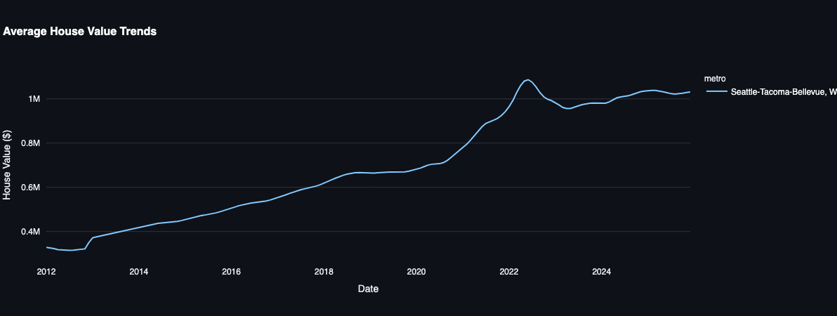
Figure 1. Average House Value Trends (Seattle-Tacoma-Bellevue, WA)
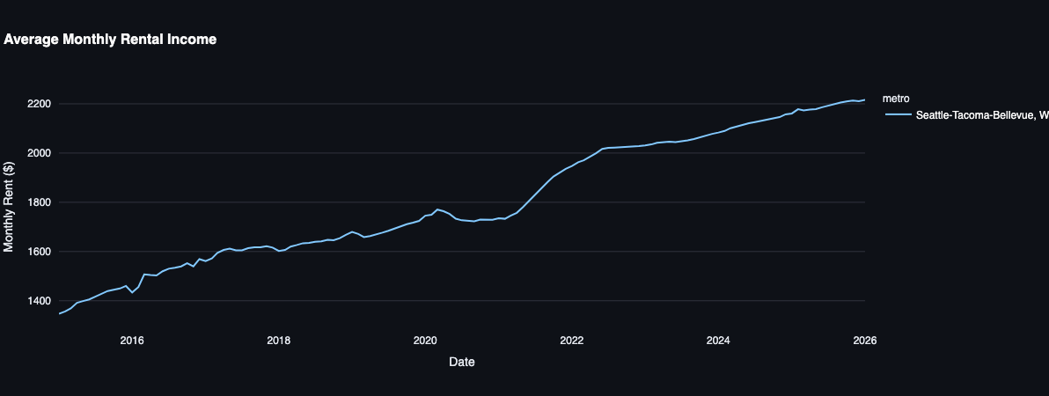
Figure 2. Average Monthly Rental Income (Seattle-Tacoma-Bellevue, WA)
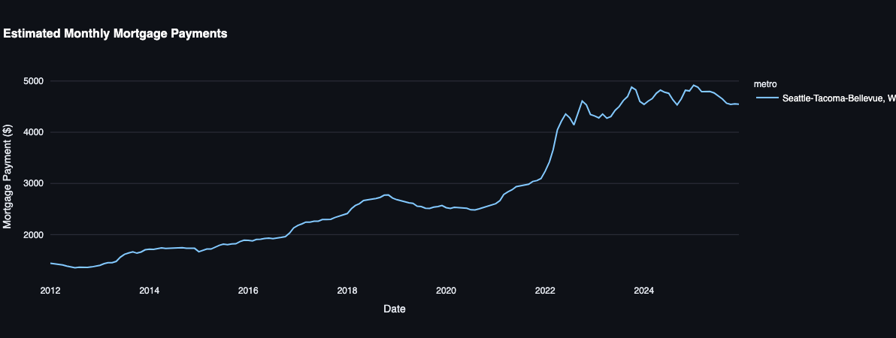
Figure 3. Estimated Monthly Mortgage Payments (Seattle-Tacoma-Bellevue, WA)
8.2 Section 2 - Investment Analysis
- Yield and Ratios Tab: Two side-by-side charts present the relationship between house value and rental income on a logarithmic scale (to address the order-of-magnitude difference between the two metrics), and gross rental yield trends over time. The logarithmic Y-axis allows meaningful visual comparison of both series without the rental line being visually suppressed.
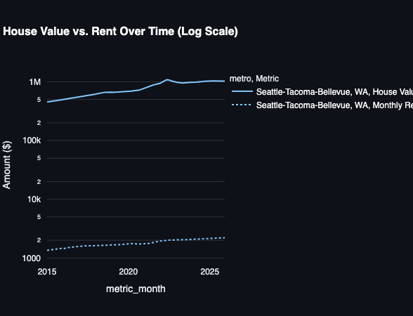
Figure 4. House Value vs. Rent Over Time (Log Scale)
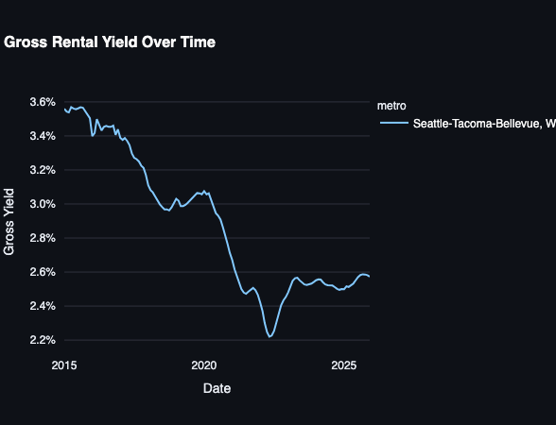
Figure 5. Gross Rental Yield Over Time
- Cash Flow and Affordability Tab: A combined rent-vs-mortgage line chart allows investors to visually identify when and where rental income crosses above mortgage payment. A dedicated net cash flow chart with a break-even reference line at $0 provides an immediate read on market profitability.
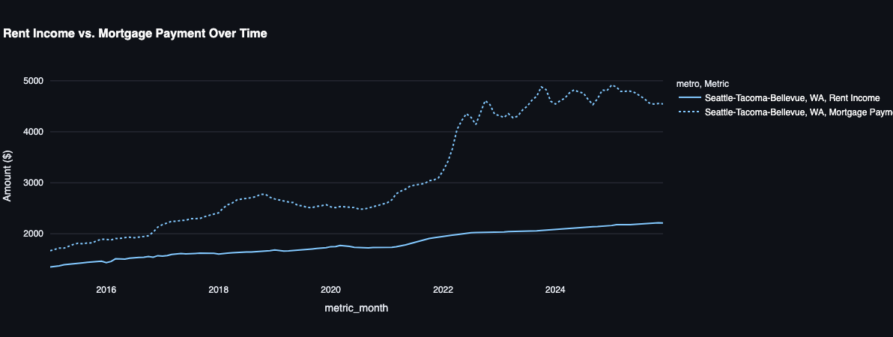
Figure 6. Rent Income vs. Mortgage Payment Over Time
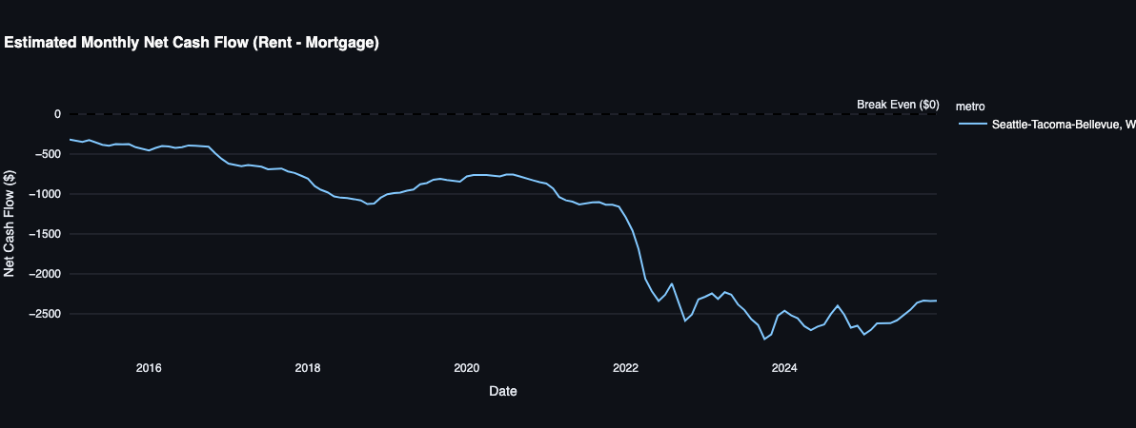
Figure 7. Estimated Monthly Net Cash Flow (Rent − Mortgage)
8.3 Dashboard Design Decisions
- Outer joins were used when merging the three data sources to ensure metros with partial data coverage are still represented where data exists, rather than being dropped entirely.
- No-data safeguards were implemented with dropna() checks before each chart render, preventing crashes for metros with incomplete datasets.
- One-hour caching via @st.cache_data(ttl=3600) minimizes redundant database queries during interactive use.
- Database credentials are stored securely in .streamlit/secrets.toml and are never hardcoded.

9. Conclusion
This project successfully delivered an end-to-end cloud-native data pipeline and investment analytics platform for the Washington State real estate market. By integrating Zillow's ZHVI, ZORI, and monthly payment datasets through a structured ETL pipeline on AWS, we produced a clean, queryable star schema that supports meaningful investment analysis.
Our key findings indicate that while major metro areas like Seattle offer strong long-term appreciation potential, smaller inland markets may present more favorable cash flow dynamics for rental investors. The gross yield and price-to-rent ratio analyses provide a practical framework for comparing markets on a risk-adjusted basis.
Leveraging AWS CloudFormation for infrastructure provisioning, AWS Glue and Step Functions for scalable and orchestrated data processing, and Streamlit with Plotly for interactive visualization, this project demonstrates the practical application of modern data engineering principles to real-world financial decision-making.
For future work, the platform could be extended in several directions. First, adding machine learning models to forecast house values and rental prices would allow investors to make forward-looking decisions. Second, expanding the geographic scope beyond Washington State to include other high-growth markets (such as Texas or Florida) would broaden the platform's usefulness. Third, integrating real-time data feeds rather than monthly snapshots would enable more timely investment analysis. Finally, adding user authentication and saved portfolio features to the dashboard would make it a more complete tool for day-to-day use.

References
[1] Zillow Research Data. https://www.zillow.com/research/data/
[2] AWS Glue Developer Guide. https://docs.aws.amazon.com/glue/latest/dg/what-is-glue.html
[3] AWS Step Functions Developer Guide. https://docs.aws.amazon.com/step-functions/latest/dg/welcome.html
[4] Streamlit Documentation. https://docs.streamlit.io/
[5] AWS CloudFormation User Guide. https://docs.aws.amazon.com/AWSCloudFormation/latest/UserGuide/Welcome.html

