1. To make sure that our data is proper for final analysis, for the initial raw data landing, we filter the house value data where date > 12/31/2011. Because in monthly payment and rent income table, the earliest data is 2012. Individual House value data from 2000 to 2011 doesn’t help us to analyze the housing investment if there’s no cost and income data.

2.
Since the AWS strictly limits the account to only allow "Free Tier" eligible hardware, I am not able to choose any other instances except micro ones.
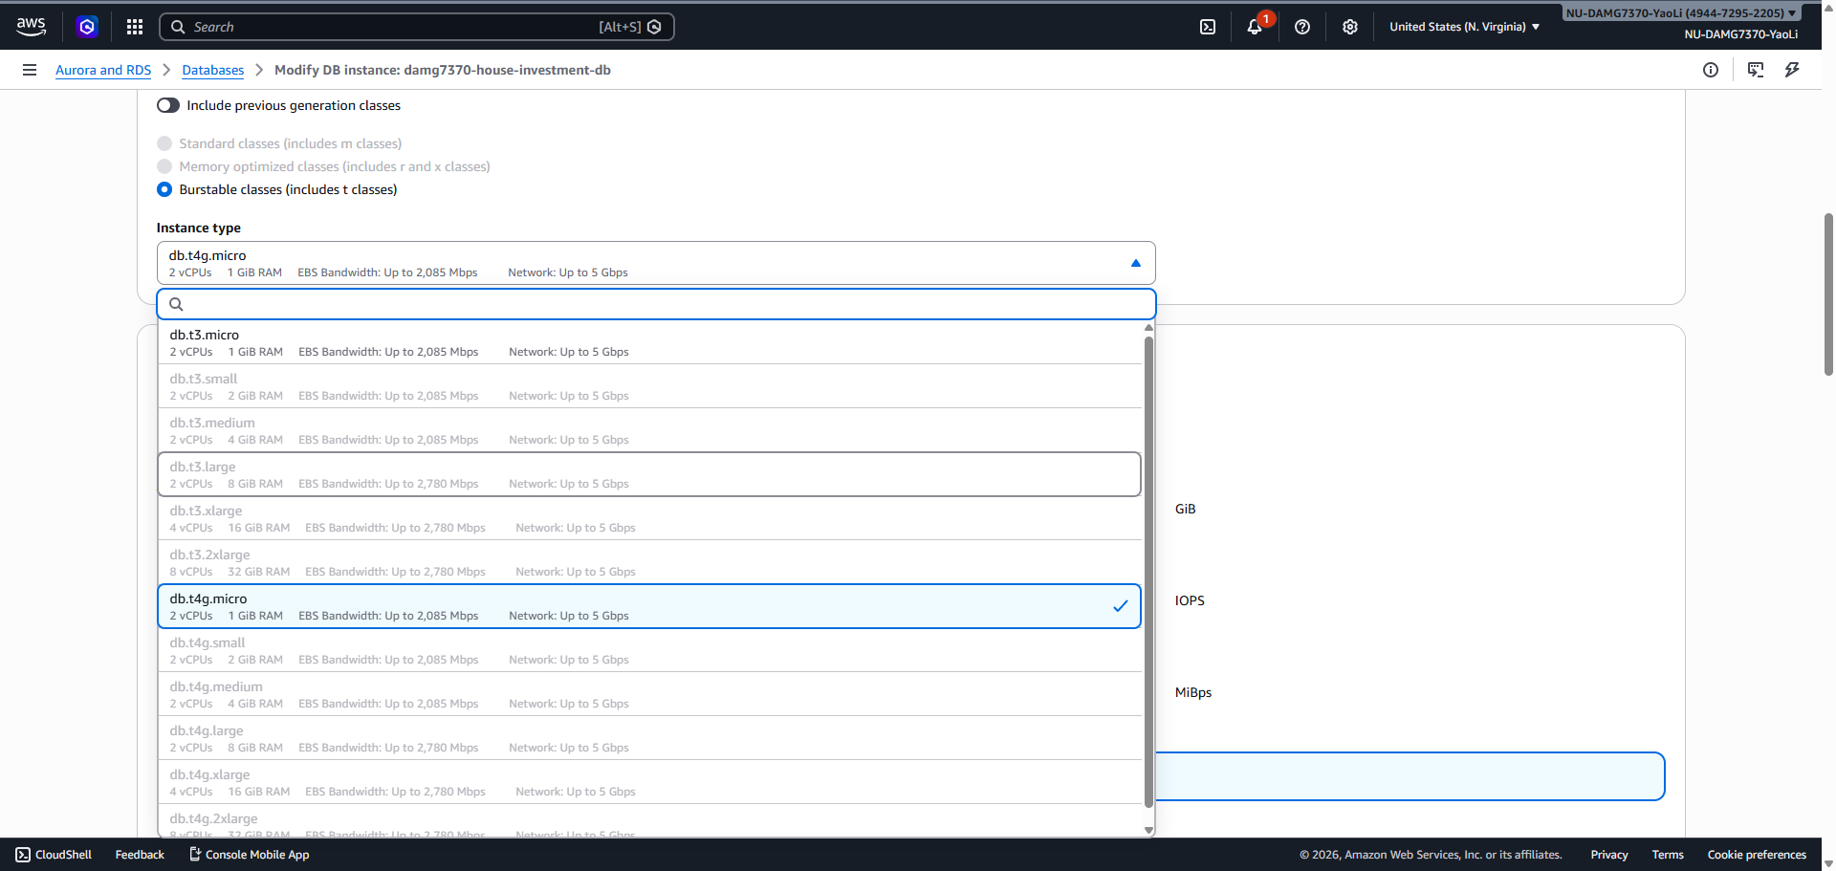
To align to the databas I/O, for the aws glue jobs, I chose G.1X and 3 as the worker type and quantity, to make sure it is not overwhelmed the database write.
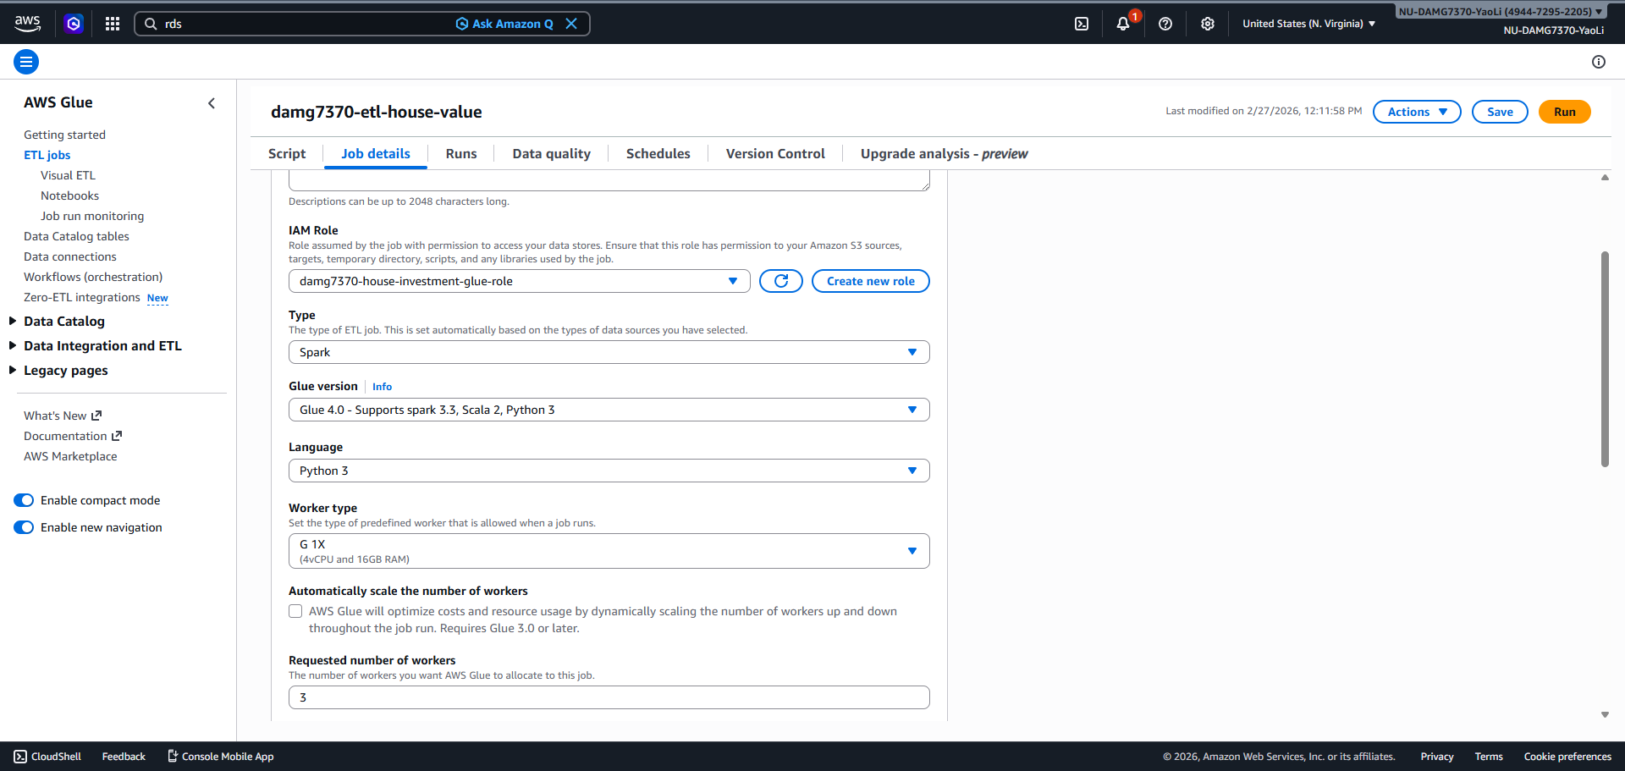

3. All the jobs can be deployed thru AWS CloudFormation, make the whole data pipeline highly re-usable

4. used the Pandas function interpolate to clean the missing data
Summary of data clean Workflow in data_clean.py
Load the CSV into a DataFrame (a table structure).
Trim whitespace so strings are clean.
Find all numeric columns.
Interpolate missing values only if they are "sandwiched" between two known numbers.
Save the result to a new file.

6.
To streamline the dataset for advanced analysis, I performed a data melting (or unpivoting) process to transform the structure from a "wide" format into a "long" format. By collapsing multiple date-specific columns into a single metric_date column and a corresponding metric_value field, I converted the data into a Tidy Data structure, which is the standard requirement for modern BI tools like Tableau and Power BI. During this transformation, I also applied a linear interpolation logic to fill missing values; this effectively calculated averages for gaps that existed between known data points while preserving the integrity of the series by ignoring leading blanks where no prior history existed. This approach ensures the dataset is now scalable, easier to filter, and ready for time-series modeling.

