<https://github.com/NUARIG/U54NigeriaCode> - Here is the link where you can download the latest csv files for arms, events, data dictionary and instrument mapping on github. Download zip folder with all the files and save it onto your desktop.

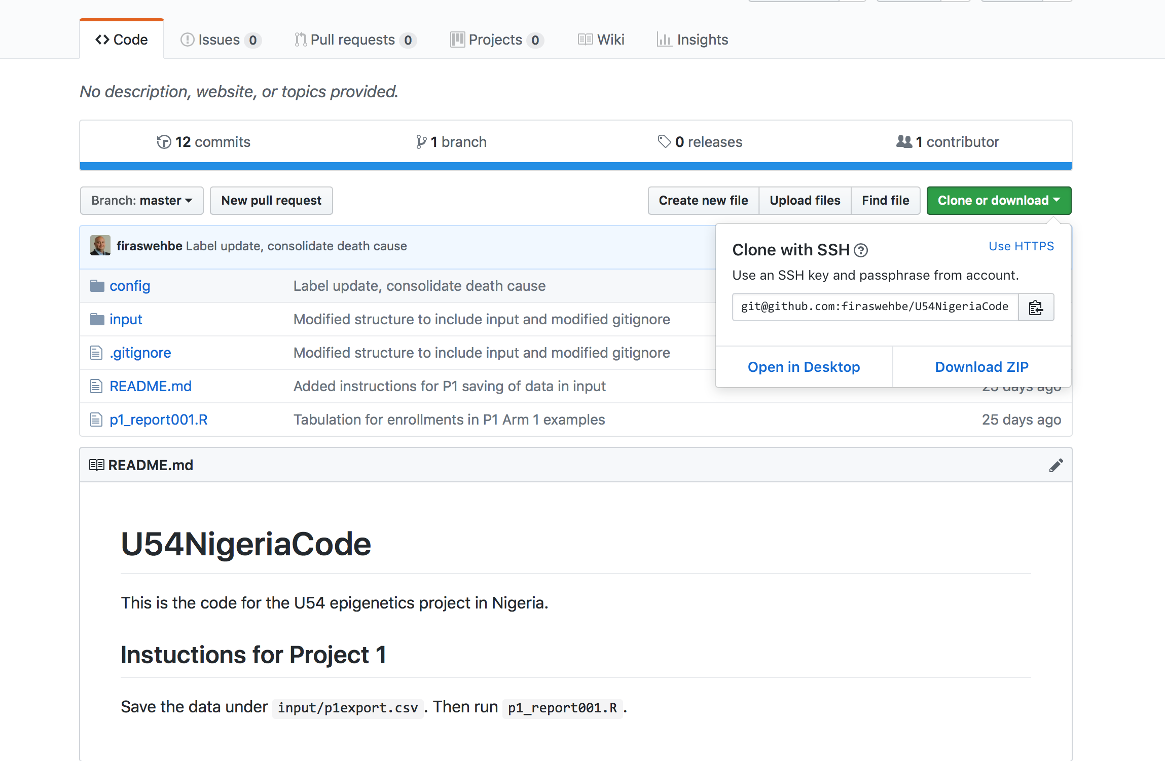

In REDCAP, this is the page you will see when you open the project.

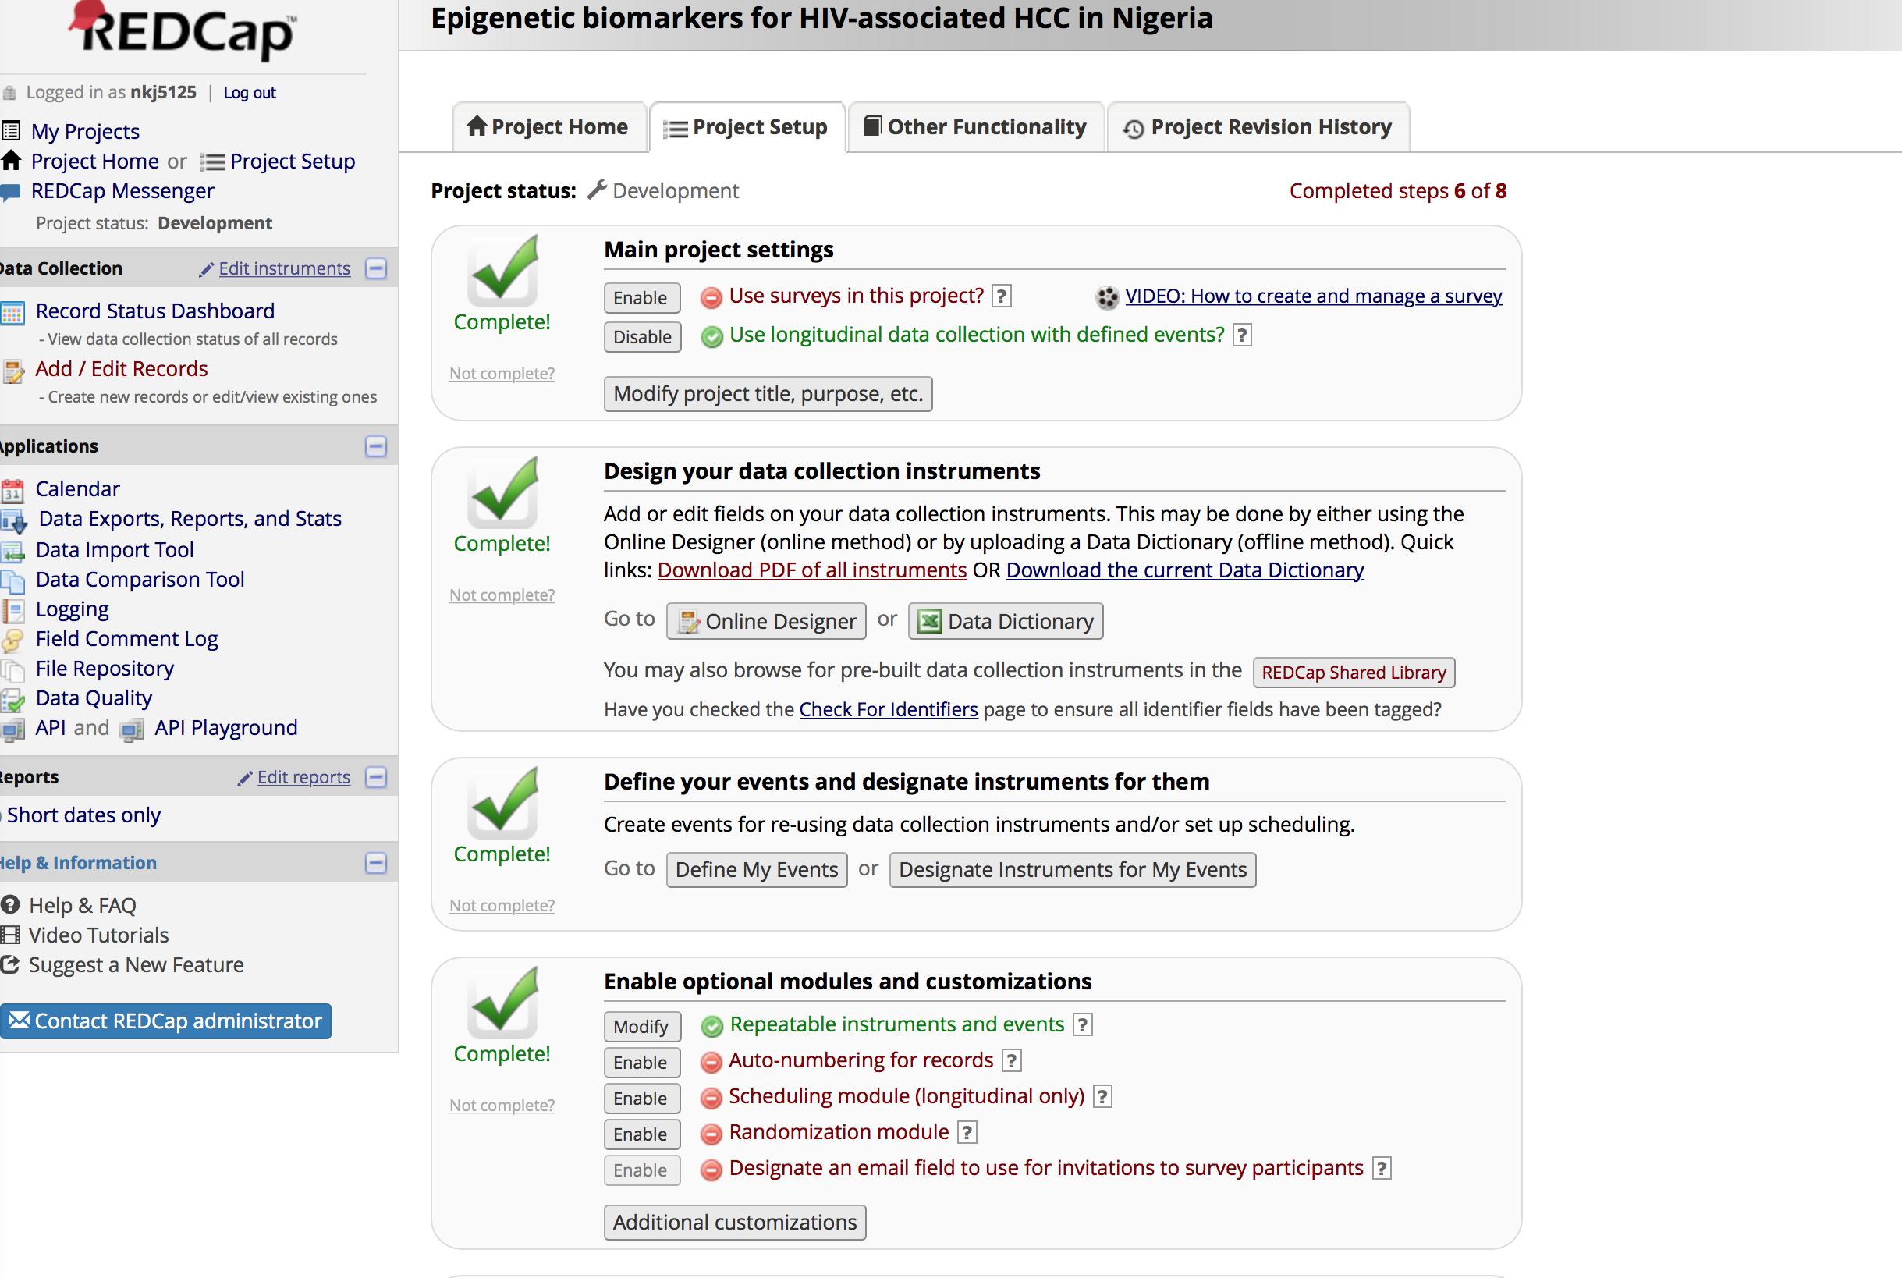

* Under Main Project settings - Enable the “Use longitudinal data collection with defined events?”
* Go to the third section “Define your events and designate instruments for them” and click “Define My Events”
* You will see “Upload or download arms/events” – Click that and Upload arms .csv file, then events .csv file in the same order. Once you upload the arms and events, it should like the screenshot below.

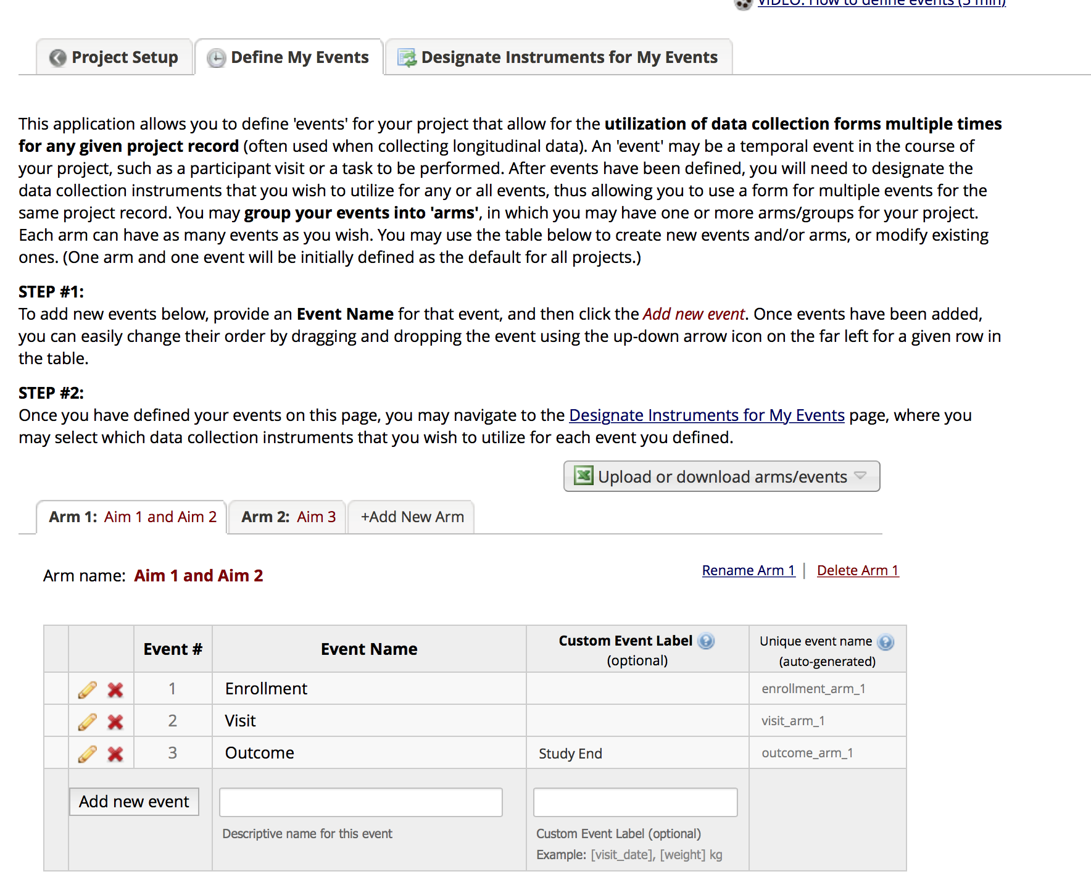

* In the next step, you go back to “Project Setup” tab on the top. In the project Setup page -in the section “Design your data collection instruments” click Data Dictionary.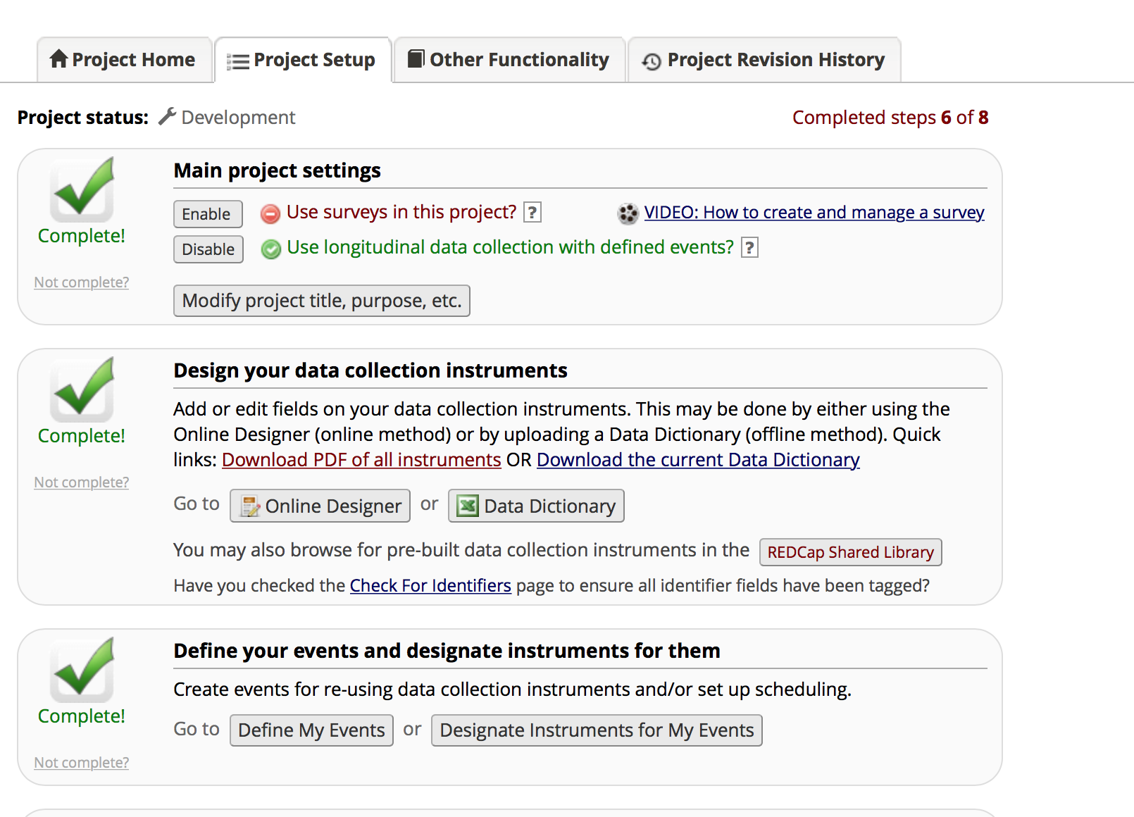
* Once you click Data dictionary, you will be directed to a page where you can upload the data dictionary csv file. The screenshot is shown below.

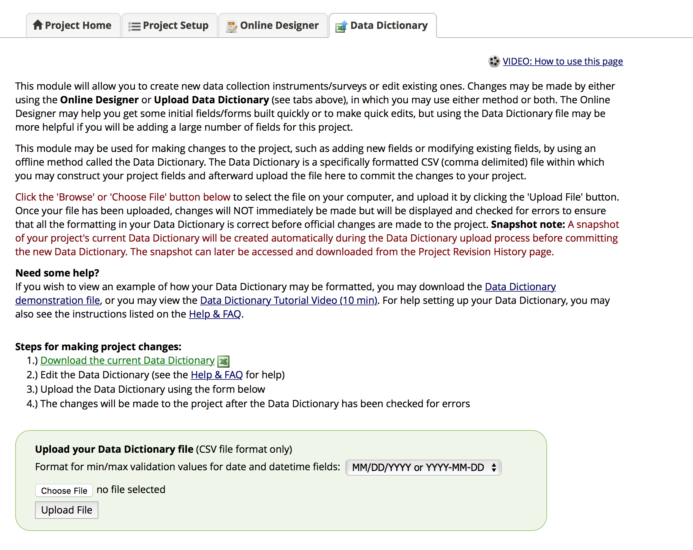

* You choose the data dictionary csv file and upload it. After you finish uploading the data dictionary file, then you go back to “Project Setup” tab on the top. Go to “Define your events and designate instruments for them” section and click on “Designate instruments for my events” and upload instrument- event mappings csv file

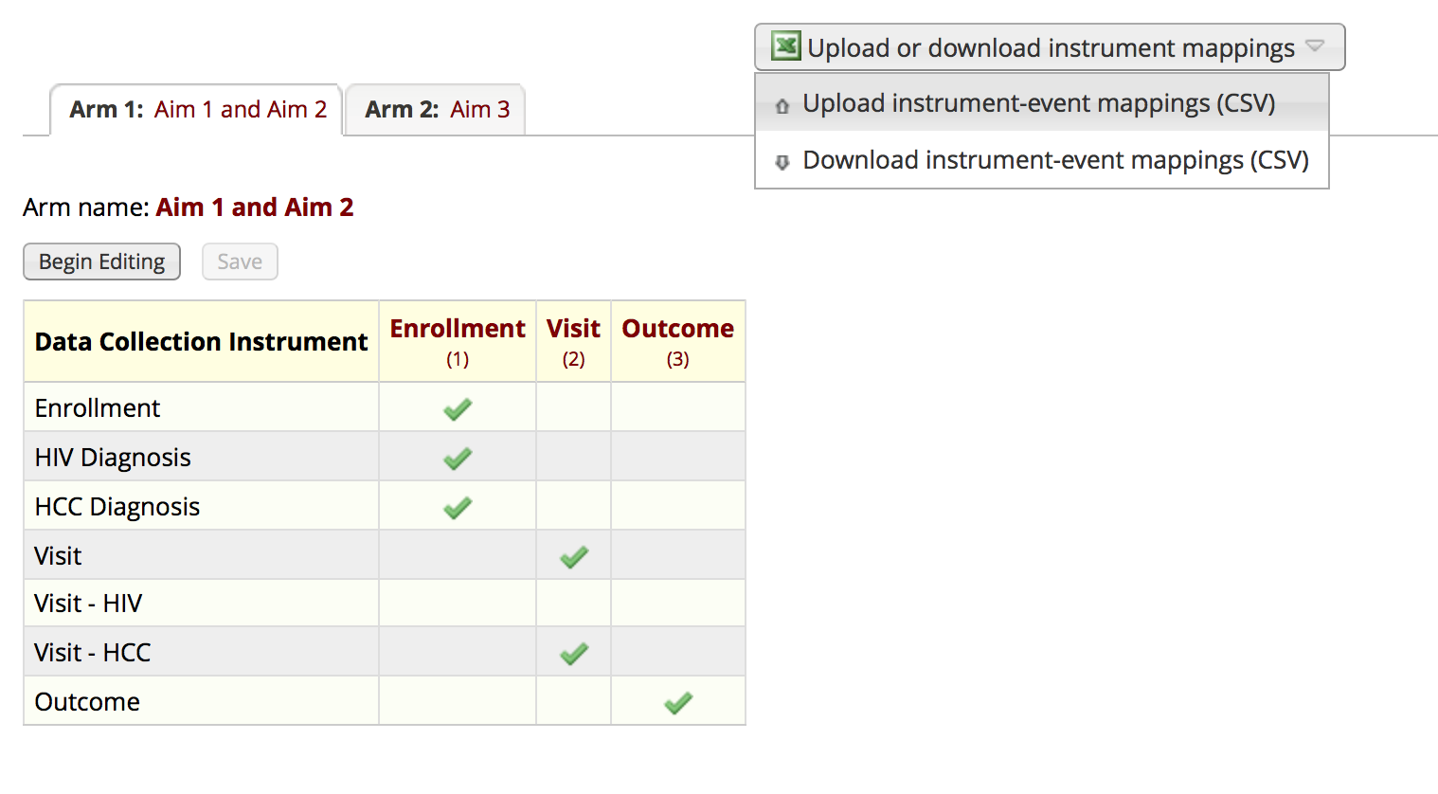

Aim 1 and 2 should look like this.

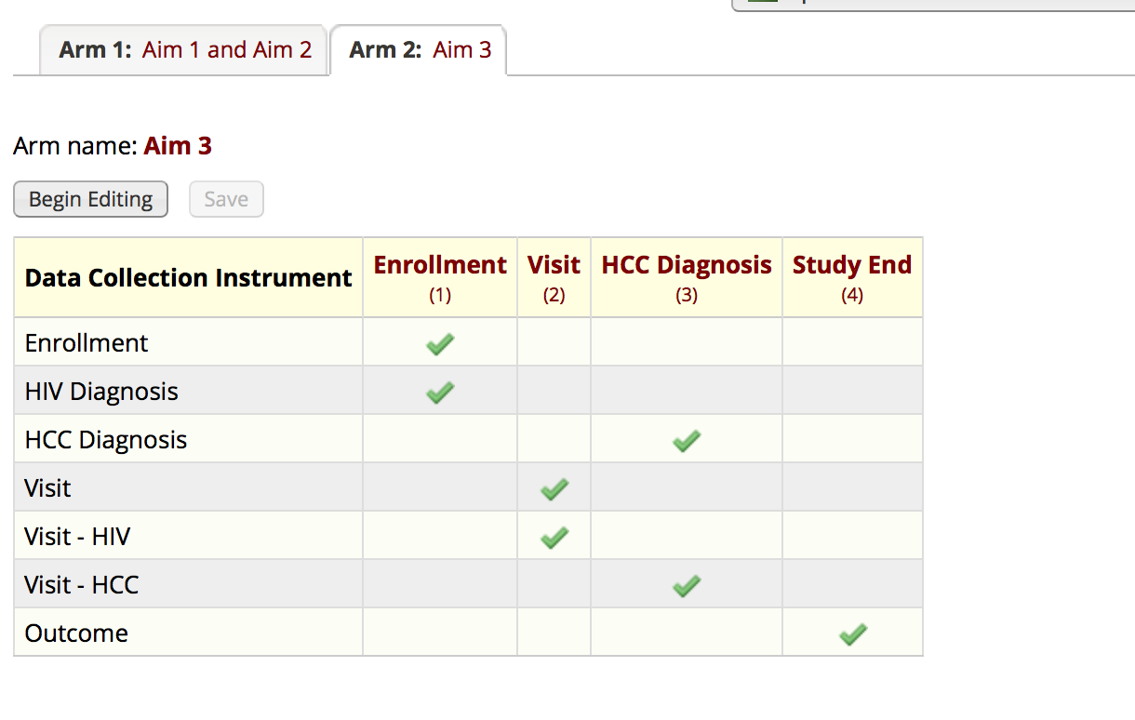

Aim 3 should look like this.

* Go back to project setup tab on the top and click on “Repeatable instruments and events” in Enable optional modules and customizations section.

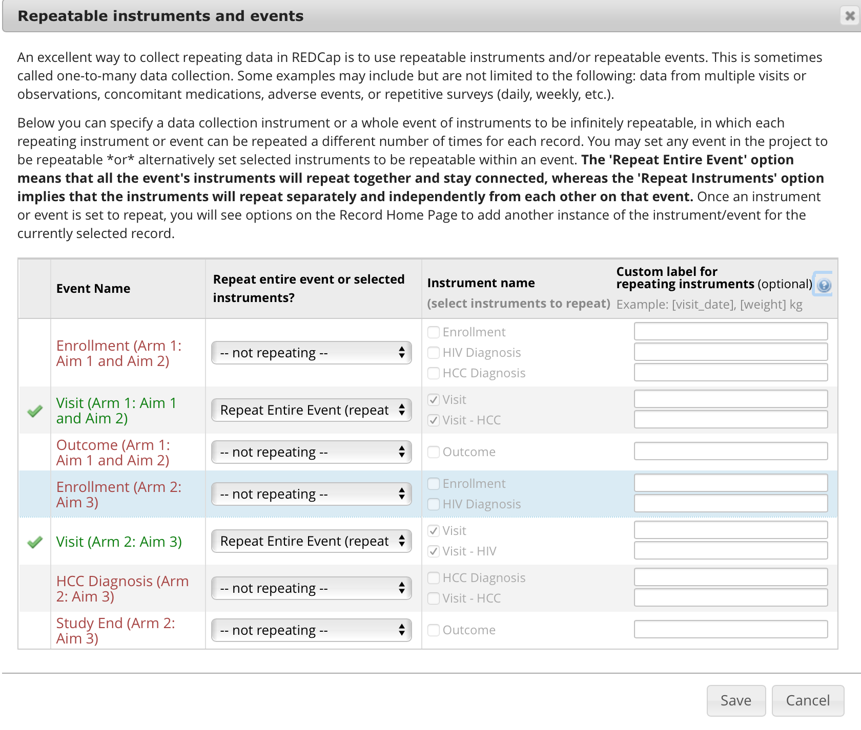

* “Visit” Event should be repeated in both Arms as shown below.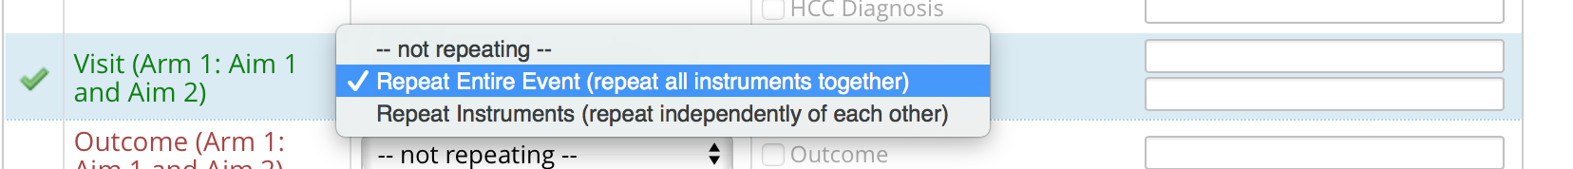
* 

Once all of this is done, your project will be ready.