Download the files from github in the same way you downloaded files for Project1 REDCAP clinical database.

In REDCAP, this is the page you will see when you open the project.

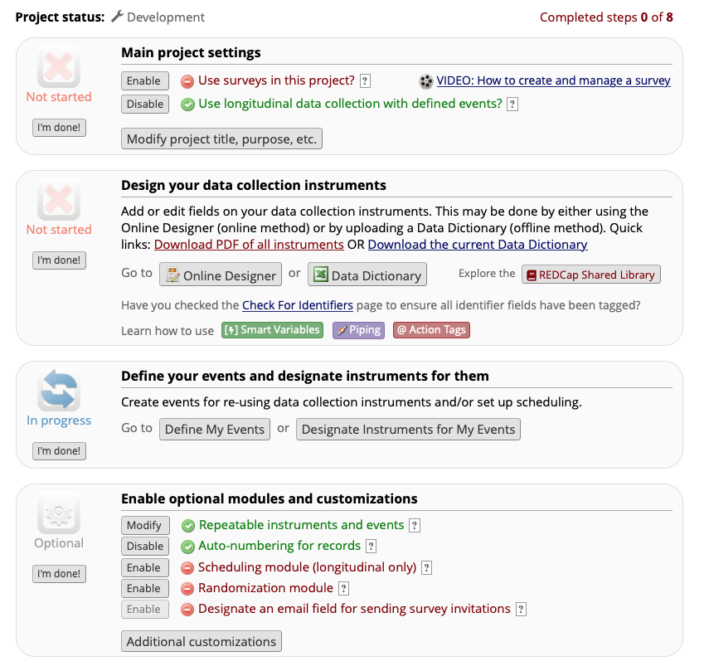

* Under Main Project settings - Enable the “Use longitudinal data collection with defined events?”
* Go to the third section “Define your events and designate instruments for them” and click “Define My Events”
* You will see “Upload or download arms/events” – Click that and Upload “P1_Specimen_Arms.csv” file, then “P1_Specimen_Events.csv” file downloaded from github in the same order. Once you upload the arms and events, it should like the screenshot below.

* In the next step, you go back to “Project Setup” tab on the top. In the project Setup page -in the section “Design your data collection instruments” click Data Dictionary.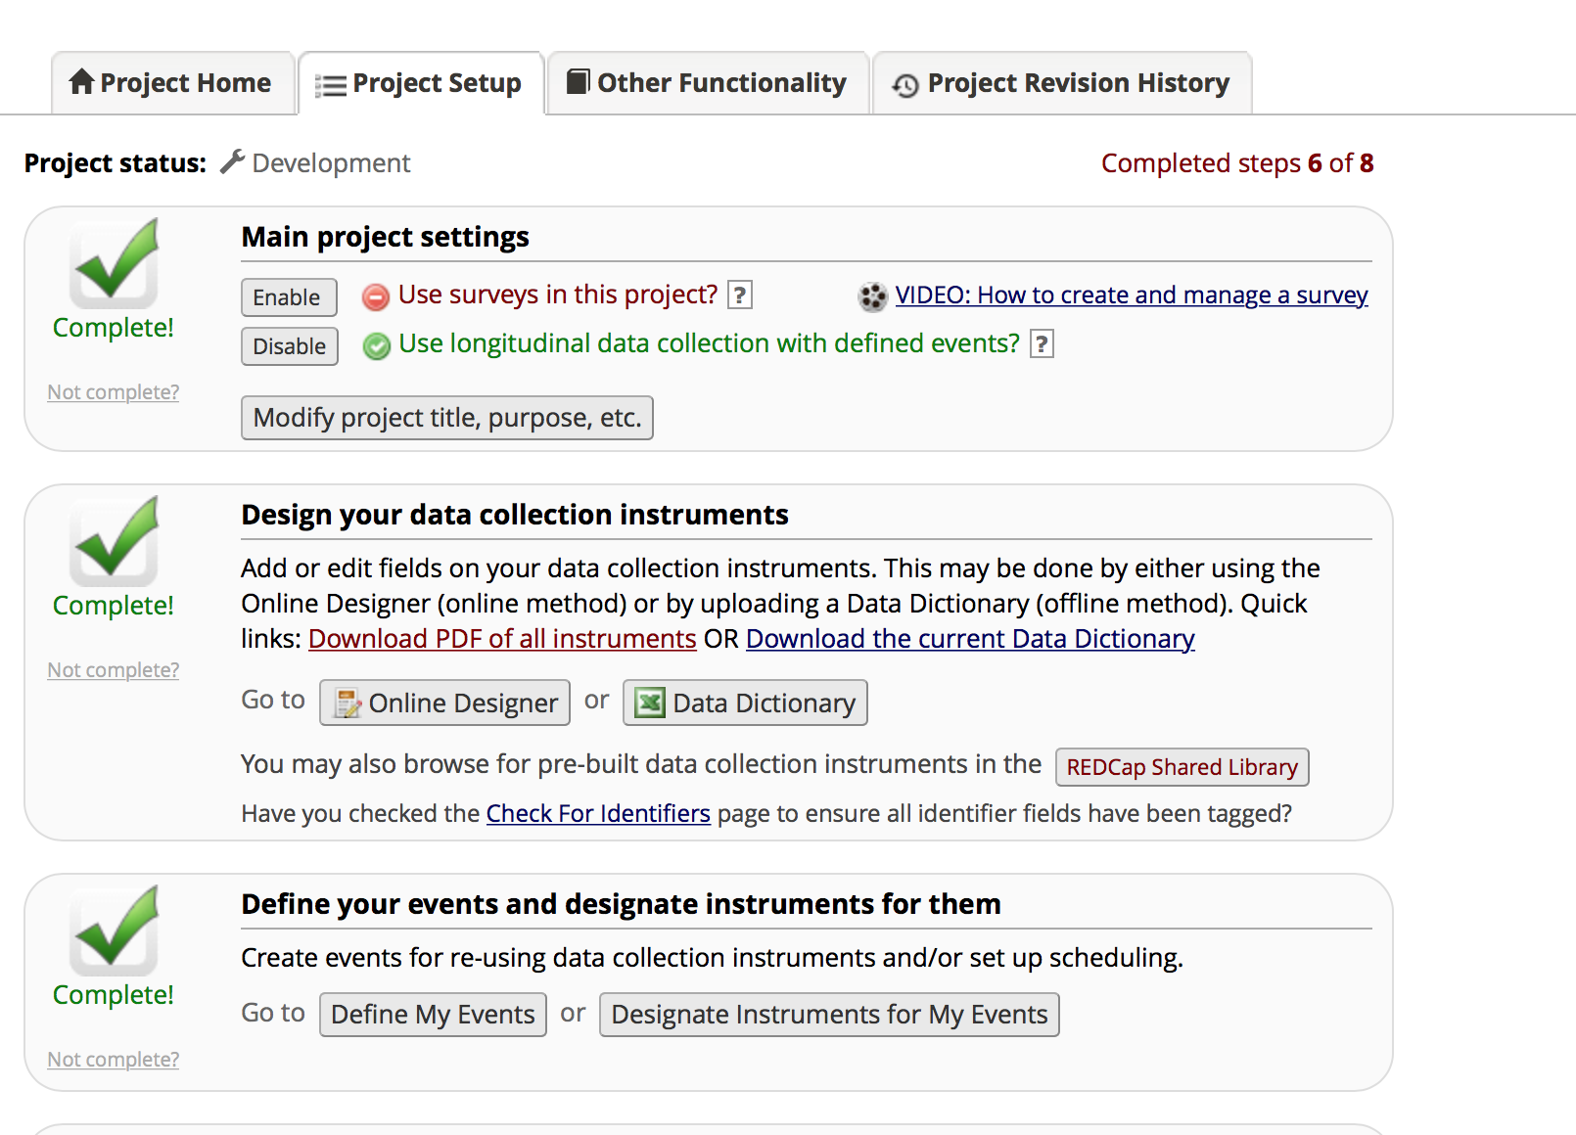
* Once you click Data dictionary, you will be directed to a page where you can upload the data dictionary csv file. The screenshot is shown below.

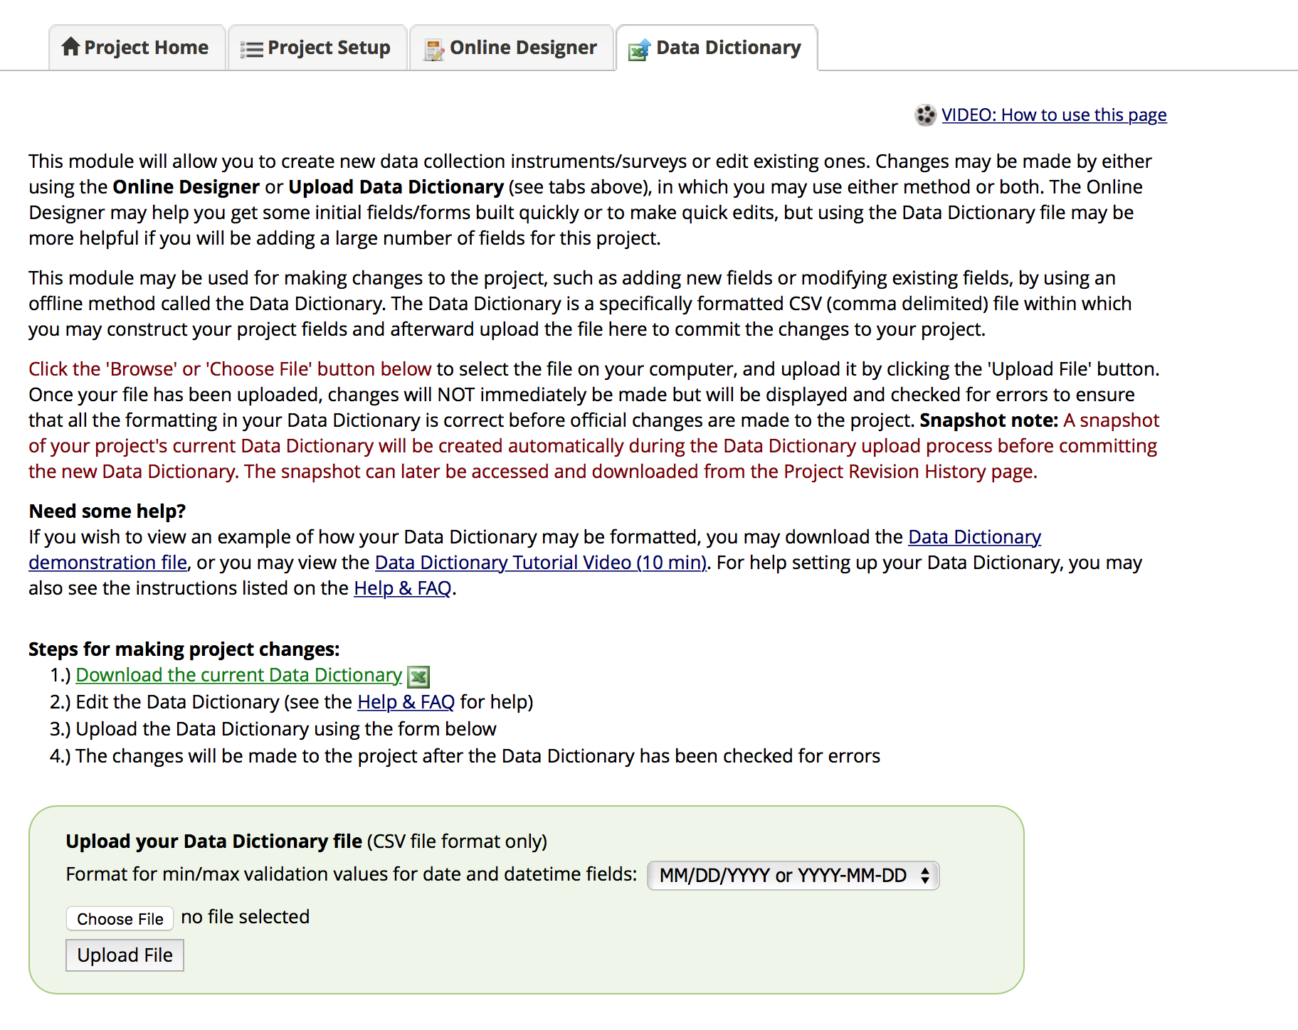

* You choose the “P1_Specimen_DataDictionary.csv” file and upload it. After you finish uploading the data dictionary file, then you go back to “Project Setup” tab on the top. Go to “Define your events and designate instruments for them” section and click on “Designate instruments for my events” and upload P1_Specimen_Events2Forms.csv file

* In the next step, Go to Project Setup. ---🡪 Enable optional modules and customizations. And Enable Repeatable instruments and events.

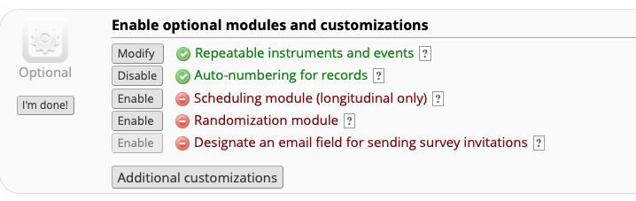

* Enable “Autonumbering for records”. Click on Modify for Repeatable instruments and events.
* A screenshot of a social media post

  Description automatically generated
* Select Repeat instruments and **NOT Repeat Entire event**
* Under Custom label for repeating instruments -
  1. For Shipping - [shipped_date]; plasma [total_ship_pl] ml; Buffy Coat [total_ship_bc] ml; Blood Serum [total_ship_bs] ml; DNA [total_ship_dna] microliters
  2. For Whole Blood - [wb_aliq], [wb_vol], [wb_rem_vol], [wb_rem_vol_ship_1], [wb_rem_vol_ship_2], [wb_rem_vol_ship_3]
  3. For Blood Plasma [pl_aliq], [pl_vol], [pl_rem_vol], [pl_rem_vol_ship_1], [pl_rem_vol_ship_2], [pl_rem_vol_ship_3]
  4. For Buffy Coat - [bc_aliq], [bc_vol], [bc_rem_vol_ship_1], [bc_rem_vol_ship_2], [bc_rem_vol_ship_3]
  5. For Blood Serum - [bs_aliq], [bs_vol], [bs_rem_vol_ship_1], [bs_rem_vol_ship_2], [bs_rem_vol_ship_3]
  6. For DNA - [dna_aliq], [dna_vol], [dna_rem_vol_ship_1], [dna_rem_vol_ship_2], [dna_rem_vol_ship_3]
  7. For PBMC - [pbmc_aliq], [pbmc_vol], [pbmc_rem_vol_ship_1], [pbmc_rem_vol_ship_2], [pbmc_rem_vol_ship_3]
  8. Once all of this is done, your project will be ready.

**Instructions for Data entry**

* **Baseline** – The forms in this event need to be filled, when the subject comes in for the first time for Blood draw.
* **Visit 2** – The forms in this event need to be filled only if the subject comes in for a second blood draw when the blood is recollected for any record due to initial insufficient sample, then please enter the data into "Visit 2 event". Otherwise leave the forms in this event blank.
* But if there is recollection due to contaminated DNA begin entering a new record.
* **Whole Blood Aliquots, Blood Plasma Aliquots, Buffy Coat Aliquots, Blood Serum Aliquots, DNA Aliquots, PBMC Aliquots** are repeatable forms– The number of instances will be the number of aliquots of that sample type (plasma, serum, buffy coat, DNA etc.,). For example, is there are 5 plasma aliquots for a subject, there will be 5 instances of ‘Blood Plasma Aliquots’ form. – one for each aliquot. These aliquot forms will also have a section at the bottom of the form to record the volume shipped and remaining volume after the sample is shipped per aliquot.
* **Shipping** – These forms should be filled if you ship any of the samples.
* Under this event, ***Sample Collection Snapshot*** form will give overall volume of whole blood and tissue samples collected for a subject.
* ***Shipping*** form – In this form the information about the volume of the samples and place to be shipped (if any) is recorded.
* ***You copy “Set a custom record label” under Additional customizations from old version of the project***.

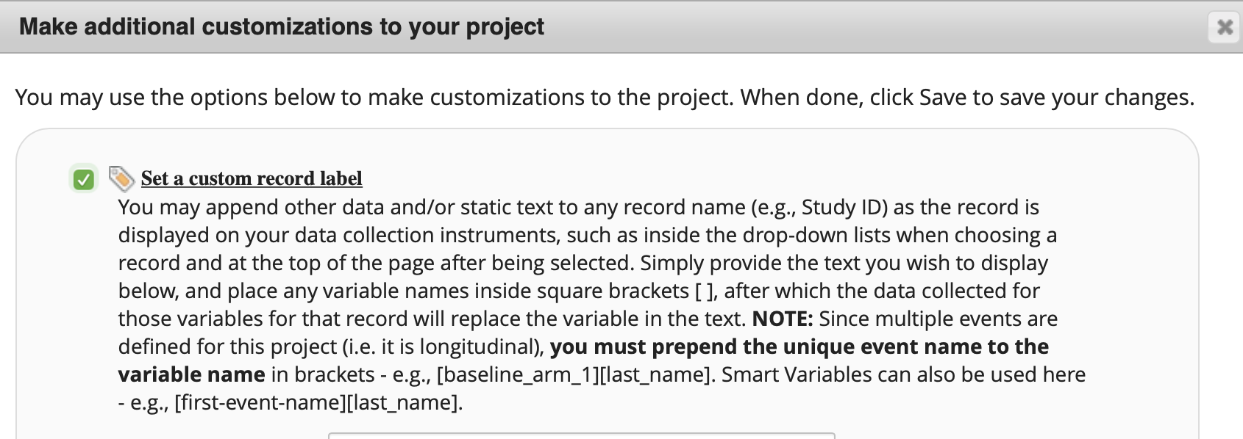

* For a record –

1. If you did not enter complete information, make sure you select “incomplete” for “Complete?” field so you can come back to the record. Check Lock in the next field so you don’t accidentally change the values. When you are ready to make changes, unlock the record and make changes.

2. If you enter the data completely, make sure you select “Unverified” for “Complete?” field so you can come back to the record. Check Lock in the next field so you don’t accidentally change the values. When you are ready to make changes, unlock the record and make changes.

3. If you enter the data completely and the data is verified, make sure you select “Complete” for “Complete?” field. Check Lock in the next field so you don’t accidentally change the values.

* If you see that there are values already in a field that means they are calculated fields. Please verify that those values are correct before you move on to next field.