**Please be careful when entering the data for the fields where you enter date, so that month and day don’t get mixed up!!!**

These are data entry instruction for the first three fields in “Patient Information” form in Specimen collection and tracking database in REDCAP.

The example values for the fields are given in the following table.

|  |  |  |  |  |  |  |  |
| --- | --- | --- | --- | --- | --- | --- | --- |
|  |  | Baseline | Aim 2 Follow-up | | Aim 3 Follow-up | | |
| **Fields** | **Task** | **Aim 1/**  **Aim 2/ Aim 3** | **6 months** | **12 months** | **1st Annual** | **2nd Annual** | **3rd Annual** |
| Unique Subject Code | Create a new record | Ex: JHCC001  LHCC001 | Ex:  JHCC001_m6  LHCC001_m6 | Ex:  JHCC001_m12  LHCC001_m12 | Ex:  JHCC001_y1  LHCC001_y1 | Ex:  JHCC001_y2  LHCC001_y2 | Ex:  JHCC001_y3  LHCC001_y3 |
| Subject Code |  | Blank | Ex:  JHCC001  LHCC001 | Ex:  JHCC001  LHCC001 | Ex:  JHCC001  LHCC001 | Ex:  JHCC001  LHCC001 | Ex:  JHCC001  LHCC001 |
| Type of Visit |  | Baseline | Aim_2 - 6 Month Visit | Aim_2 - 12 Month Visit | Aim_3 - 1st Annual Visit | Aim_3 - 2nd Annual Visit | Aim_3 - 3rd Annual Visit |

Detailed information and screenshots are in the following pages.

**Type of Visit -**

* **BASELINE** - Blood sample collected at time of enrollment – Aim 1/Aim 2/Aim 3

**Unique subject Code**

* Can be JUTH- JHCC001
* Can be LUTH- LHCC001

**Subject Code**

* Will be left blank

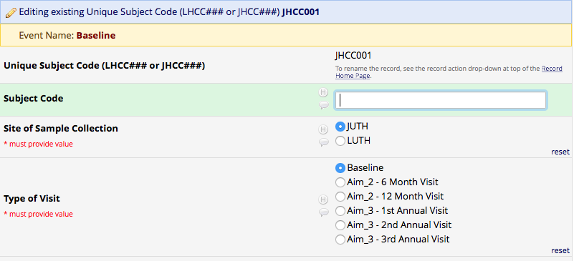

**When you create a record for follow-up visits**

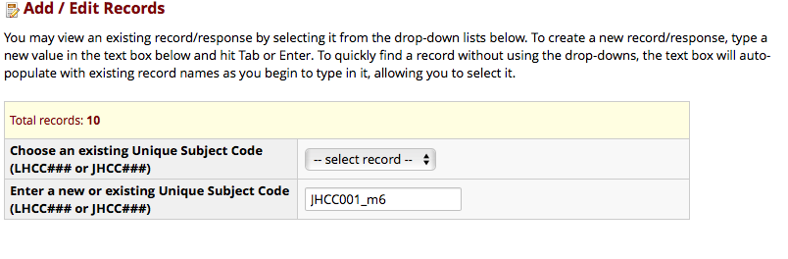

**Type of Visit -**

* **Aim_2 – 6 Month Visit** - Blood sample collected at 6 Month Follow-up – Aim 2

**Unique subject Code**

* Can be JUTH- JHCC001_m6
* Can be LUTH- LHCC001_m6

**Subject Code**

* Will be JHCC001 for JUTH
* Will be LHCC001 for LUTH

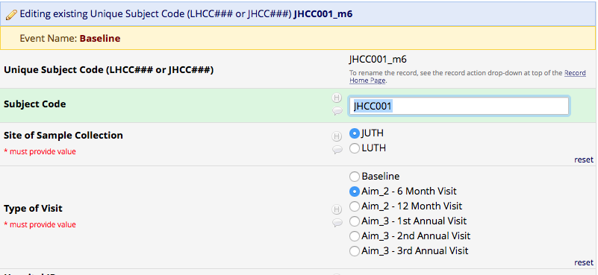

**Type of Visit -**

* **Aim_2 – 12 Month Visit** - Blood sample collected at 12 Month Follow-up – Aim2

**Unique subject Code**

* Can be JUTH- JHCC001_m12
* Can be LUTH- LHCC001_m12

**Subject Code**

* Will be JHCC001 for JUTH
* Will be LHCC001 for LUTH

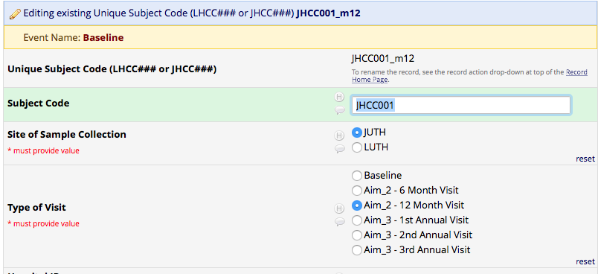

For the sake of explanation in this document, JHCC002/LHCC002 are considered subjects enrolled in Aim 3.

**Type of Visit -**

* **Aim_3 – 1st Annual Visit** - Blood sample collected at 1st Annual Follow-up – Aim 3

**Unique subject Code**

* Can be JUTH- JHCC002_y1
* Can be LUTH- LHCC002_y1

**Subject Code**

* Will be JHCC002 for JUTH
* Will be LHCC002 for LUTH

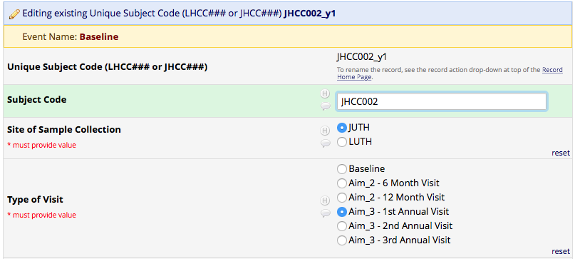

For the sake of explanation in this document, JHCC001/LHCC002 are considered subjects enrolled in Aim 3.

**Type of Visit -**

* **Aim_3 – 2nd Annual Visit** - Blood sample collected at 2nd Annual Follow-up – Aim3

**Unique subject Code**

* Can be JUTH- JHCC002_y2
* Can be LUTH- LHCC002_y2

**Subject Code**

* Will be JHCC002 for JUTH
* Will be LHCC002 for LUTH

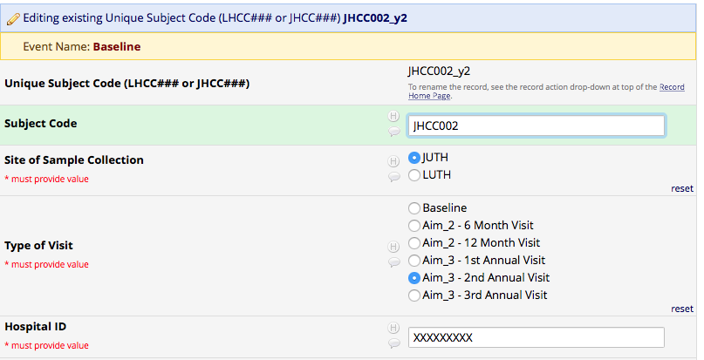

For the sake of explanation in this document, JHCC001/LHCC002 are considered subjects enrolled in Aim 3.

**Type of Visit -**

* **Aim_3 – 3rd Annual Visit** - Blood sample collected at 3rd Annual Follow-up – Aim3

**Unique subject Code**

* Can be JUTH- JHCC002_y3
* Can be LUTH- LHCC002_y3

**Subject Code**

* Will be JHCC002 for JUTH
* Will be LHCC002 for LUTH

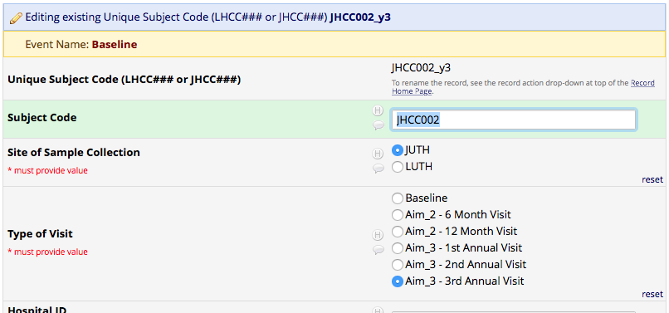

The records would like this:

