Please follow the following steps in order.

* Download the raw data file and Send the csv file through secure REDCAP survey.
* Backup the data at your end.
* Then start the process of uploading the updated Data dictionary for Project 1.

GO to Project Setup –

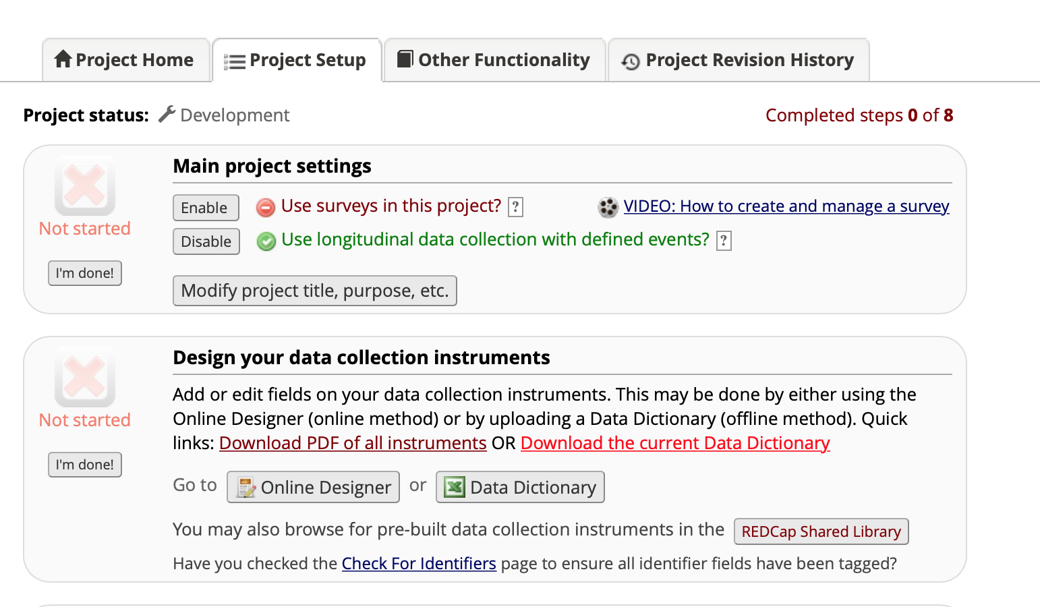

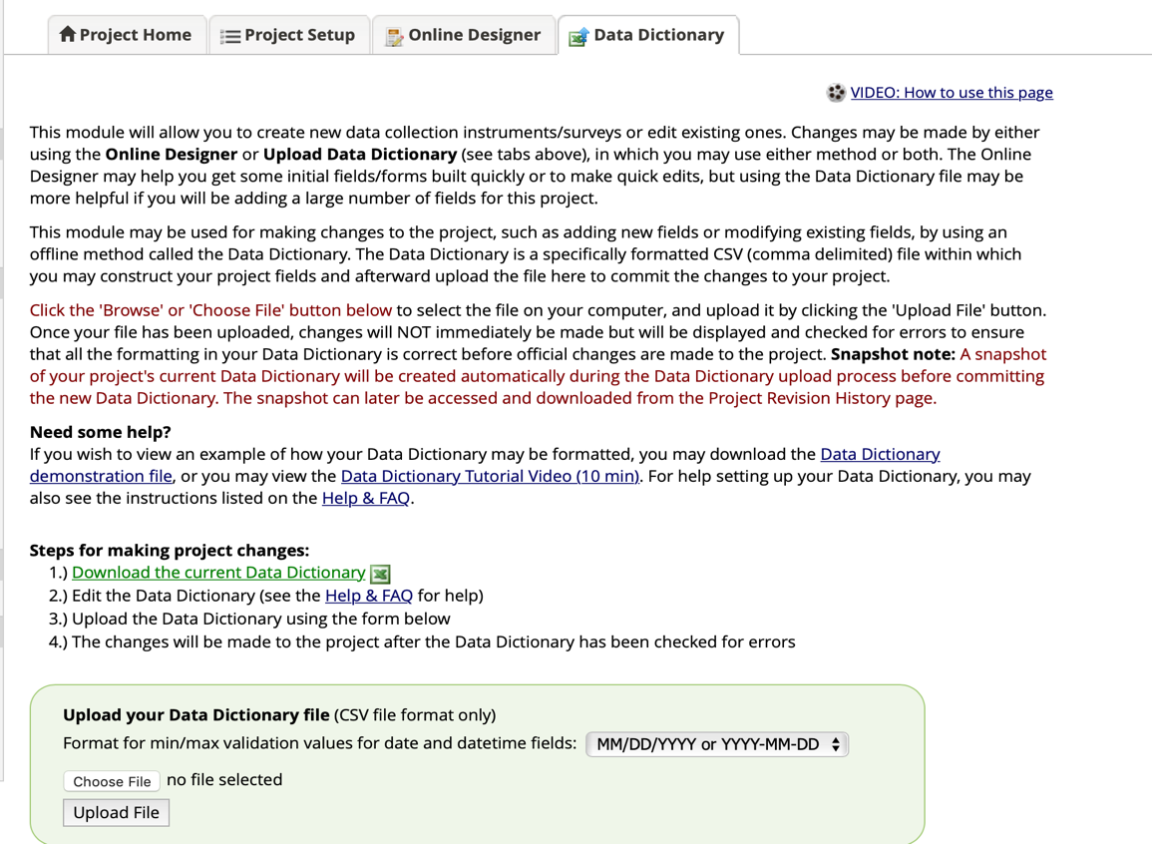

You upload the updated data dictionary by downloading from Github.

Next step is to go Project Setup – and Go to “Designate instruments for my Events”

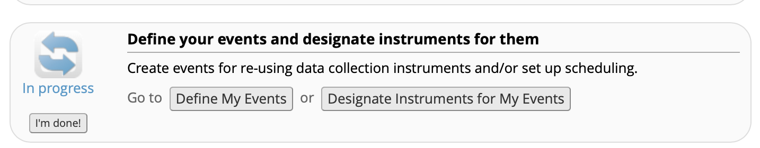

You will see the screen below. Select “Begin Editing”

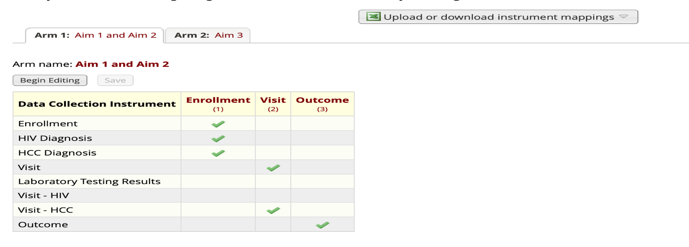

And you select box that is marked below for Arm 1: Aim 1 and Aim 2. 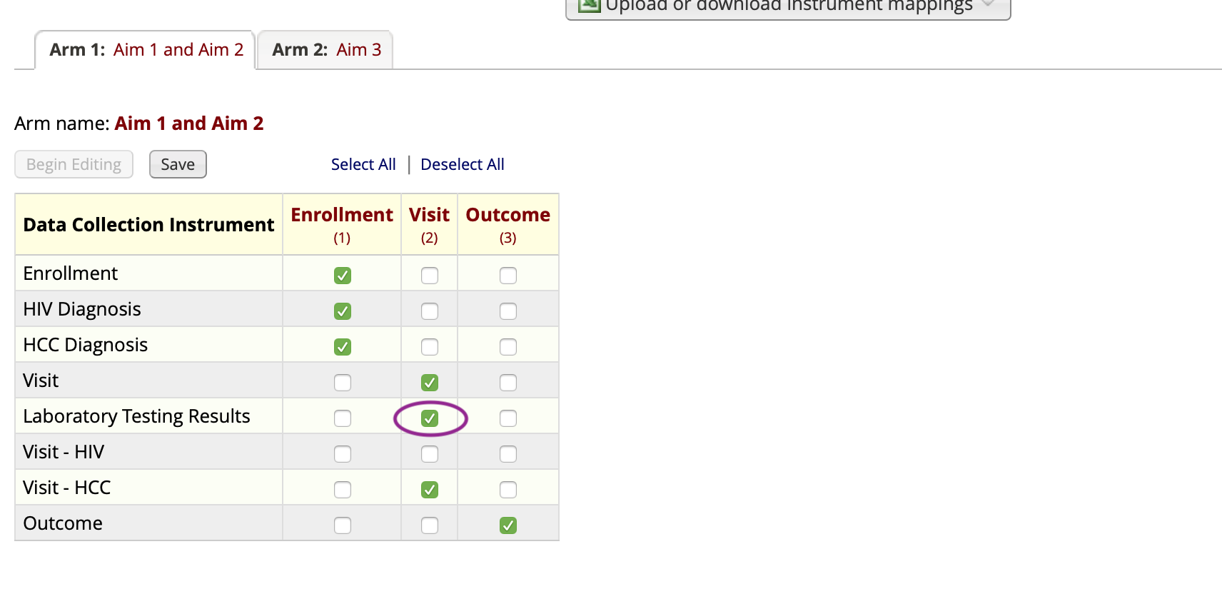

And you select box that is marked below for Arm 2: Aim 3.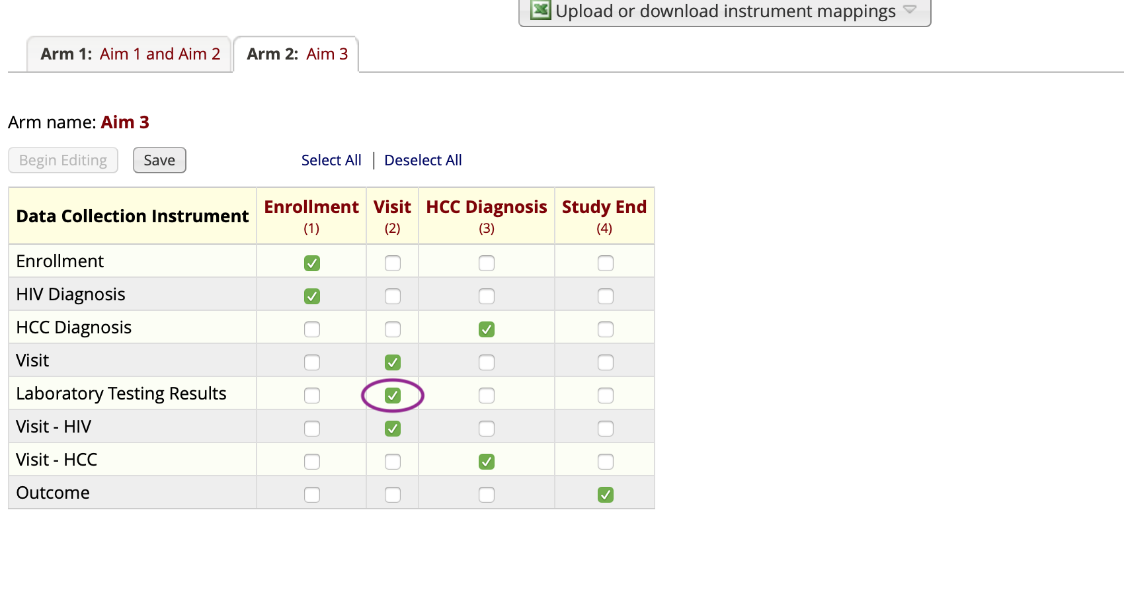

Next, click “Record Status Dashboard” under “Data collection” tab. You should see the records as following screenshot – empty bubbles as marked below.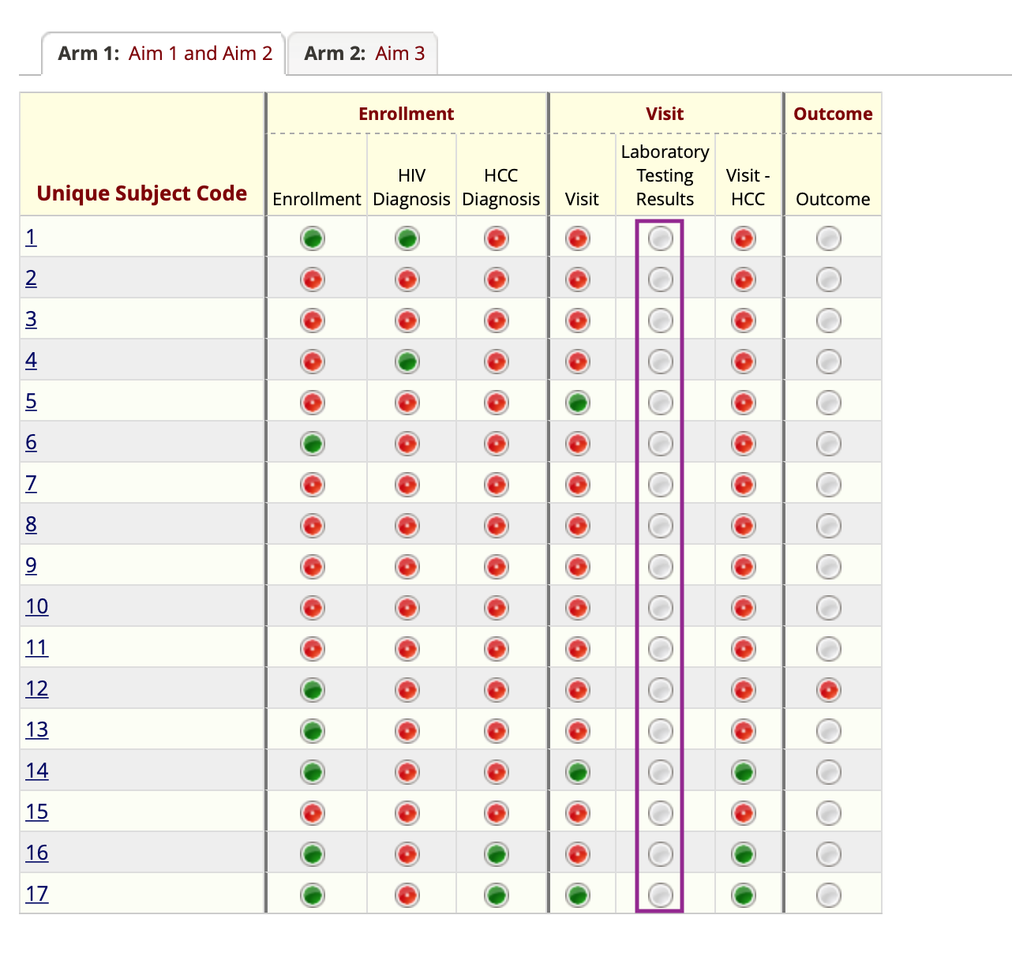 **Now go to each record and update the data for the fields in Laboratory Testing Results form**