Disburser is a web-based tool for submitting and managing disbursement requests for specimen and/or data from biorepositories across Robert H. Lurie Comprehensive Cancer Center of Northwestern University.

The application allows a user to:

* View in a centralized location available specimen and data biorepositories.
* See an overview of the contents of each specimen and data biorepository.
* Submit disbursement requests to specimen and data biorepositories.
* Track the approval and fulfillment of disbursement requests.
* Log in with a Northwestern NetID or setup an account with an email address.
* Vote and comment on disbursement requests as a biorepository committee member.

This user guide is meant for Disburser biorepository committee members. Other user guides cover using Disburser as a submitter/investigator and a biorepository administrator/coordinator.

**Access**

Permission to use Disburser is available to all owners of a Northwestern NetID and password. Alternatively, non-Northwestern individuals can setup an account with an email address and a password of their choice.

Disburser is located at the following URL:

<https://disburser.cancer.northwestern.edu/>

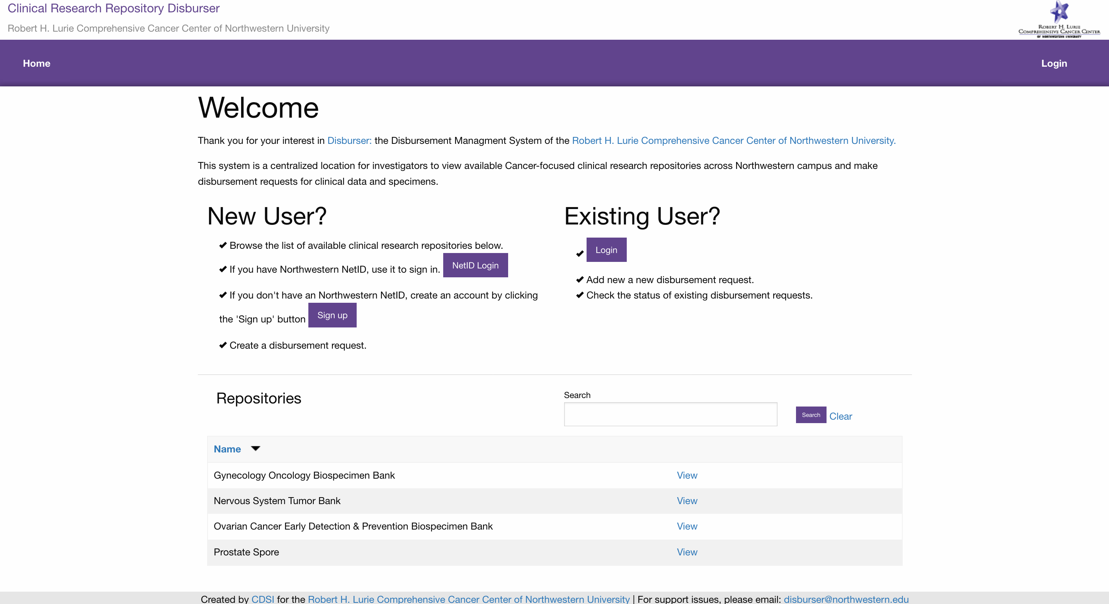

**Login with a Northwestern NetID**

Click the ‘Login’ link in the upper right corner. You will be asked if you have a Northwestern NetID.

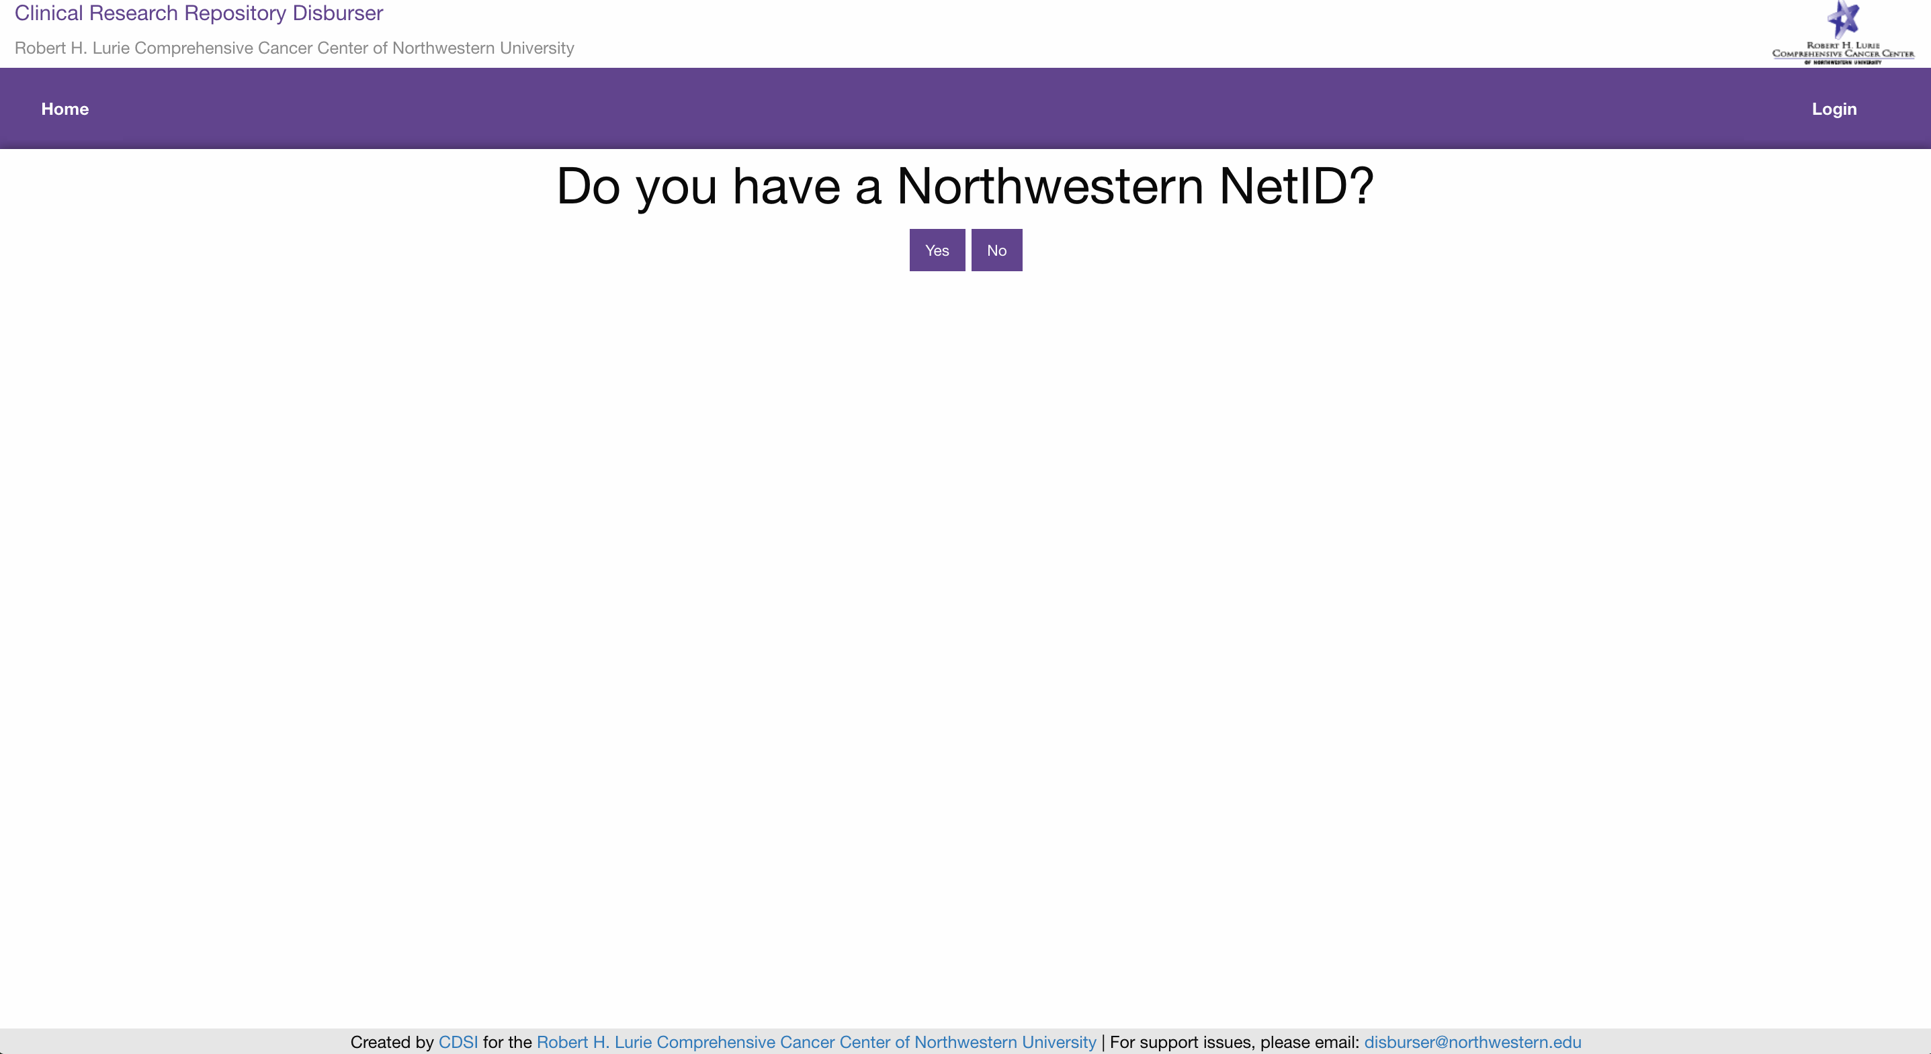

If you have a Northwestern NetID, click the ‘Yes’ button. You will be asked to login with your NetID and password.

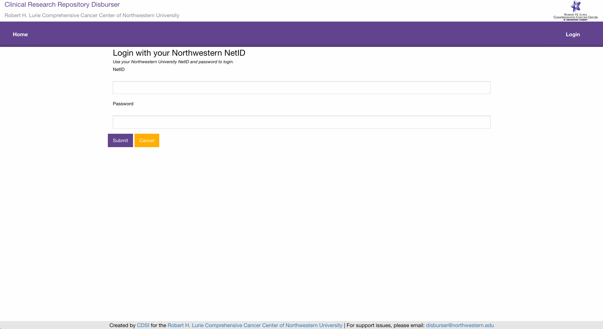

**Login with an Email Address**

If you do not have a Northwestern NetID, you can setup a Disburser account with an email address and a password of your choice. Click the ‘Login’ link in the upper right corner. You will be asked if you have a Northwestern NetID. If you do not have a Northwestern NetID, click the ‘No’ button. You will be asked to login with your Email and a password of your choice.

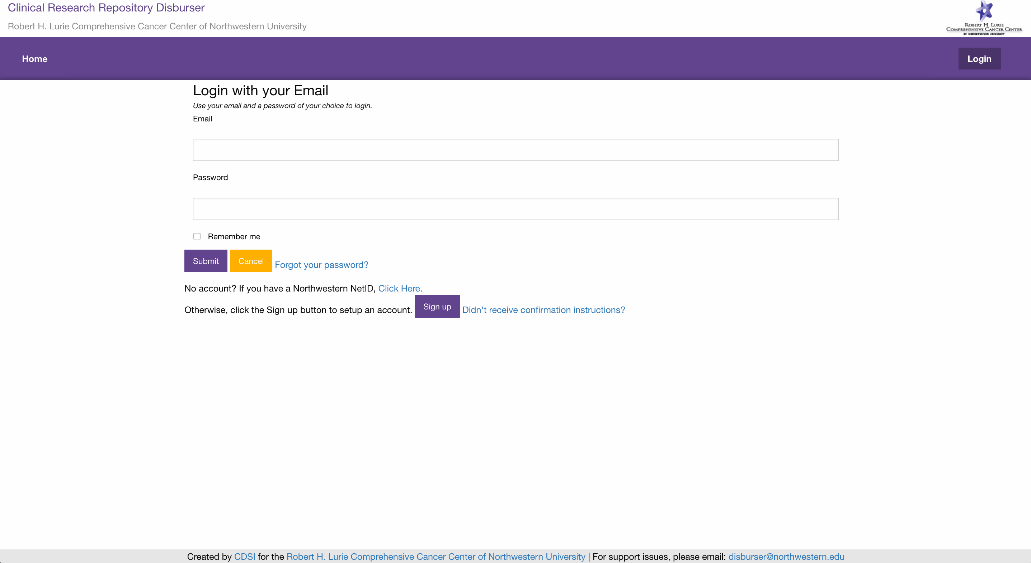

If you do not have a Disburser account setup, click the ‘Sign up’ button. You will be prompted to enter a ‘First Name’, ‘Last Name’, ‘Email’ and ‘Password’.

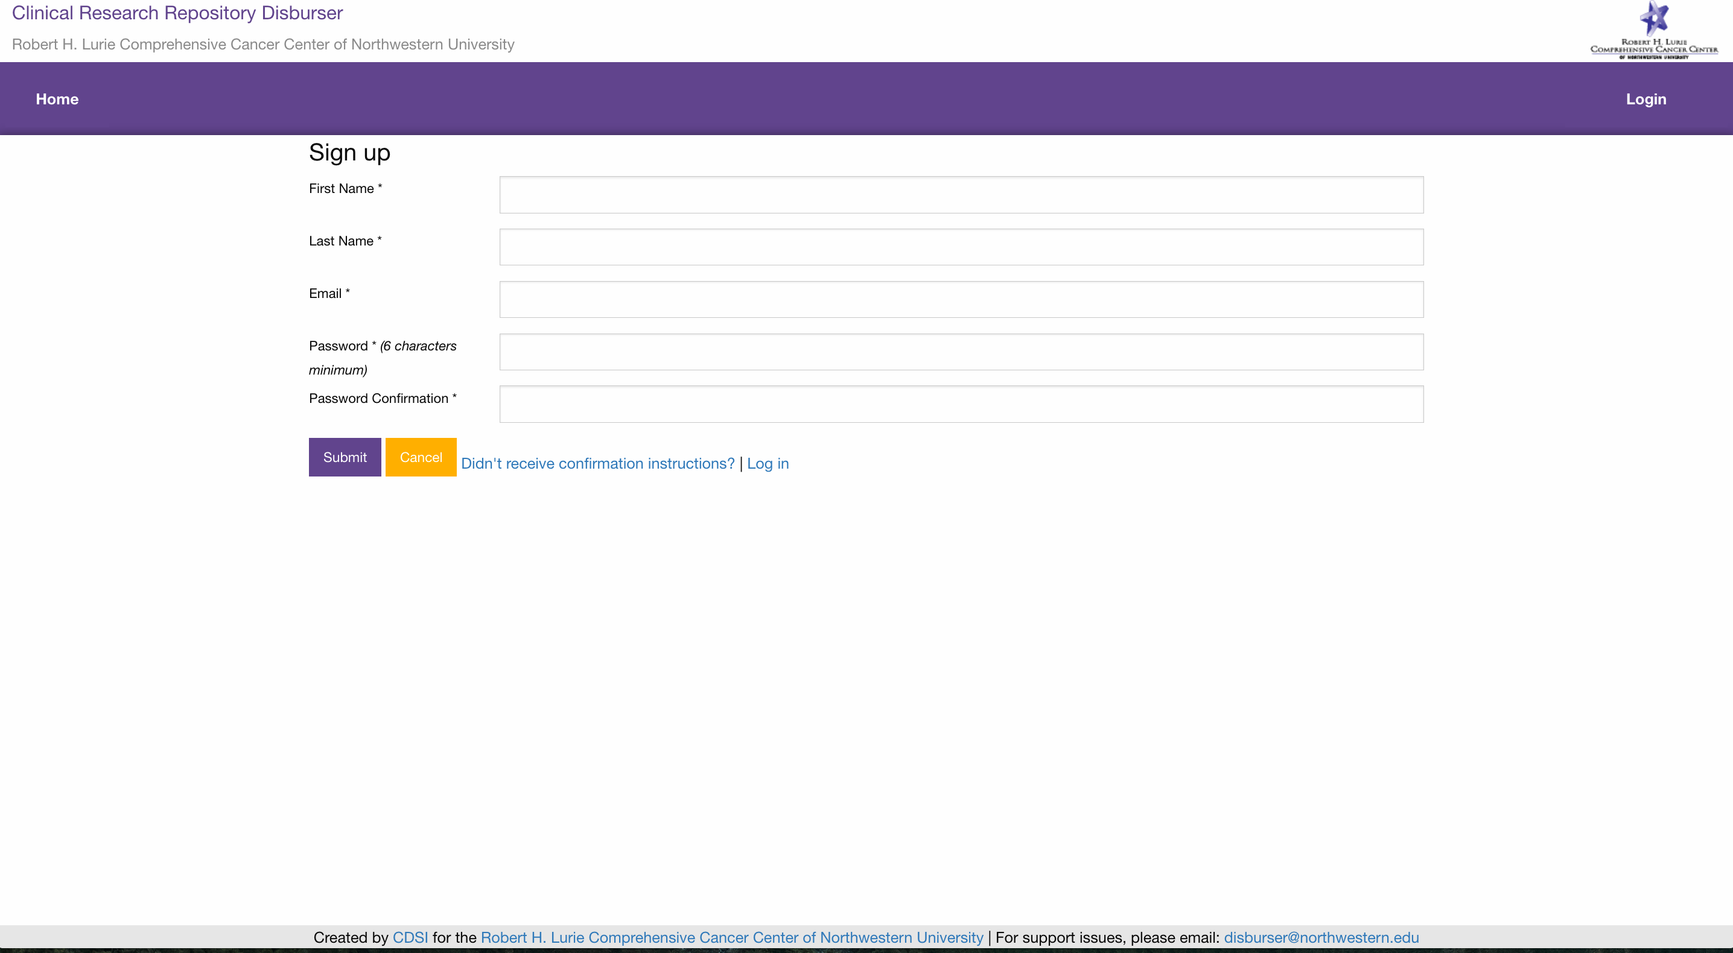

An email message with a confirmation link will be sent to your email address. Follow the link to activate your account.

**Voting on a Disbursement Request**

Upon a disbursement request being set to a ‘Status’ of ‘committee review’, all committee members will be notified via email to vote and comment on the disbursement request. Upon login, all committee members will have a menu item ‘Committee’. Clicking this menu item lists all the disbursement requests the committee member needs to vote on or has voted on previously.

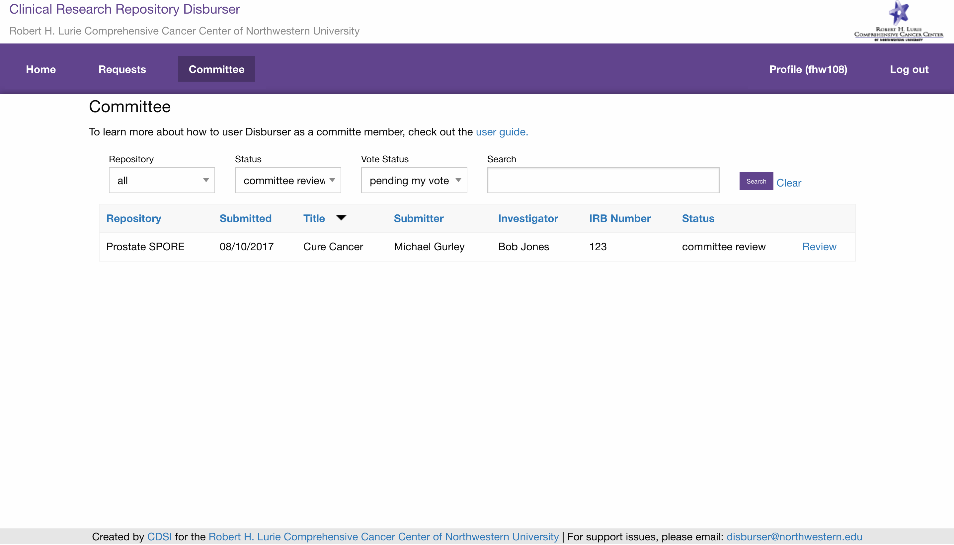

A committee member may filter the list of disbursement requests by ‘Repository’, ‘Status’ and ‘Vote Status’. By default, the page will list disbursement requests with a ‘Status’ of ‘committee review’ and a ‘Vote Status’ of ‘pending my vote’. Click the ‘Review’ link on the disbursement request you are interested in.

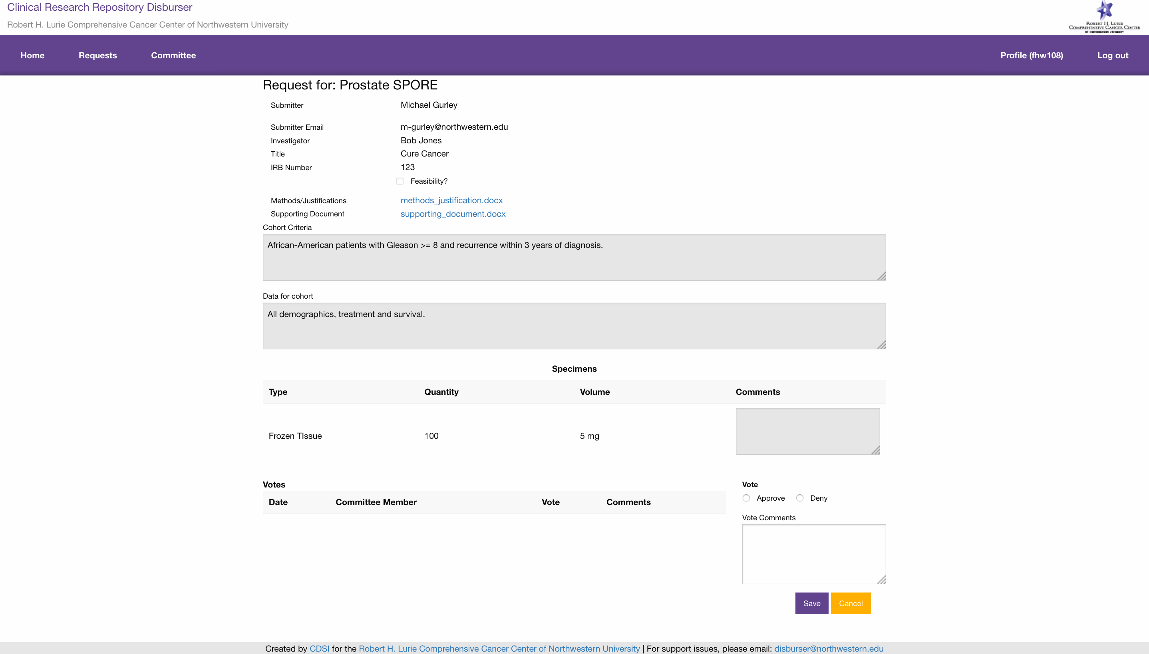

You will be able to see how other committee members have voted on the request and their comments. You can either ‘Approve’ or ‘Deny’ and a disbursement request and provide comments.

**Support Issues**

Please report any problems you encounter to:

[disburser@northwestern.edu](mailto:disburser@northwestern.edu)