Disburser is a web-based tool for submitting and managing disbursement requests for specimen and/or data from biorepositories across Robert H. Lurie Comprehensive Cancer Center of Northwestern University. The application allows a user to:

* View in a centralized location available specimen and data biorepositories.
* See an overview of the contents of each specimen and data biorepository.
* Submit disbursement requests to specimen and data biorepositories.
* Track the approval and fulfillment of disbursement requests.
* Log in with a Northwestern NetID or setup an account with an email address.

This user guide is meant for investigators or submitters of disbursement requests to Disburser. Other user guides cover using Disburser as a biorepository member committee member, biorepository coordinator or biorepository administrator.

**Access**

Permission to use Disburser is available to all owners of a Northwestern NetID and password. Alternatively, non-Northwestern individuals can setup an account with an email address and a password of their choice. Disburser is located at the following URL:

<https://disburser.cancer.northwestern.edu/>

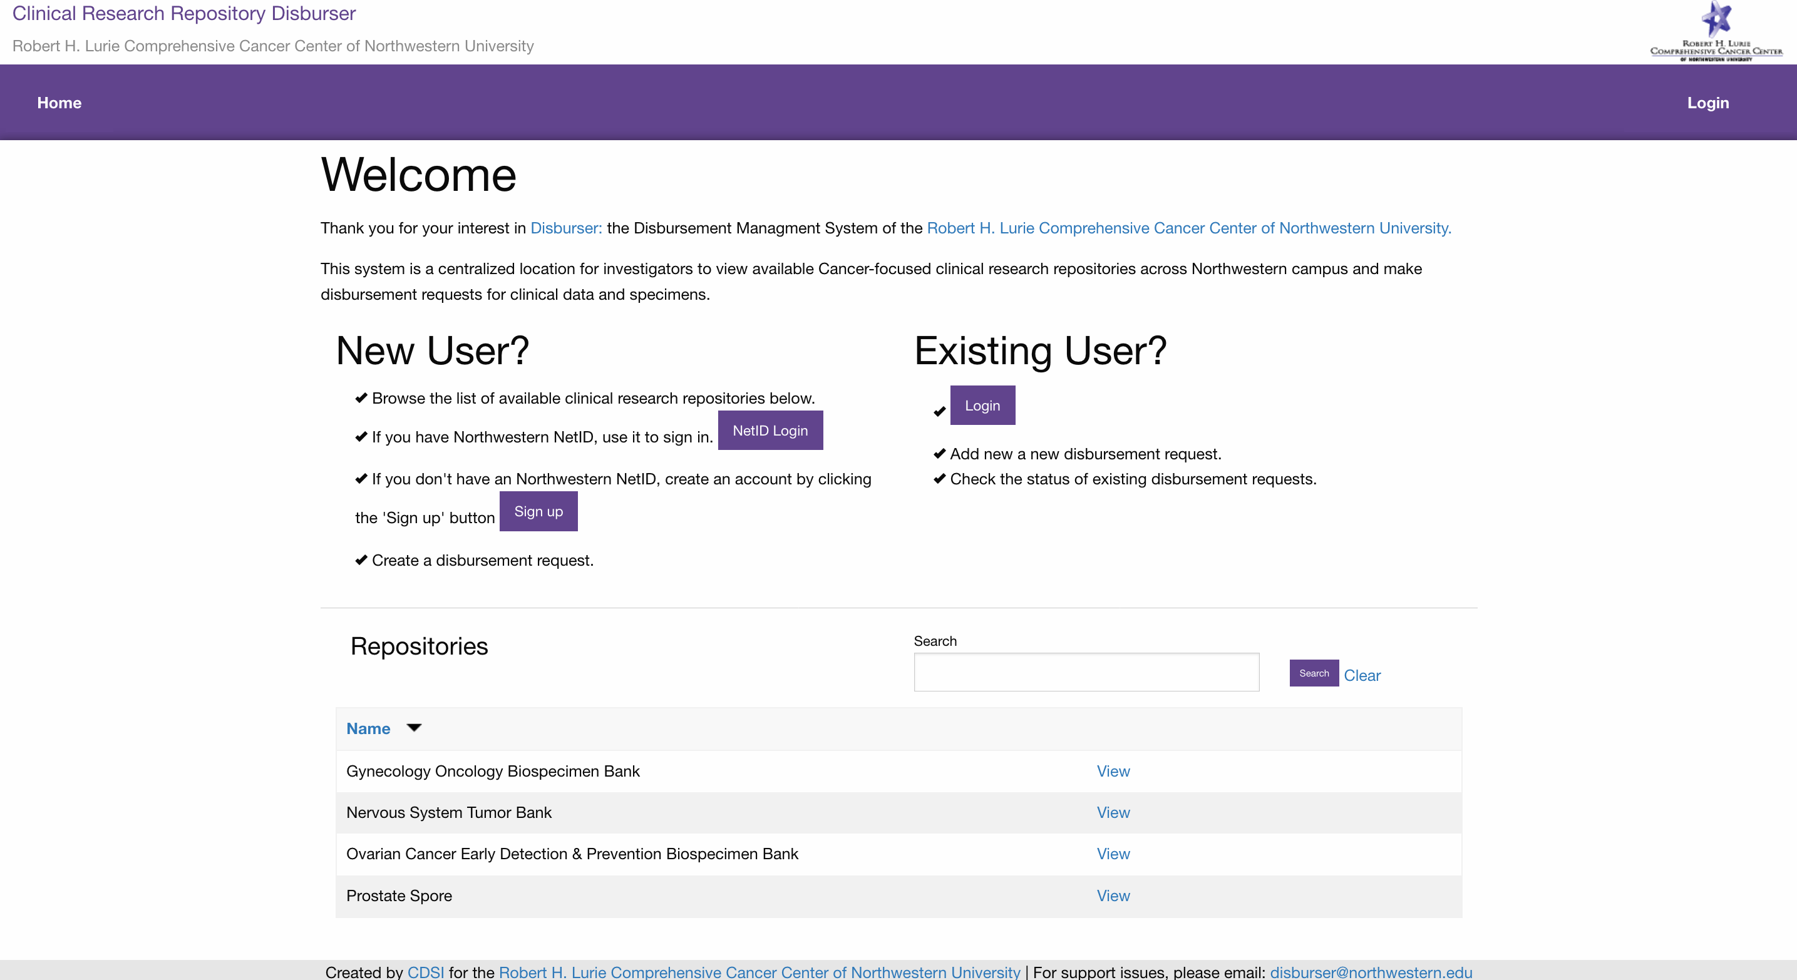

**Login with a Northwestern NetID**

Click the ‘Login’ link in the upper right corner. You will be asked if you have a Northwestern NetID.

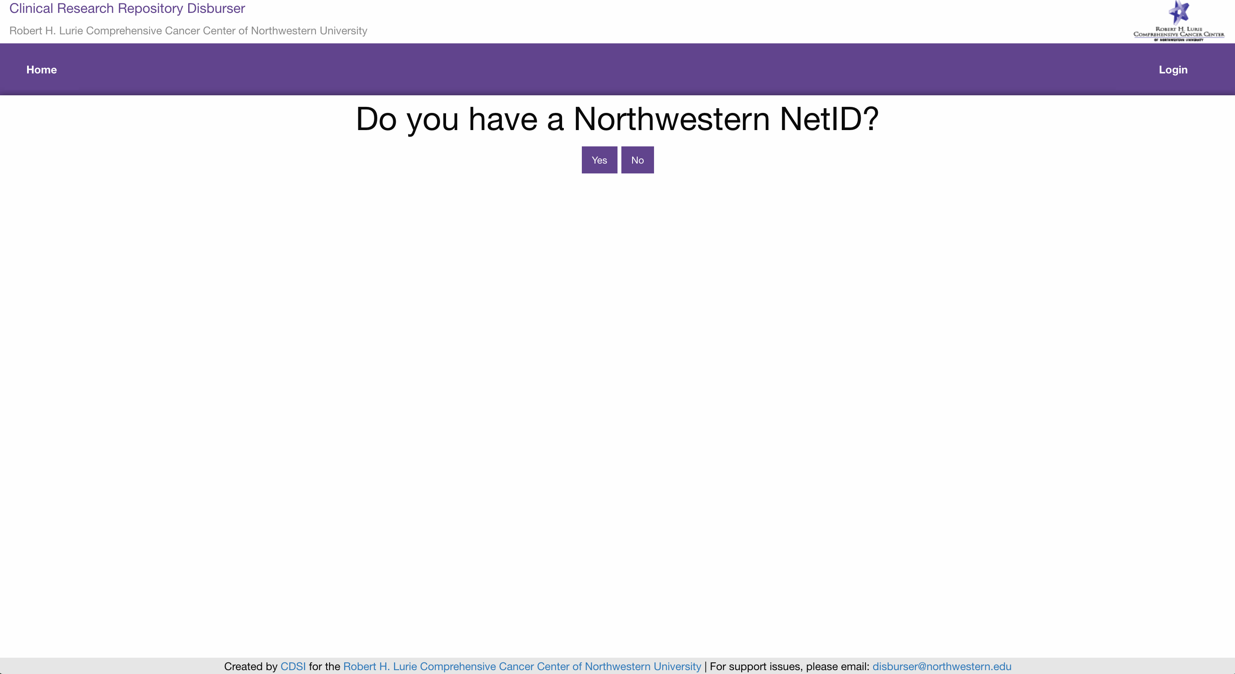

If you have a Northwestern NetID, click the ‘Yes’ button. You will be asked to login with your NetID and password.

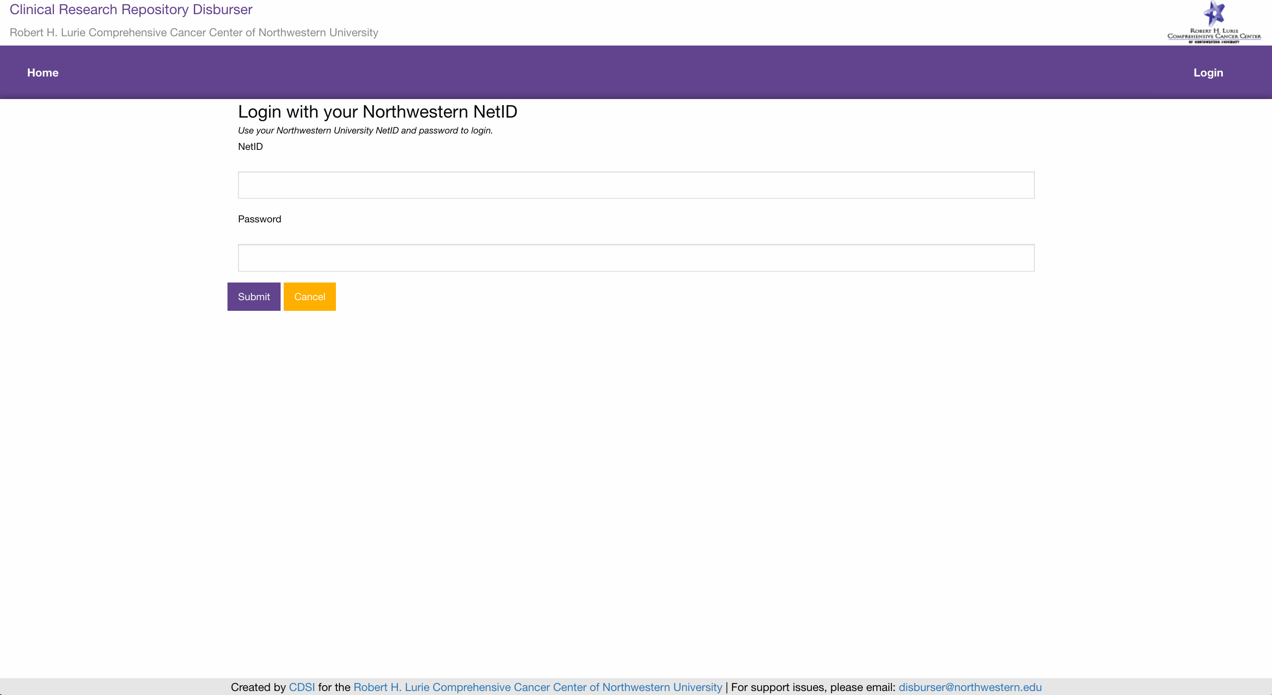

**Login with an Email Address**

If you do not have a Northwestern NetID, you can setup a Disburser account with an email address and a password of your choice. Click the ‘Login’ link in the upper right corner. You will be asked if you have a Northwestern NetID. If you do not have a Northwestern NetID, click the ‘No’ button. You will be asked to login with your email and a password of your choice.

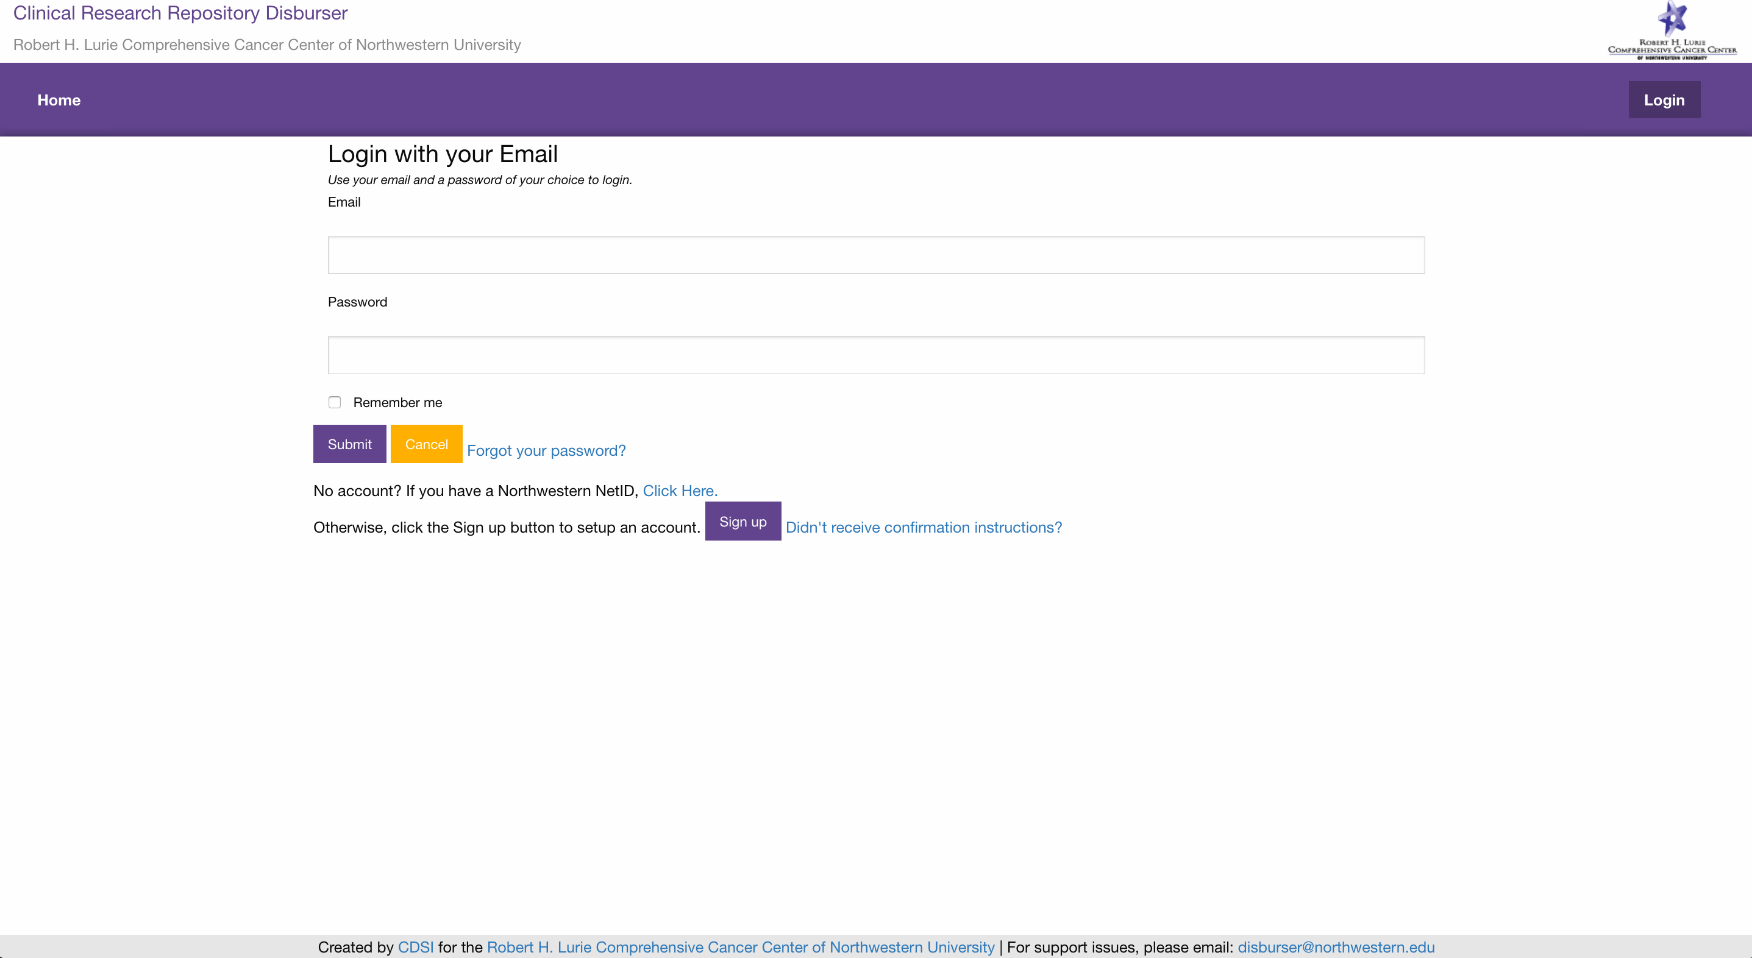

If you do not have a Disburser account setup, click the ‘Sign up’ button. You will be prompted to enter a ‘First Name’, ‘Last Name’, ‘Email’ and ‘Password’.

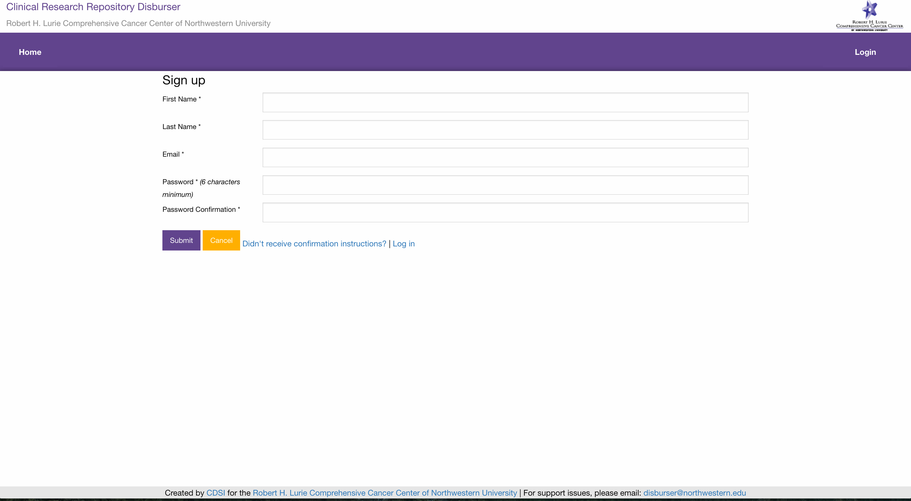

An email message with a confirmation link will be sent to your email address. Follow the link to activate your account.

**Submitting a Disbursement Request**

Before logging into Disburser, you will see on the home page a list of all the available biorepositories.



Click ‘View’ on the biorepository that interests you. This will bring you to the home page of the biorepository.

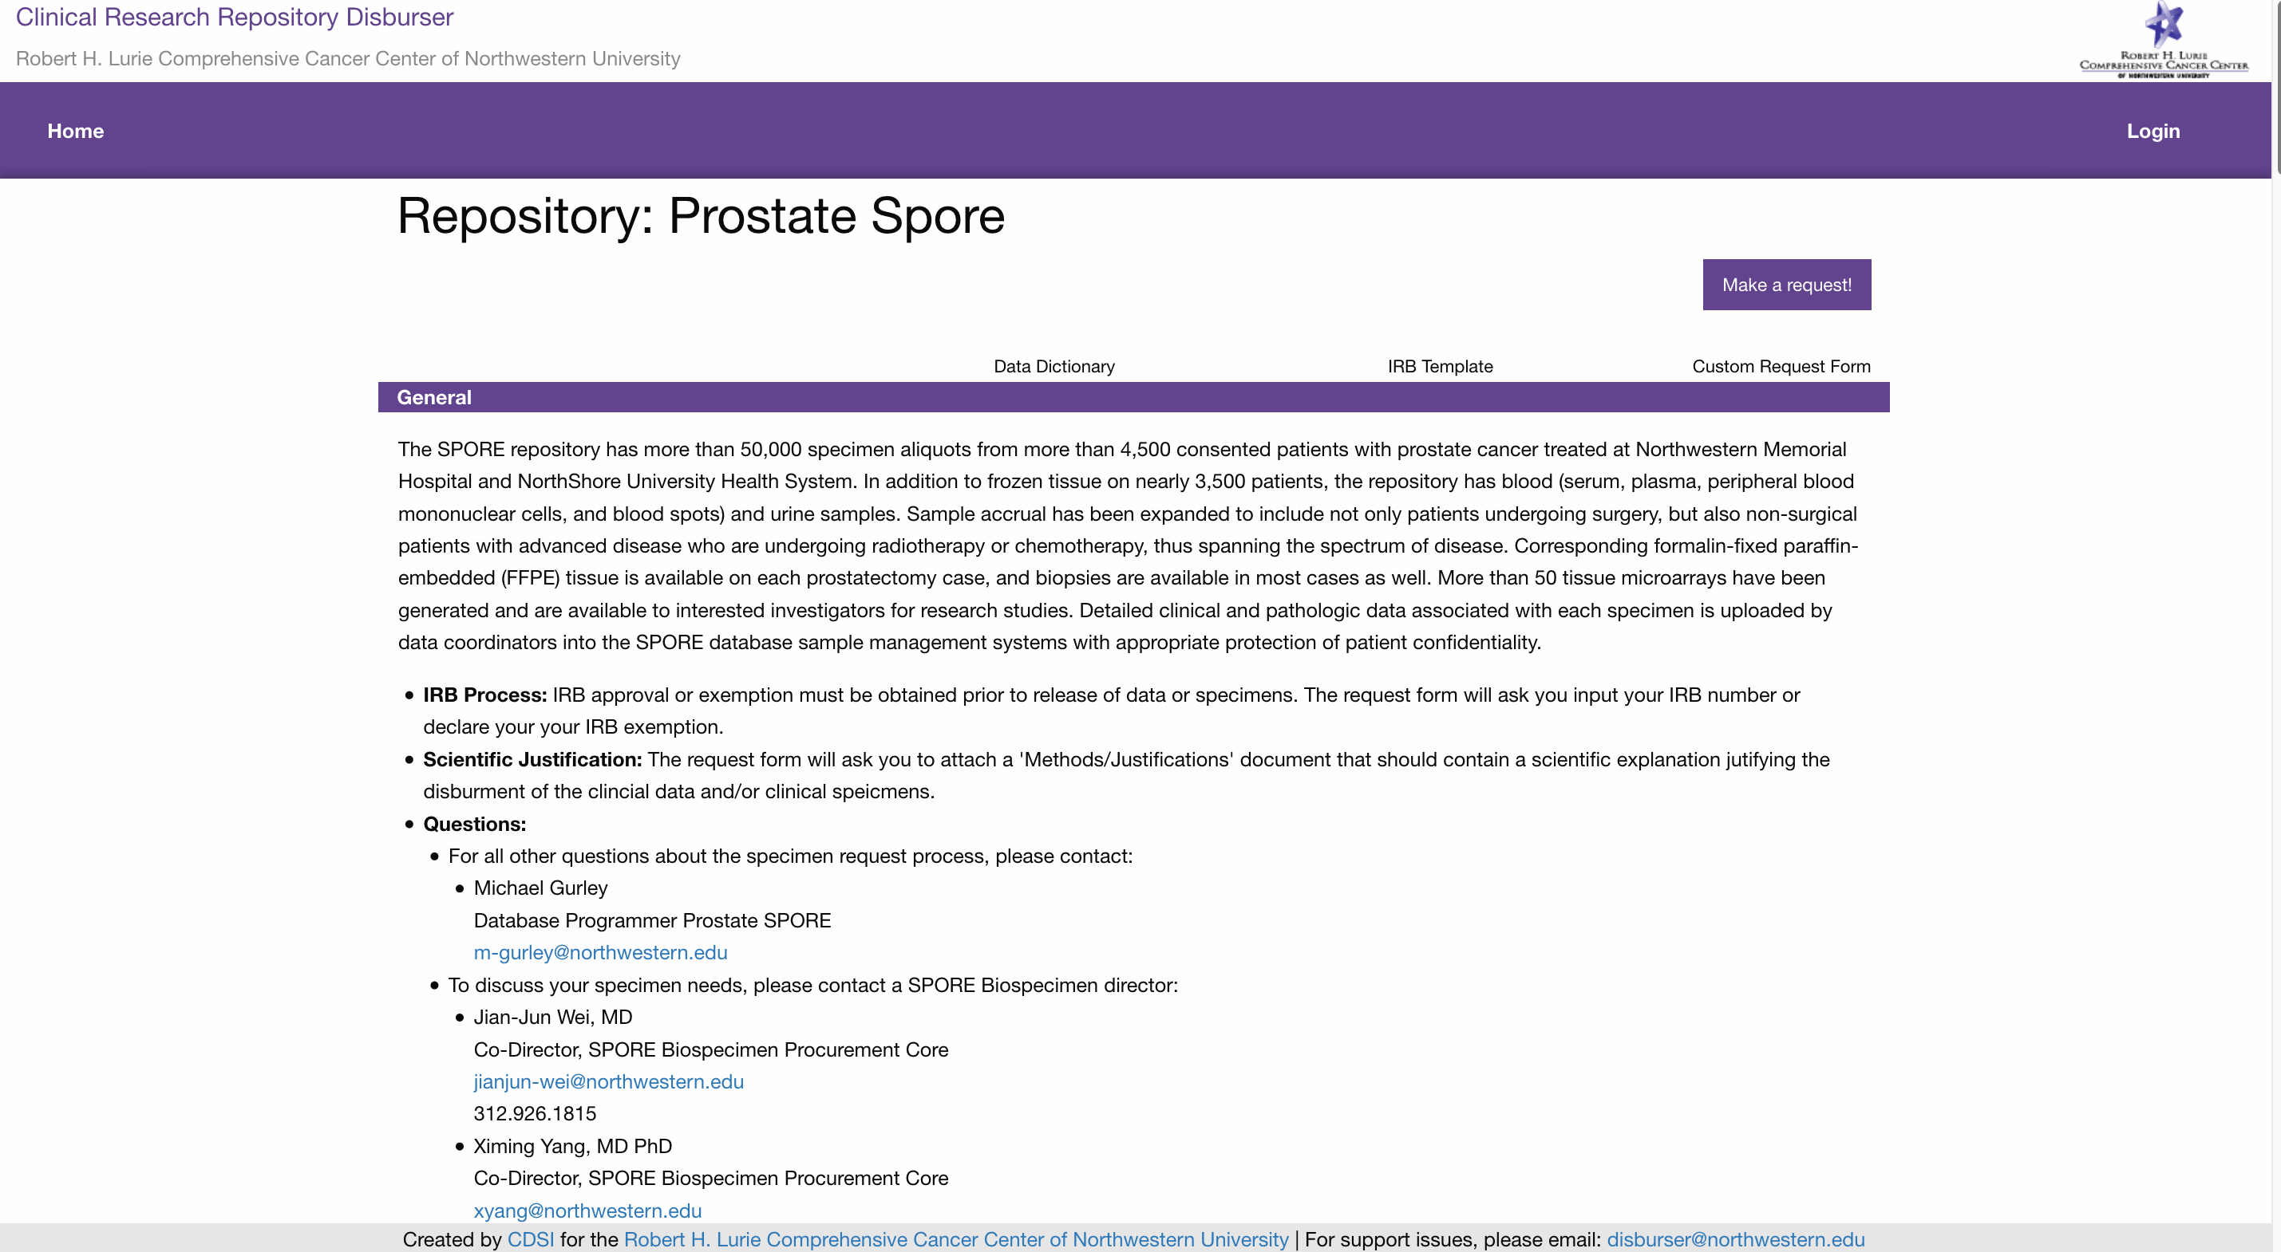

The biorepository homepage provides an overview of the operation and contents of the biorepository. If you are interested in submitting a disbursement, click the ‘Make a request!’ button. This will bring you to the ‘New Request’ page for the chosen biorepository.

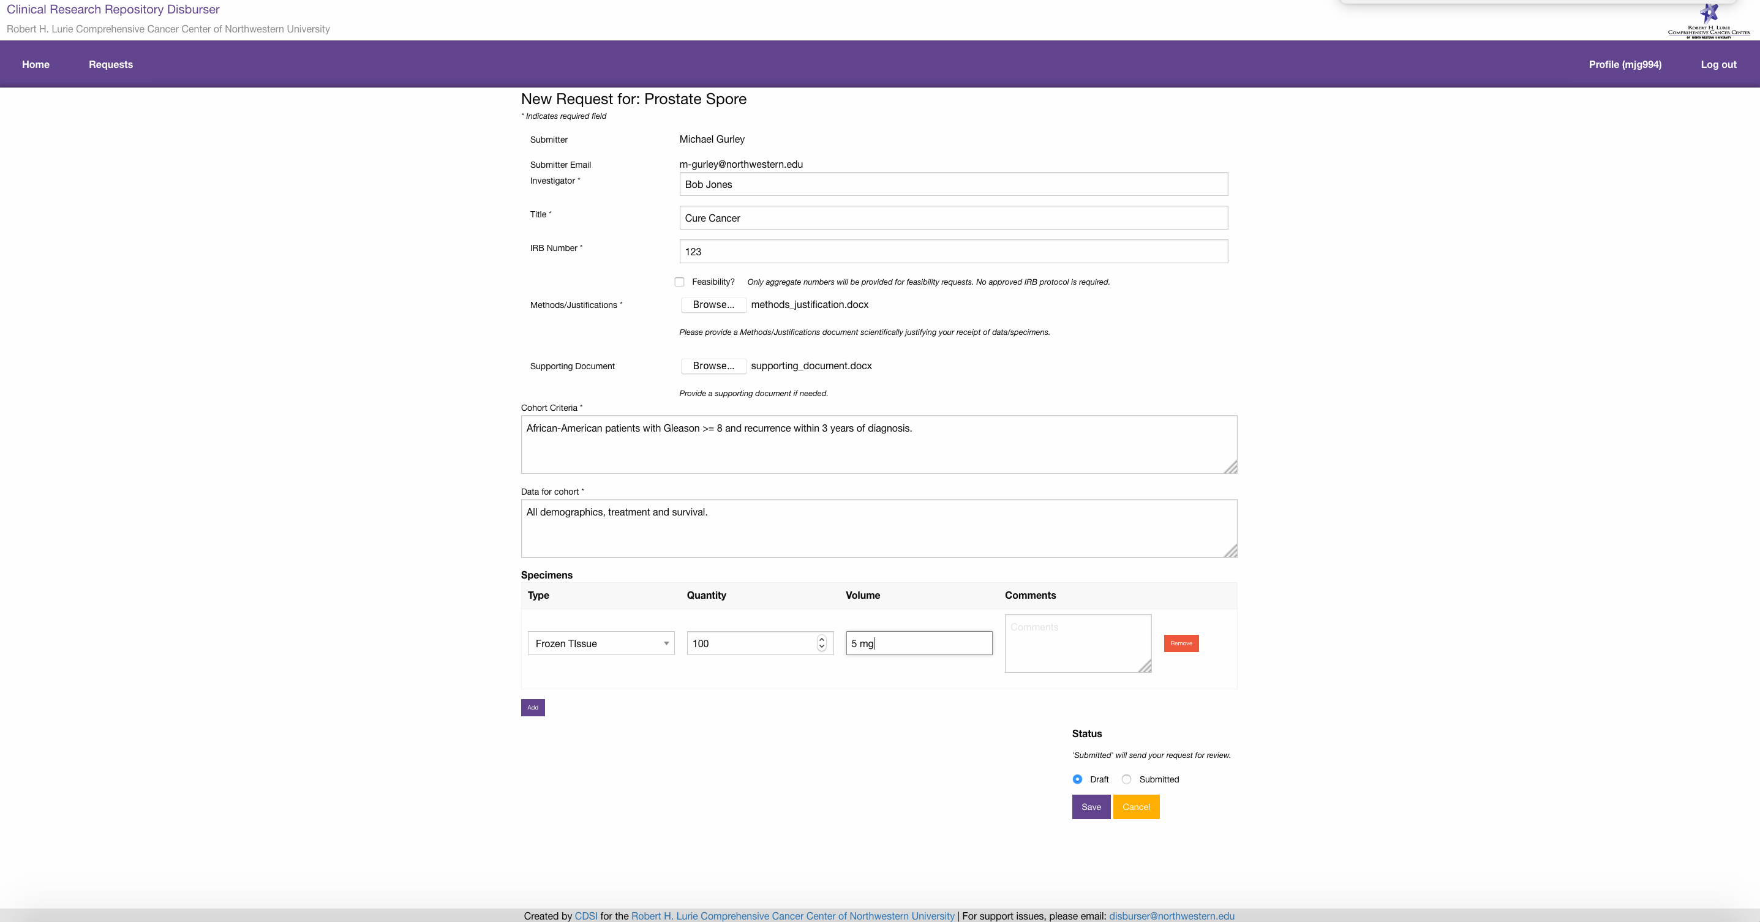

The ‘New Request’ page asks you to fill in the following fields:

* ‘Investigator’: the principal investigator of the disbursement request.
* ‘Title’: the title of the research project for the disbursement request.
* ‘IRB Number’: the IRB number of the research project for the disbursement request. Not required if ‘Feasibility’ is checked.
* ‘Feasibility’: Boolean flag marking whether a disbursement request is for feasibility. Only aggregate numbers will be delivered for feasibility requests. No approved IRB research project is required.
* ‘Methods/Justifications’: Upload a document that provides a scientific justification for the receipt of data/specimens.
* ‘Supporting Document’: Optionally, upload a document that provides any necessary supporting documentation.
* ‘Cohort Criteria’: Specify the selection criteria for the cohort of patients.
* ‘Data for cohort’: Specify additional data points to be disbursed for the cohort of patients.
* ‘Specimens’: Specification of the ‘Type’, ‘Quantity’, ‘Volume’ and ‘Comments’ of the requested specimens.
* ‘Status’: A disbursement request can be saved with a status of ‘Draft’ or ‘Submitted’.
  + Saving a disbursement request with a status of ‘Draft’ will not submit the request for review to the biorepository. A ‘Draft’ disbursement request can be saved with a status of ‘Submitted’ later.
  + Saving a disbursement request with a status of ‘Submitted’ will notify the biorepository administrators to begin processing the disbursement request.

Upon submission of a disbursement request with a status of ‘Submitted’, you will receive an email confirmation.

**Tracking Disbursement Requests.**

You will be able to view the progress of your disbursement requests, by clicking the ‘Requests’ menu item.



The submitter of a disbursement request will be notified via email as a disbursement requests changes statuses. A disbursement request has 3 different statuses.

* ‘Status’: The overall status of the disbursement request tracks its progress from submission to approval or denial.
  + ‘Draft’: An initial state of the disbursement request. ‘Draft’ disbursement requests will not be sent to the attention of the biorepository administrators.
  + ‘Submitted’: A ‘Submitted’ disbursement request will be sent to the attention of the biorepository administrators.
  + ‘Committee Review’: Notifies the biorepository committee members to vote on the disbursement request. Committee votes will not be visible to the disbursement request submitter.
  + ‘Approved’: An ‘Approved’ disbursement request will send an email to the submitter that the disbursement request has been approved. The email will include instructions on how to work with biorepository coordinators to fulfill the disbursement request.
  + ‘Denied’: A ‘Denied’ disbursement request will send an email to the submitter that the disbursement request has been denied by the biorepository committee.
  + ‘Canceled’: A ‘Canceled’ disbursement will send an email to the submitter that a disbursement request has been canceled. A submitter may cancel their own request as long as the disbursement request has a status of ‘Draft’ or ‘Submitted’. All other statuses can only be canceled by the biorepository administrator.
* ‘Data Status’: The ‘Data Status’ tracks the progress of the fulfillment of the data component of a disbursement request. At times, the fulfillment of a disbursement request’s data will be handled separately from its specimen component.
  + ‘Not Started’: The initial state of a disbursement request’s data status. ‘Not Started’ means a biorepository coordinator has not begun the process of fulfilling the data for the disbursement request.
  + ‘Data Checked: A ‘Data Checked’ data status means a biorepository coordinator has queried the requisite biorepository and the cohort criteria *can* be met. An email notification will be sent to the submitter that a disbursement request has a data status of ‘Data Checked’
  + ‘Insufficient Data’: An ‘Insufficient Data’ data status means the biorepository coordinator has queried the requisite biorepository and the cohort criteria *cannot* be met. An email notification will be sent to the submitter that a disbursement request has a data status of ‘Insufficient Data’.
  + ‘Query Fulfilled’: A ‘Query Fulfilled’ data status means the biorepository coordinator has prepared and delivered the disbursement request data to the submitter. An email notification will be sent to the submitter that a disbursement request has a data status of ‘Query Fulfilled’.
* ‘Specimen Status’: The ‘Specimen Status’ tracks the progress of the fulfillment of the specimen component of a disbursement request. At times, the fulfillment of a disbursement request’s specimens will be handled separately from its data component.
  + ‘Not Started’: The initial state of a disbursement request’s specimen status. ‘Not Started’ means a biorepository coordinator has not begun the process of fulfilling the specimens for the disbursement request.
  + ‘Inventory Checked: An ‘Inventory Checked’ data status means a biorepository coordinator has checked the requisite biorepository specimen inventory and the disbursement request for specimens can be met. An email notification will be sent to the submitter that a disbursement request has a specimen status of ‘Inventory Checked’
  + ‘Insufficient Specimens’: An ‘Insufficient Specimens’ specimen status means a biorepository coordinator has checked the requisite biorepository specimen inventory and the disbursement request for specimens *cannot* be met. An email notification will be sent to the submitter that a disbursement request has a specimen status of ‘Insufficient Specimens’.
  + ‘Inventory Fulfilled’: An ‘Inventory Fulfilled’ specimen status means a biorepository coordinator has prepared and delivered the disbursement request specimens to the submitter. An email notification will be sent to the submitter that a disbursement request has a specimen status of ‘Inventory Fulfilled’.

A submitter may click on the ‘Edit’ link to view the details of a disbursement request. The status history, data status history and specimen status history are available for inspection. Within the edit screen of a disbursement request, a user may cancel a request by clicking the ‘Cancel’ button. A user may also update the details of a disbursement request. A disbursement request may be updated after it has been submitted. However, this should only be done in consultation with the biorepository administrator or biorepository coordinator.

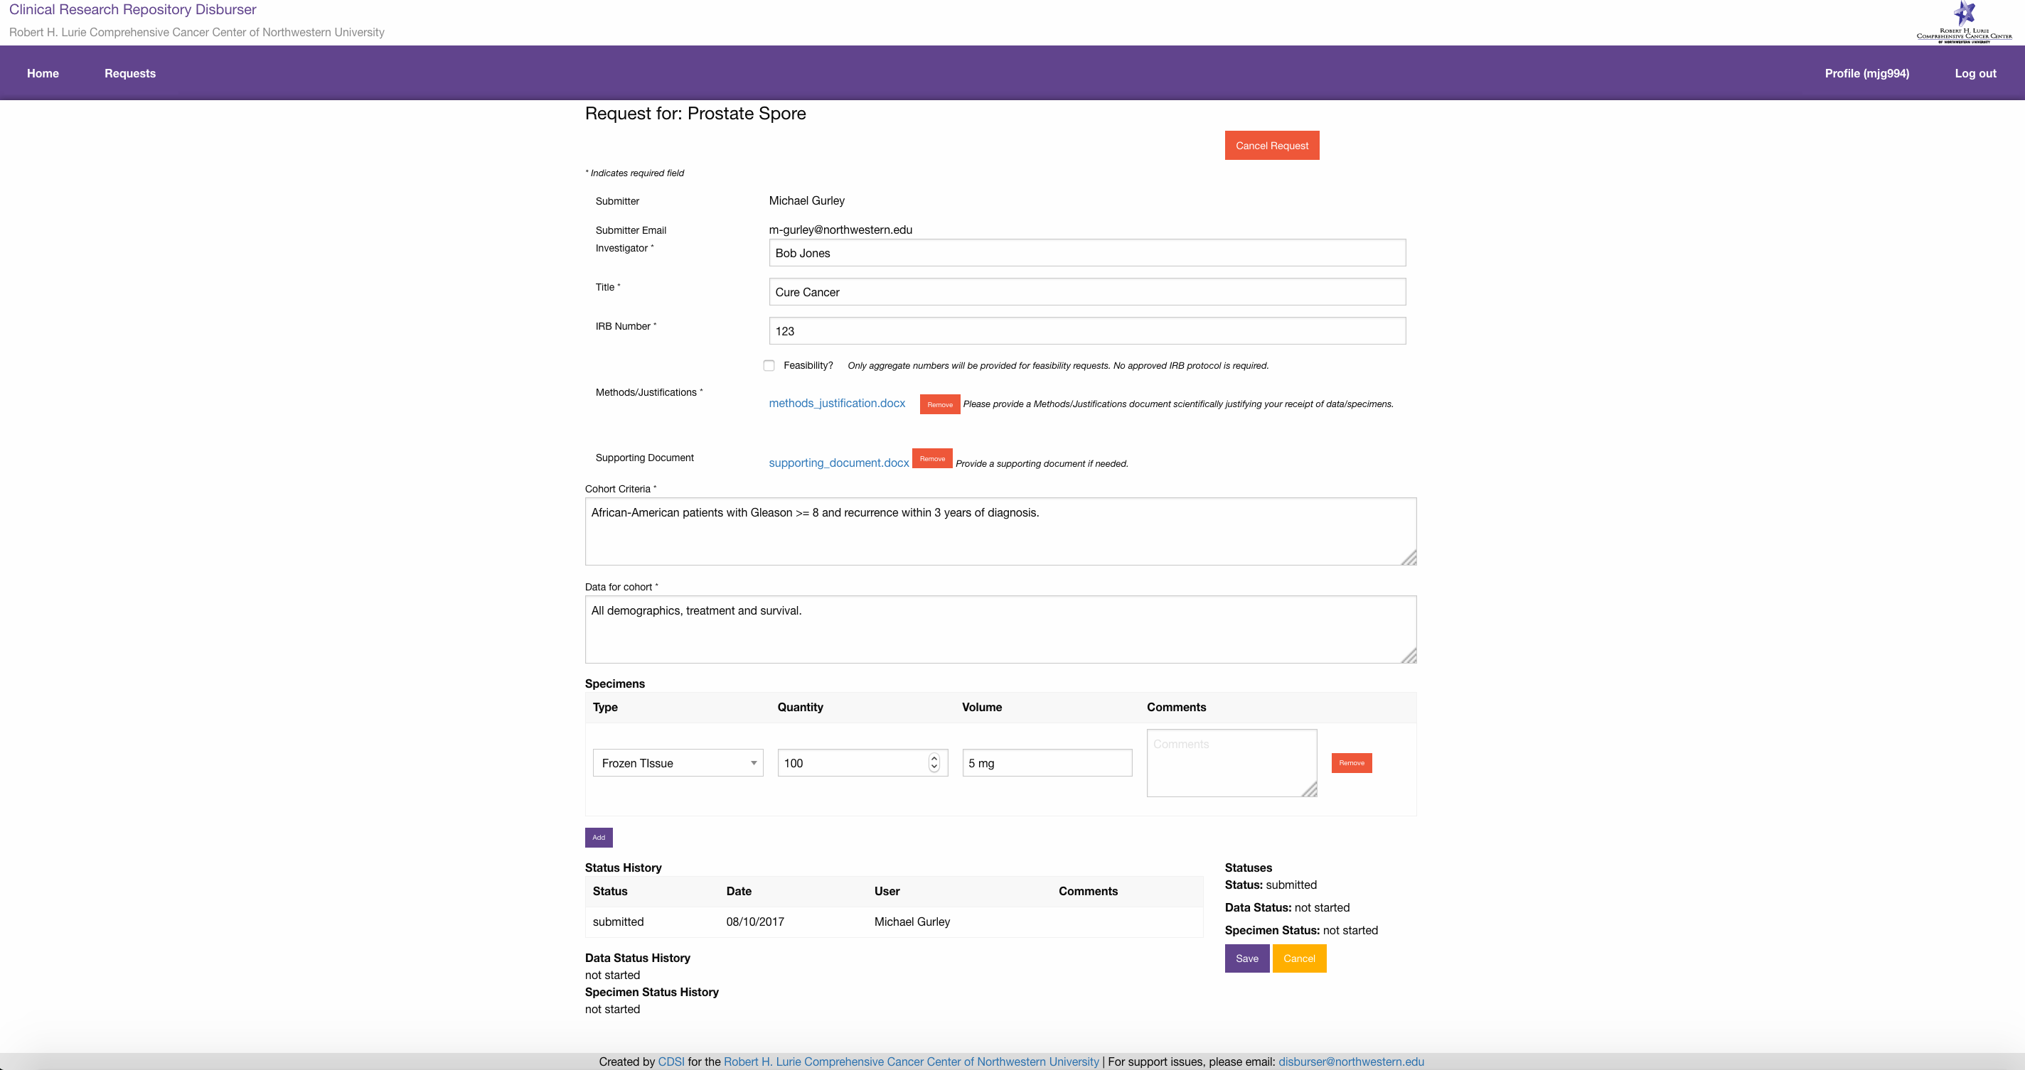

**Support Issues**

Please report any problems you encounter to:

[disburser@northwestern.edu](mailto:disburser@northwestern.edu).