Allowed the login session to timeout while logged into C3PR through SSO. When the user resumes activity in the screen, this is the error message received

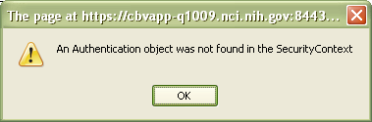

Error message does not clearly indicate that the users session has timed out.

