Here is the investigator details for the study that I created in C3PR that I’m trying to send:
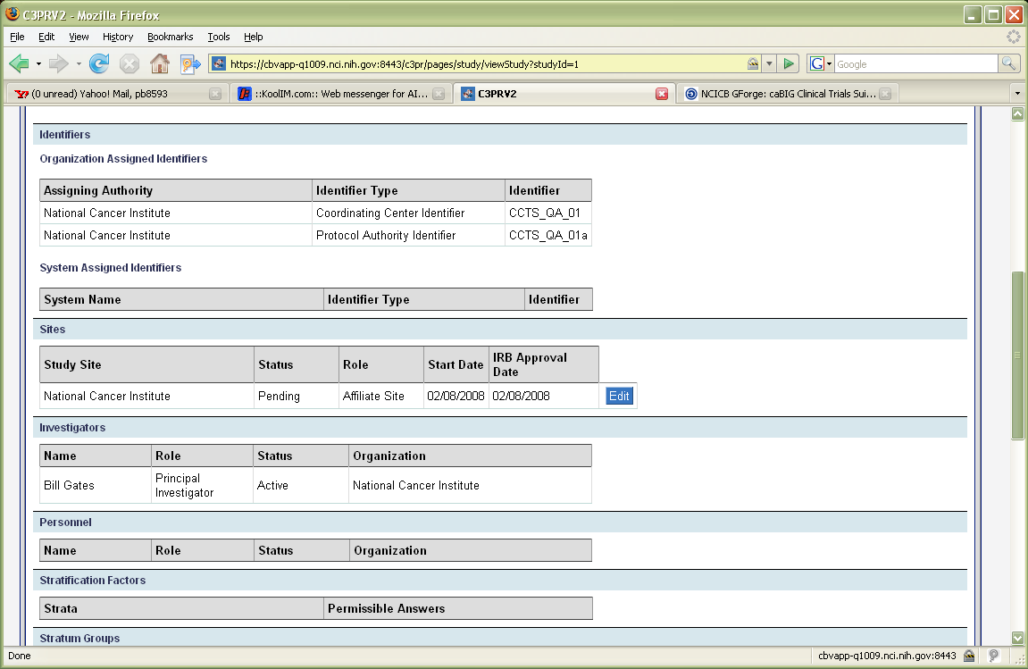

Here is what C3PR has for the investigator details for Bill Gates (the investigator defined in the study)
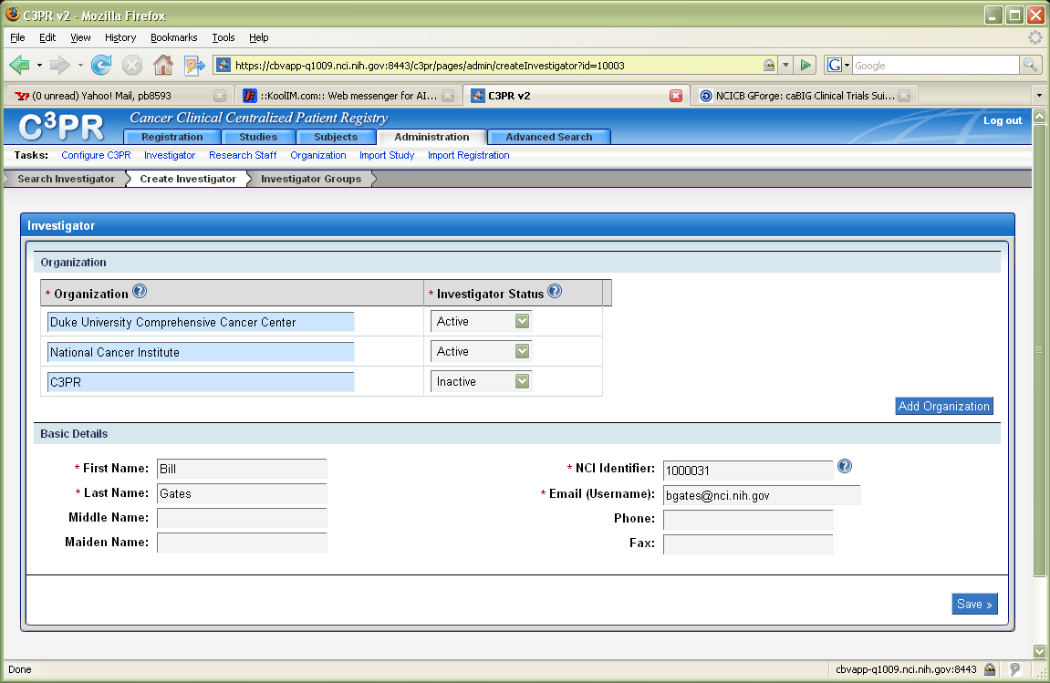

And here is what is in caAERS for that same investigator:

