PSC – Dashboard>Site Coordinator. Select the ‘Change’ button.

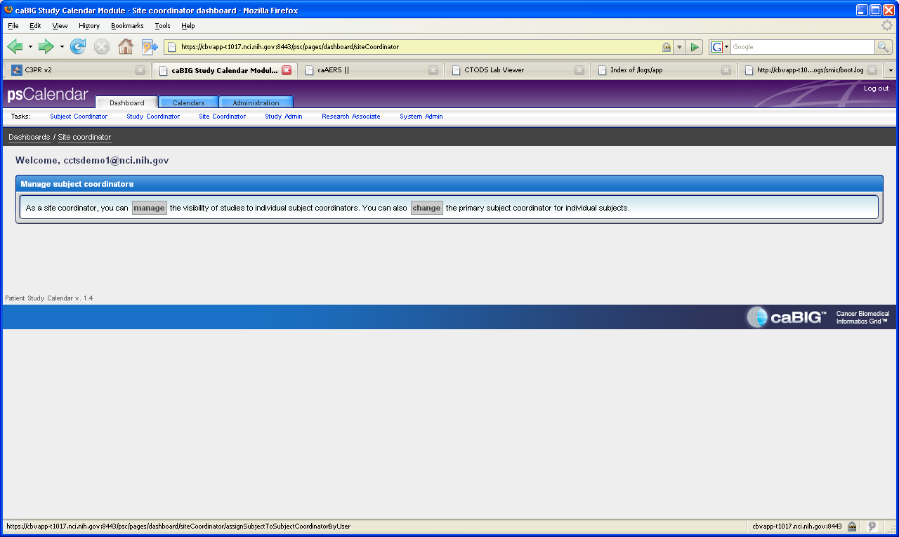

Receive the following error on the screen.

