Scenario:
On the GTS server, created a new user thru GAARDS called: cctsuser1@nci.nih.gov

Logged into C3PR as cctsdemo1@nci.nih.gov and created new user in C3PR

Defined the First Name as ccts
Last Name as user1
And email as ccts1@mail.com

User was added to the C3PR csm_user table as ccts1@mail.com

Logged out of C3PR with cctsdemo1@nci.nih.gov userid.

Logged into C3PR (via CAS) with userid: cctsuser1@nci.nih.gov

This user has valid certificates on CAS so a successful login thru CAS was completed; however the user was added to the C3PR postgres database with the email id of ccts1@mail.com

Received the below error – valid error condition based on the userid of cctsuser1@nci.nih.gov not being in the csm_user table for C3PR

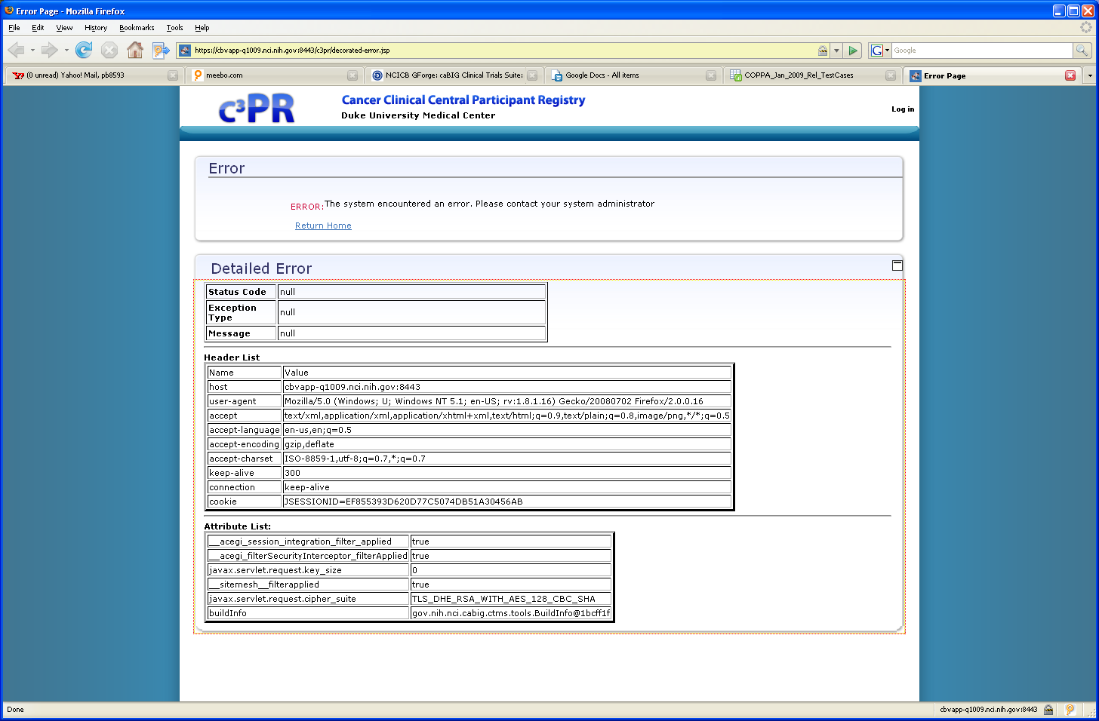

However, because the CAS login under cctsuser1@nci.nih.gov was successful but the login to C3PR failed, user is unable to ‘logout’ of C3PR or CAS. Closing the browser and starting a new window in the same ‘Firefox’ session or in a new Firefox browser automatically routes the user back to this error page when the browser url is entered: https://cbvapp-q1009.nci.nih.gov. In order to get back to the CAS login page via the browser: https://cbvapp-q1009.nci.nih.gov:8443/c3pr have to start a new IE session.

