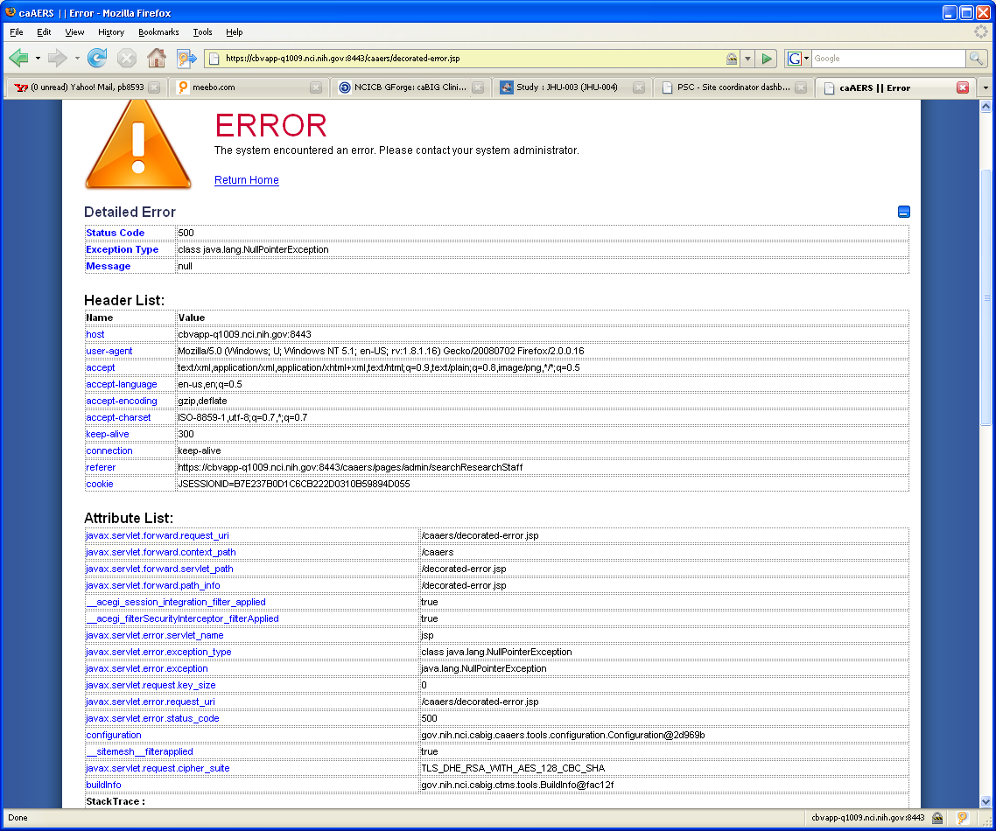

StackTrace :
java.lang.NullPointerException
at org.apache.jsp.decorated_002derror_jsp._jspService(decorated_002derror_jsp.java:317)
at org.apache.jasper.runtime.HttpJspBase.service(HttpJspBase.java:94)
at javax.servlet.http.HttpServlet.service(HttpServlet.java:802)
at org.apache.jasper.servlet.JspServletWrapper.service(JspServletWrapper.java:324)
at org.apache.jasper.servlet.JspServlet.serviceJspFile(JspServlet.java:292)
at org.apache.jasper.servlet.JspServlet.service(JspServlet.java:236)
at javax.servlet.http.HttpServlet.service(HttpServlet.java:802)
at org.apache.catalina.core.ApplicationFilterChain.internalDoFilter(ApplicationFilterChain.java:237)
at org.apache.catalina.core.ApplicationFilterChain.doFilter(ApplicationFilterChain.java:157)
at com.opensymphony.module.sitemesh.filter.PageFilter.doFilter(PageFilter.java:39)
at org.extremecomponents.table.filter.SitemeshPageFilter.doFilter(SitemeshPageFilter.java:39)
at org.apache.catalina.core.ApplicationFilterChain.internalDoFilter(ApplicationFilterChain.java:186)
at org.apache.catalina.core.ApplicationFilterChain.doFilter(ApplicationFilterChain.java:157)
at org.extremecomponents.table.filter.AbstractExportFilter.doFilter(AbstractExportFilter.java:49)
at org.apache.catalina.core.ApplicationFilterChain.internalDoFilter(ApplicationFilterChain.java:186)
at org.apache.catalina.core.ApplicationFilterChain.doFilter(ApplicationFilterChain.java:157)
at gov.nih.nci.cabig.caaers.web.AuditInfoFilter.doFilter(AuditInfoFilter.java:35)
at org.apache.catalina.core.ApplicationFilterChain.internalDoFilter(ApplicationFilterChain.java:186)
at org.apache.catalina.core.ApplicationFilterChain.doFilter(ApplicationFilterChain.java:157)
at gov.nih.nci.cabig.ctms.web.filters.BeansInRequestFilter.doFilter(BeansInRequestFilter.java:39)
at org.apache.catalina.core.ApplicationFilterChain.internalDoFilter(ApplicationFilterChain.java:186)
at org.apache.catalina.core.ApplicationFilterChain.doFilter(ApplicationFilterChain.java:157)
at org.acegisecurity.util.FilterChainProxy$VirtualFilterChain.doFilter(FilterChainProxy.java:264)
at org.acegisecurity.intercept.web.FilterSecurityInterceptor.invoke(FilterSecurityInterceptor.java:107)
at org.acegisecurity.intercept.web.FilterSecurityInterceptor.doFilter(FilterSecurityInterceptor.java:72)
at org.acegisecurity.util.FilterChainProxy$VirtualFilterChain.doFilter(FilterChainProxy.java:274)
at org.acegisecurity.ui.ExceptionTranslationFilter.doFilter(ExceptionTranslationFilter.java:110)
at org.acegisecurity.util.FilterChainProxy$VirtualFilterChain.doFilter(FilterChainProxy.java:274)
at org.acegisecurity.providers.anonymous.AnonymousProcessingFilter.doFilter(AnonymousProcessingFilter.java:125)
at org.acegisecurity.util.FilterChainProxy$VirtualFilterChain.doFilter(FilterChainProxy.java:274)
at org.acegisecurity.wrapper.SecurityContextHolderAwareRequestFilter.doFilter(SecurityContextHolderAwareRequestFilter.java:81)
at org.acegisecurity.util.FilterChainProxy$VirtualFilterChain.doFilter(FilterChainProxy.java:274)
at org.acegisecurity.ui.AbstractProcessingFilter.doFilter(AbstractProcessingFilter.java:217)
at org.acegisecurity.util.FilterChainProxy$VirtualFilterChain.doFilter(FilterChainProxy.java:274)
at org.acegisecurity.ui.logout.LogoutFilter.doFilter(LogoutFilter.java:106)
at org.acegisecurity.util.FilterChainProxy$VirtualFilterChain.doFilter(FilterChainProxy.java:274)
at org.acegisecurity.context.HttpSessionContextIntegrationFilter.doFilter(HttpSessionContextIntegrationFilter.java:229)
at org.acegisecurity.util.FilterChainProxy$VirtualFilterChain.doFilter(FilterChainProxy.java:274)
at org.acegisecurity.securechannel.ChannelProcessingFilter.doFilter(ChannelProcessingFilter.java:138)
at org.acegisecurity.util.FilterChainProxy$VirtualFilterChain.doFilter(FilterChainProxy.java:274)
at org.acegisecurity.util.FilterChainProxy.doFilter(FilterChainProxy.java:148)
at org.acegisecurity.util.FilterToBeanProxy.doFilter(FilterToBeanProxy.java:98)
at org.apache.catalina.core.ApplicationFilterChain.internalDoFilter(ApplicationFilterChain.java:186)
at org.apache.catalina.core.ApplicationFilterChain.doFilter(ApplicationFilterChain.java:157)
at com.opensymphony.module.sitemesh.filter.PageFilter.parsePage(PageFilter.java:118)
at com.opensymphony.module.sitemesh.filter.PageFilter.doFilter(PageFilter.java:52)
at org.apache.catalina.core.ApplicationFilterChain.internalDoFilter(ApplicationFilterChain.java:186)
at org.apache.catalina.core.ApplicationFilterChain.doFilter(ApplicationFilterChain.java:157)
at org.apache.catalina.core.StandardWrapperValve.invoke(StandardWrapperValve.java:214)
at org.apache.catalina.core.StandardValveContext.invokeNext(StandardValveContext.java:104)
at org.apache.catalina.core.StandardPipeline.invoke(StandardPipeline.java:520)
at org.apache.catalina.core.StandardContextValve.invokeInternal(StandardContextValve.java:198)
at org.apache.catalina.core.StandardContextValve.invoke(StandardContextValve.java:152)
at org.apache.catalina.core.StandardValveContext.invokeNext(StandardValveContext.java:104)
at org.apache.catalina.authenticator.AuthenticatorBase.invoke(AuthenticatorBase.java:540)
at org.apache.catalina.core.StandardValveContext.invokeNext(StandardValveContext.java:102)
at org.apache.catalina.core.StandardPipeline.invoke(StandardPipeline.java:520)
at org.apache.catalina.core.StandardHostValve.invoke(StandardHostValve.java:137)
at org.apache.catalina.core.StandardValveContext.invokeNext(StandardValveContext.java:104)
at org.apache.catalina.valves.ErrorReportValve.invoke(ErrorReportValve.java:118)
at org.apache.catalina.core.StandardValveContext.invokeNext(StandardValveContext.java:102)
at org.apache.catalina.core.StandardPipeline.invoke(StandardPipeline.java:520)
at org.apache.catalina.core.StandardEngineValve.invoke(StandardEngineValve.java:109)
at org.apache.catalina.core.StandardValveContext.invokeNext(StandardValveContext.java:104)
at org.globus.tomcat.coyote.valves.HTTPSValve.invoke(HTTPSValve.java:51)
at org.apache.catalina.core.StandardValveContext.invokeNext(StandardValveContext.java:102)
at org.apache.catalina.core.StandardPipeline.invoke(StandardPipeline.java:520)
at org.apache.catalina.core.ContainerBase.invoke(ContainerBase.java:929)
at org.apache.coyote.tomcat5.CoyoteAdapter.service(CoyoteAdapter.java:160)
at org.apache.coyote.http11.Http11Processor.process(Http11Processor.java:799)
at org.apache.coyote.http11.Http11Protocol$Http11ConnectionHandler.processConnection(Http11Protocol.java:705)
at org.apache.tomcat.util.net.TcpWorkerThread.runIt(PoolTcpEndpoint.java:577)
at org.apache.tomcat.util.threads.ThreadPool$ControlRunnable.run(ThreadPool.java:683)
at java.lang.Thread.run(Thread.java:595)

