Difference in EPOCHs & ARMS in study between C3PR and PSC.

Created a study in C3PR with Epoch 1 having 2 arms and epoch 2 having 1 arm. Broadcast the study.

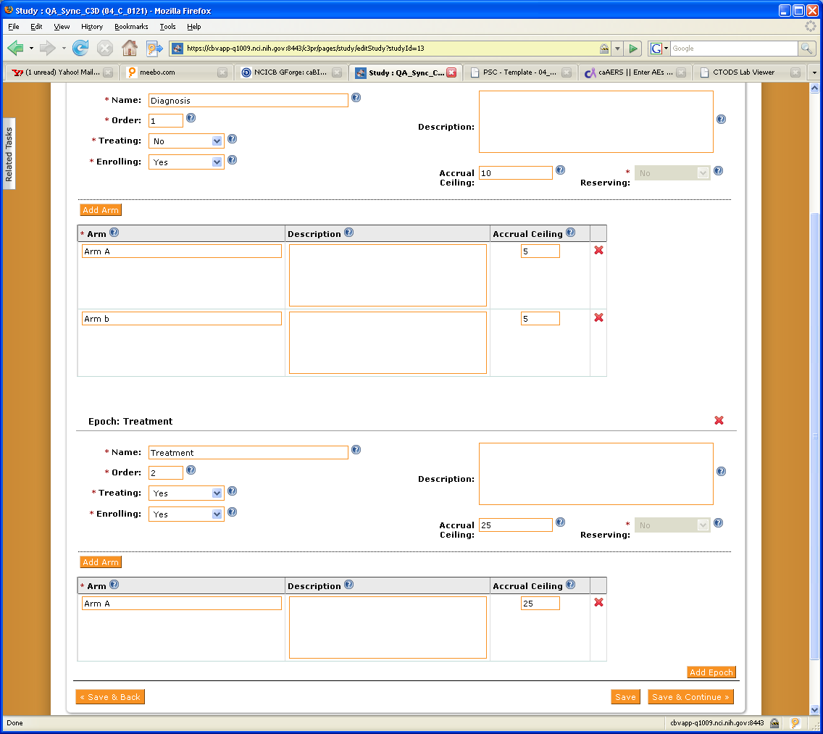

What I see in PSC is Just the EPOCH with no Arms for the Diagnosis EPOCH (#1) and the 1 ARM as defined for the Treatment EPOCH.

