Lab Results in Lab Viewer:
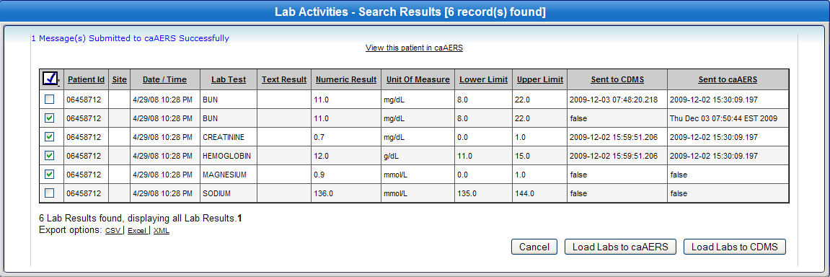
Exported lab results with issues highlighted in red:
