General
- According to the main contents page, after Installing Applications section, we have the Configuring Applications section:
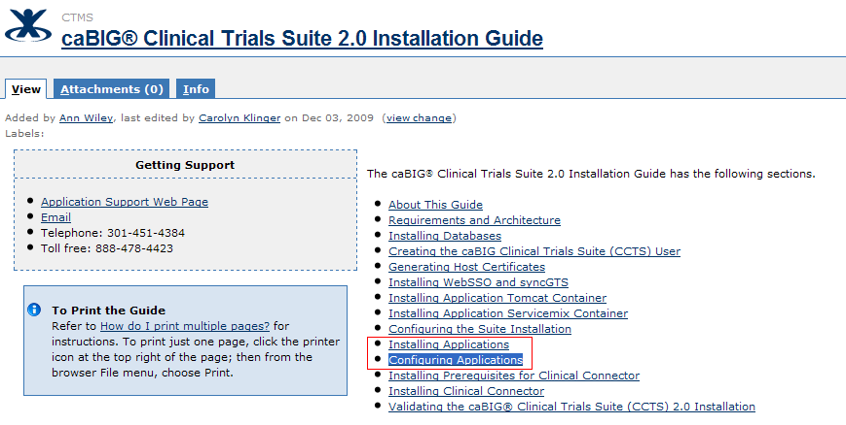
But when we go to the Installing Applications section, the next section shown in the left hand navigation is the Installing Prerequisites for Clinical Connector:
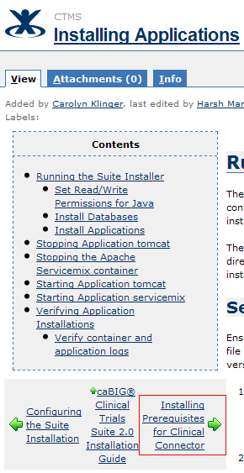
This should actually link to Configuring Applications section

- Highlighted section needs to be removed in left hand navigation of section “About this Guide”
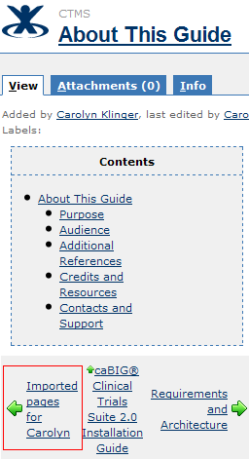
- Highlighted section in the “Installing Prerequisites for Clinical Connector” section should be updated to “Configuring Applications”
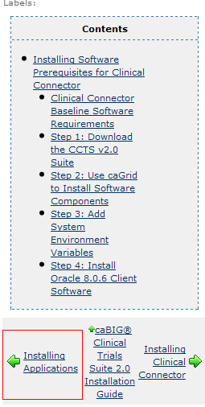

Section: Configuring Applications
- The left hand menu should change to reflect the previous/next section in the below highlighted areas:
