- C3PR dashboard for Study Coordinator
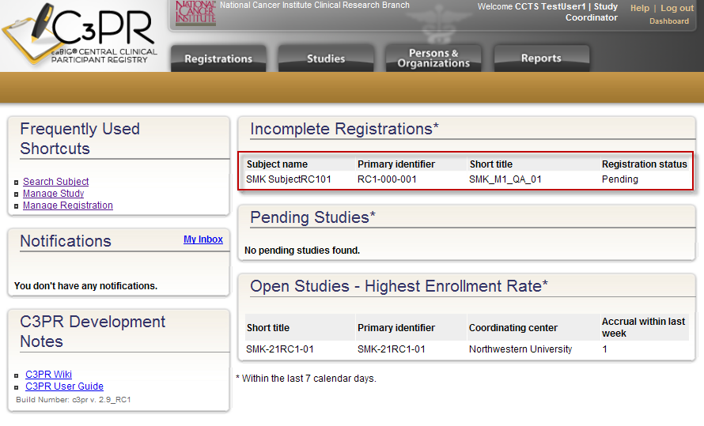
- Page displayed when the “SMK SubjectRC101” registration link is clicked
