I send labs to caAERS from LabViewer and I get the success message, but the highlighted column does not update with the timestamp.
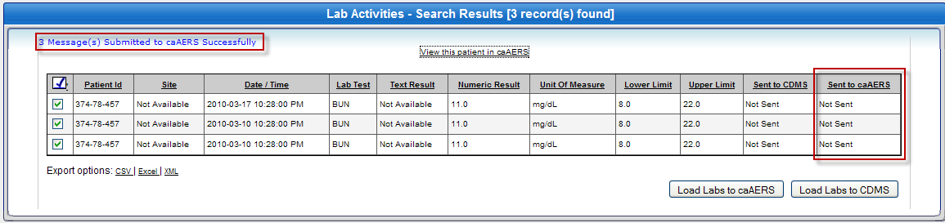

But, these labs are visible in caAERS.
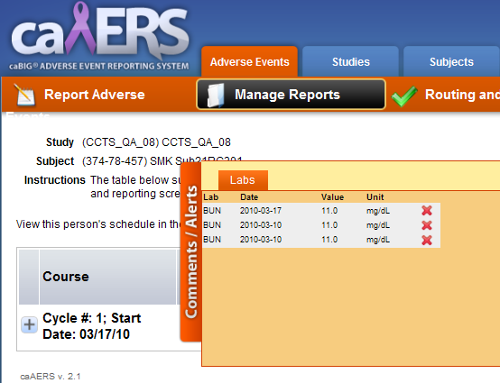

I get the same issue for CDMS also. As seen below, I get a success message for sending labs to CDMS, but the highlighted column does not update with the timestamp. I also received success messages from CDMS confirming the lab loading.

