This is the study I used for the test
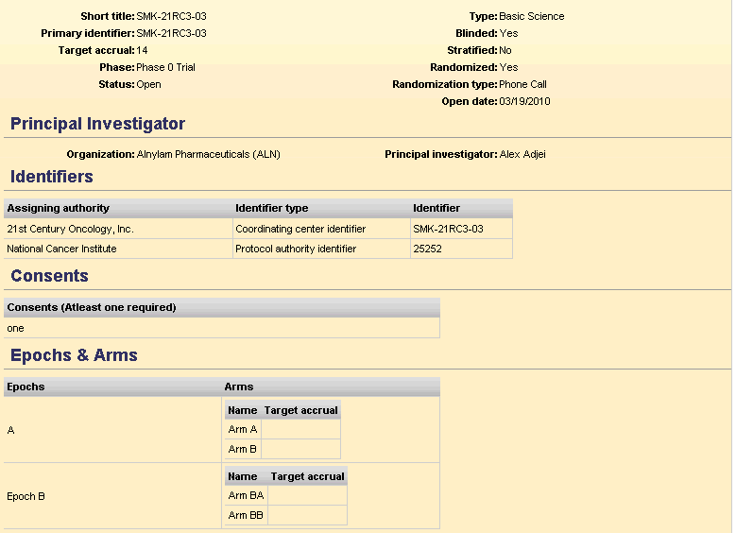
I added Epoch B /Arm BA/ Arm BB with the amendment

This is the successful registration message:
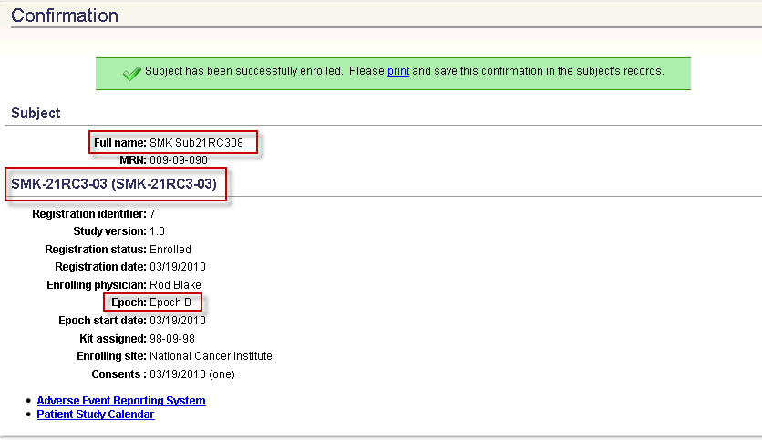
The Subject (SMK Sub21RC308) is registered to Epoch B of the study

This is the screenshot of the patient’s calendar in PSC
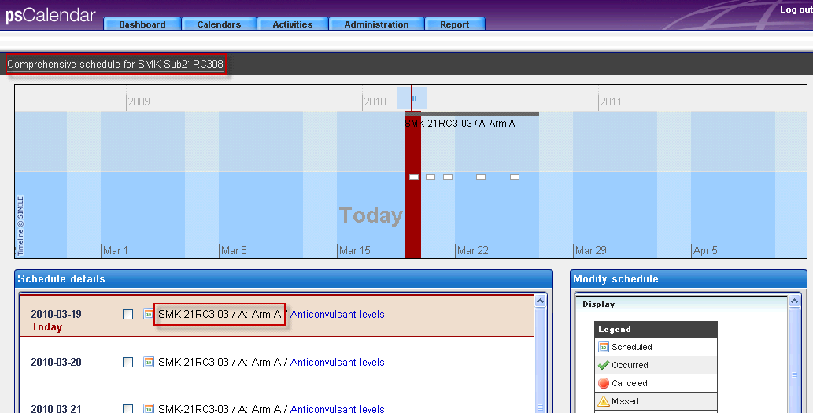
PSC has registered the subject to Epoch A/Arm A of the same study.

