Bug Report

Unable to log out from PSC application when using unprivileged user access level.

“ccts_rez_all_su”

URL: https://cbiit-qa-suite-linux.nci.nih.gov:8443/psc/pages/cal/studyList
Test Environment: QA
Login Info: ccts_rez_all_su
Role:
- Subject Manager
- Registrar

Steps to reproduce:
Example:
- From suite level login to PSC
- You receive “forbidden” error, which means the user with subject manager and registrar don’t have access to apps. But unable to logout from this page.
- Try to use different user levels to login to “PSC” application, but the PSC application still shows logged on by the previous user “ccts_rez_all_su”.
- By clearing the history of web page, the previous user “ccts_rez_all_su” can be logged out, and then another user is able to login to PSC application.
- Please see below screen shots for more details.

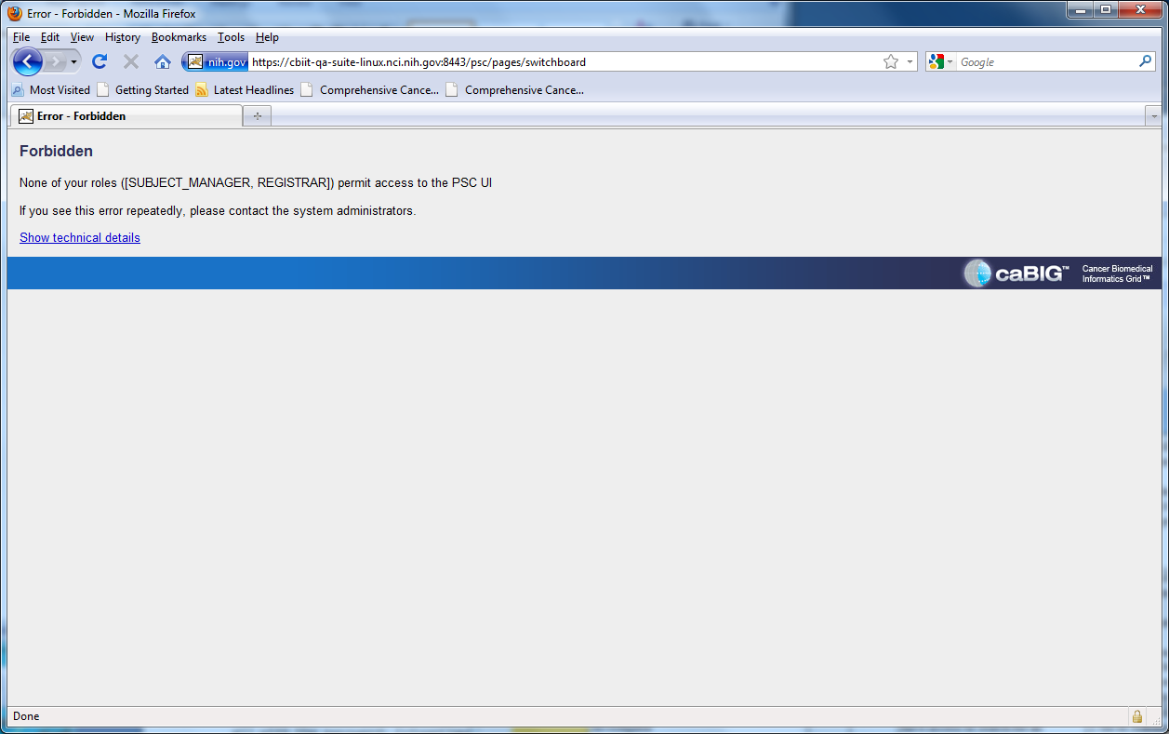

Thanks,
Reza Mehri

