C3PR :
Study name: Amend_DBL_Test
URL: https://cbiit-qa-suite-linux.nci.nih.gov:8443/c3pr/pages/study/amendStudy?studyId=45
Software Version: CCTS-Rel 2.2.1
User: ccts_su

Steps to reproduce:
- Login to Suite/C3PR.
- Create a new study (without eligibility, randomization).
- Click “Open Study” link.
- Click “Open Study”.
- Set effective date to previous date of the current date. Example: today is “01/13/2011”, but set the effective date to “01/12/2011”.
- Click “Open Study” again.
- Click “Broadcast” link.
- Click “Check Response” link several times.
- Click “Amend Study”, and then amend the study.
- Click “Manage Study” link.
- Click “Amend Study” link.
- Click “Amend Study” to confirm the amendment.
- In “Amendment Details” screen, fill out all mandatory fields with data, and select a few reasons for amendment.
- Make sure you select Amendment type: ”Immediate”, Amendment date: “current date”.
- Click “Save & Continue” link to save the amendment.
- Try to amend this amended study again.
- In “Amendment details” screen, insert the values below: Version name/number = 34, Amendment type= Immediate after grace period, Grace period (days)= 2, Amendment date= 01/12/2011 (back dated), and reasons= Basic detail & Consent.
- Click “save & continue “ link. Saves and you’re in details screen.
- Click “Summary” tab.
- Click “Apply Amendment” tab.
- Click “Apply Amendment’ link again to confirm the amendment.
- Receive the “Oops” error message.
Please see screen shots below.

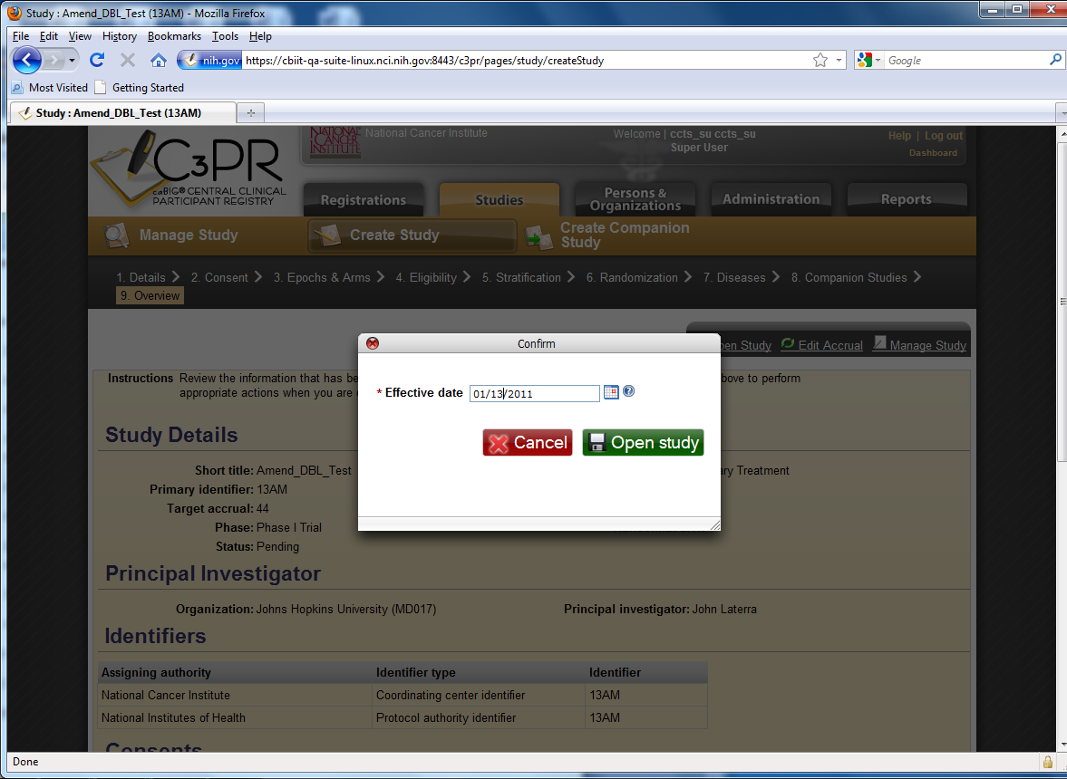

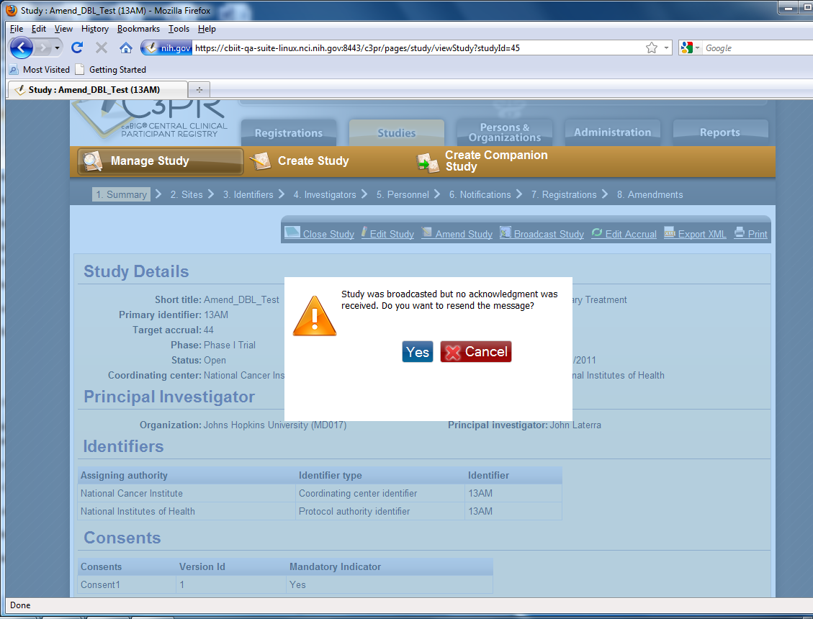

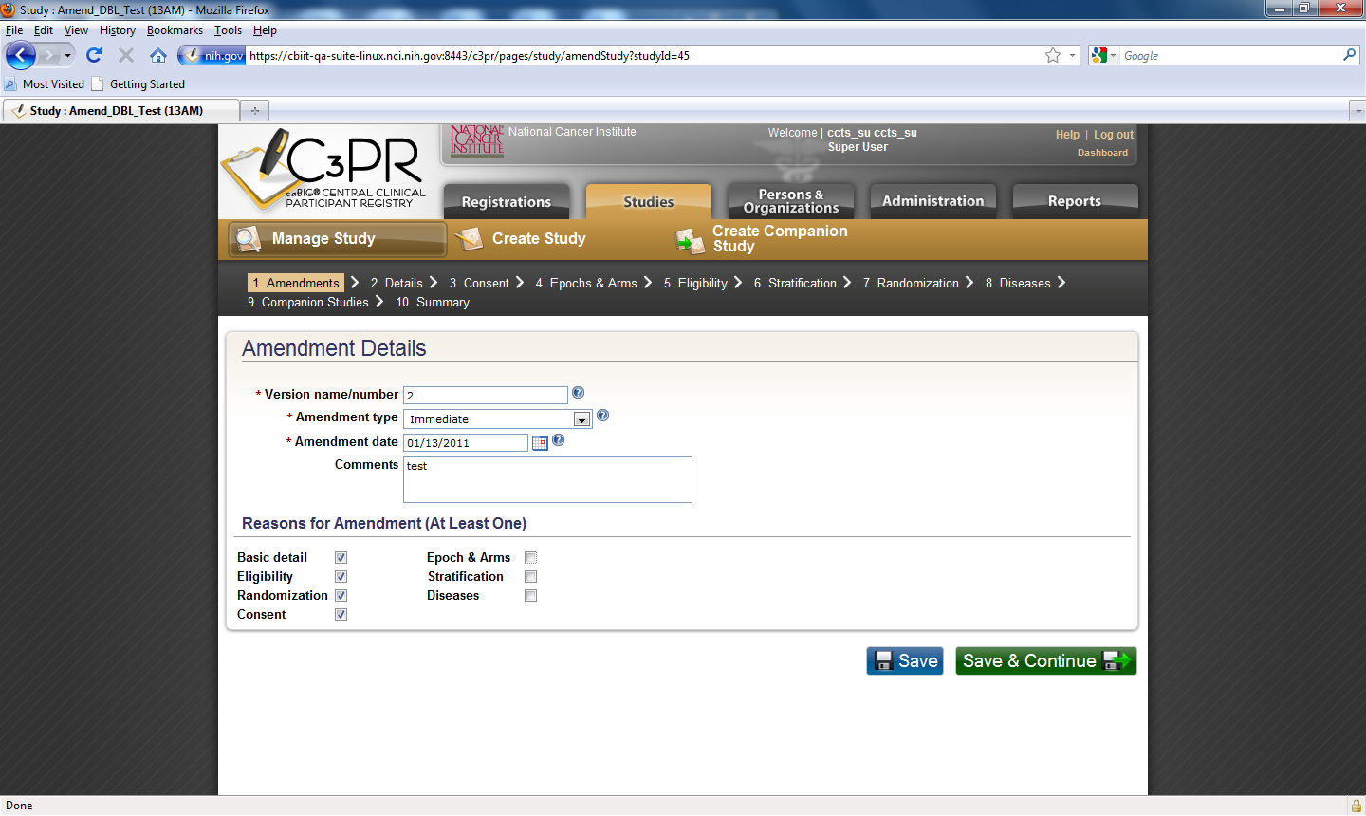
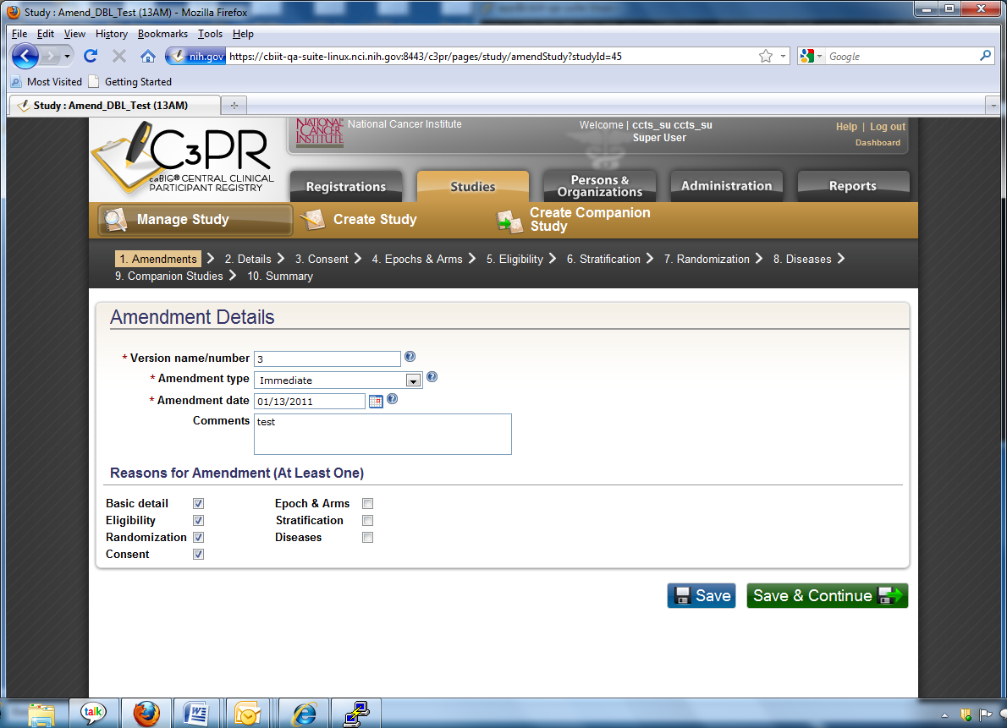
First Amendment
