Study: CCTS_KT_02
This study is a stand alone companion study, stratified and randomized.
Epoch type “Treatment” with two arms.
Inclusion criteria “>40”, Exclusion criteria “per cancerous”.
With Stratum Groups and disease.

- To amend the study with Study coordinator role.
- Select the study .

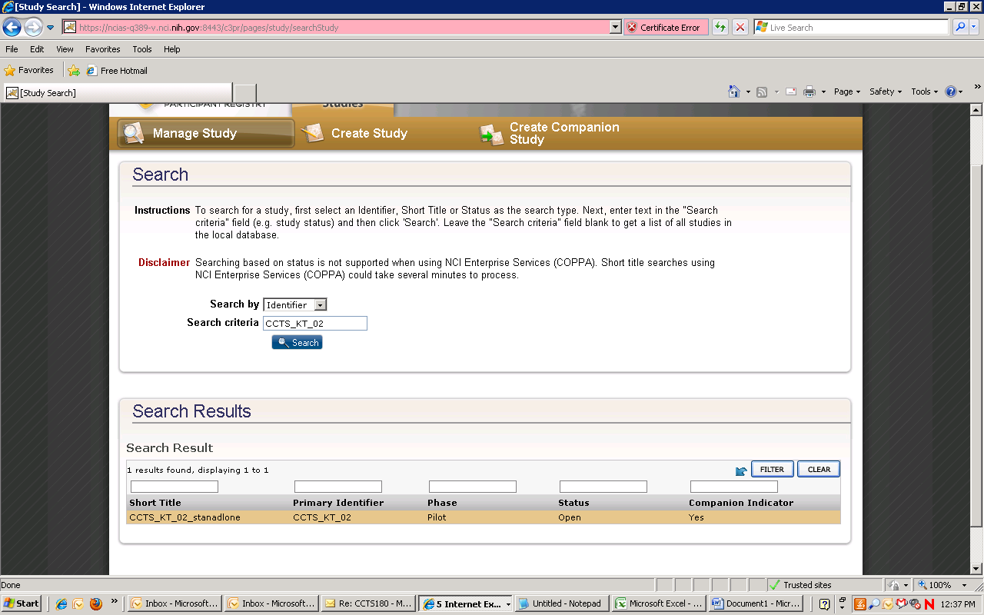

- Click “Amend “ study:
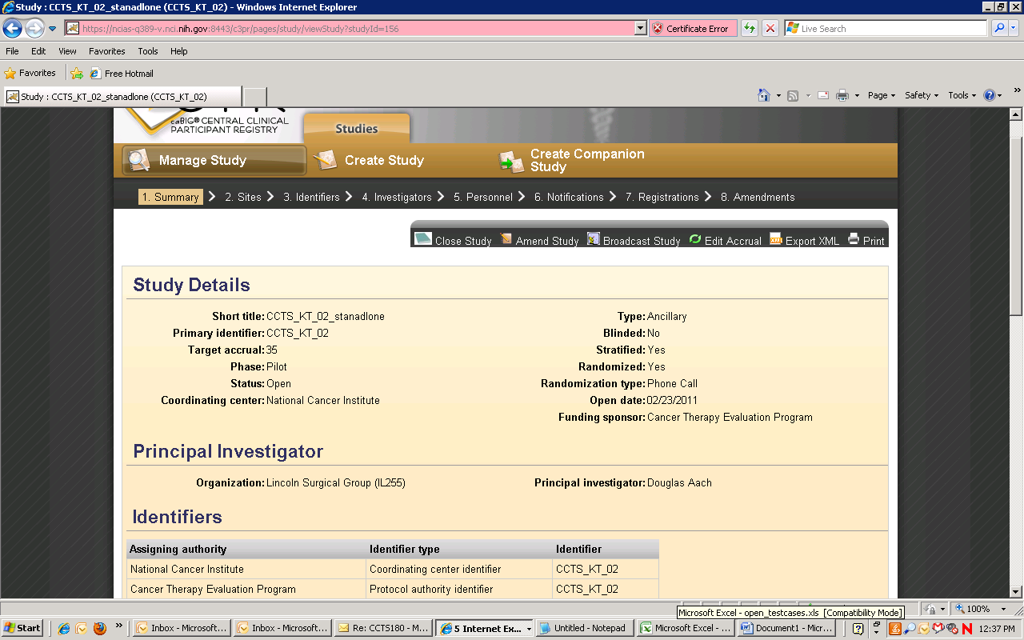

- Oops page:
