Selecting the link for the Adverse Event in PSC brings up a new window of caAERS and shows the following:

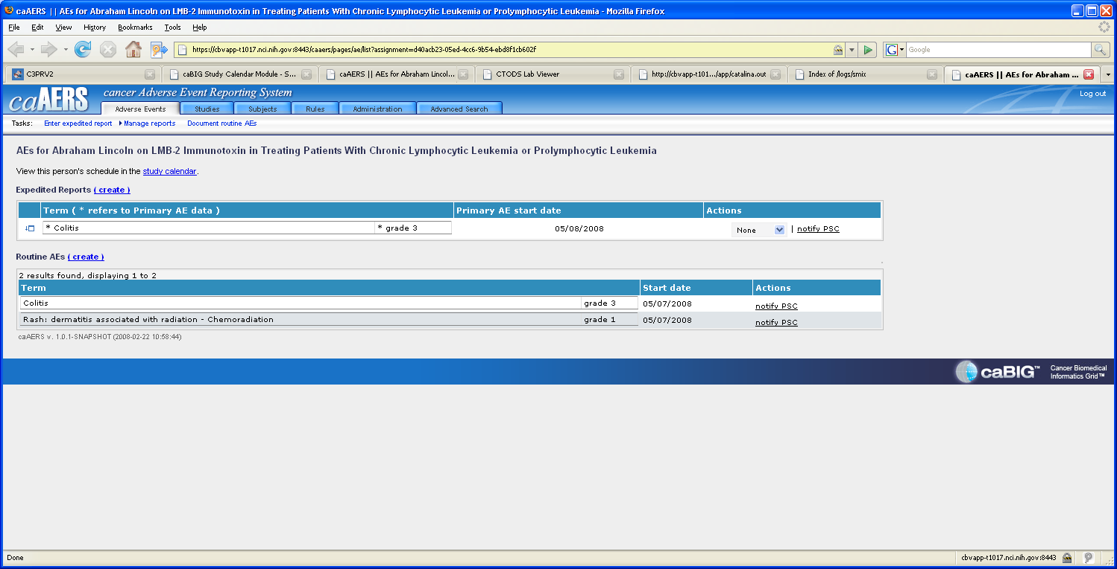

When viewing in the new window opened in caAERS, the Actions is set at ‘Notify PSC’

Whereas – if you look at the caAERS session that the user already had open to submit the AE to PSC it reflects the correct status:

