Study created by cctsdemo1 userid that has admin, study coordinator, registrar and site coordinator roles.

Study saved but not yet broadcast.

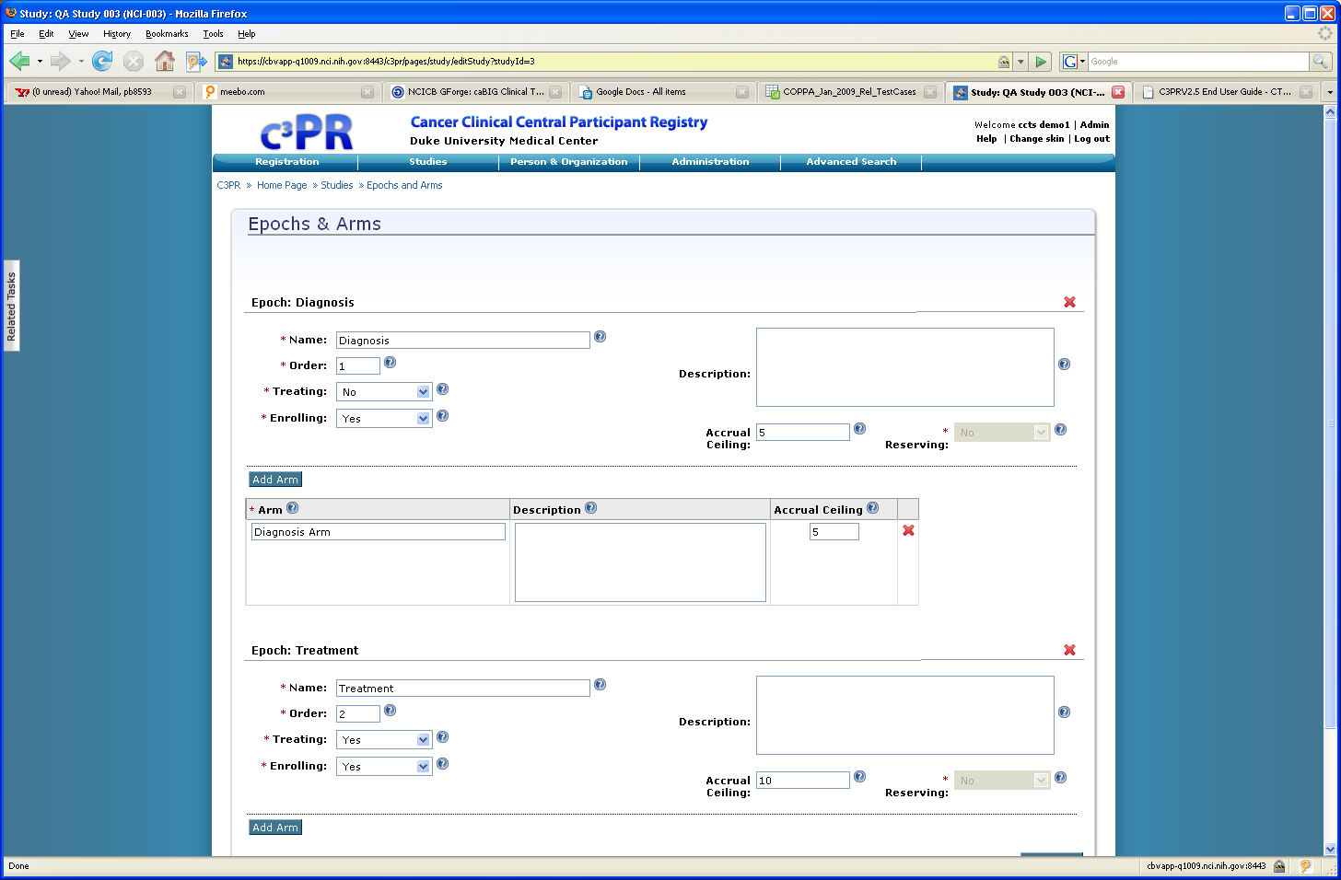

Login to the same study with the cctsuser1 userid that has the role of study coordinator. Search studies – user role can see 2 studies…..select one of the studies shown in the list. This user does not have edit permissions to the Study even though they have the role of study coordinator and the study has not been broadcast downstream.
CCTSUser1 is associated to Good Samaritan Hosp which is listed on the Sites page..but userid is unable to edit the study.

