On the Investigators page – Initially Peter Bell was listed as the primary investigator for John Hopkins University (Coordinating Center).

I decided to select John Hopkins University(Site) and add Peter Bells as the Investigator for the Site as well.

That produced the 2nd screen snapshot error – and the logfile printout.

But in addition to that – when I brought the study back up and returned to the investigators page, I noticed that the Hosp defined on the right is now Good Samaritan Hosp – which is the funding sponsor site.

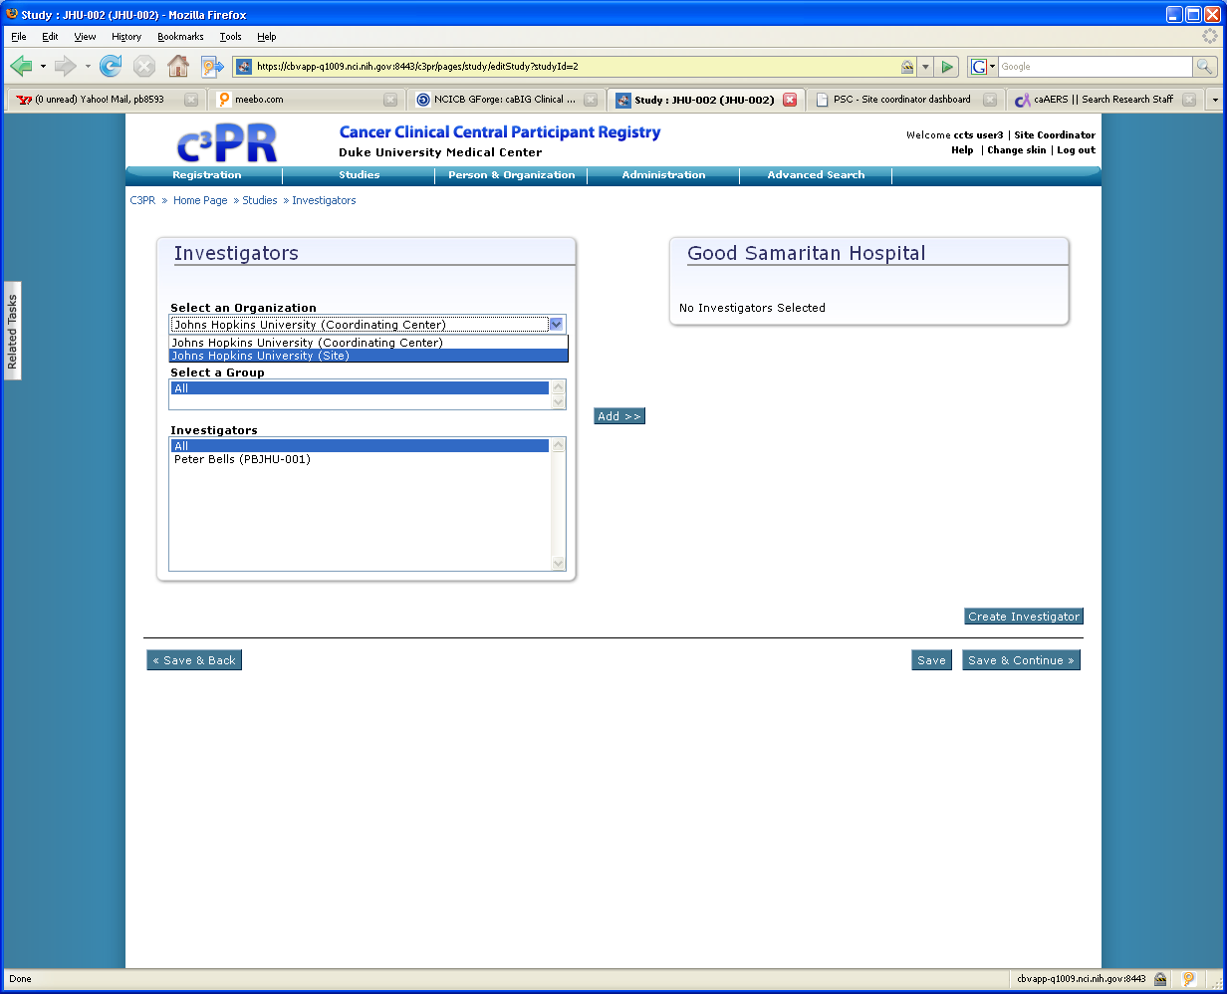

If I just select Save & Continue on this screen, the screen is re-drawn – now with the correct list of investigators for John Hopkins University (Site) – however selecting that user still results in the same error condition. Regardless of what scenario I try going forward, I can not correct the Investigator assignments and proceed past this window – thus I can not complete this study.

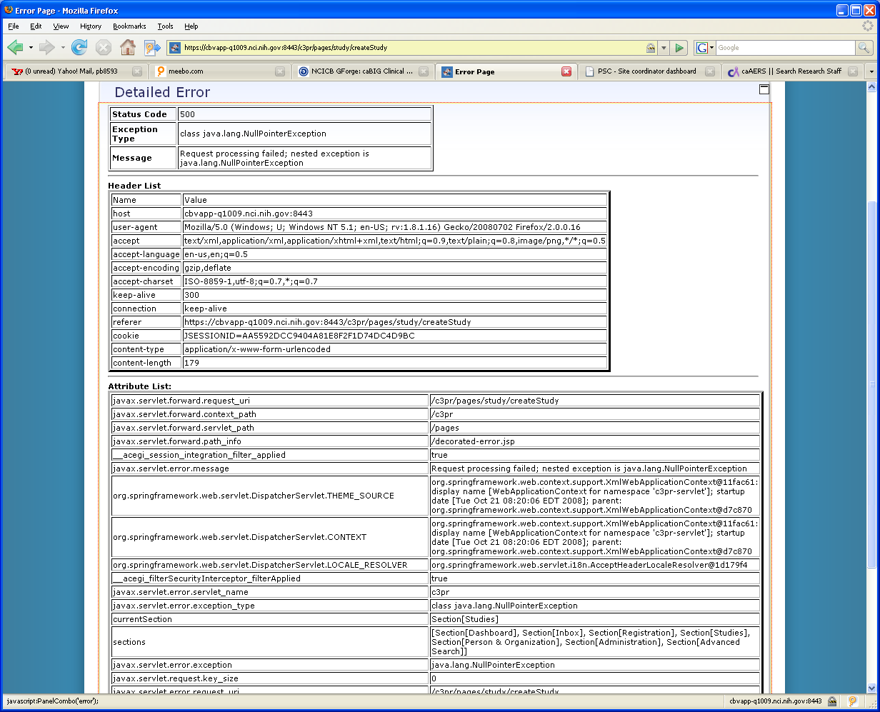

2008-10-21 08:19:41 StandardContext[/c3pr]Set web app root system property: 'c3pr.root' = [/usr/local/jakarta-tomcat-5.0.28-8080/jakarta-tom
cat-5.0.28/webapps/c3pr/]
2008-10-21 08:19:41 StandardContext[/c3pr]Initializing Log4J from [/usr/local/jakarta-tomcat-5.0.28-8080/jakarta-tomcat-5.0.28/webapps/c3pr/
WEB-INF/log4j.properties]
2008-10-21 08:19:42 StandardContext[/c3pr]Initializing Spring root WebApplicationContext
2008-10-21 08:20:06 StandardContext[/c3pr]Initializing Spring FrameworkServlet 'public'
2008-10-21 08:20:06 StandardContext[/c3pr]Initializing Spring FrameworkServlet 'c3pr'
2008-10-21 09:37:12 StandardWrapperValve[c3pr]: Servlet.service() for servlet c3pr threw exception
java.lang.NullPointerException
at edu.duke.cabig.c3pr.web.study.StudyInvestigatorsTab.postProcessOnValidation(StudyInvestigatorsTab.java:85)
at edu.duke.cabig.c3pr.web.study.StudyTab.postProcess(StudyTab.java:198)
at edu.duke.cabig.c3pr.web.study.StudyTab.postProcess(StudyTab.java:35)
at gov.nih.nci.cabig.ctms.web.tabs.AbstractTabbedFlowFormController.postProcessPage(AbstractTabbedFlowFormController.java:128)
at gov.nih.nci.cabig.ctms.web.tabs.AutomaticSaveFlowFormController.postProcessPage(AutomaticSaveFlowFormController.java:118)
at edu.duke.cabig.c3pr.utils.web.spring.tabbedflow.AutomaticSaveAjaxableFormController.postProcessPage(AutomaticSaveAjaxableFormCont
roller.java:69)
at edu.duke.cabig.c3pr.web.study.CreateStudyController.postProcessPage(CreateStudyController.java:139)
at org.springframework.web.servlet.mvc.AbstractWizardFormController.processFormSubmission(AbstractWizardFormController.java:506)
at org.springframework.web.servlet.mvc.AbstractFormController.handleRequestInternal(AbstractFormController.java:265)
at edu.duke.cabig.c3pr.utils.web.spring.tabbedflow.AutomaticSaveAjaxableFormController.handleRequestInternal(AutomaticSaveAjaxableFo
rmController.java:39)
at org.springframework.web.servlet.mvc.AbstractController.handleRequest(AbstractController.java:153)
at org.springframework.web.servlet.mvc.SimpleControllerHandlerAdapter.handle(SimpleControllerHandlerAdapter.java:48)
at org.springframework.web.servlet.DispatcherServlet.doDispatch(DispatcherServlet.java:858)
at org.springframework.web.servlet.DispatcherServlet.doService(DispatcherServlet.java:792)
at org.springframework.web.servlet.FrameworkServlet.processRequest(FrameworkServlet.java:476)
at org.springframework.web.servlet.FrameworkServlet.doPost(FrameworkServlet.java:441)
at javax.servlet.http.HttpServlet.service(HttpServlet.java:709)
at javax.servlet.http.HttpServlet.service(HttpServlet.java:802)
at org.apache.catalina.core.ApplicationFilterChain.internalDoFilter(ApplicationFilterChain.java:237)
at org.apache.catalina.core.ApplicationFilterChain.doFilter(ApplicationFilterChain.java:157)
at edu.duke.cabig.c3pr.web.SkinFilter.doFilter(SkinFilter.java:87)
at org.apache.catalina.core.ApplicationFilterChain.internalDoFilter(ApplicationFilterChain.java:186)
at org.apache.catalina.core.ApplicationFilterChain.doFilter(ApplicationFilterChain.java:157)
at com.opensymphony.module.sitemesh.filter.PageFilter.parsePage(PageFilter.java:118)
at com.opensymphony.module.sitemesh.filter.PageFilter.doFilter(PageFilter.java:52)
at org.extremecomponents.table.filter.SitemeshPageFilter.doFilter(SitemeshPageFilter.java:39)
at org.apache.catalina.core.ApplicationFilterChain.internalDoFilter(ApplicationFilterChain.java:186)
at org.apache.catalina.core.ApplicationFilterChain.doFilter(ApplicationFilterChain.java:157)
at org.extremecomponents.table.filter.AbstractExportFilter.doFilter(AbstractExportFilter.java:49)
at org.apache.catalina.core.ApplicationFilterChain.internalDoFilter(ApplicationFilterChain.java:186)
at org.apache.catalina.core.ApplicationFilterChain.doFilter(ApplicationFilterChain.java:157)
at edu.duke.cabig.c3pr.utils.web.OpenSessionInViewInterceptorFilter.doFilter(OpenSessionInViewInterceptorFilter.java:45)
at org.apache.catalina.core.ApplicationFilterChain.internalDoFilter(ApplicationFilterChain.java:186)
at org.apache.catalina.core.ApplicationFilterChain.doFilter(ApplicationFilterChain.java:157)
at edu.duke.cabig.c3pr.utils.web.OpenSessionInViewInterceptorFilter.doFilter(OpenSessionInViewInterceptorFilter.java:45)
at org.apache.catalina.core.ApplicationFilterChain.internalDoFilter(ApplicationFilterChain.java:186)
at org.apache.catalina.core.ApplicationFilterChain.doFilter(ApplicationFilterChain.java:157)
at edu.duke.cabig.c3pr.utils.web.AuditInfoFilter.doFilter(AuditInfoFilter.java:37)
at org.apache.catalina.core.ApplicationFilterChain.internalDoFilter(ApplicationFilterChain.java:186)
at org.apache.catalina.core.ApplicationFilterChain.doFilter(ApplicationFilterChain.java:157)
at org.acegisecurity.util.FilterChainProxy$VirtualFilterChain.doFilter(FilterChainProxy.java:264)
at org.acegisecurity.intercept.web.FilterSecurityInterceptor.invoke(FilterSecurityInterceptor.java:107)
at org.acegisecurity.intercept.web.FilterSecurityInterceptor.doFilter(FilterSecurityInterceptor.java:72)
at org.acegisecurity.util.FilterChainProxy$VirtualFilterChain.doFilter(FilterChainProxy.java:274)
at org.acegisecurity.ui.ExceptionTranslationFilter.doFilter(ExceptionTranslationFilter.java:110)
at org.acegisecurity.util.FilterChainProxy$VirtualFilterChain.doFilter(FilterChainProxy.java:274)
at org.acegisecurity.wrapper.SecurityContextHolderAwareRequestFilter.doFilter(SecurityContextHolderAwareRequestFilter.java:81)
at org.acegisecurity.util.FilterChainProxy$VirtualFilterChain.doFilter(FilterChainProxy.java:274)
at org.acegisecurity.ui.AbstractProcessingFilter.doFilter(AbstractProcessingFilter.java:217)
at org.acegisecurity.util.FilterChainProxy$VirtualFilterChain.doFilter(FilterChainProxy.java:274)
at org.acegisecurity.ui.logout.LogoutFilter.doFilter(LogoutFilter.java:106)
at org.acegisecurity.util.FilterChainProxy$VirtualFilterChain.doFilter(FilterChainProxy.java:274)
at org.acegisecurity.context.HttpSessionContextIntegrationFilter.doFilter(HttpSessionContextIntegrationFilter.java:229)
at org.acegisecurity.util.FilterChainProxy$VirtualFilterChain.doFilter(FilterChainProxy.java:274)
at org.acegisecurity.securechannel.ChannelProcessingFilter.doFilter(ChannelProcessingFilter.java:138)
at org.acegisecurity.util.FilterChainProxy$VirtualFilterChain.doFilter(FilterChainProxy.java:274)
at org.acegisecurity.util.FilterChainProxy.doFilter(FilterChainProxy.java:148)
at org.acegisecurity.util.FilterToBeanProxy.doFilter(FilterToBeanProxy.java:98)
at org.apache.catalina.core.ApplicationFilterChain.internalDoFilter(ApplicationFilterChain.java:186)
at org.apache.catalina.core.ApplicationFilterChain.doFilter(ApplicationFilterChain.java:157)
at gov.nih.nci.cabig.ctms.web.filters.BeansInRequestFilter.doFilter(BeansInRequestFilter.java:39)
at org.apache.catalina.core.ApplicationFilterChain.internalDoFilter(ApplicationFilterChain.java:186)
at org.apache.catalina.core.ApplicationFilterChain.doFilter(ApplicationFilterChain.java:157)
at org.apache.catalina.core.StandardWrapperValve.invoke(StandardWrapperValve.java:214)
at org.apache.catalina.core.StandardValveContext.invokeNext(StandardValveContext.java:104)
at org.apache.catalina.core.StandardPipeline.invoke(StandardPipeline.java:520)
at org.apache.catalina.core.StandardContextValve.invokeInternal(StandardContextValve.java:198)
at org.apache.catalina.core.StandardContextValve.invoke(StandardContextValve.java:152)
at org.apache.catalina.core.StandardValveContext.invokeNext(StandardValveContext.java:104)
at org.apache.catalina.authenticator.AuthenticatorBase.invoke(AuthenticatorBase.java:540)
at org.apache.catalina.core.StandardValveContext.invokeNext(StandardValveContext.java:102)
at org.apache.catalina.core.StandardPipeline.invoke(StandardPipeline.java:520)
at org.apache.catalina.core.StandardHostValve.invoke(StandardHostValve.java:137)
at org.apache.catalina.core.StandardValveContext.invokeNext(StandardValveContext.java:104)
at org.apache.catalina.valves.ErrorReportValve.invoke(ErrorReportValve.java:118)
at org.apache.catalina.core.StandardValveContext.invokeNext(StandardValveContext.java:102)
at org.apache.catalina.core.StandardPipeline.invoke(StandardPipeline.java:520)
at org.apache.catalina.core.StandardEngineValve.invoke(StandardEngineValve.java:109)
at org.apache.catalina.core.StandardValveContext.invokeNext(StandardValveContext.java:104)
at org.globus.tomcat.coyote.valves.HTTPSValve.invoke(HTTPSValve.java:51)
at org.apache.catalina.core.StandardValveContext.invokeNext(StandardValveContext.java:102)
at org.apache.catalina.core.StandardPipeline.invoke(StandardPipeline.java:520)
at org.apache.catalina.core.ContainerBase.invoke(ContainerBase.java:929)
at org.apache.coyote.tomcat5.CoyoteAdapter.service(CoyoteAdapter.java:160)
at org.apache.coyote.http11.Http11Processor.process(Http11Processor.java:799)
at org.apache.coyote.http11.Http11Protocol$Http11ConnectionHandler.processConnection(Http11Protocol.java:705)
at org.apache.tomcat.util.net.TcpWorkerThread.runIt(PoolTcpEndpoint.java:577)
at org.apache.tomcat.util.threads.ThreadPool$ControlRunnable.run(ThreadPool.java:683)
at java.lang.Thread.run(Thread.java:595)

