Selected the View/Edit button for CBC/Platelet (first row) – when the popup was presented, selected <SAVE> because there is no other option…..below error was presented on the screen………..

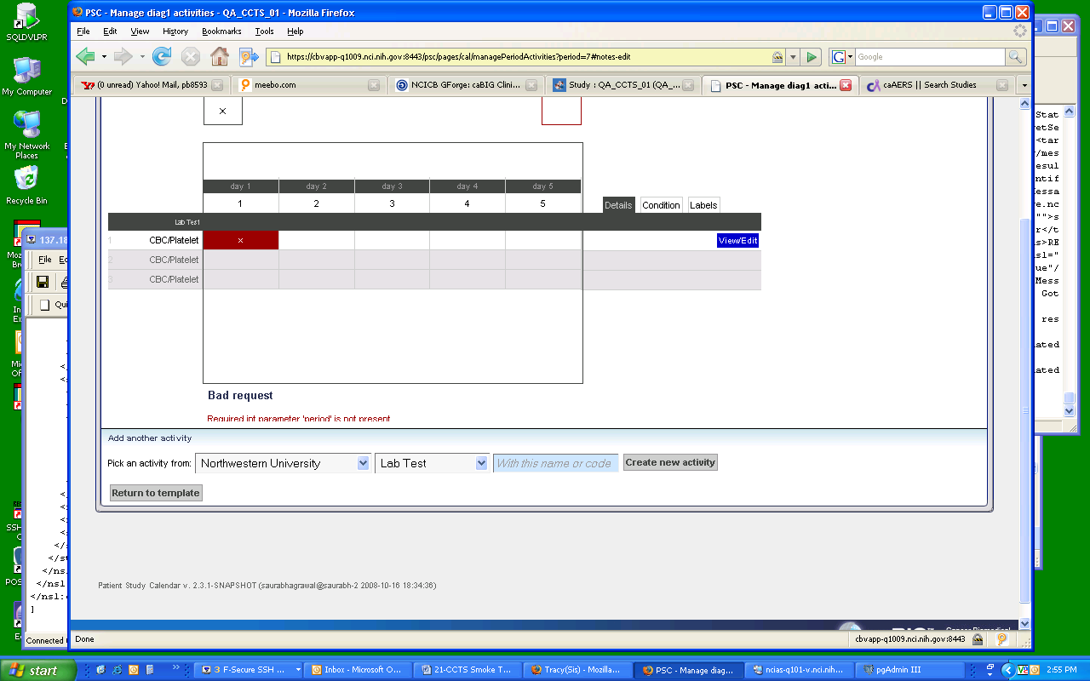

Two Issues:
> Error is unreadable when presented because part of it is appearing below the separator line.
> Do not know what the error pertains to

