Windows open prior to beginning the PSC Hot Link where the Hot Link was selected once and PSC was brought up and then logged out in the new window:

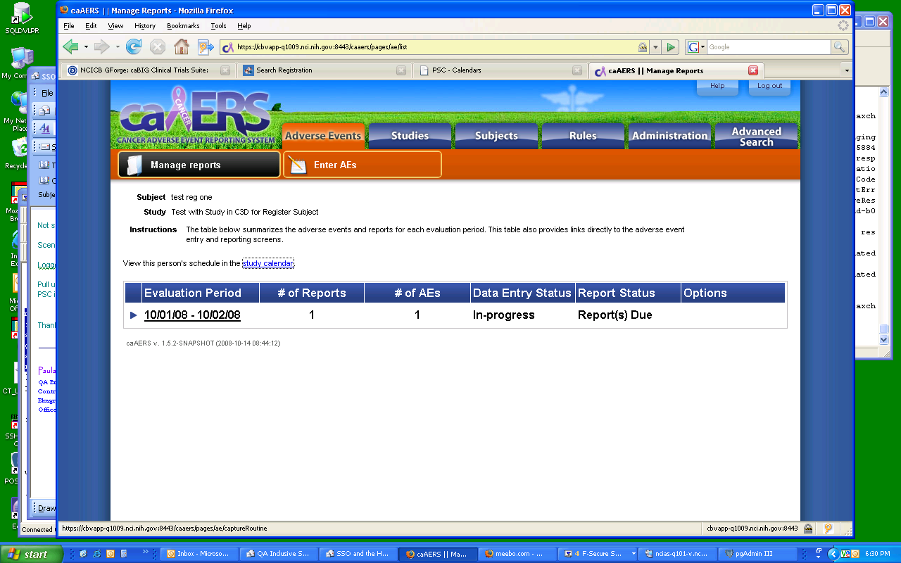

In caAERS, select the Study calendar hot link: this time I am directed to the CAS login page because I had already been logged in and then logged out of PSC once.
Notice that I have 2 CAS Central Authentication tabs instead of just one:

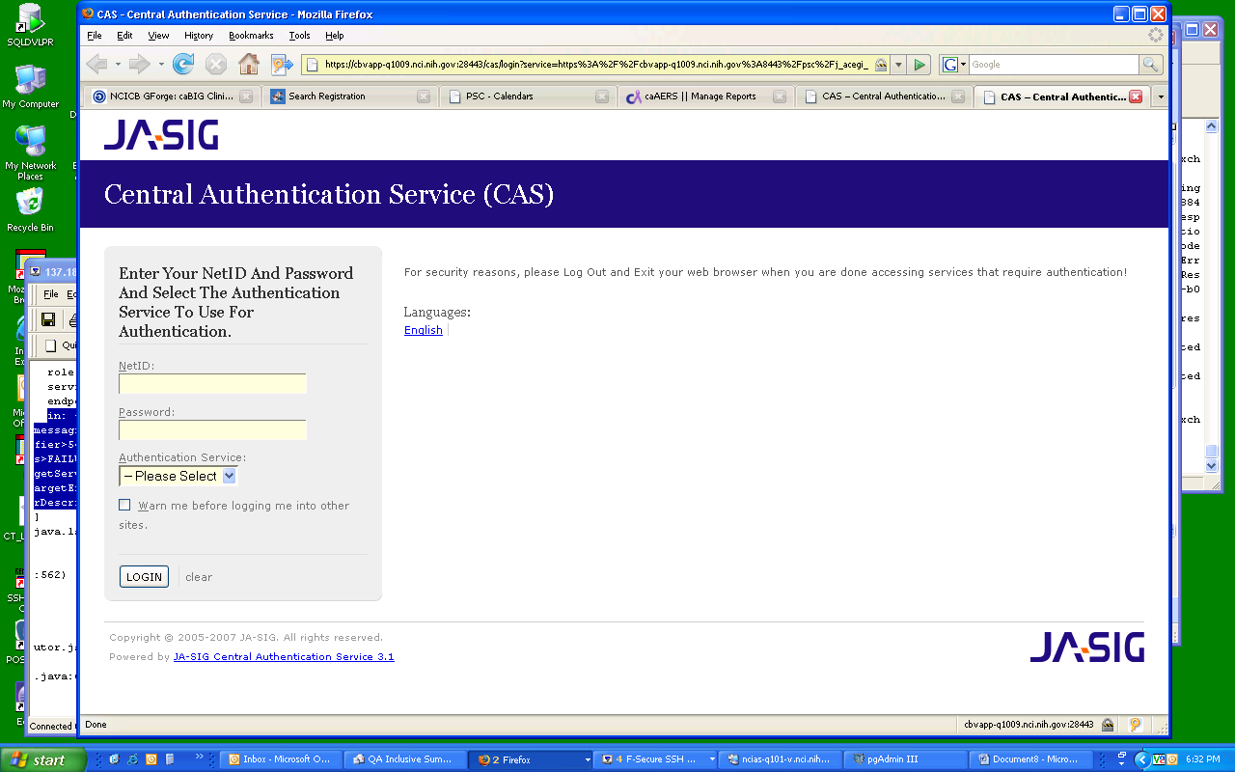

And notice that if I try to return to my ACTIVE PSC window session that I had open I am returned to the CAS login window……because logging out of the 2nd window session that I got when I selected the link…….logged me out of the current active session of PSC that I had as well.

