Hot Linking via Manage Registration from C3PR to caAERS when patient does not exist in caAERS produces the below:

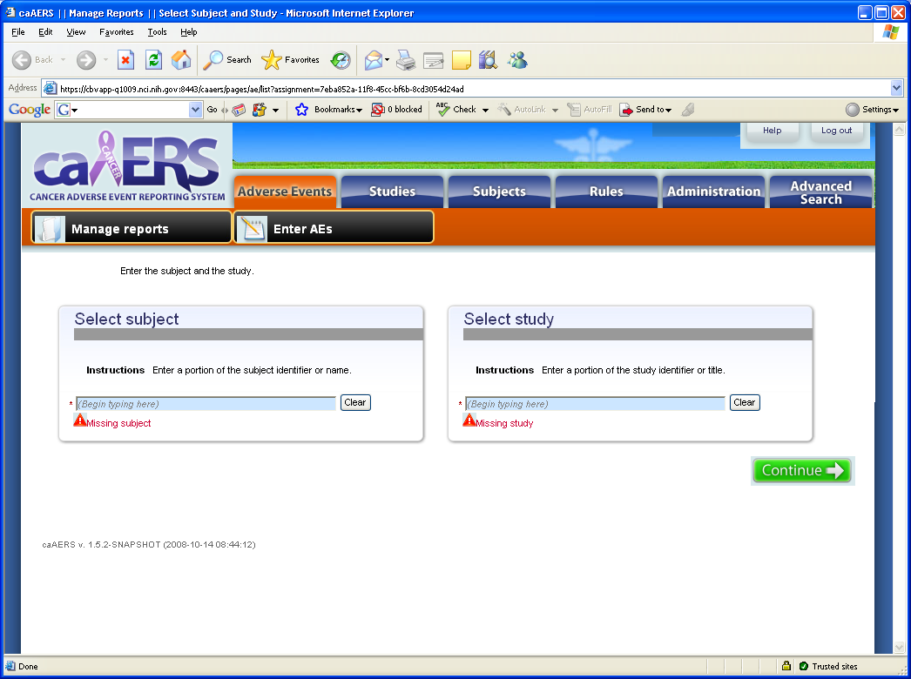

Should the user receive an error indicating the user selected “name” does not exist in caAERS

