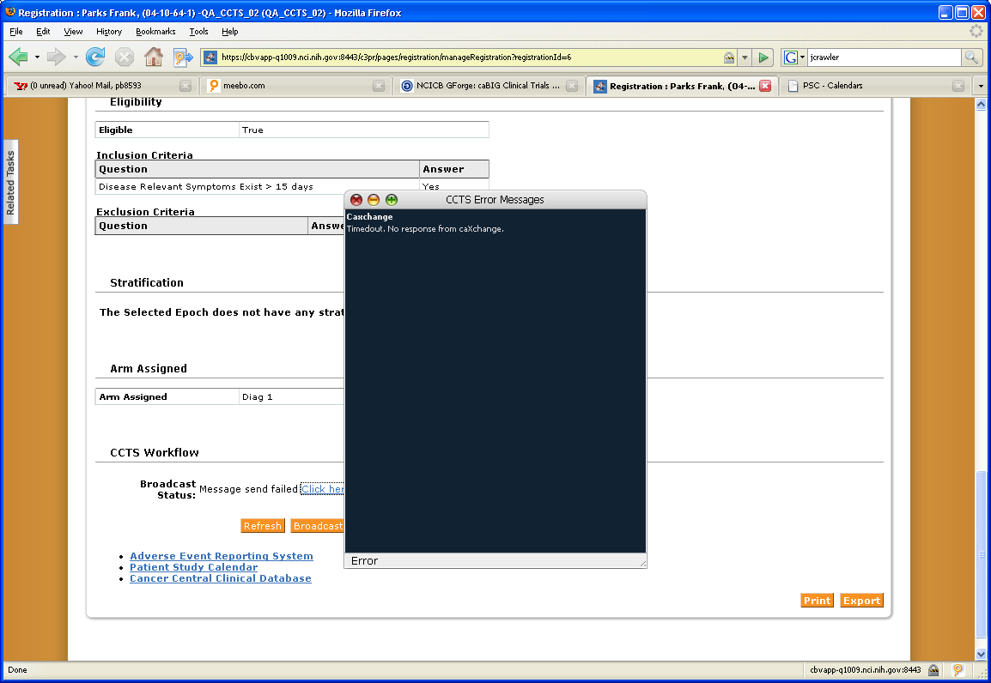
caXchange Error returned:

sly:83] Request send to ESB for key {http://caxchange.cagrid.nci.nih.gov/CaXchangeRequestProcessor/Context}CaXchangeResponseServiceResultsKey=113eeff0-a6bd-11dd-966c-ff99c09c2917
Oct 30, 2008 3:58:06 PM org.globus.wsrf.impl.security.authorization.ServiceAuthorizationChain authorize
INFO: Authorized "/O=caBig/OU=caGrid/OU=ccts/OU=Dorian IdP/CN=cctsdemo1@nci.nih.gov" to invoke "{http://caxchange.cagrid.nci.nih.gov/CaXchangeRequestProcessor/Context}getResponse".
Oct 30, 2008 3:58:09 PM org.globus.wsrf.impl.security.authorization.ServiceAuthorizationChain authorize
INFO: Authorized "/O=caBig/OU=caGrid/OU=ccts/OU=Dorian IdP/CN=cctsdemo1@nci.nih.gov" to invoke "{http://caxchange.cagrid.nci.nih.gov/CaXchangeRequestProcessor/Context}getResponse".
<?xml version="1.0" encoding="UTF-8"?><caXchangeResponseMessage xmlns="http://caXchange.nci.nih.gov/messaging"><responseMetadata><externalIdentifier>14bf4920-5fbc-45f9-ab66-84ffc5c17bb3</externalIdentifier><caXchangeIdentifier>113eeff0-a6bd-11dd-966c-ff99c09c2917</caXchangeIdentifier></responseMetadata><response><responseStatus>FAILURE</responseStatus><caXchangeError><errorCode>600</errorCode><errorDescription>Invalid payload error: Line:0Error:cvc-elt.4.2: Cannot resolve 'NonTreatmentEpochType' to a type definition for element 'epoch'.
Line:0Error:cvc-complex-type.2.4.a: Invalid content was found starting with element 'scheduledEpoch'. One of '{"gme://ccts.cabig/1.0/gov.nih.nci.cabig.ccts.domain":scheduledEpoch}' is expected.
Line:0Error:cvc-elt.4.2: Cannot resolve 'ScheduledNonTreatmentEpochType' to a type definition for element 'scheduledEpoch'.
</errorDescription></caXchangeError></response></caXchangeResponseMessage>2008-10-30 15:58:12,625 INFO listener.CaxchangeResponseListener [ActiveMQ Session Task,onMessage:76] Got response for caXchangeIdentifier.113eeff0-a6bd-11dd-966c-ff99c09c2917

C3PR Log:

2008-10-30 15:58:12,750 DEBUG [edu.duke.cabig.c3pr.esb.impl.CaXchangeMessageBroadcasterImpl] - Elapsed time : 6 seconds
2008-10-30 15:58:12,750 DEBUG [edu.duke.cabig.c3pr.esb.impl.CaXchangeMessageBroadcasterImpl] - Elapsed time : 6 seconds
2008-10-30 15:58:12,750 DEBUG [edu.duke.cabig.c3pr.esb.impl.CaXchangeMessageBroadcasterImpl] - Checking caXchange for response
2008-10-30 15:58:12,750 DEBUG [edu.duke.cabig.c3pr.esb.impl.CaXchangeMessageBroadcasterImpl] - Checking caXchange for response
2008-10-30 15:58:12,872 DEBUG [edu.duke.cabig.c3pr.esb.impl.CaXchangeMessageBroadcasterImpl] - Received response from caXchange
2008-10-30 15:58:12,872 DEBUG [edu.duke.cabig.c3pr.esb.impl.CaXchangeMessageBroadcasterImpl] - Received response from caXchange
2008-10-30 15:58:12,872 DEBUG [edu.duke.cabig.c3pr.esb.impl.CaXchangeMessageBroadcasterImpl] - caXchange Response follows.....

2008-10-30 15:58:12,872 DEBUG [edu.duke.cabig.c3pr.esb.impl.CaXchangeMessageBroadcasterImpl] - caXchange Response follows.....

2008-10-30 15:58:12,872 DEBUG [edu.duke.cabig.c3pr.esb.impl.CaXchangeMessageBroadcasterImpl] - gov.nih.nci.caxchange.Response@6e2e80b1
2008-10-30 15:58:12,872 DEBUG [edu.duke.cabig.c3pr.esb.impl.CaXchangeMessageBroadcasterImpl] - gov.nih.nci.caxchange.Response@6e2e80b1
2008-10-30 15:58:12,872 DEBUG [edu.duke.cabig.c3pr.esb.impl.CaXchangeMessageBroadcasterImpl] - Received response from caXchange for externalId14bf4920-5fbc-45f9-ab66-84ffc5c17bb3
2008-10-30 15:58:12,872 DEBUG [edu.duke.cabig.c3pr.esb.impl.CaXchangeMessageBroadcasterImpl] - Received response from caXchange for externalId14bf4920-5fbc-45f9-ab66-84ffc5c17bb3
2008-10-30 15:58:12,872 DEBUG [edu.duke.cabig.c3pr.esb.impl.CaXchangeMessageBroadcasterImpl] - Setting authentication object in SecurityContext.
2008-10-30 15:58:12,872 DEBUG [edu.duke.cabig.c3pr.esb.impl.CaXchangeMessageBroadcasterImpl] - Setting authentication object in SecurityContext.
2008-10-30 15:58:12,872 DEBUG [edu.duke.cabig.c3pr.esb.impl.CaXchangeMessageBroadcasterImpl] - Received failure from caXchange
2008-10-30 15:58:12,872 DEBUG [edu.duke.cabig.c3pr.esb.impl.CaXchangeMessageBroadcasterImpl] - Received failure from caXchange
2008-10-30 15:58:12,872 DEBUG [edu.duke.cabig.c3pr.utils.DefaultCCTSMessageWorkflowCallbackFactory] - Recording send failed for objectId14bf4920-5fbc-45f9-ab66-84ffc5c17bb3
2008-10-30 15:58:12,872 DEBUG [edu.duke.cabig.c3pr.utils.DefaultCCTSMessageWorkflowCallbackFactory] - Recording send failed for objectId14bf4920-5fbc-45f9-ab66-84ffc5c17bb3
2008-10-30 15:58:12,894 DEBUG [edu.duke.cabig.c3pr.esb.impl.CaXchangeMessageBroadcasterImpl] - looking at caXchange error..
2008-10-30 15:58:12,894 DEBUG [edu.duke.cabig.c3pr.esb.impl.CaXchangeMessageBroadcasterImpl] - looking at caXchange error..
2008-10-30 15:58:12,894 DEBUG [edu.duke.cabig.c3pr.esb.impl.CaXchangeMessageBroadcasterImpl] - looking at aplication level error..
2008-10-30 15:58:12,894 DEBUG [edu.duke.cabig.c3pr.esb.impl.CaXchangeMessageBroadcasterImpl] - looking at aplication level error..
2008-10-30 15:58:35,279 DEBUG [edu.duke.cabig.c3pr.web.security.RegexPrivilegeAndObjectIdGenerator] - ############### Returning edu.duke.cabig.c3pr.domain.StudySubject:READ #################

