When a register subject is performed, the below screen is displayed to the user.

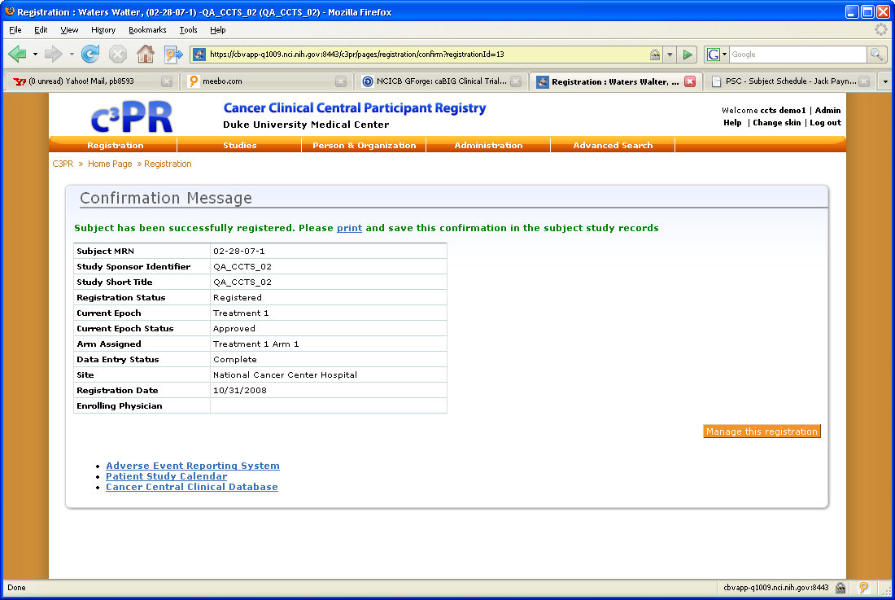

This confirmation message implies that the subject was successfully registered; however this is just to C3PR – not that the subject was successfully broadcast and loaded into the downstream applications.

In order to see the broadcast status, the user must select the Manage this registration button.

If this is the screen to be displayed to the end user regarding the subject registration, then the broadcast details need to be supplied on this page so the user does not have to enter the “Manage This Registration” option to see if the subject was successfully broadcast. This screen should also contain the C3D Patient ID position.

