Study Overview:
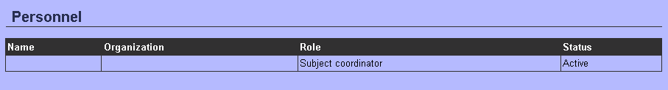
Now, when I go back to Personnel section, this is what I see:
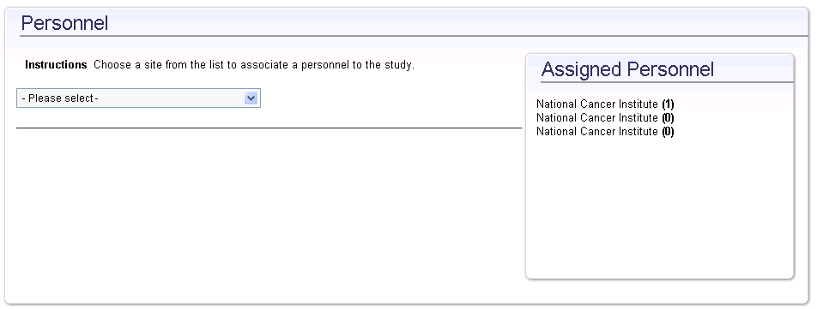
When I try to select the first National Cancer Institute, it just shows me this:
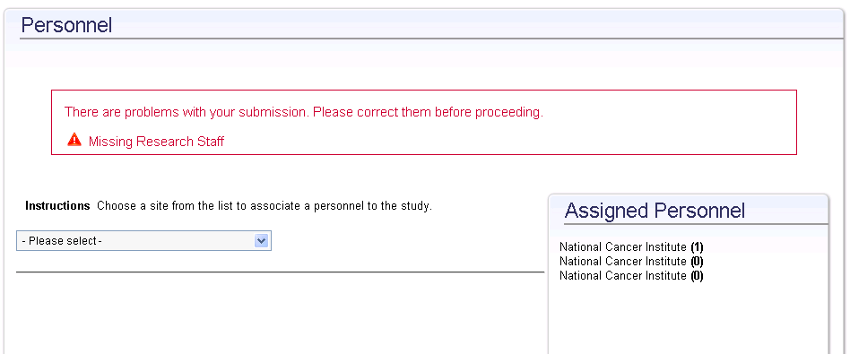

So I can’t select the blank record to delete it.

