- Added the new user
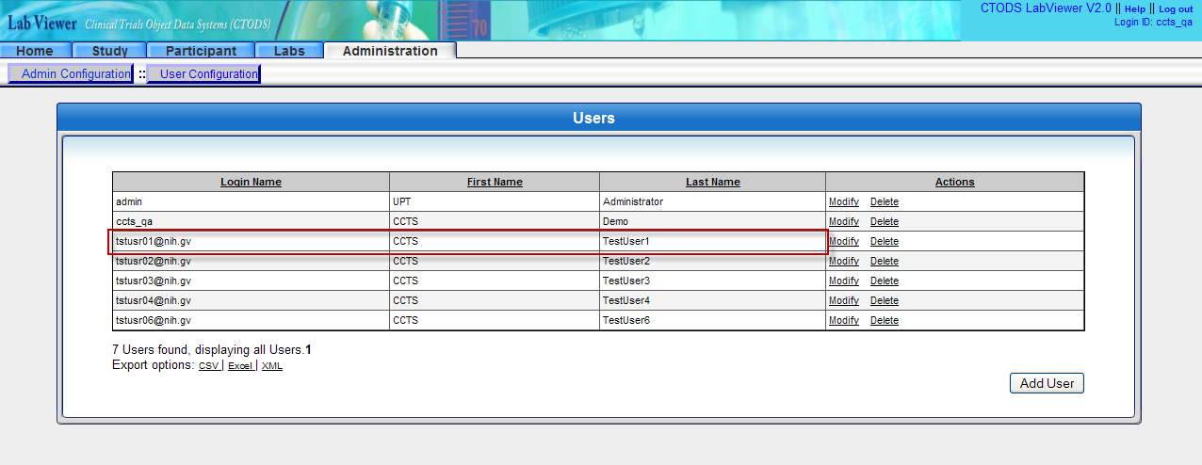
- Logging into LabViewer using new user credentials gives below error
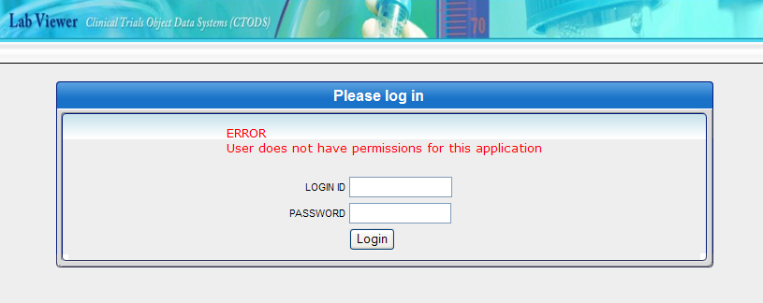

The user can still webSSO into other CCTS apps
