- User is in C3PR as Site Coordinator
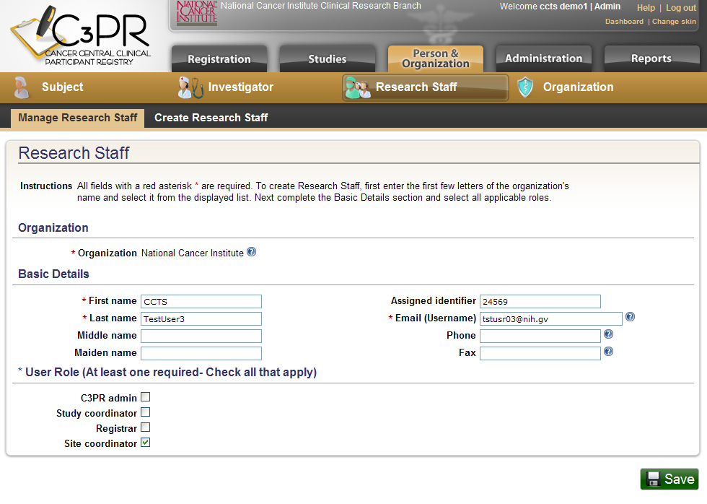
- User is in LabViewer
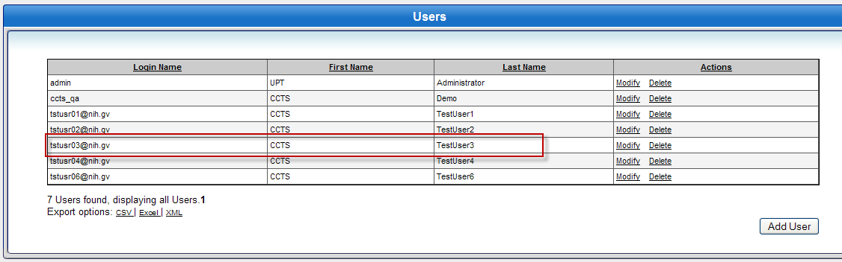

- Broadcasting a study from C3PR as a Site Coordinator displays an error
