Releasing Template as Study Coordinator
- Logging in as Study Coordinator shows the newly broadcast study
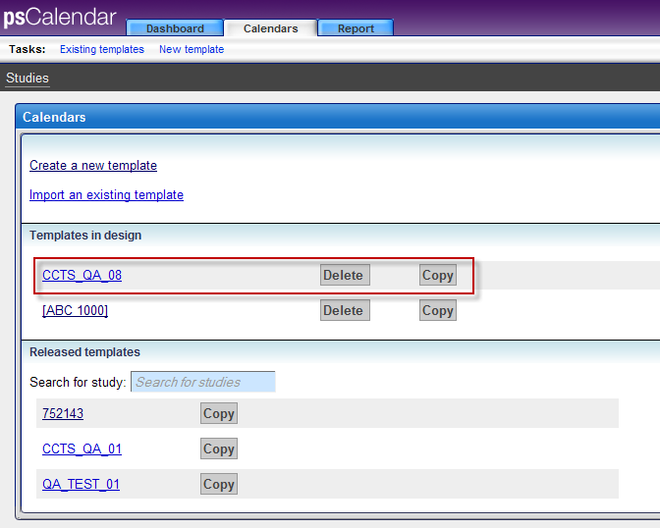
- After adding periods and activities to the Arms, the template was ready for release
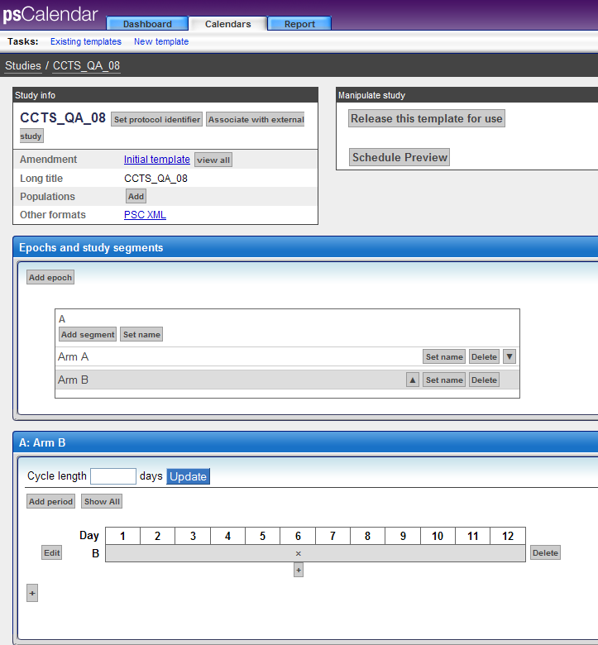
- Clicking on Release This Template opens up a confirmation screen.
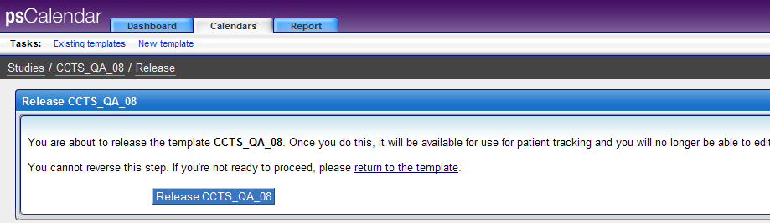
- As soon as I release the template, I get the below screen.
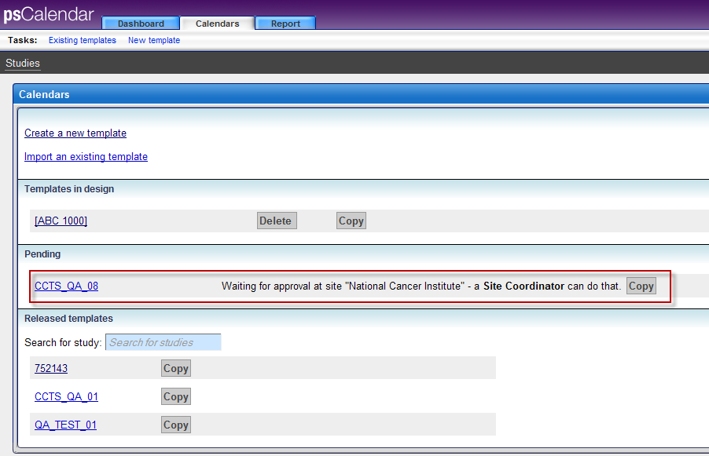

Releasing Template as Admin
- Login as Admin into PSC and click on Study Coordinator. The newly broadcast study is visible
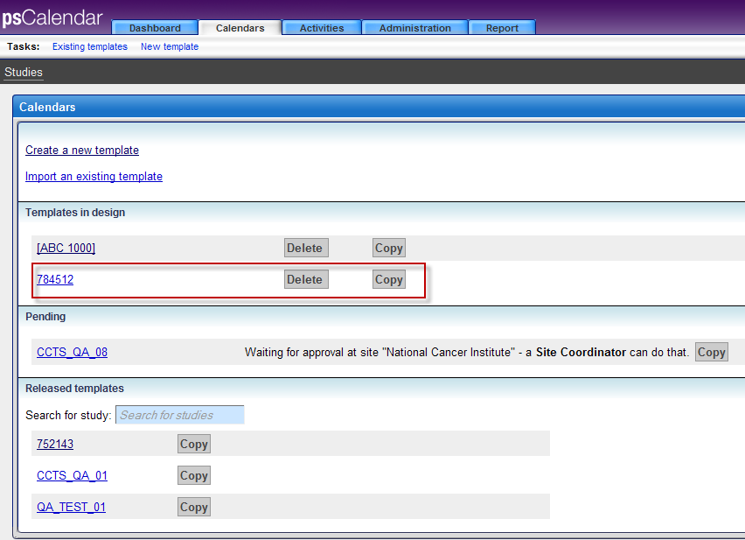
- After adding periods and activities to the Arms, the template was ready for release
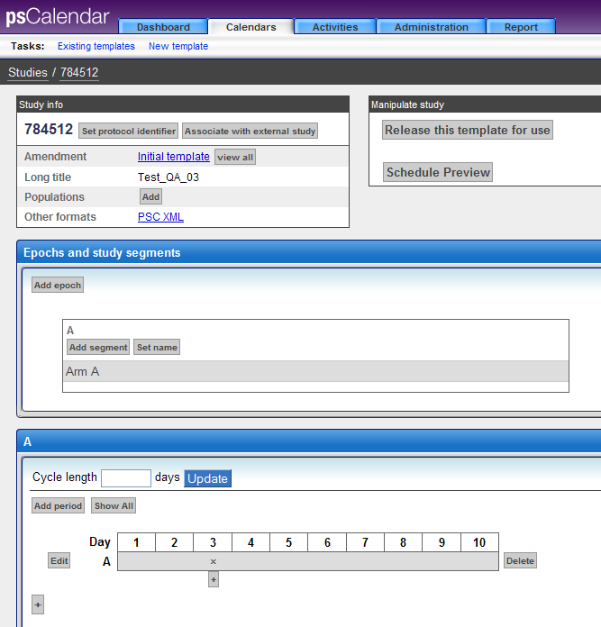
- Clicking on Release This Template opens up a confirmation screen
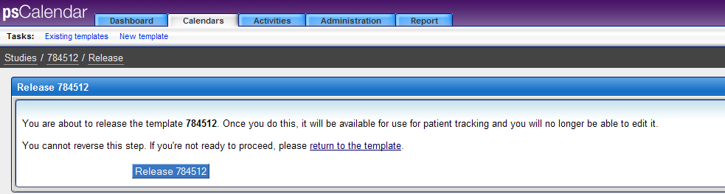

- As soon as I release the template, I get the below screen
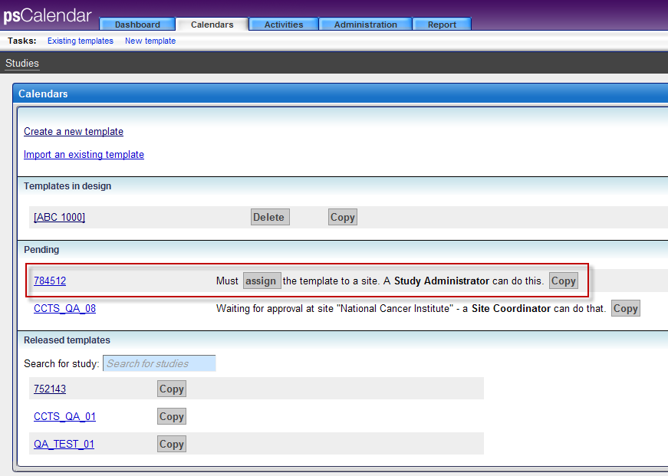
Now it is asking the Study Admin to assign the template to a site.

