- The lab data for the SMK_M1_QA_01
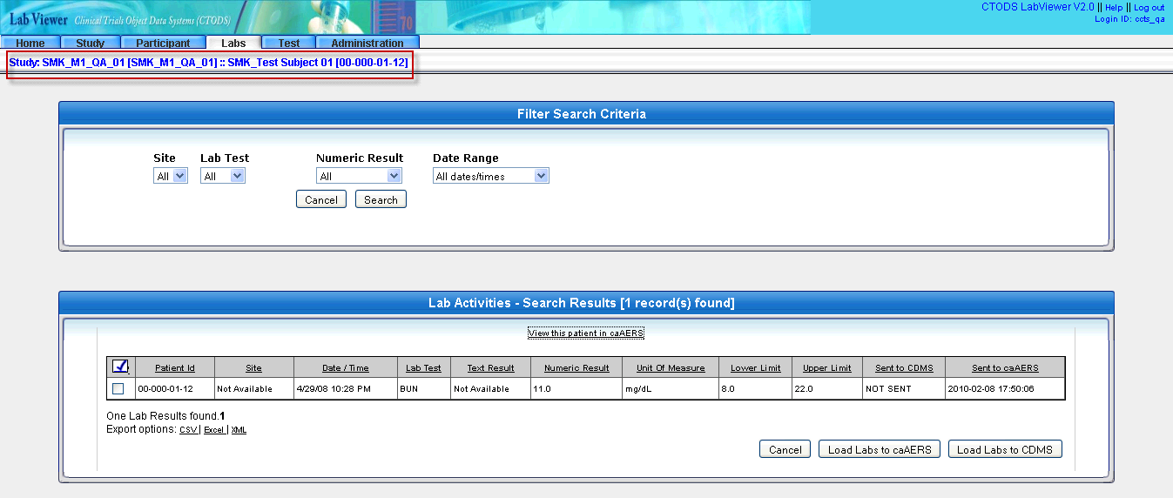

- The caAERS report page
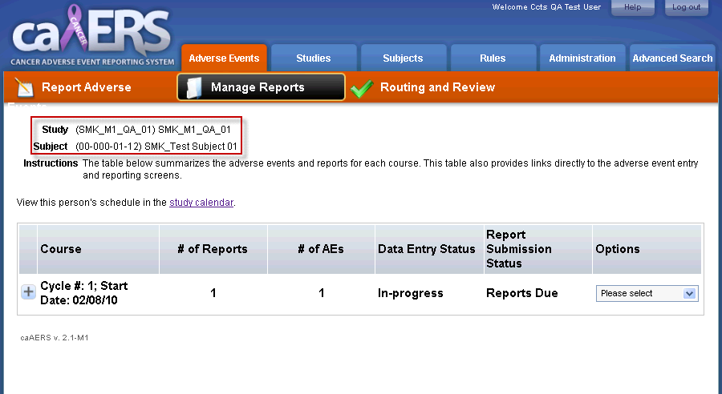

- Lab data page of a new patient and study (CCTS_QA_08)
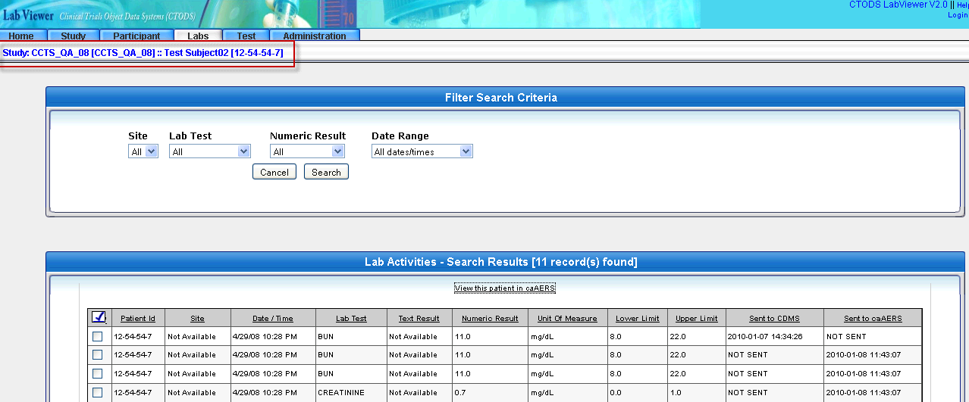
- Clicking on the caAERS hotlink opens the old patient report
