While running our smoke tests on QA for RC4, I ran an Investigator search for LN:Ernst. Below is the result I got back:

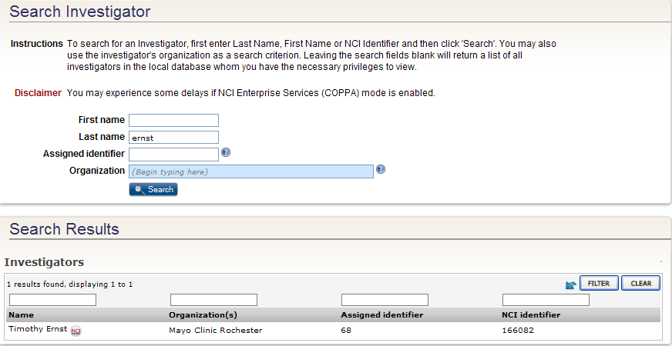

When I ran the same search on caAERS, I got back the below results:

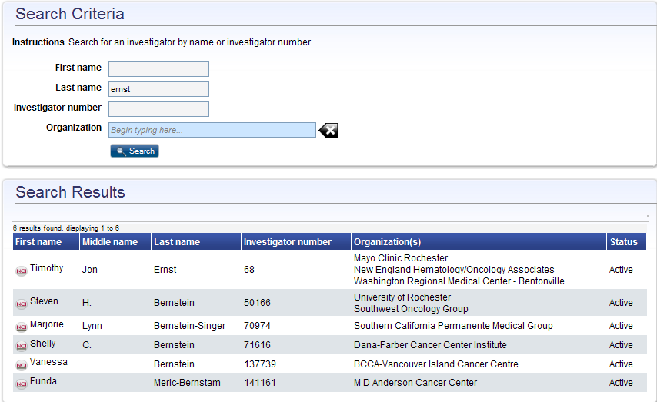

The results from caAERS are consistent with what exists on the PO database.
