Screen shot for the role that I used for the search.

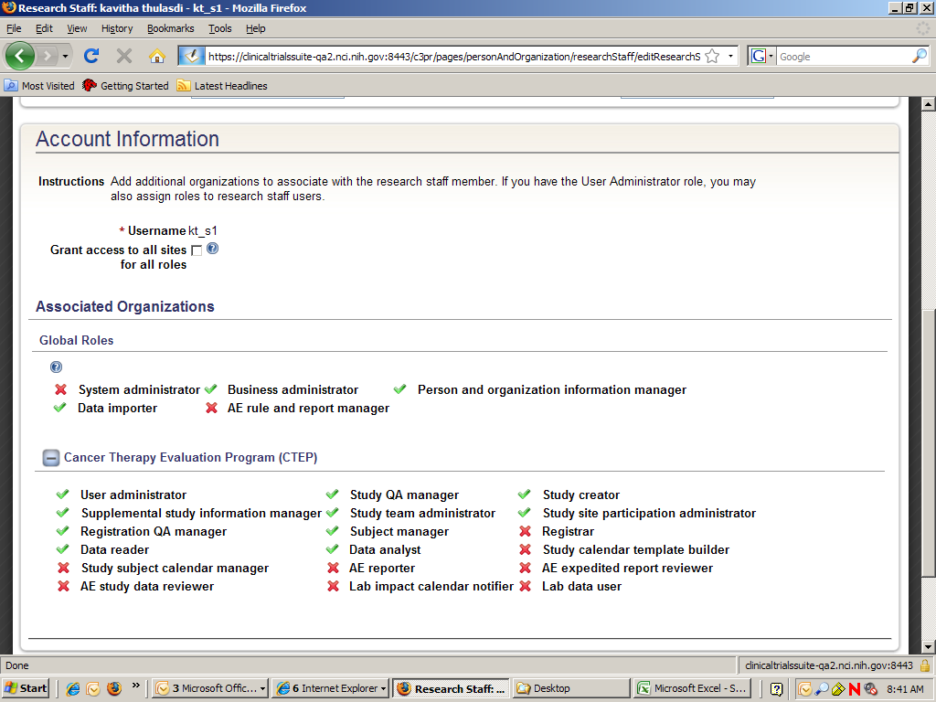

Screen shot for the blank research staff search results from COPPA

