Bugs Report
Test case_CCTS085 related:
Minimizing the calendar calendar page from right to left side causes all sub-frames to display abnormally.
URL: https://cbiit-qa-suite-linux.nci.nih.gov:8443/psc/pages/cal/studyList
Test Environment: QA3
Login Info: ccts_rez_all_st
Role:
- Supplemental Study Info. Manager
- Study Site Participation Admin
- Study QA Manager
- Study Calendar Template Builder
- Study Team Admin.
- Study Creator

Steps to reproduce:
Example:
- Go “Calendar” tab
- Click “Studies” link
- Under “Released templates” section
- Click a” CCTS_QA_01”
- Try to minimize this page from right to left, and you’ll see all sub frames crumble together.
- Please see below screen shots for more details.

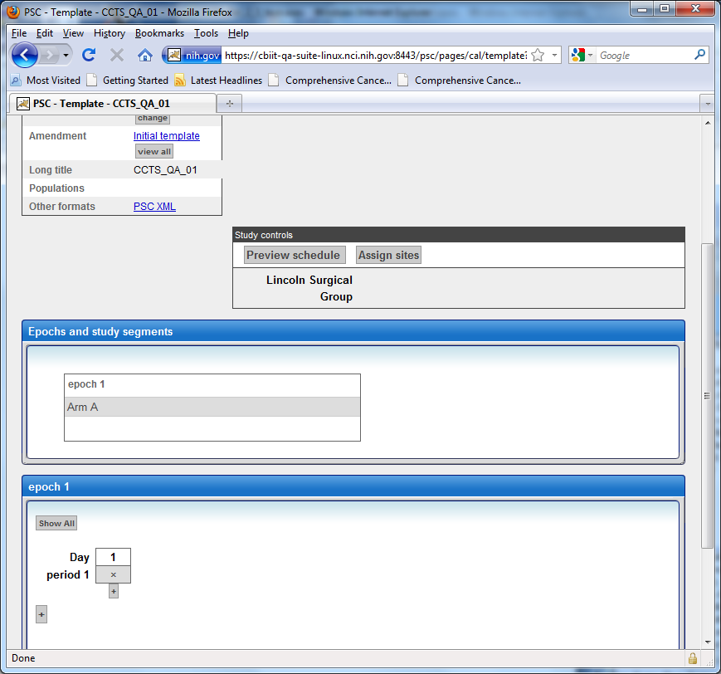
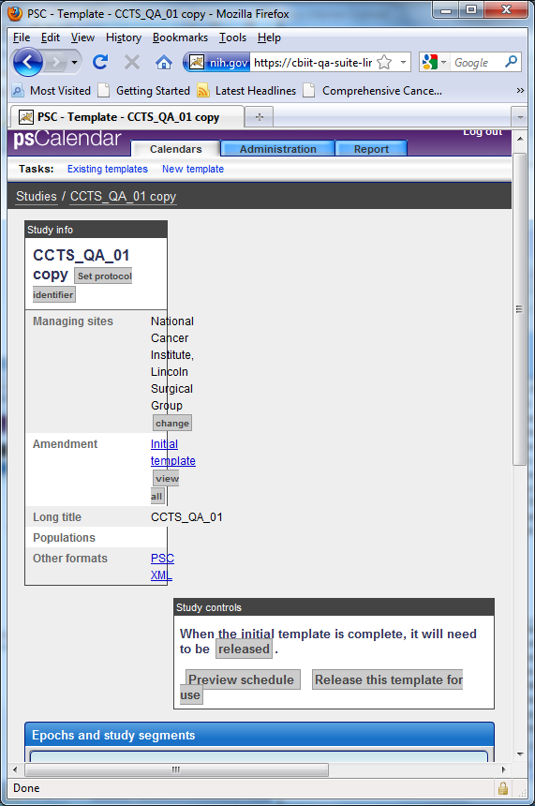

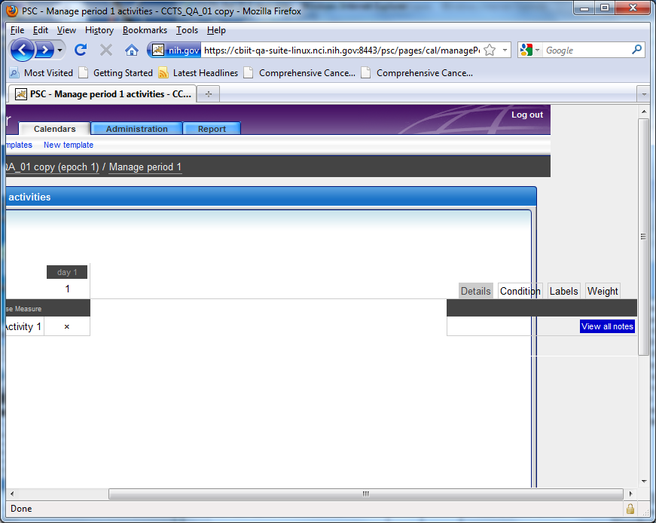

Thanks,
Reza Mehri

