Bugs Report
Test case_CCTS085 related:
The user information is missing from all PSC-web pages.
URL: https://cbiit-qa-suite-linux.nci.nih.gov:8443/psc/pages/cal/studyList
Test Environment: QA3
Login Info: ccts_rez_all_st
Role:
- Supplemental Study Info. Manager
- Study Site Participation Admin
- Study QA Manager
- Study Calendar Template Builder
- Study Team Admin.
- Study Creator

Steps to reproduce:
- Login to PSC web site
- You’ll observe that the following information is missing from the top of web page.
- User’s first name
- User’s last name
- User’s role

Example Screen

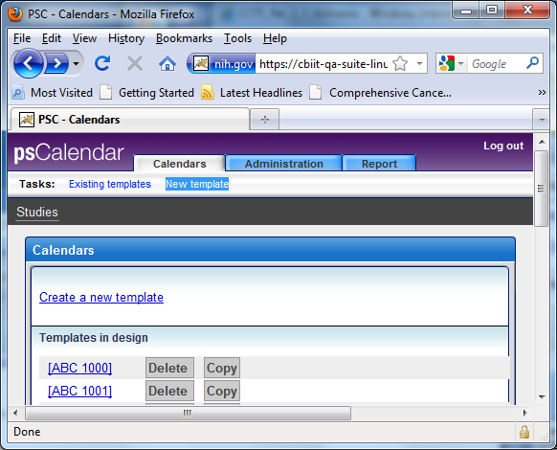

Thanks,
Reza Mehri

